HarvestHub User Manual
  - Customer farmer and admin guide
Android version 1.0.19 | Build 20
Use this manual to learn what each HarvestHub page does and how to move through shopping, farm management and admin tasks. Every illustrated entry includes the page location, a screenshot and an explanation of its controls.

Start with your role
Customers browse produce, choose a farmer, place orders and follow their progress. Farmers maintain their own listings, farm details and incoming orders. Administrators manage marketplace accounts, listings, orders and public information.

Complete the main tasks
Shop for produce: Sign in > Home or Explore > Product details > Choose farmer if shown > Add to cart > Checkout > Orders.
Manage a farm: Sign in as a farmer > Complete Your Farm Profile > Add products > Review Orders > Advance eligible order statuses.
Manage the platform: Sign in with an admin account > Dashboard > Users, Products, Orders or More.
Change two-step verification: Open App settings or Password & Security > Change the email verification switch > Confirm your current password > Verify the email code.
Leave an account: Open Profile or admin More > Logout > Sign out. The app returns directly to the shared sign in page.

Reading the screenshots
Screenshots use example accounts and data. Your names, prices, stock, notifications and report totals will differ. Some pages scroll; the screenshot shows the initial view or the part needed to explain the feature. The same shared page may be reached from more than one role.
Checkout records orders without an online payment gateway. Always review the selected seller, quantity, total and delivery details before confirming. A saved product or followed farm does not reserve stock.

Contents
Select an entry in Word to jump to its illustrated page.

Getting started
01 Starting HarvestHub 4
02 Welcome to HarvestHub 5
03 Discover fresh food 6
04 Meet local farmers 7
05 Meet the Ola assistant 8
06 Sign in 9
07 Farmer account entry 10
08 Create a customer account 11
09 Set customer credentials 12
10 Create a farmer account 13
11 Set farmer credentials 14
12 Reset a forgotten password 15
13 Verify an email code 16
14 Browse as a guest 17

Customer workspace
15 Customer home 18
16 Explore products 19
17 Refine a product search 20
18 Product details and farmer choice 21
19 A product that is sold out 22
20 Browse farmers and farms 23
21 View a farm 24
22 Saved products 25
23 Followed farmers 26
24 Review the cart 27
25 Confirm an order 28
26 Order confirmation 29
27 Customer orders 30
28 Track an order 31
29 Choose a pickup window 32
30 Ask the Ola assistant 33
31 Customer profile 34

Farmer workspace
32 Farmer dashboard 35
33 Farmer products 36
34 Add a product 37
35 Edit a product 38
36 Farmer orders 39

Contents continued
Select an entry in Word to jump to its illustrated page.

Farmer workspace
37 Manage an order 40
38 Advance an order status 41
39 Farmer reports 42
40 Farmer account profile 43
41 Edit the farm profile 44

Admin workspace
42 Admin dashboard 45
43 Manage users 46
44 Customer account details 47
45 Farmer account details 48
46 Admin product catalog 49
47 Admin orders 50
48 Admin profile and tools 51
49 Admin account actions 52
50 Log out of an account 53
51 Manage product categories 54
52 Add or rename a category 55
53 Platform reports 56
54 Sales analytics 57
55 Admin settings 58
56 Read customer feedback 59
57 Edit public information 60
58 Add or edit a market 61

Shared account and support pages
59 Edit personal details 62
60 App preferences 63
61 Change a password 64
62 Two step verification enabled 65
63 Confirm disabling two step verification 66
64 Two step verification disabled 67
65 Confirm enabling two step verification 68
66 Notifications and updates 69
67 Farmers market directory 70
68 Choose a map location 71
69 About HarvestHub 72
70 Contact and feedback 73
71 Loading empty and error screens 74

01 Starting HarvestHub
Open HarvestHub on your phone
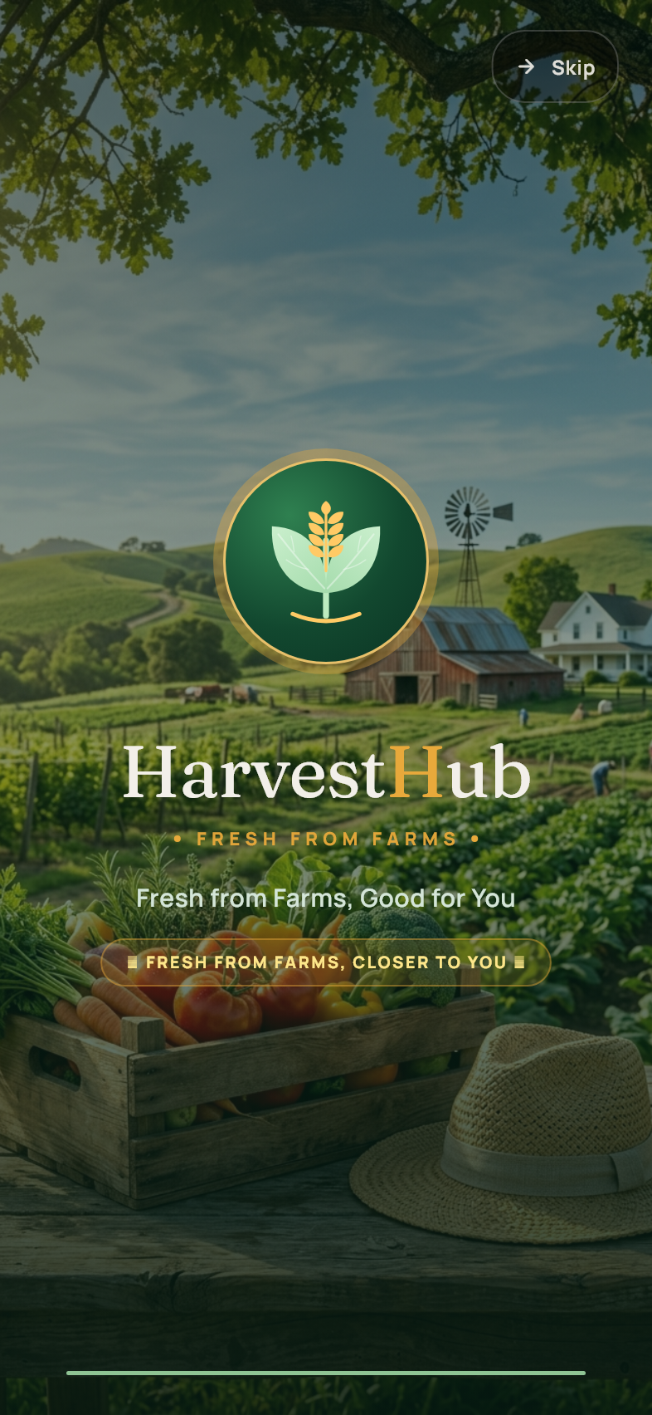
Getting started
The opening screen appears while HarvestHub starts and restores your session. Wait for the welcome screens, sign in page or your account dashboard. If the app cannot load online information, check your connection and reopen it. Your saved account role determines the dashboard shown after sign in.

02 Welcome to HarvestHub
First launch > Welcome
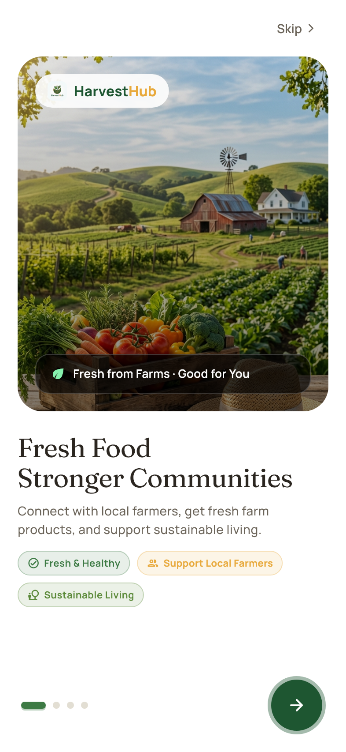
Getting started
This introduction explains the local farm marketplace. Swipe left or tap the round arrow to continue. The progress marks show which introduction you are viewing. Use Skip if you want to move directly to the account entry screen.

03 Discover fresh food
Welcome > Second introduction
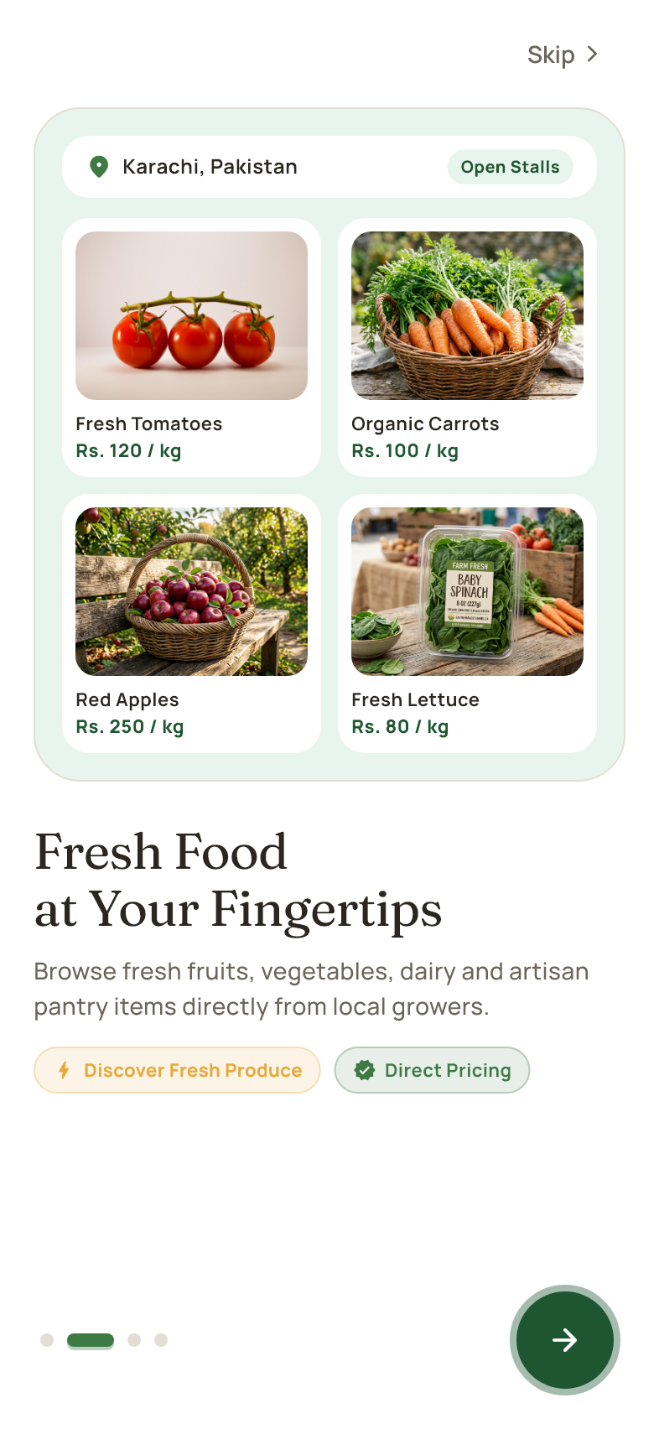
Getting started
The second introduction shows how customers discover produce and browse product categories. Continue with the arrow or swipe left. Product cards in the introduction explain the shopping experience; open the live catalog after entering the app to see current listings and prices.

04 Meet local farmers
Welcome > Third introduction
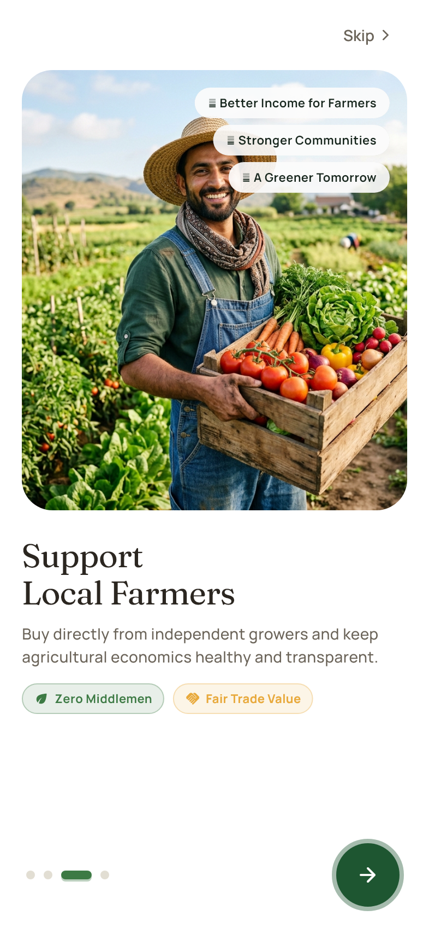
Getting started
This page introduces the farmers behind the produce. Customers can visit farm profiles and follow their preferred growers. Farmers have a separate account workspace for products and orders. Continue to the final introduction using the arrow or a left swipe.

05 Meet the Ola assistant
Welcome > Final introduction
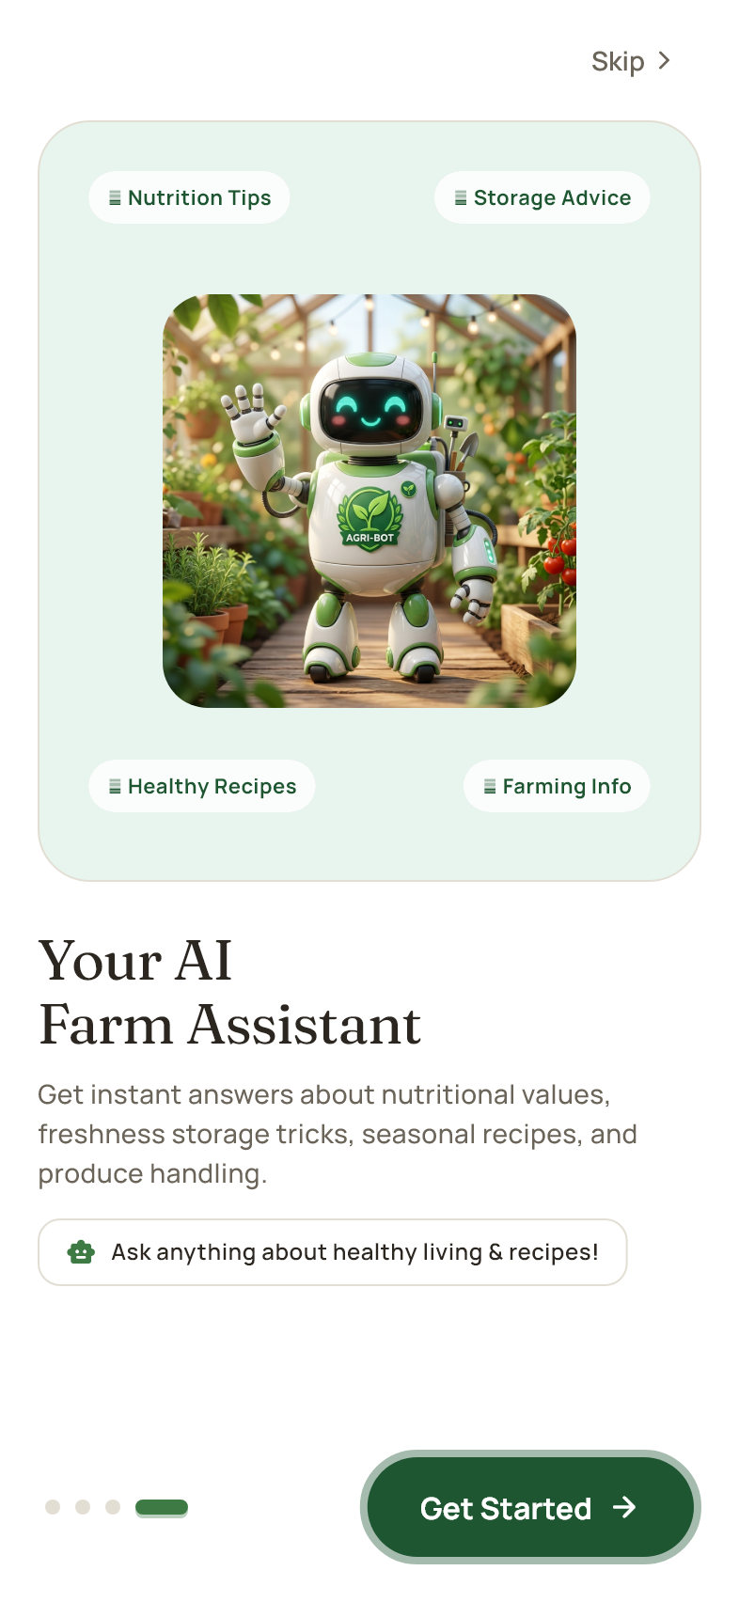
Getting started
The final introduction presents Ola, the in-app assistant. Tap Get Started to open sign in and registration. Once you enter the app, the assistant can answer general questions and explain app features. Availability of live answers depends on the connection and assistant service.

06 Sign in
Welcome > Get Started
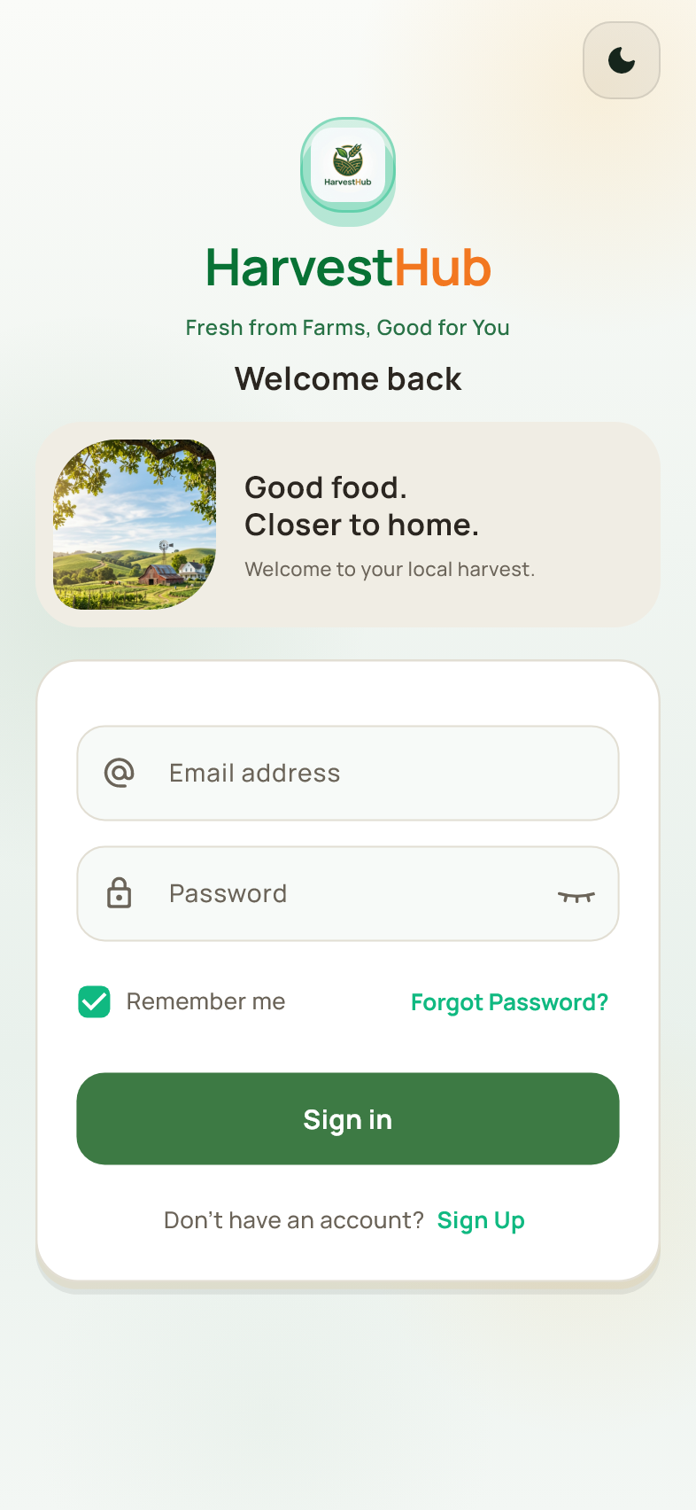
Getting started
Enter your registered email and password, then tap Sign In. HarvestHub recognizes the role stored on your account and opens the customer, farmer or admin workspace. Complete email verification when requested. The eye icon shows or hides the password. Forgot Password opens recovery, Sign Up opens registration, and Explore demo mode allows guest browsing.

07 Farmer account entry
Sign in or registration > Farmer option
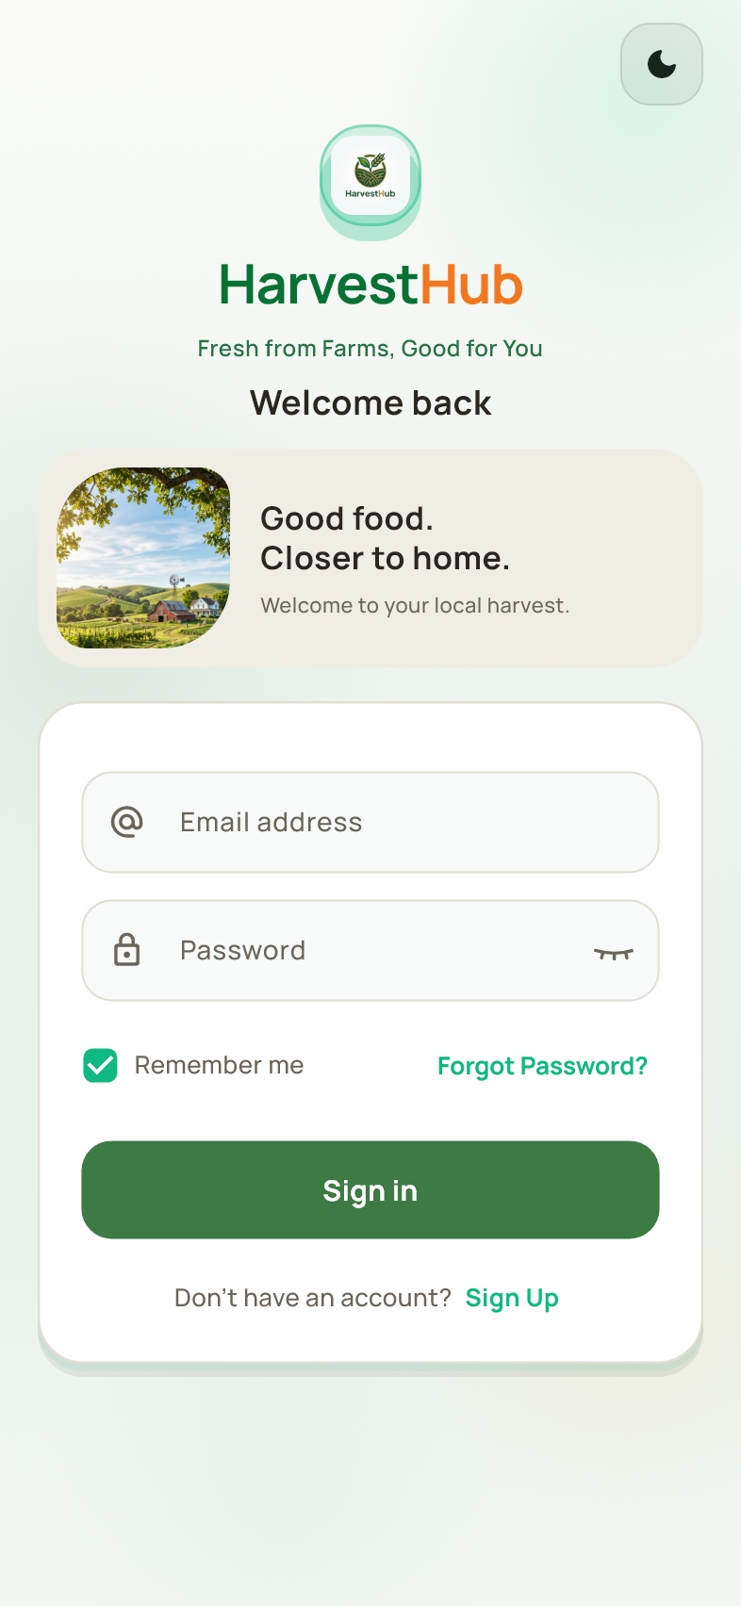
Getting started
Farmers use the same email and password sign in process. Existing accounts open the role already assigned to them; selecting a registration option does not change an existing account role. New sellers should choose Farmer when creating an account. Admin accounts use the shared sign in page and are not created through public registration.

08 Create a customer account
Sign in > Sign Up > Customer
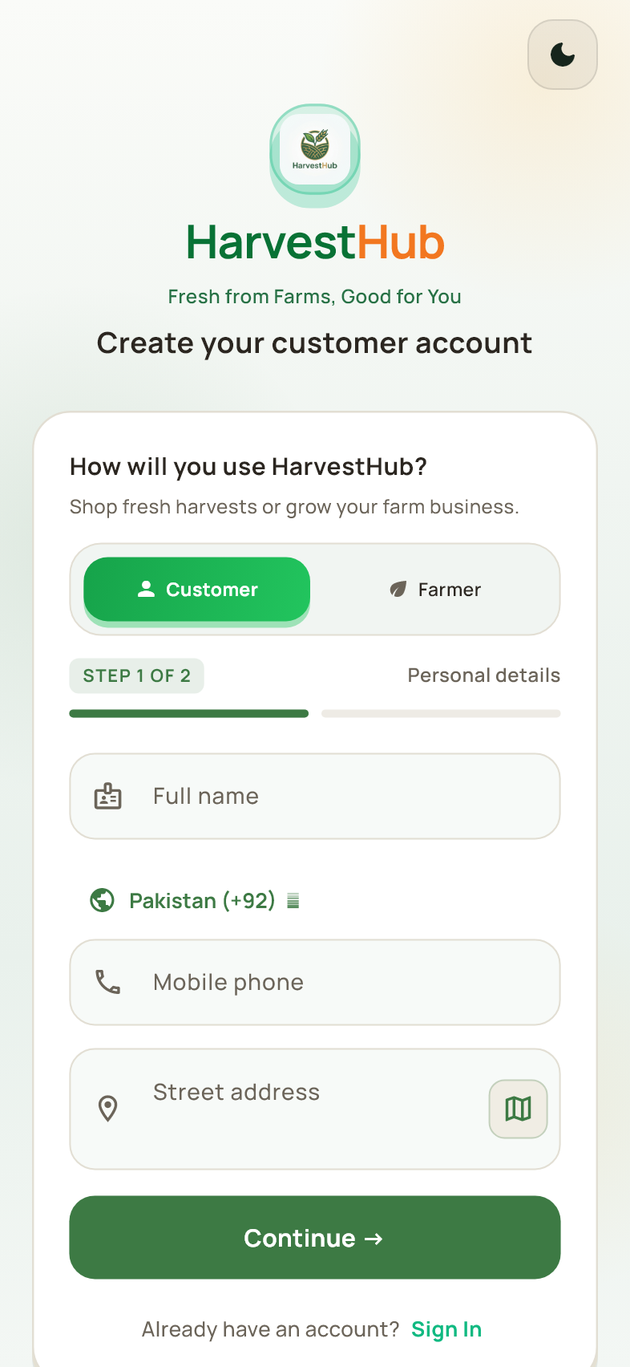
Getting started
Choose Customer and enter your full name, mobile number and street address. Use the location control when available to select an address on the map. Tap Continue to move to account security. Correct any validation message beside a field before proceeding; these details are used for your customer profile.

09 Set customer credentials
Customer registration > Continue
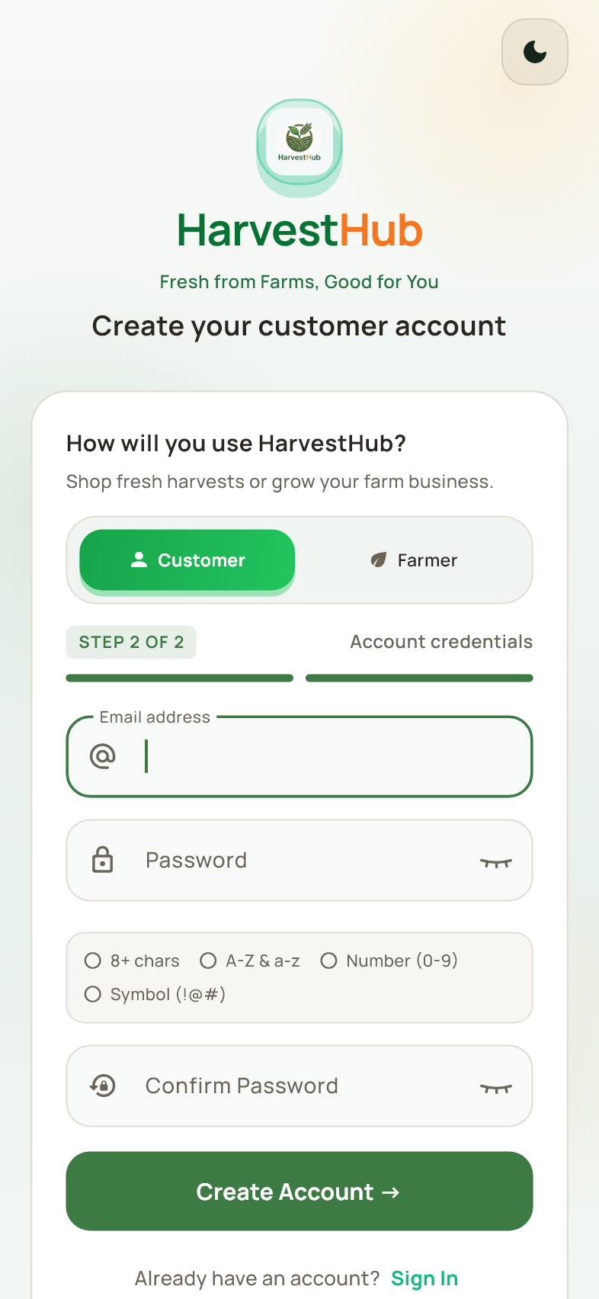
Getting started
Enter a valid email address, choose a password and repeat it in Confirm Password. Follow the strength requirements shown on the form before creating the account. Complete the email verification step when prompted. Keep access to this email because it is used for sign in verification and recovery.

10 Create a farmer account
Sign in > Sign Up > Farmer
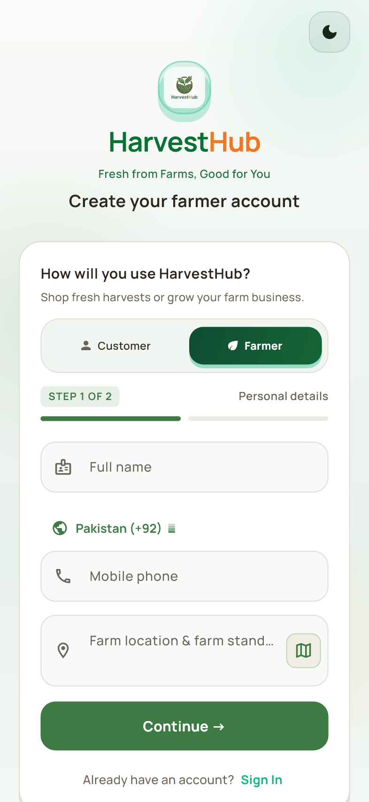
Getting started
Select Farmer and enter your personal and contact details. Continue to the security form after the required fields are valid. A farmer account opens the seller workspace, where you can complete your farm profile and add products. Use an address that helps customers understand your farm or pickup location.

11 Set farmer credentials
Farmer registration > Continue
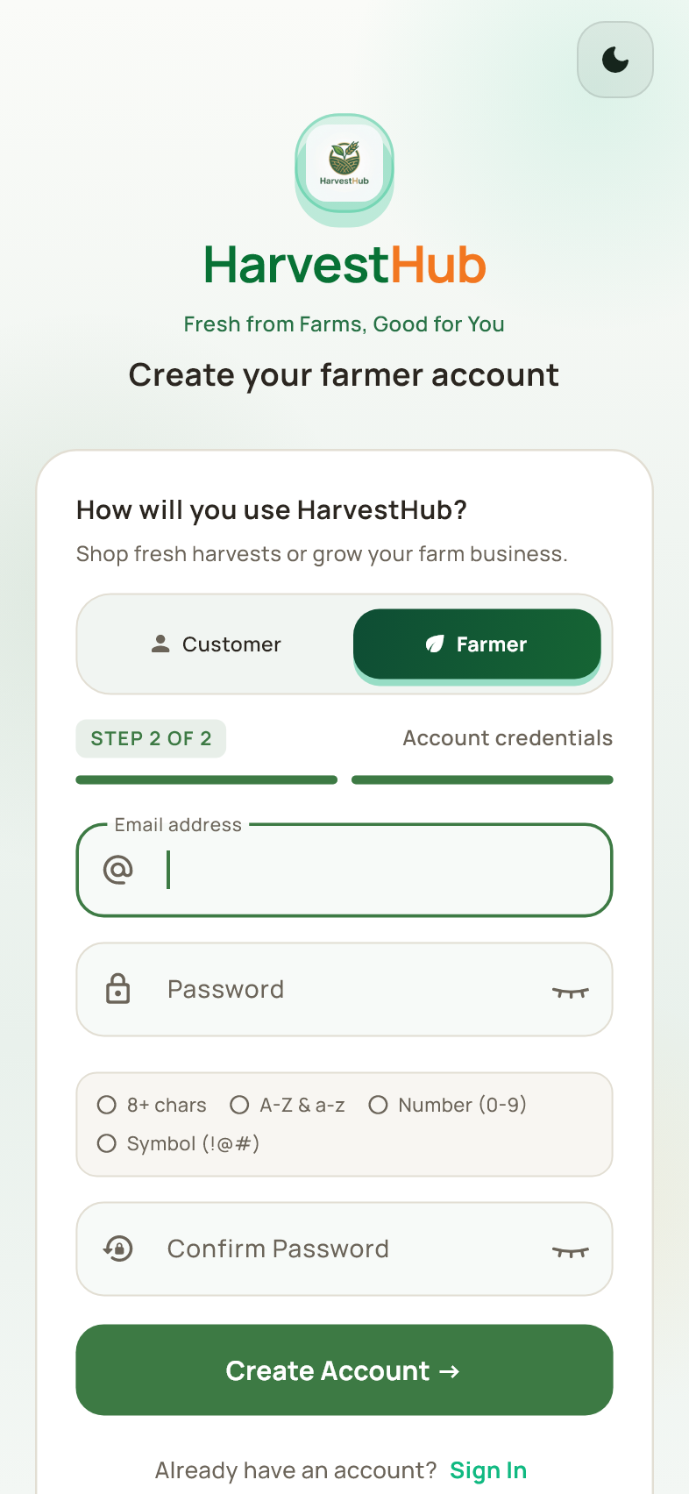
Getting started
Enter the email and password you will use for the farmer account. Confirm the password and tap Create Account. Follow the email verification instructions to finish. After entering the farmer workspace, review your farm information before publishing listings for customers.

12 Reset a forgotten password
Sign in > Forgot Password
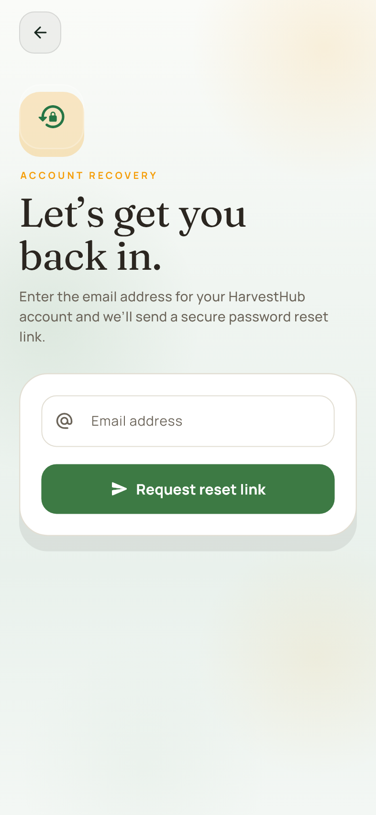
Getting started
Enter the email registered to your account and tap Request reset link. Check that inbox, including the spam folder, and follow the password reset instructions in the email. Return to sign in with the new password. Do not enter an email verification code in the password field; verification has its own page.

13 Verify an email code
Sign in or account security > Email verification
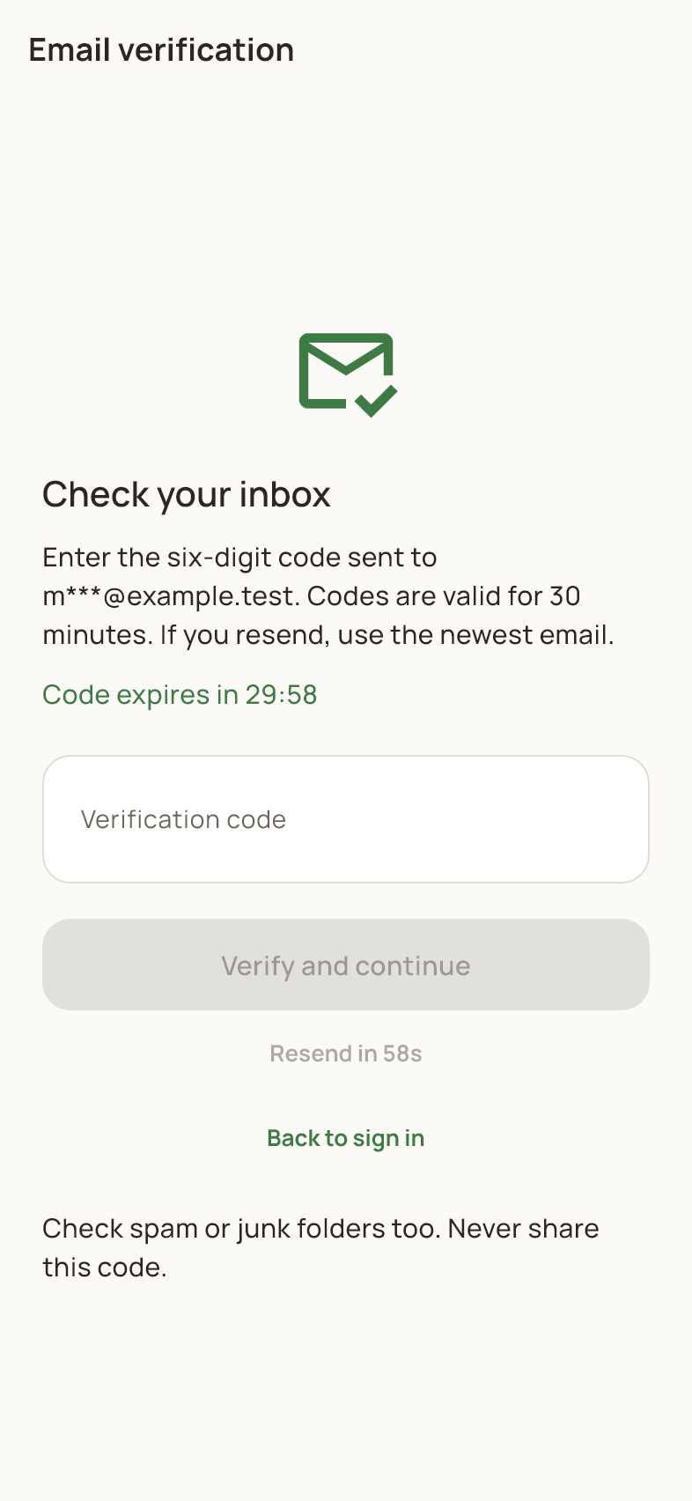
Getting started
Enter the six digit code sent to your email and tap Verify and continue. The page shows the code destination and expiry information. Use the resend option when its waiting period ends, then use the latest code. This screen is used for protected sign in and for confirming changes to two-step verification.

14 Browse as a guest
Guest mode > An account-only feature
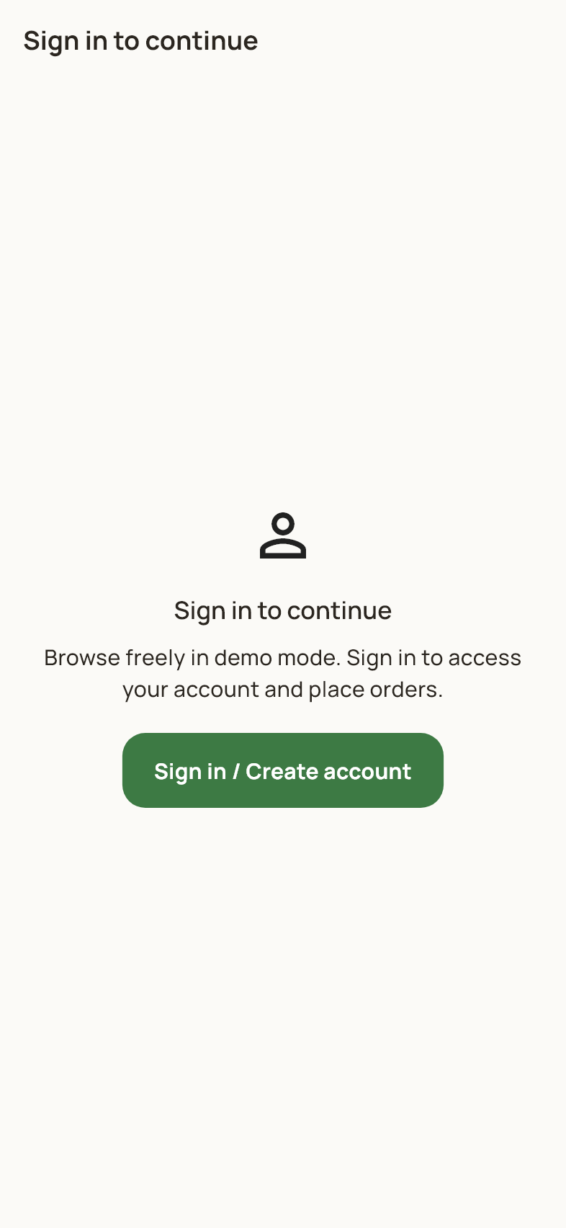
Getting started
Guests can browse the marketplace before creating an account. This page appears when a feature needs a signed in user, such as account details or order access. Tap Sign in / Create account to continue with an account, or go back to browsing. Adding items to the cart and checkout also require sign in.

15 Customer home
Customer sign in > Home
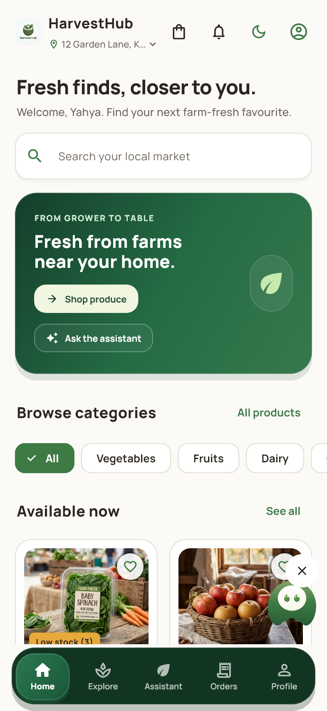
Customer workspace
Home shows categories, available produce and shortcuts to shopping features. Tap a product to view its details or open Explore to search. The updated catalog shows one card for the same product name, category and pack size. Where several farmers sell it, an available lower priced offer is shown first; other farmers remain selectable on the product page.

16 Explore products
Customer navigation > Explore
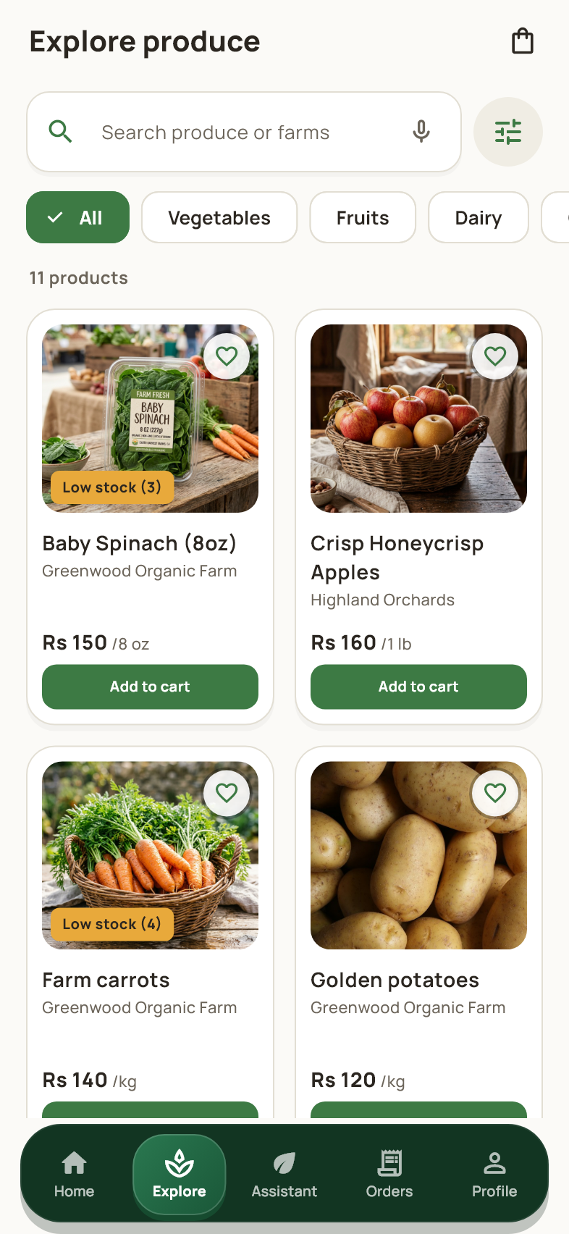
Customer workspace
Search by product or farm and use the category chips to narrow the catalog. Open a product card to see price, stock and seller details. Matching offers are grouped so repeated copies of the same product do not fill the list. Use the filter icon for farm, availability, price order and distance options.

17 Refine a product search
Explore > Filter icon
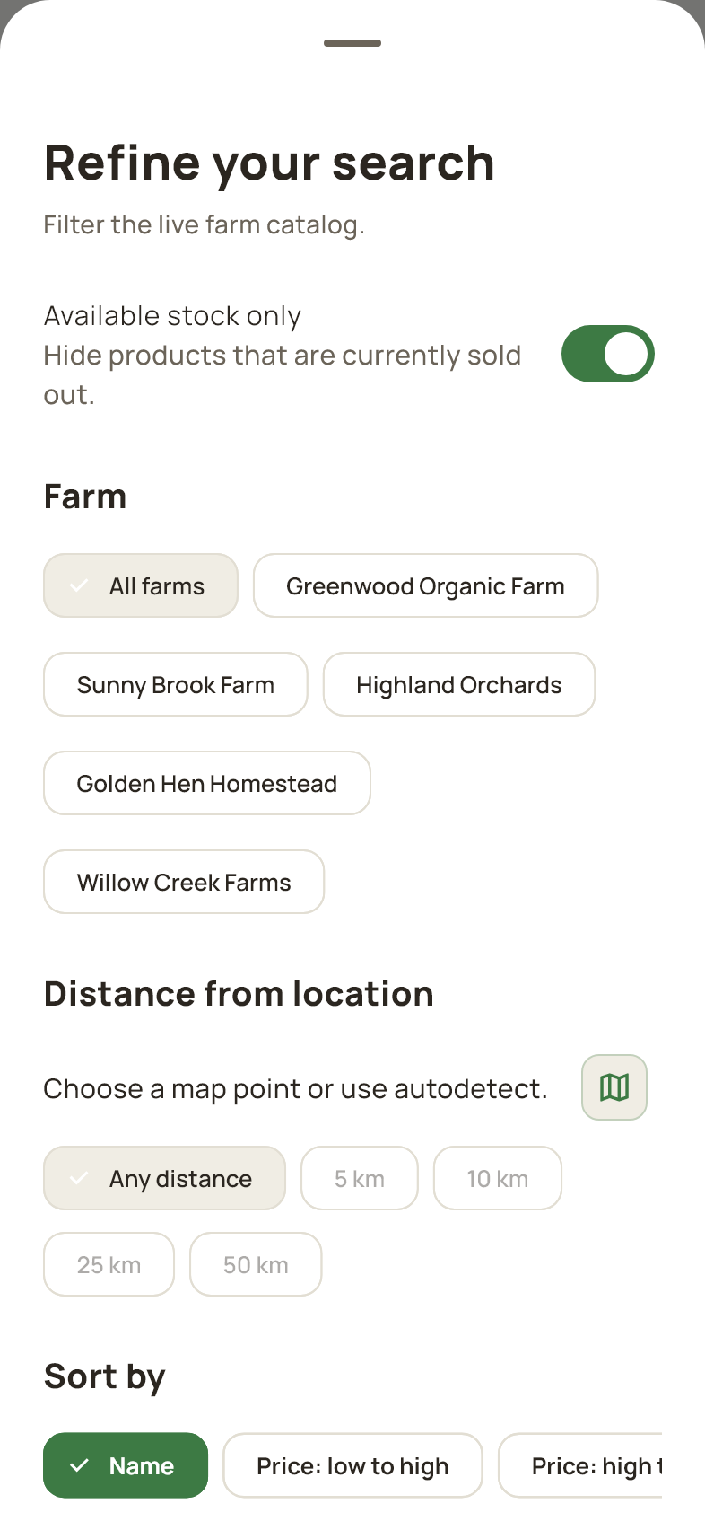
Customer workspace
Select the farms and availability options you want to see, choose a sort order and adjust distance when you have a location. The location control opens a map picker. Filters are applied before matching product offers are grouped, so choosing a specific farm still shows that farm's matching items. Apply the filter controls shown in the sheet to return to results.

18 Product details and farmer choice
Home or Explore > A product
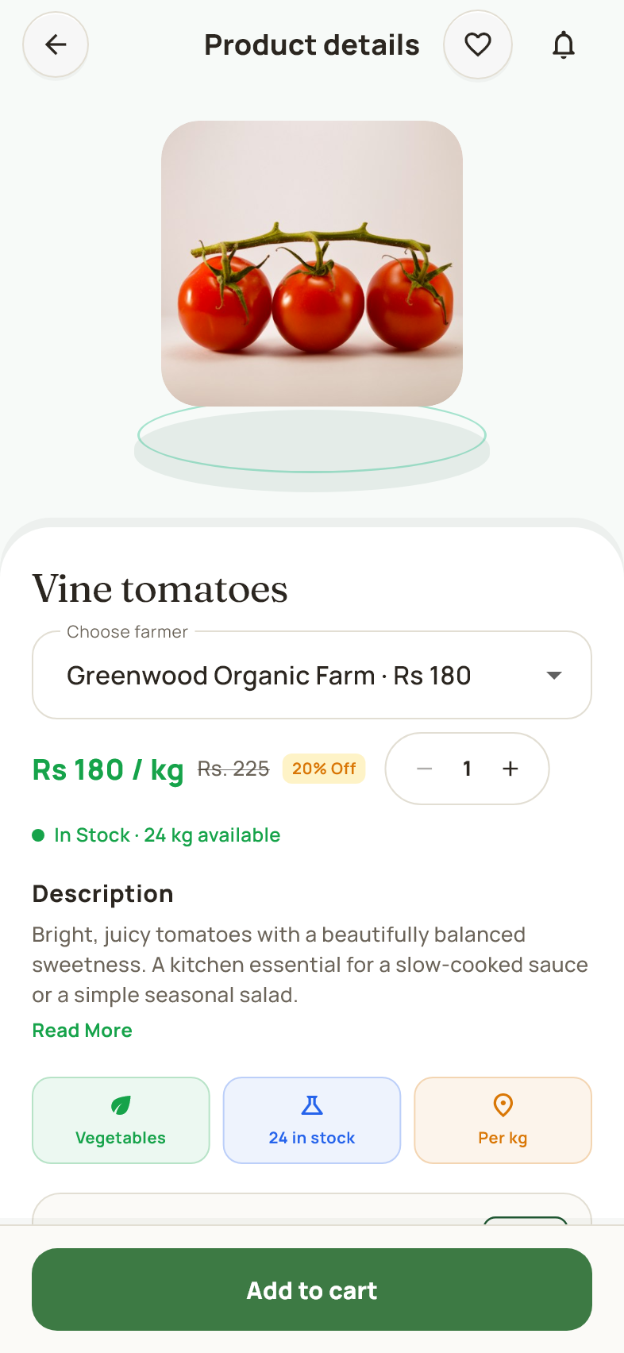
Customer workspace
Review the photos, description, unit price, stock and selected farm before ordering. Where matching offers exist, Choose farmer switches the seller, price and available stock. Set the quantity and tap Add to cart; the cart receives the chosen farmer's listing. The heart saves the listing, and the farm link opens the seller profile. Scroll for more details and related produce.

19 A product that is sold out
Catalog or saved products > A sold out listing
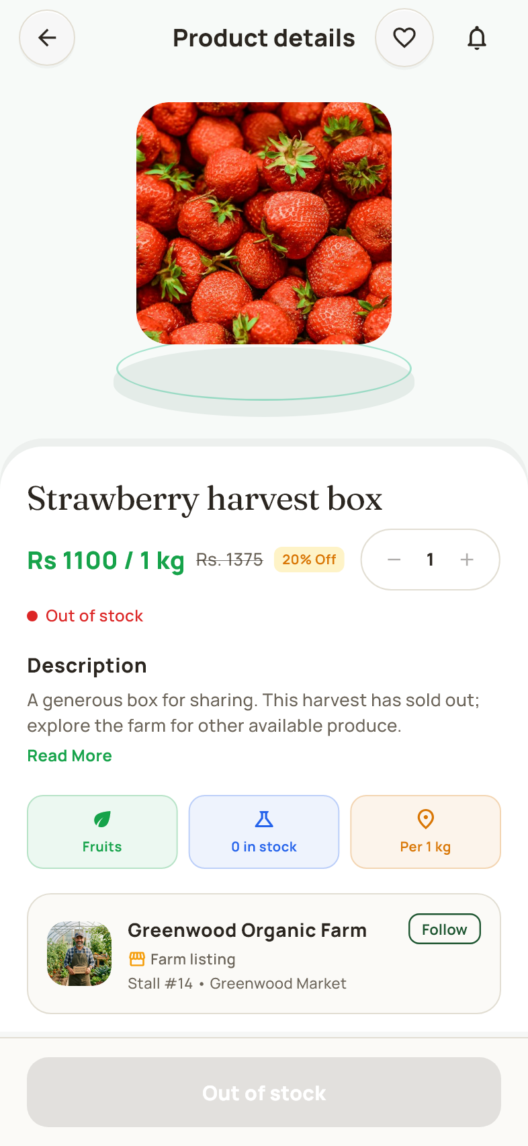
Customer workspace
A sold out listing remains viewable but cannot be added to the cart. Read its details or open the farm to find other produce. If another matching farmer offer is available, select it from the farmer selector. Stock can change, so confirm the displayed availability before placing an order.

20 Browse farmers and farms
Customer profile > My Favorite Farmers or farm directory
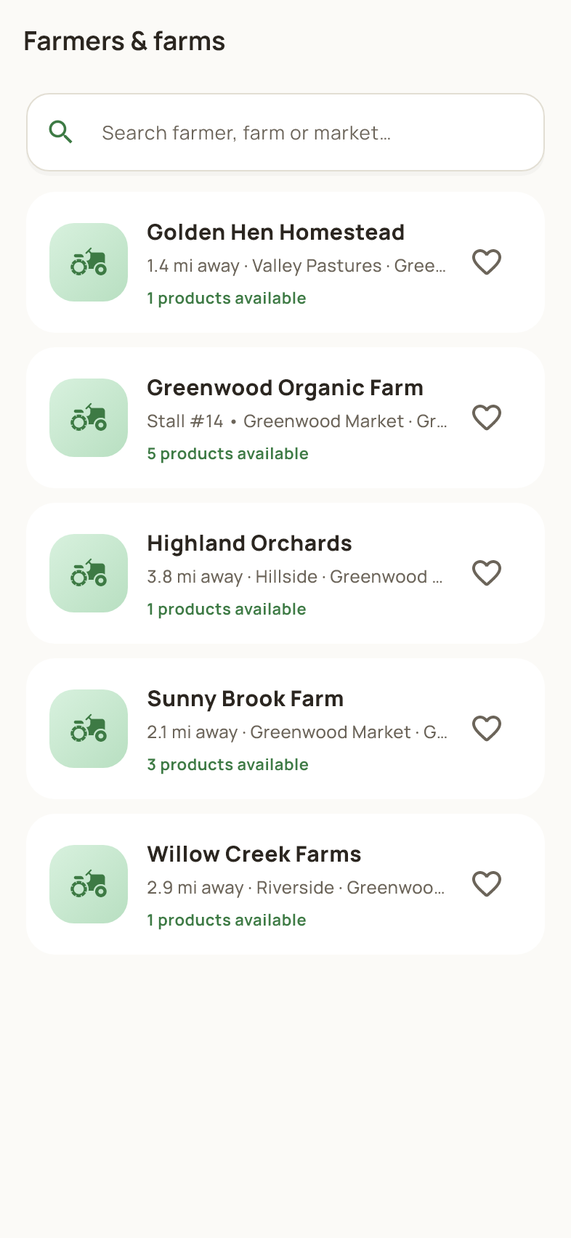
Customer workspace
This directory lists farms and lets you search for a grower. Tap a farm to view its story and available products. Use the heart or follow control to save a farm. Following a farm makes it easier to return to that grower; it does not place an order or reserve stock.

21 View a farm
Product details or farm directory > A farm
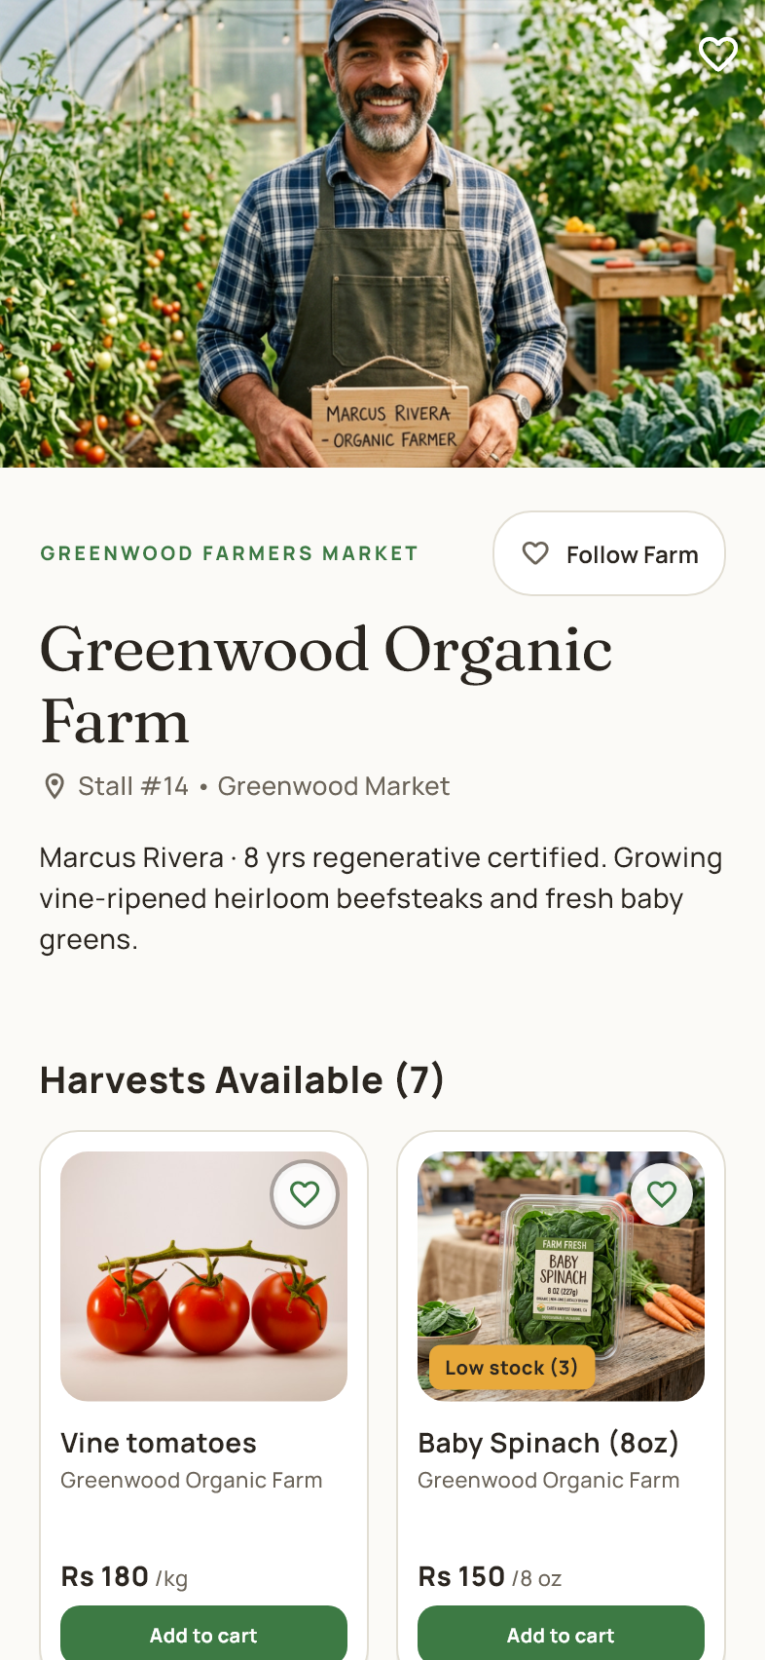
Customer workspace
The farm page shows the grower's photo, story, location information and available harvests. Follow the farm to save it, or tap a product to inspect and buy that seller's listing. Products shown on a farm page belong to that farm, so you can shop directly from the grower you selected.

22 Saved products
Customer profile or wishlist shortcut > My Wishlist
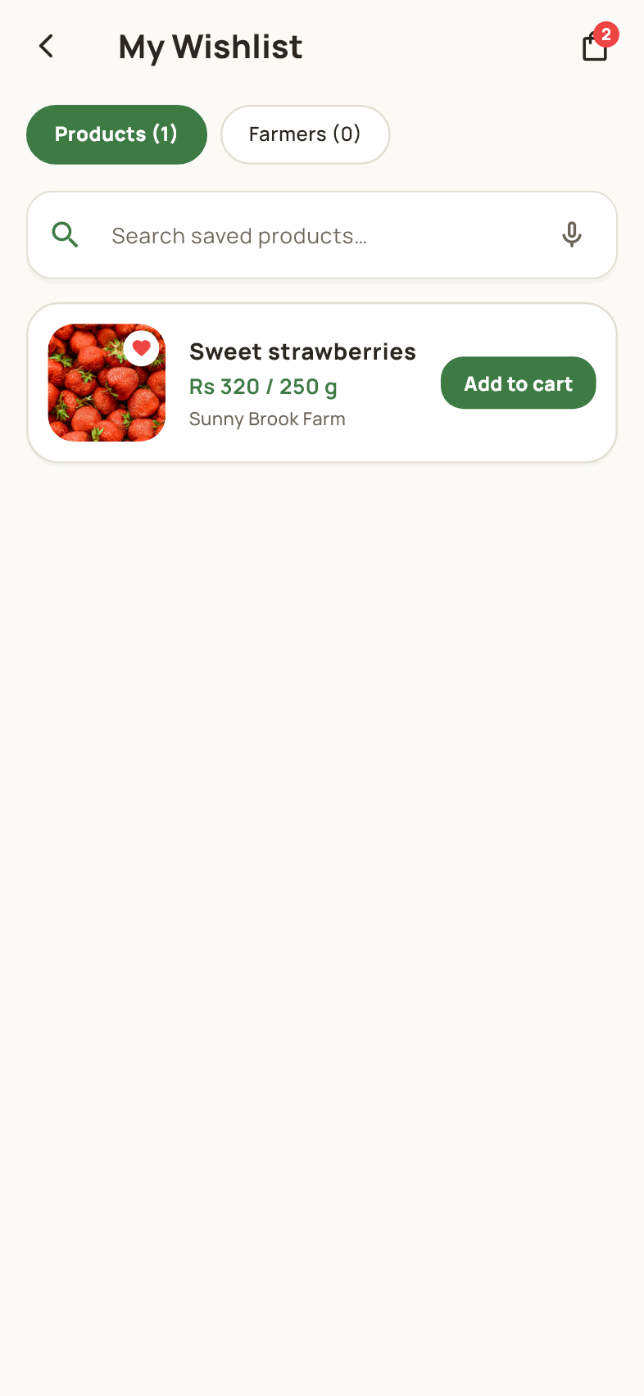
Customer workspace
The Products tab collects listings saved with the heart control. Search your saved items and open a card to check its latest details. Tap the heart again to remove an item. Saved products are tied to their seller listings, and saving an item does not reserve its current price or stock.

23 Followed farmers
My Wishlist > Farmers tab
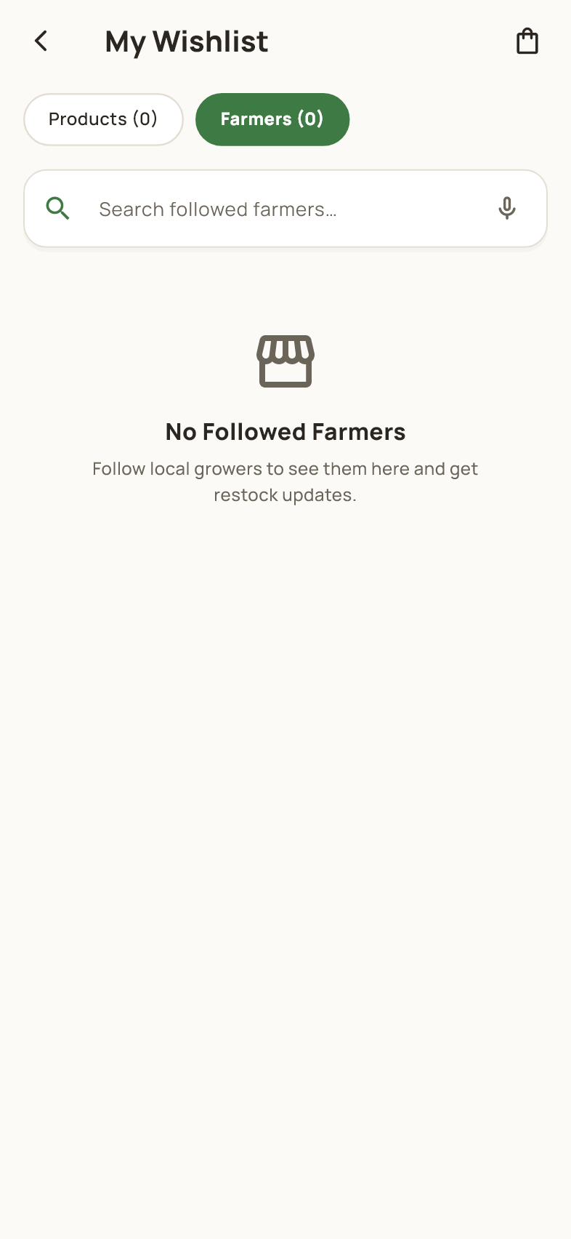
Customer workspace
The Farmers tab lists the farms you follow. Tap a row to visit the farm and browse its produce. Use the follow control to stop following a farm. Your saved products and followed farms are separate lists, so removing one does not automatically remove entries from the other.

24 Review the cart
Customer navigation or product page > Cart
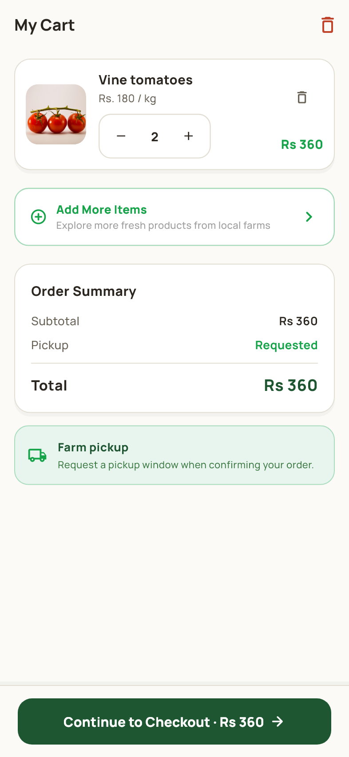
Customer workspace
The cart lists your chosen products and quantities, with the total shown below. Adjust quantities using the controls, remove an item or clear the basket when needed. Quantities must stay within available stock. Tap Continue to Checkout when the items are correct. Products from different farmers may become separate orders at confirmation.

25 Confirm an order
Cart > Continue to Checkout
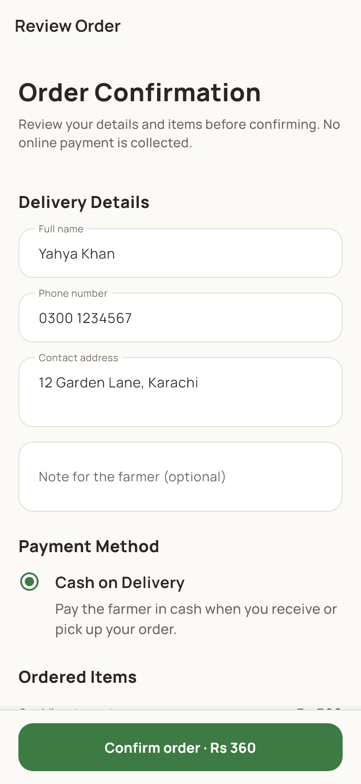
Customer workspace
Check the recipient name, mobile number, delivery address and order items. Add delivery notes if needed, then review the total and the payment method shown. Tap Confirm order once to submit. The current app records orders without an online payment gateway; the cash on delivery choice does not charge a bank card. Resolve any stock or account error before retrying.

26 Order confirmation
Checkout > Successful confirmation
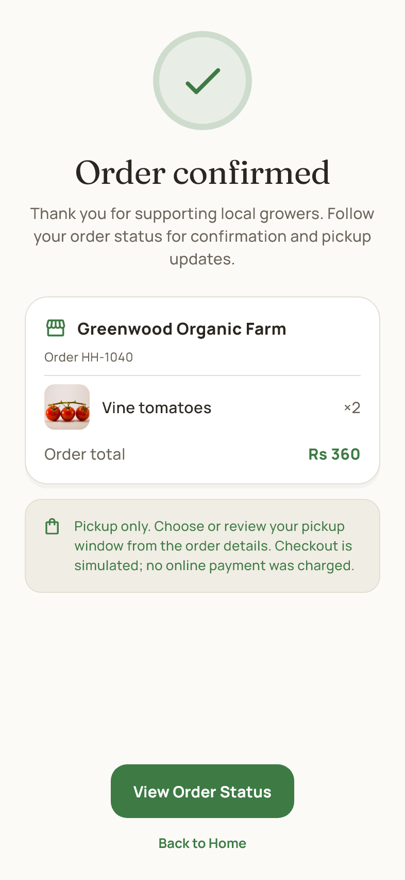
Customer workspace
This screen confirms that the app recorded your order and lists the related farm order details. Use View Order Status to follow progress, or return Home to continue browsing. If your cart contained items from several farms, each farm has its own order. Check the order list rather than submitting the same checkout again.

27 Customer orders
Customer navigation > Orders
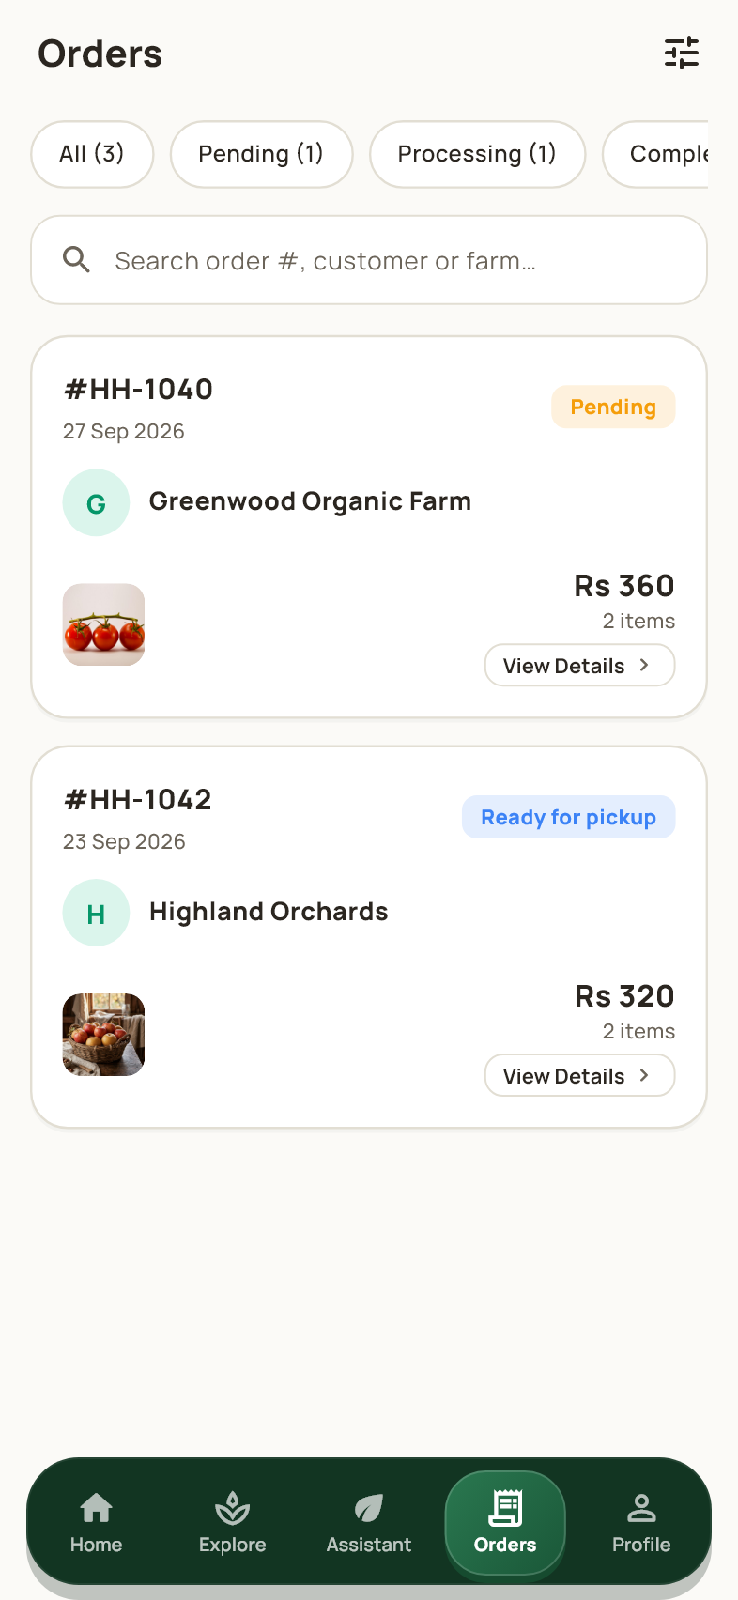
Customer workspace
The order list shows your orders and their current status. Use the tabs and search field to find the order you need. Tap an order card to see its items, timeline and pickup details. The customer view is limited to your account's orders; farmer and admin workspaces have different order scopes.

28 Track an order
Orders > An order card
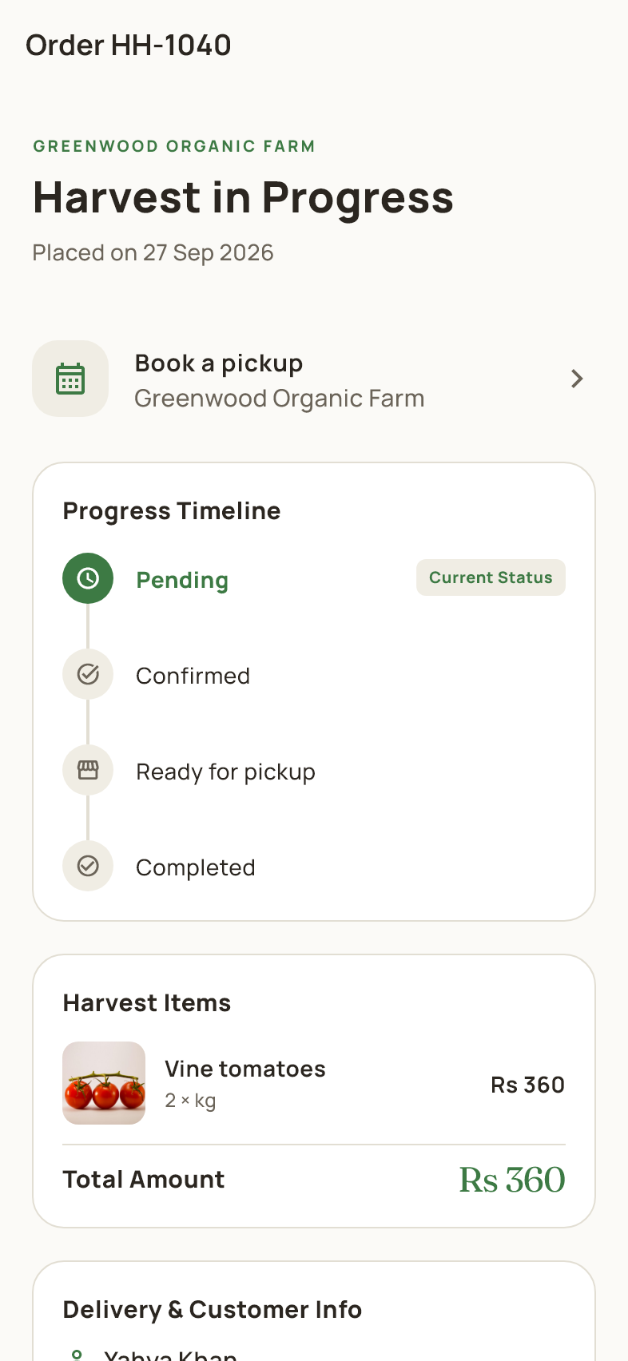
Customer workspace
The detail page shows the order number, farm, progress timeline and purchased items. Scroll to review delivery and contact details. For an active order, use the pickup area to choose or update an available window. Status changes appear on the timeline as the farmer or admin manages the order.

29 Choose a pickup window
Order details > Book a pickup or Your pickup
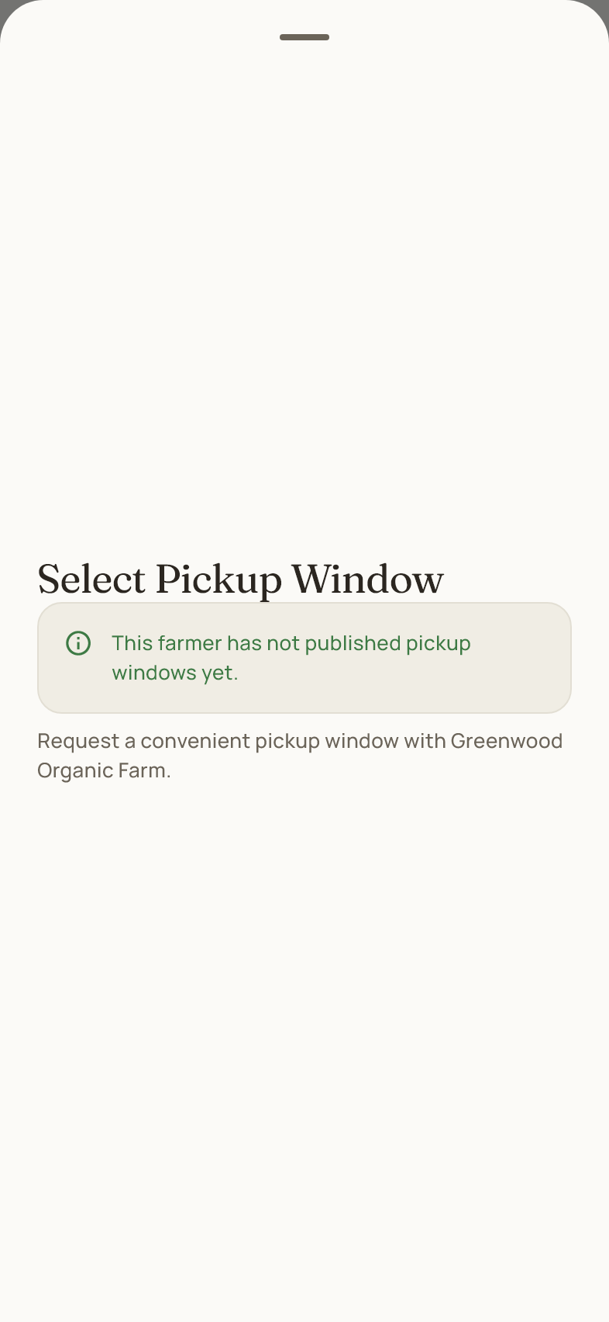
Customer workspace
Choose a window published by the farm. Your selected window is saved against the order and shown in its details. Open the same area to change it; use Cancel Slot when available to remove only the pickup booking. If no windows are listed, the farmer has not published pickup options yet.

30 Ask the Ola assistant
Customer navigation > Assistant or floating Ola control
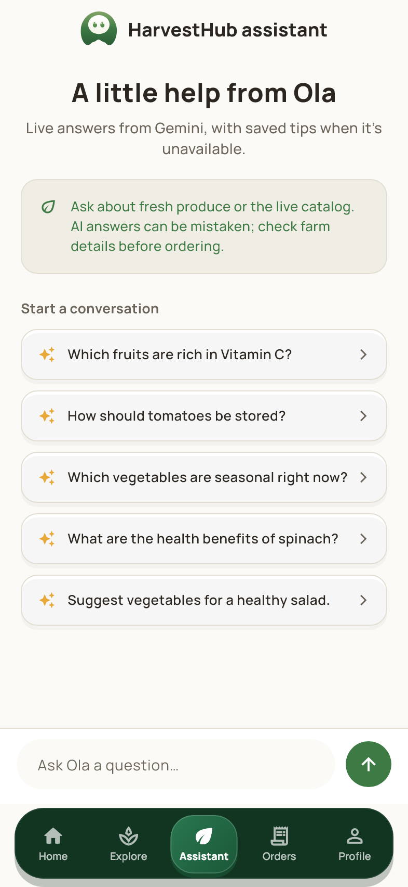
Customer workspace
Type a question or use a suggested prompt to ask about produce or app features. The conversation appears above the input field. Live answers require the assistant service; saved guidance may be offered if it is unavailable. Use the catalog and order pages to verify current stock, prices and order status. Do not share passwords or email codes in chat.

31 Customer profile
Customer navigation > Profile
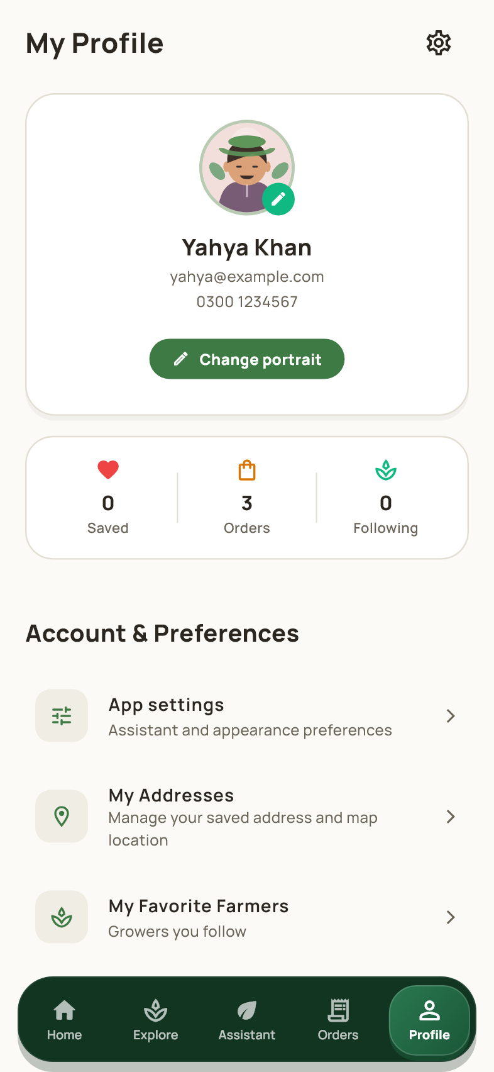
Customer workspace
Profile brings together account details, saved addresses, favorite farmers, settings and support links. Tap the portrait control to change your image, or open the personal details editor to update your name, phone and address. Scroll to Password & Security, markets, notifications and Logout. Statistics summarize the account rather than creating new activity.

32 Farmer dashboard
Farmer sign in > Dashboard
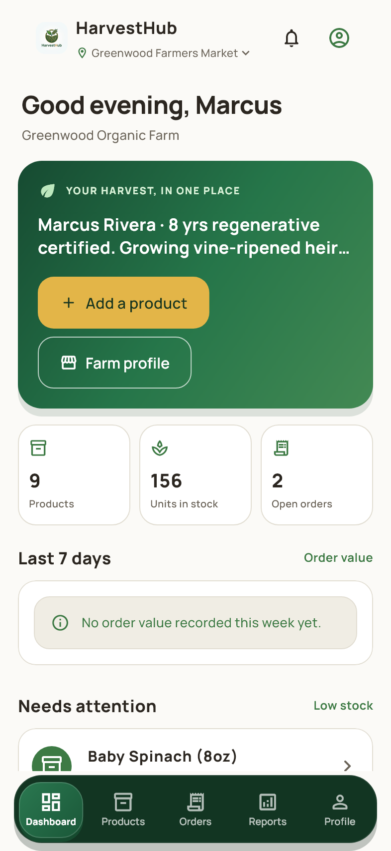
Farmer workspace
The dashboard summarizes your farm, inventory and order activity. Use Add product to create a listing or Farm profile to update your public information. Review the attention areas and recent activity, then open Products or Orders for detailed work. The farmer workspace is restricted to the farms and listings owned by your account.

33 Farmer products
Farmer navigation > Products
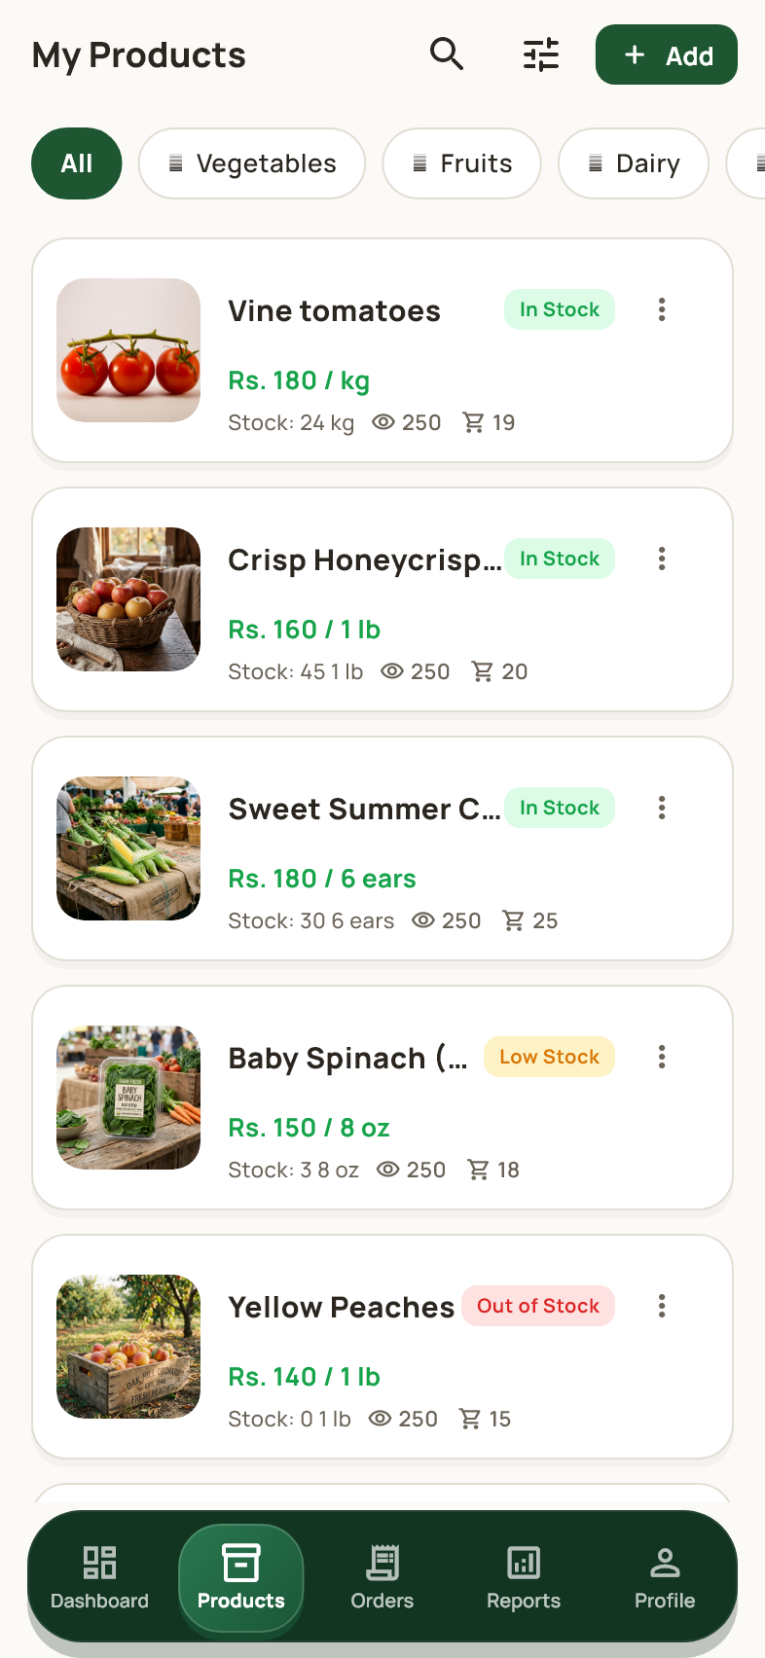
Farmer workspace
This list contains your farm's products with stock and price information. Search or filter the inventory and tap a listing to edit it. Add creates a new product. Repeated records with the same listing ID are shown once, and another farmer's products do not appear as your inventory. Different products and pack sizes remain separate listings.

34 Add a product
Farmer Products or Dashboard > Add product
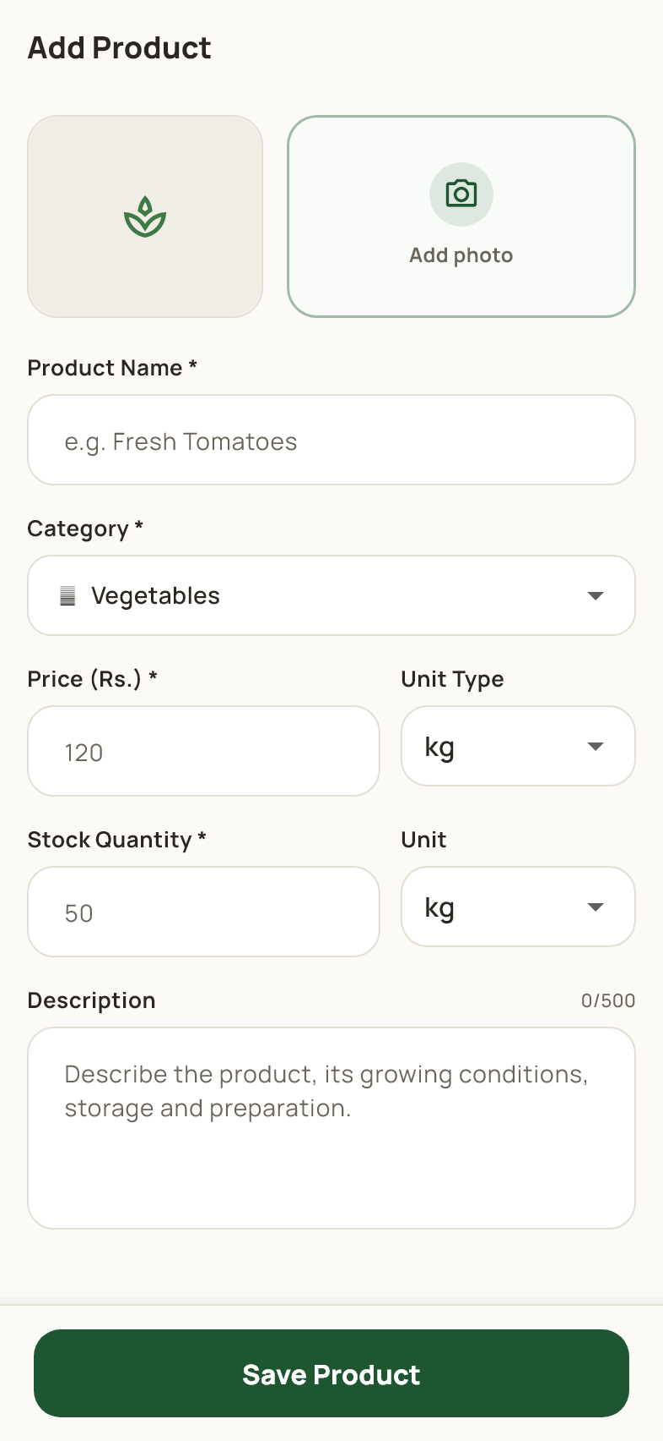
Farmer workspace
Choose a product image and enter the name, category, price, stock, unit and description. Use the required formats shown by the form, then tap Save Product. A valid listing is attached to the current farm. Review the saved product in inventory and confirm that its price and quantity are correct before customers order it.

35 Edit a product
Farmer Products > A listing
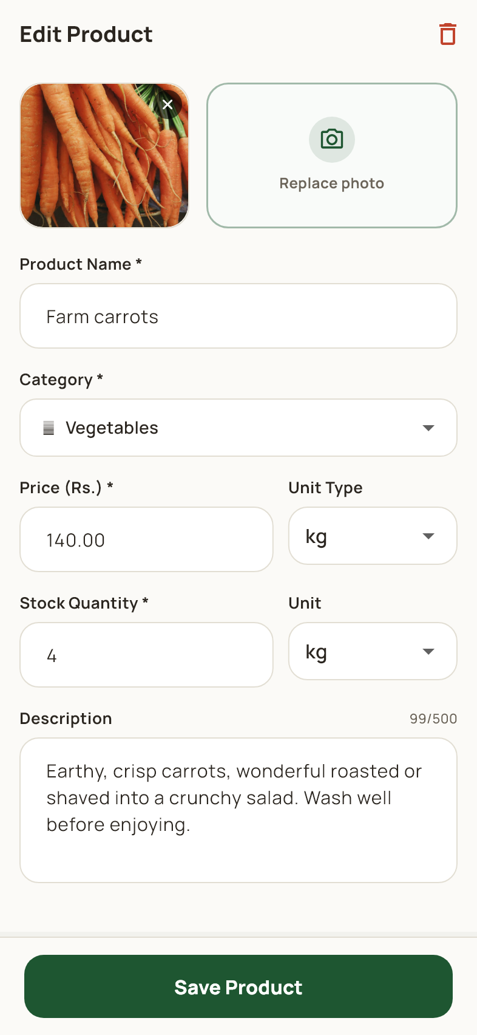
Farmer workspace
Update the selected listing's image, name, category, price, available quantity, unit or description, then tap Save Product. The changes affect that farm's listing. Use the delete control only when you want to remove the listing from the active catalog, and read the confirmation first. Existing orders retain their purchased item details.

36 Farmer orders
Farmer navigation > Orders
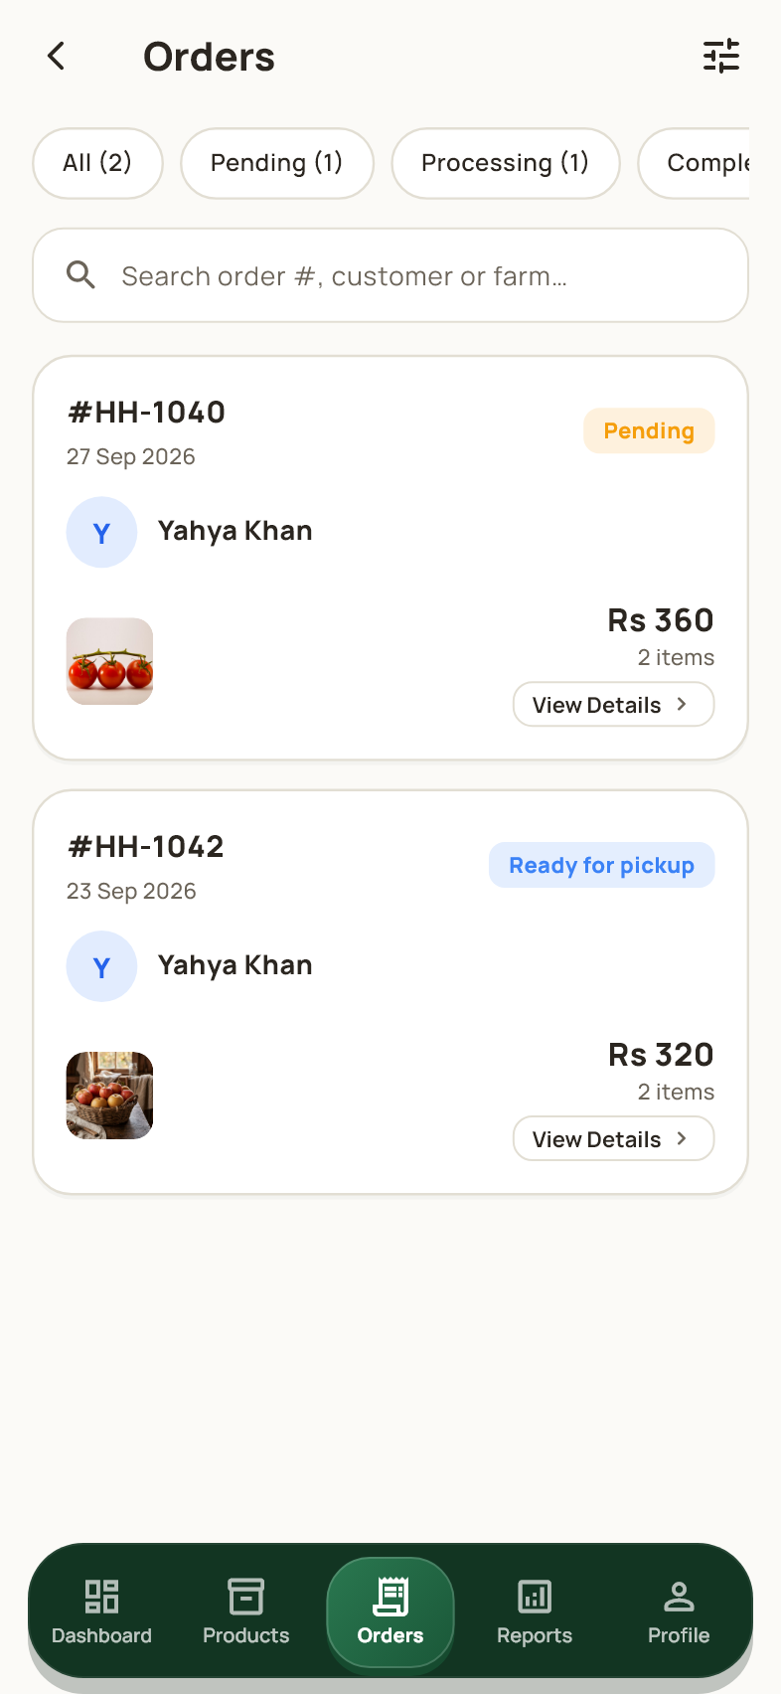
Farmer workspace
The farmer order list shows orders associated with your farm. Use the status filters and search field to locate work awaiting confirmation or preparation. Open an order before changing its status so you can review the customer, items and pickup information. Orders for another farmer are outside this account's management scope.

37 Manage an order
Farmer Orders > An order
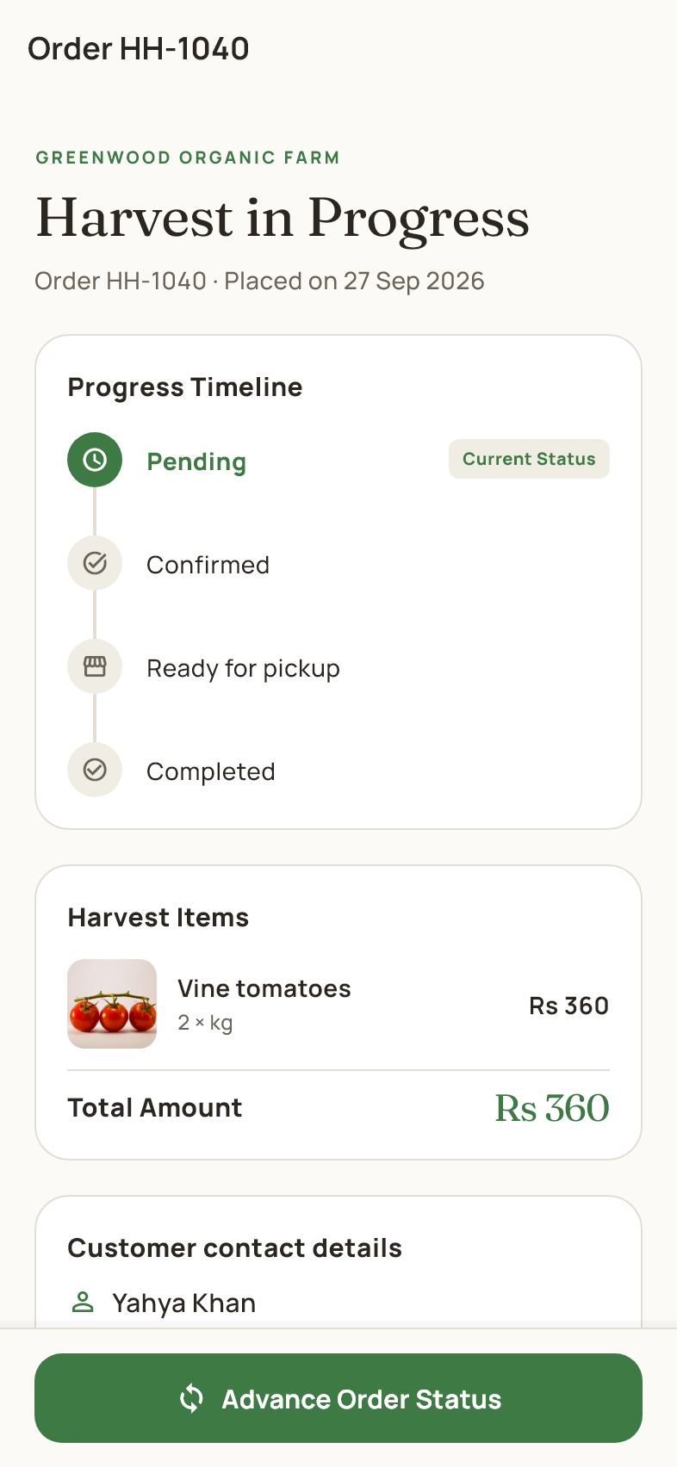
Farmer workspace
This version of the order detail page includes management actions. Review the timeline, purchased items, customer contact and pickup information. Tap Advance Order Status to move the order through the permitted steps. A cancellation action is available for eligible active orders; read its confirmation because cancellation restores the ordered stock.

38 Advance an order status
Order management > Advance Order Status
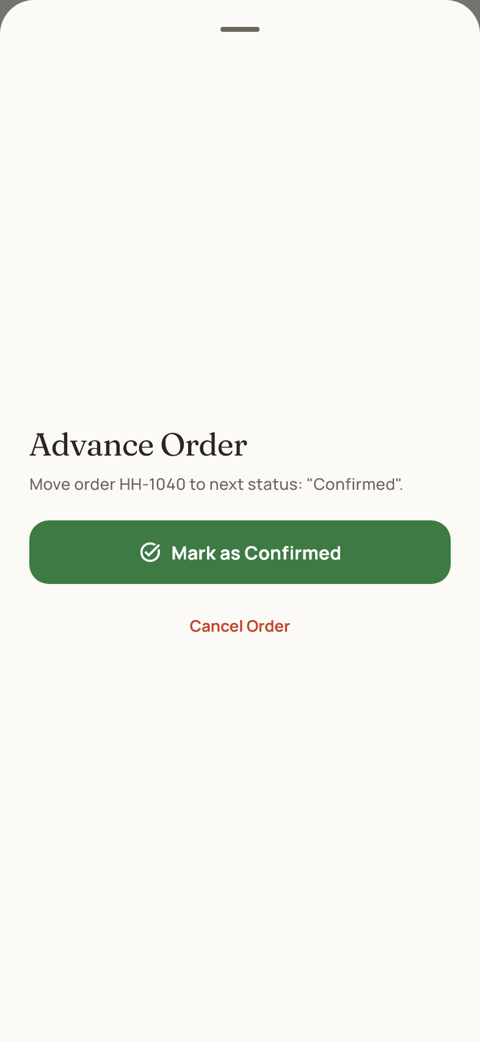
Farmer workspace
The sheet shows the next permitted status action for the selected order. Confirm it only after the corresponding work is complete. Orders normally progress from Pending to Confirmed, Ready for pickup and Completed. Cancellation is a separate action for an eligible order. The customer sees the updated progress in their order details.

39 Farmer reports
Farmer navigation > Reports
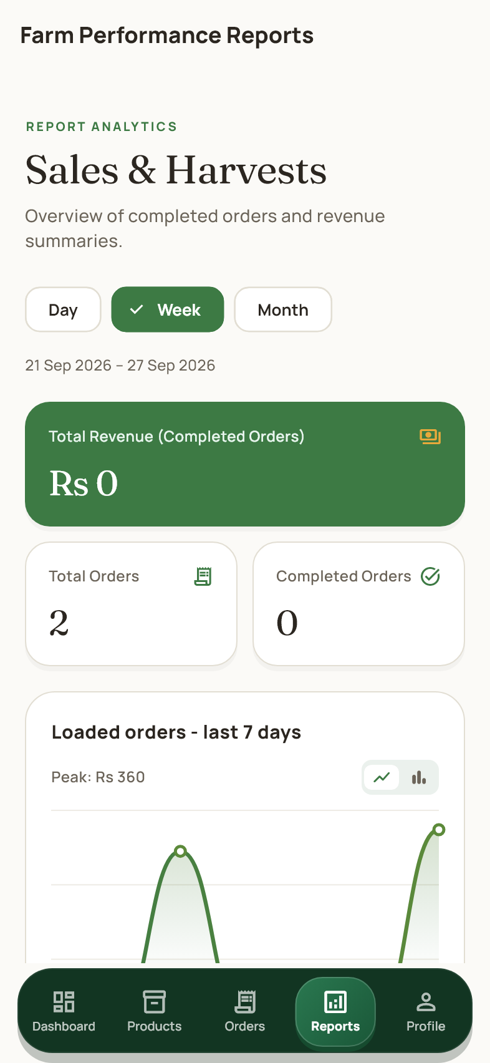
Farmer workspace
Reports summarize the farm's sales and order activity for the selected period. Switch the period controls to compare recent results and scroll through the summaries and charts. Completed sales and other order values can represent different measures, so read each label. These reports describe records in the app and are not proof of an online payment.

40 Farmer account profile
Farmer navigation > Profile
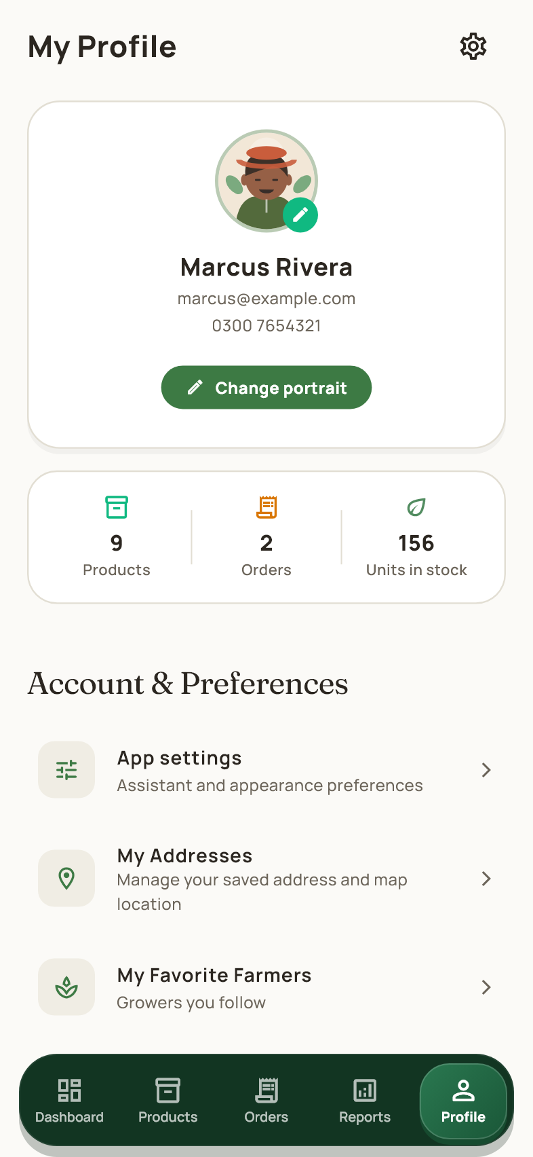
Farmer workspace
The farmer profile includes personal account options and a link to Your Farm Profile. Edit personal details separately from the farm's public story and pickup information. Settings, support, password security, markets and notifications are available from this area. Scroll to Logout when you want to leave the farmer account.

41 Edit the farm profile
Farmer Profile > Your Farm Profile
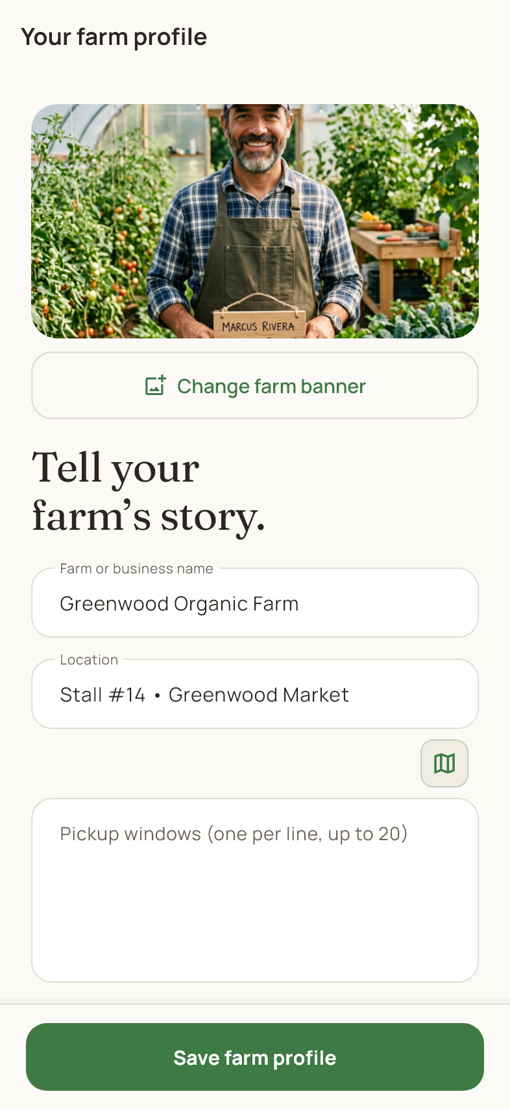
Farmer workspace
Update the farm's image, name, market, story and location information. Scroll to review the additional public details and pickup options provided by the form. Tap Save farm profile when the information is ready. Customers see the saved public farm information, and published pickup windows become available from eligible order pages.

42 Admin dashboard
Admin sign in > Dashboard
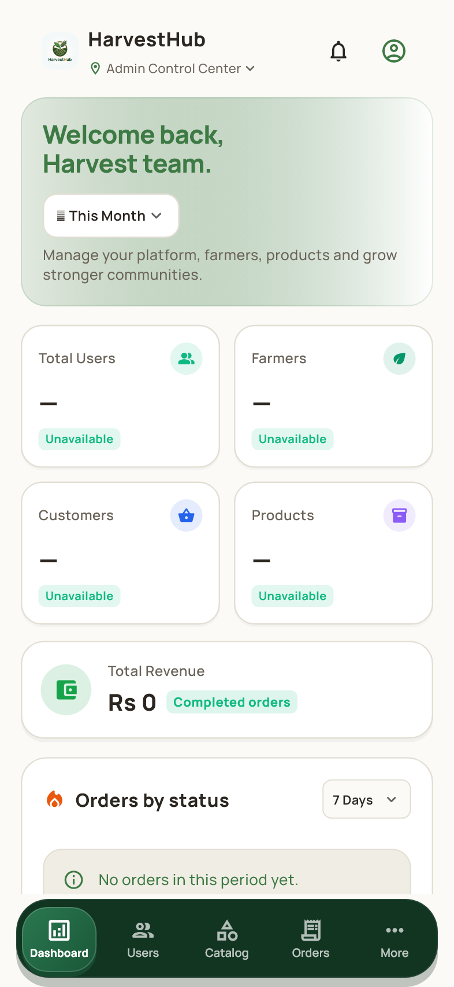
Admin workspace
The dashboard shows marketplace totals and shortcuts to users, products, orders and reports. Review the recent orders and status summaries, then open the relevant management area. Admin access comes from the account's assigned role after shared sign in. The dashboard is not available to ordinary customer or farmer accounts.

43 Manage users
Admin navigation > Users
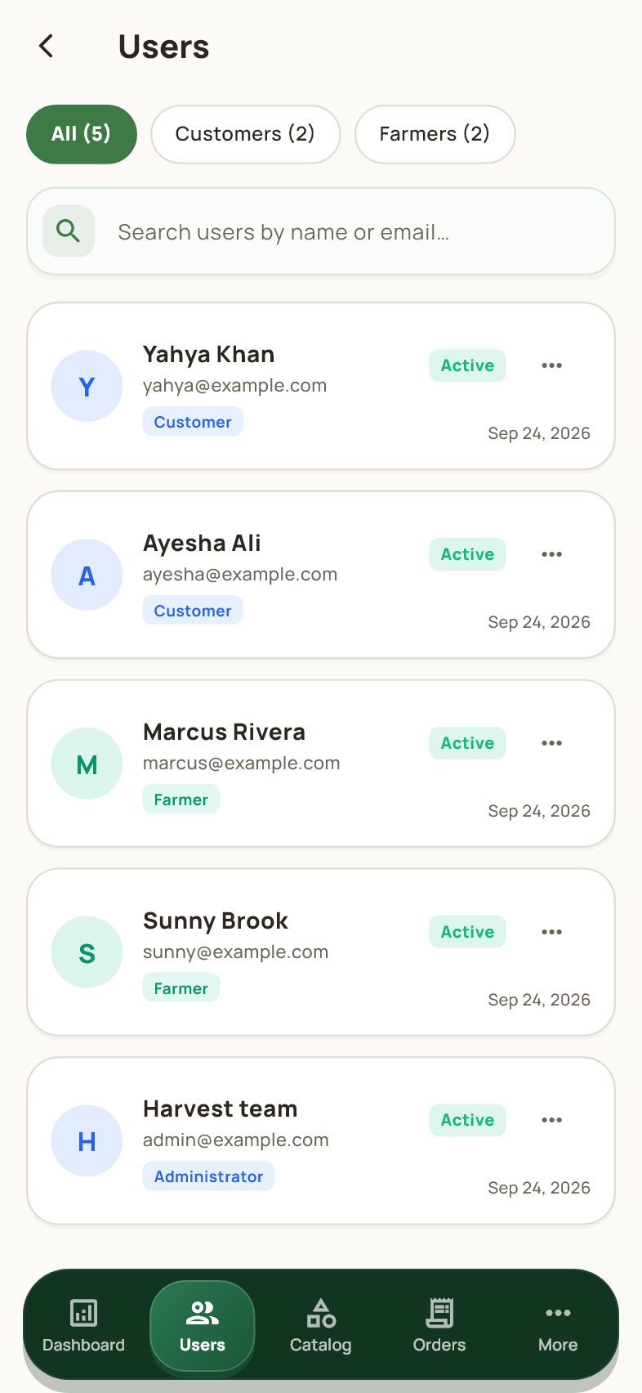
Admin workspace
Search accounts and switch between the customer and farmer filters. Each row shows the account identity and current access status. Tap a row to inspect details and available management controls. Review the selected account carefully before editing or suspending access; those changes affect the person's ability to use the marketplace.

44 Customer account details
Admin Users > A customer
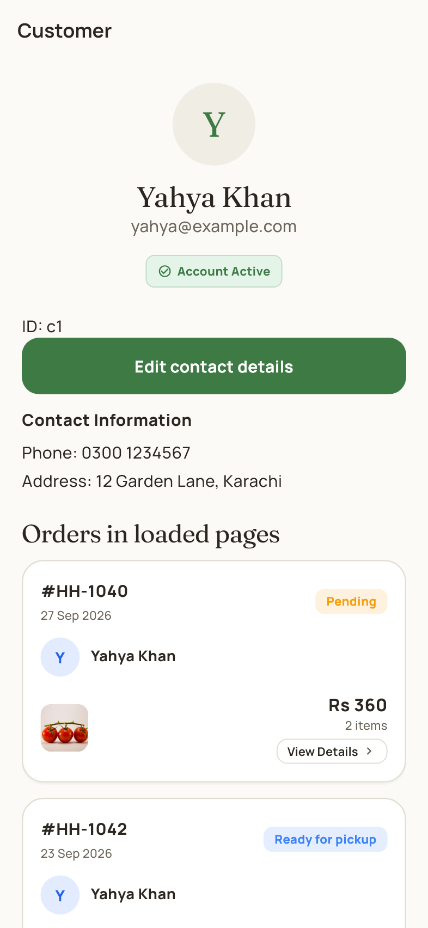
Admin workspace
The detail page shows the selected customer's contact information and related account information. Use Edit contact details to correct the fields that the app allows administrators to manage. The access control can suspend or restore an eligible account. Account details belong to the selected user, not to the administrator currently signed in.

45 Farmer account details
Admin Users > A farmer
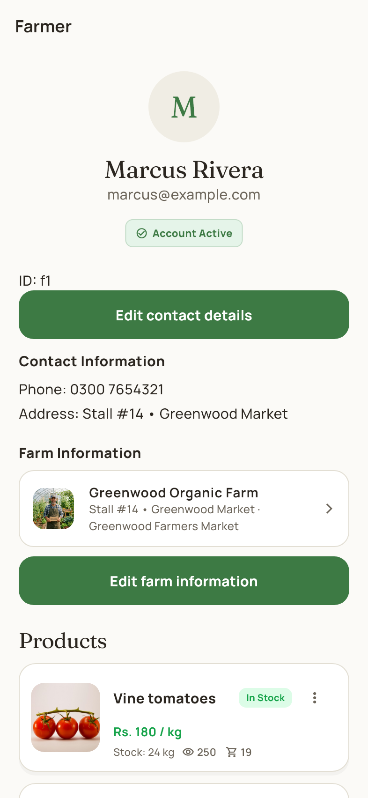
Admin workspace
Review the farmer's contact details, farm information and product listings from one page. The edit controls open the account or farm editor for the selected farmer. Suspend or restore access only after confirming the correct account. Product ownership remains attached to that farmer when an administrator reviews or edits the listing.

46 Admin product catalog
Admin navigation > Catalog
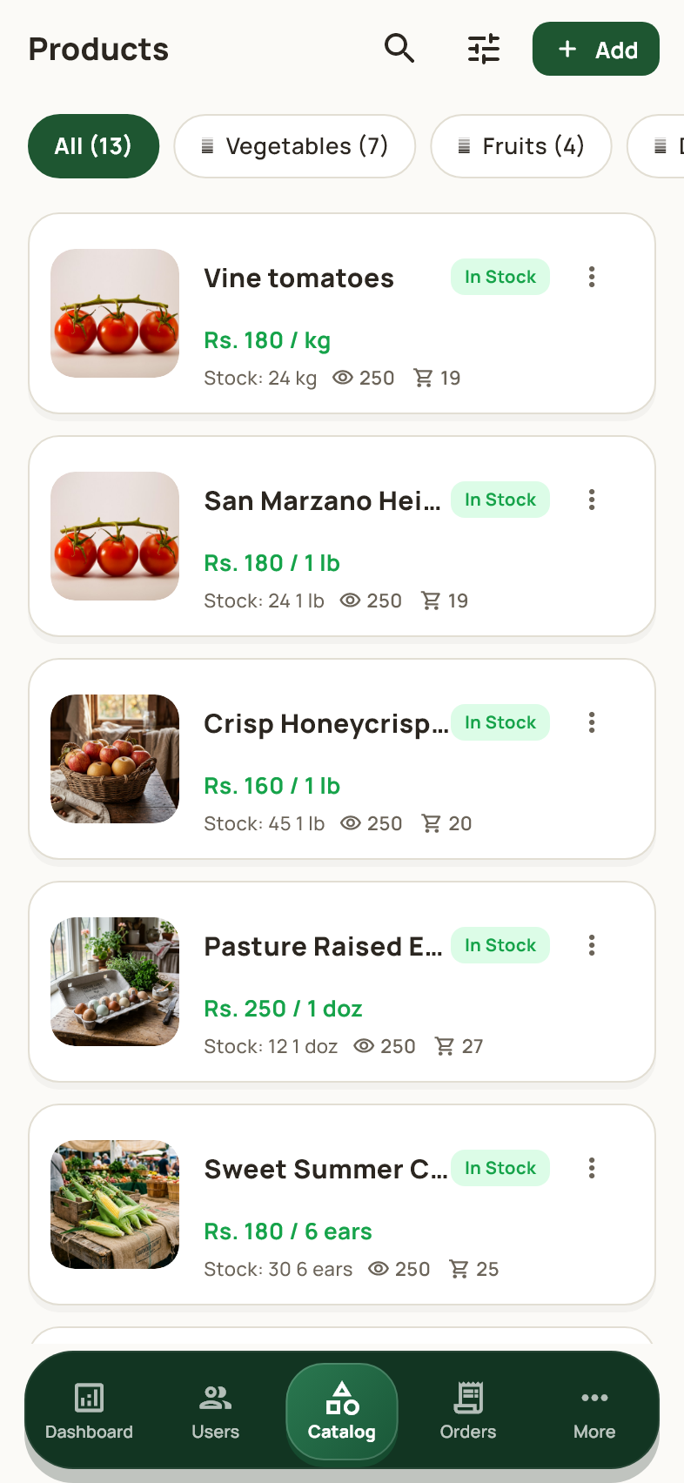
Admin workspace
The admin catalog lists marketplace listings and their inventory details. Search and filter the list, then open a product to inspect or edit it. Different farmers' offers remain separate management records even when the customer catalog groups them into one product card. This preserves each seller's price, stock and ownership.

47 Admin orders
Admin navigation > Orders
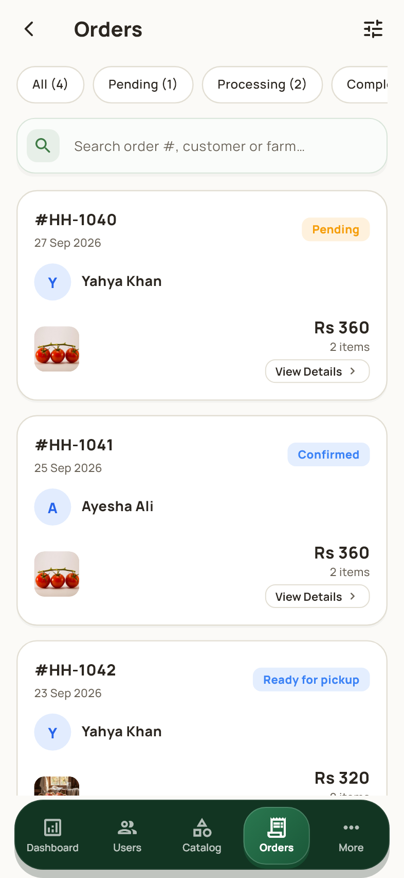
Admin workspace
Administrators can search and review orders across the marketplace. Use the status filters to find pending, processing or completed work and open an order for details. Available management actions follow the order's current state. Check the customer and farm on the detail page before making any change.

48 Admin profile and tools
Admin navigation > More
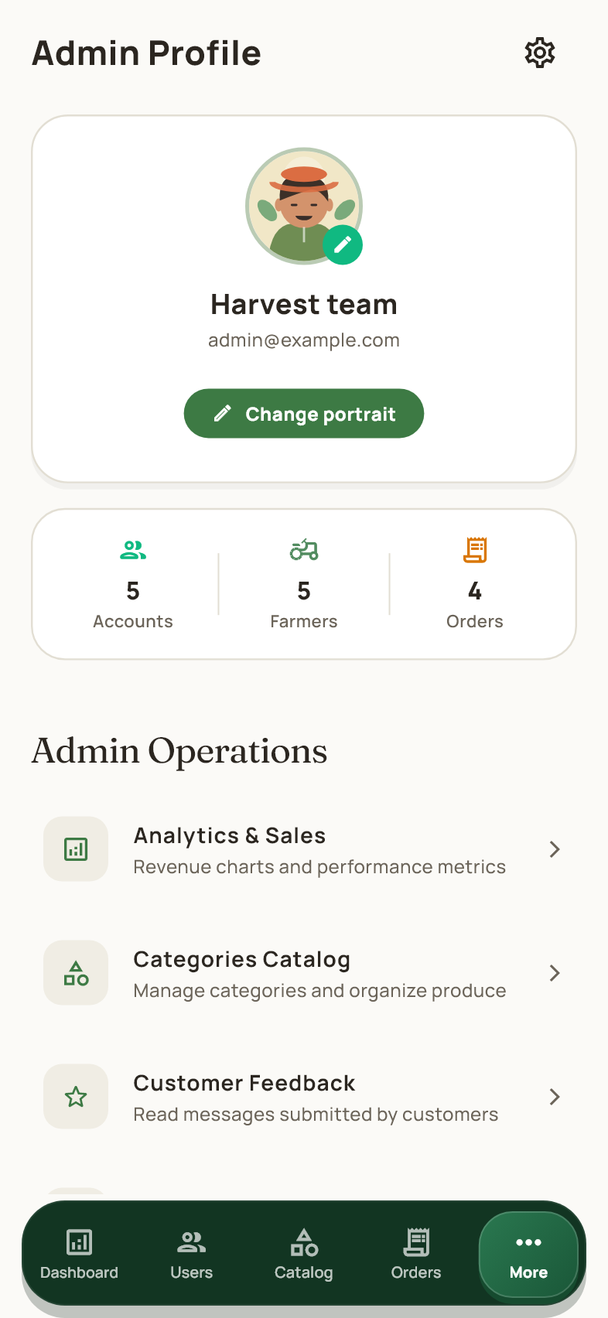
Admin workspace
The admin profile provides shortcuts to analytics, categories, feedback, reports, account access and system settings. Tap a tool to open its management page. The statistics link to marketplace accounts, farmers and orders, with more detail available from Dashboard and Reports. Scroll down for common account options and Logout.

49 Admin account actions
Admin More > Scroll down
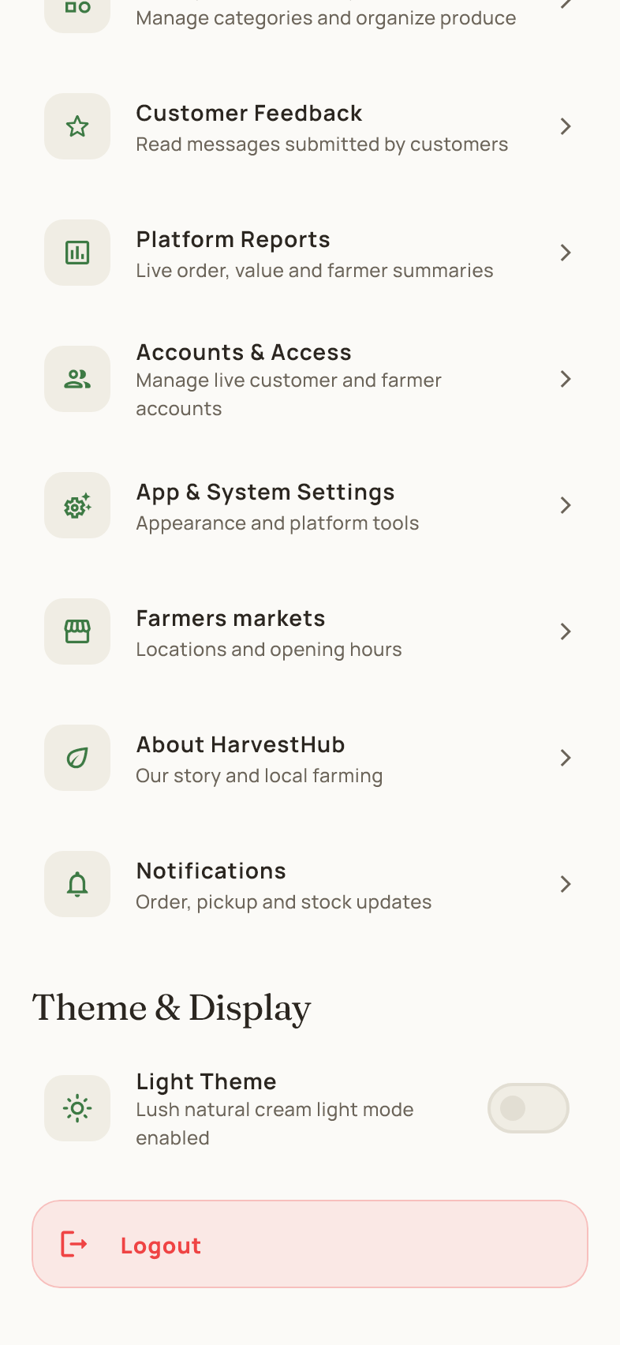
Admin workspace
The lower profile area contains platform tool links, markets, About HarvestHub, notifications, appearance and Logout. Tap the action you need instead of returning to the dashboard to find it. Logout opens a confirmation; after confirmation, the app clears the local account view and returns directly to sign in.

50 Log out of an account
Profile or Admin More > Logout
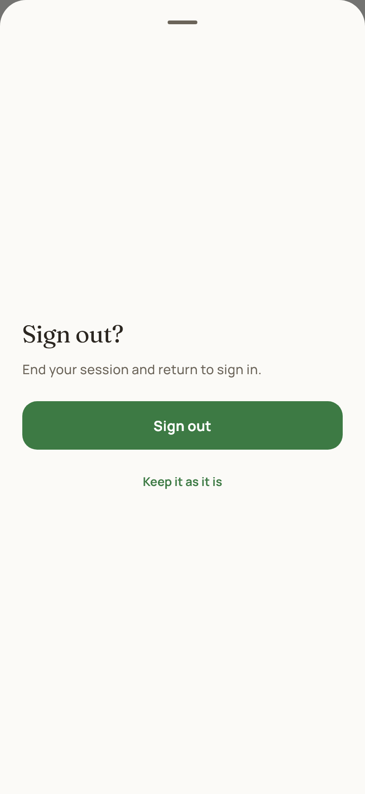
Admin workspace
Tap Sign out to end the session, or Keep it as it is to stay signed in. After confirmation, the sign in page opens immediately, including when Logout was reached from an admin subpage. The Android back button does not reopen the signed out admin dashboard. Sign in again with the account you want to use next.

51 Manage product categories
Admin More > Categories Catalog
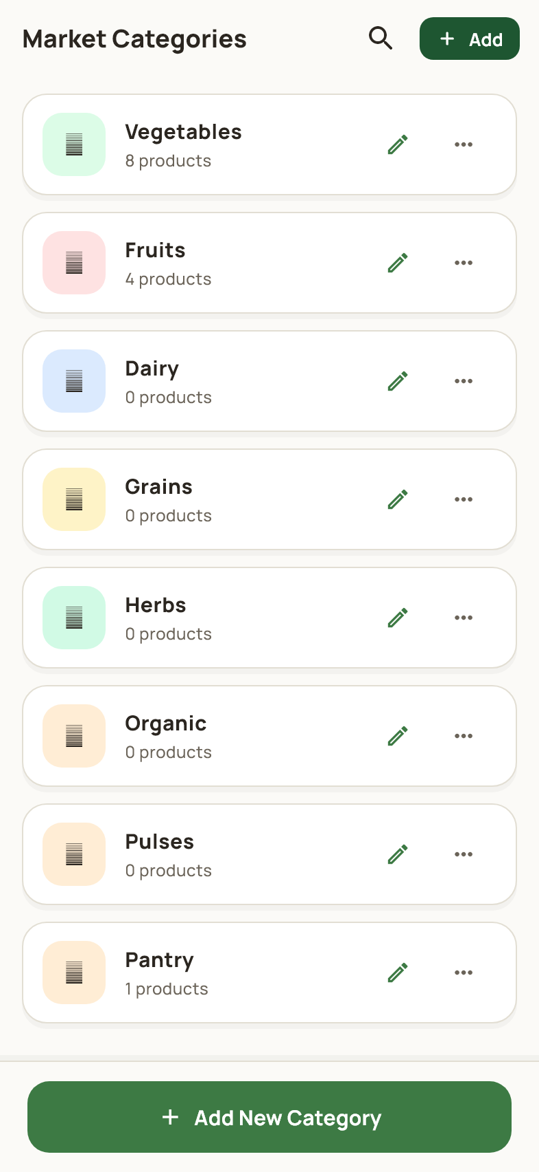
Admin workspace
This page lists the categories used to organize products. Review the product count beside a category, edit its name or use Add New Category. Renaming a category updates its product classification. A category that is still in use cannot be removed without addressing the linked products first.

52 Add or rename a category
Categories > Add New Category or edit icon
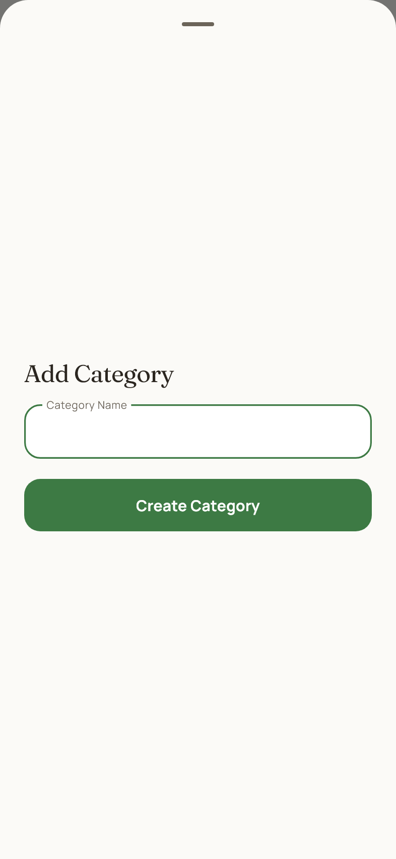
Admin workspace
Enter a clear category name and save it using the dialog action. When editing, review the existing name before replacing it. Validation prevents empty or duplicate categories. After saving, the catalog and product forms use the updated category list.

53 Platform reports
Admin More > Platform Reports
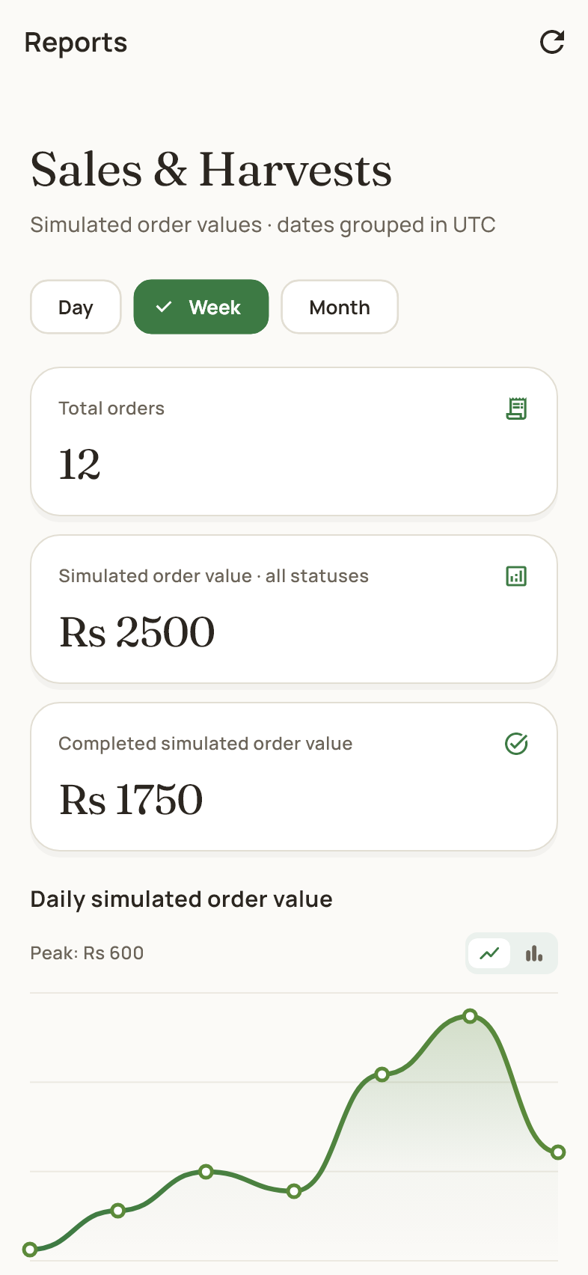
Admin workspace
The report page summarizes marketplace orders, order value, completed sales and active farmers. Change the date range to compare periods and scroll through the charts and totals. Interpret each metric using its label; order value and completed sales are not interchangeable. No online payment settlement is implied by these figures.

54 Sales analytics
Admin More > Analytics & Sales
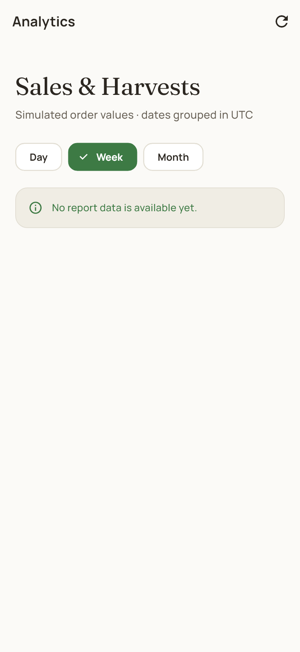
Admin workspace
Analytics presents order and value trends for the available reporting periods. Select a period and inspect the summary cards and charts. Use these views to compare activity over time, then open the order management pages for individual records. If there is no activity in a period, the report can show zero totals or an empty chart.

55 Admin settings
Admin More > App & System Settings
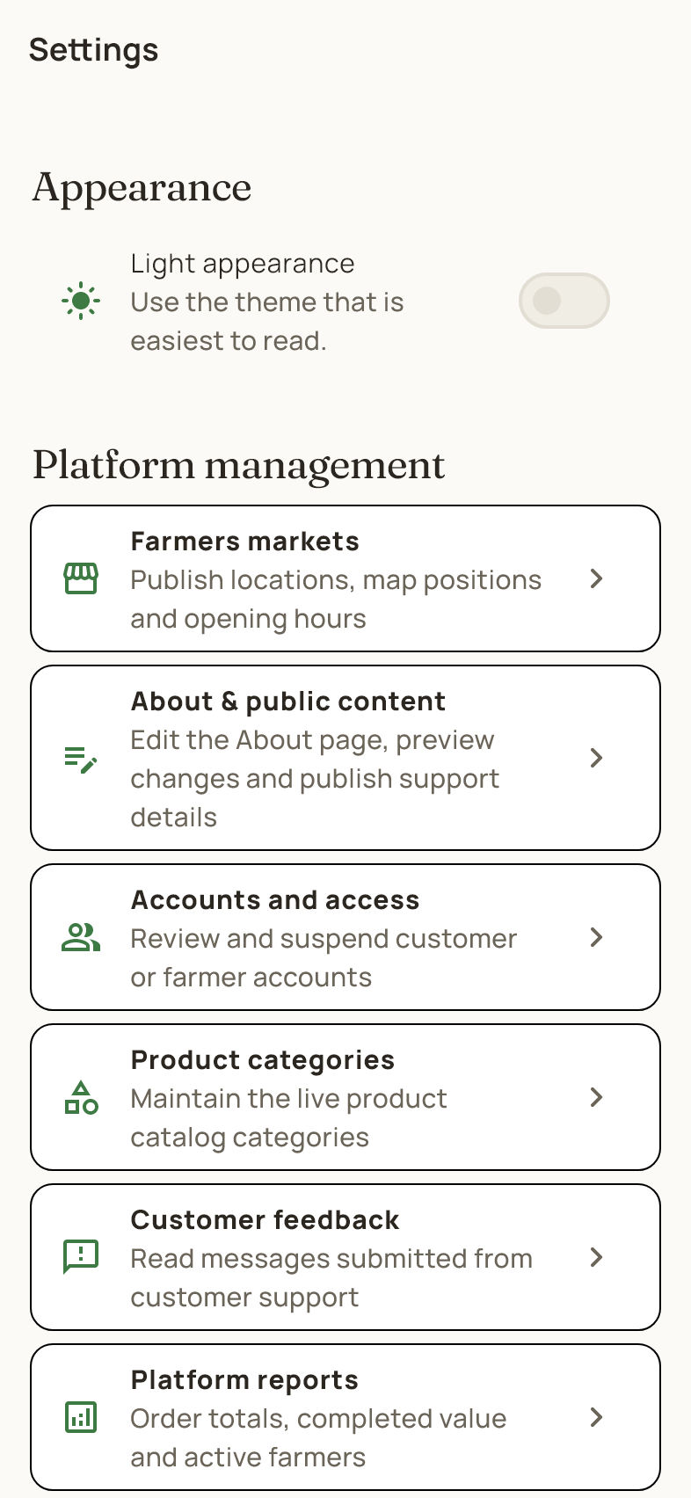
Admin workspace
Settings includes appearance, account security and links to platform management tools. Open markets, public content, users, categories, feedback or reports from this page. For a signed in live account, the two-step verification control is available in Account security. Changes to appearance are personal preferences; management actions affect the selected marketplace records.

56 Read customer feedback
Admin More > Customer Feedback
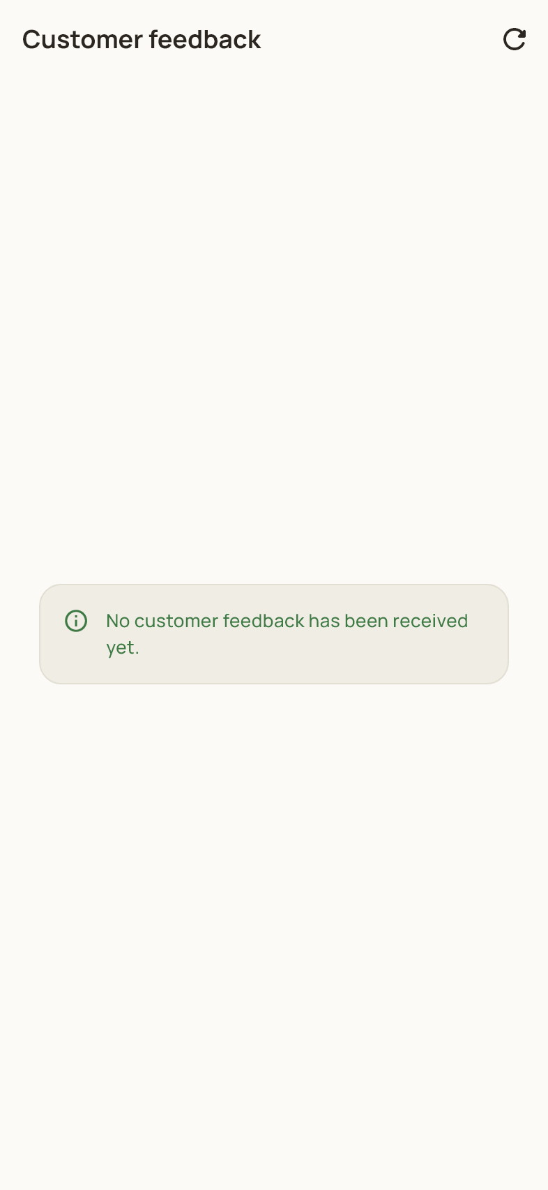
Admin workspace
This page displays messages submitted through the customer support form. Read each message and the available sender details, and use the provided read controls when present. An empty page means no feedback is available in the current data. This area is a feedback inbox rather than a live customer chat.

57 Edit public information
Admin Settings > About & public content
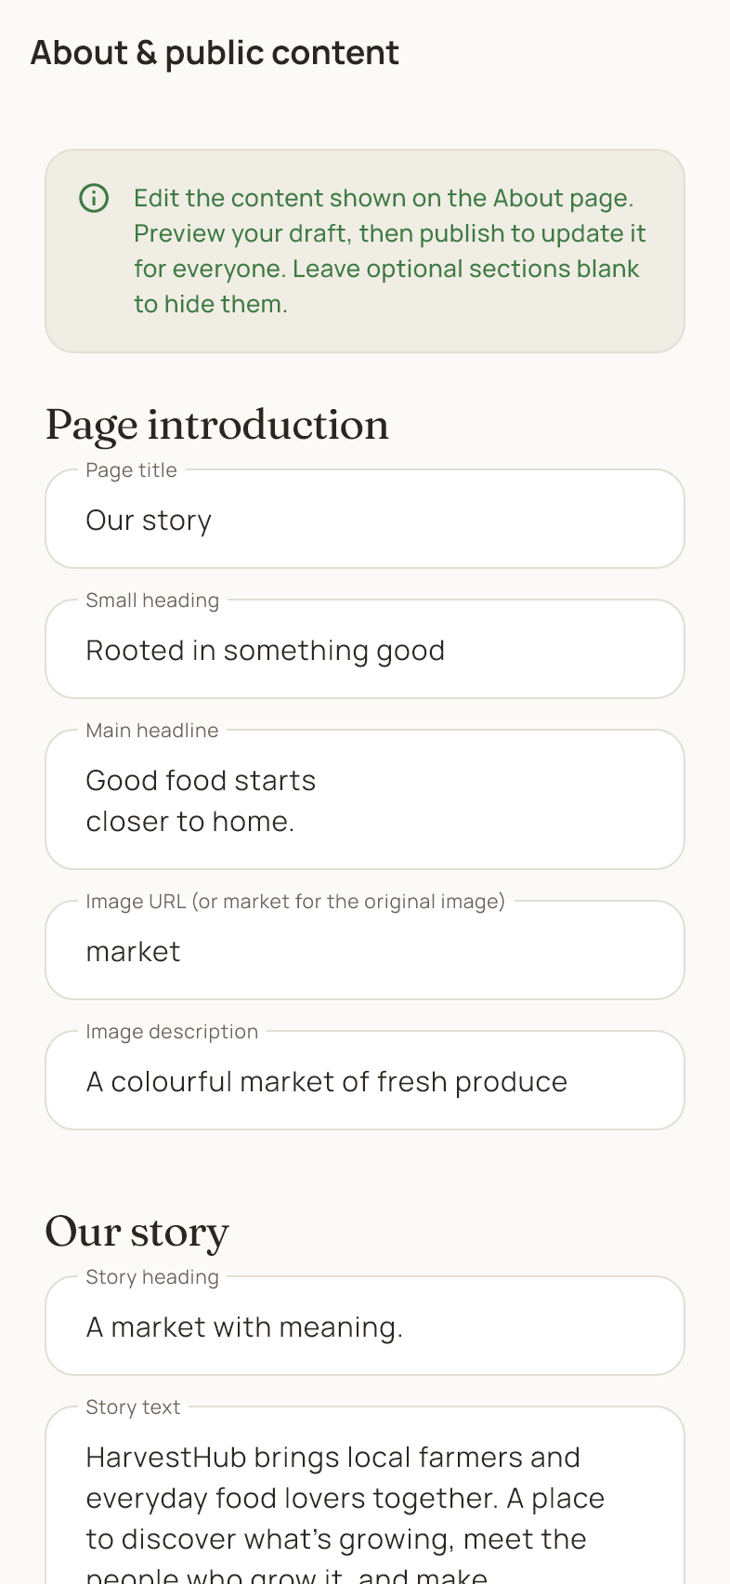
Admin workspace
Edit the introduction, story and support information used on the public About and contact pages. Scroll through the form and review the preview before publishing. Save or publish with the provided action when the content is ready. Check the public page afterward to confirm the wording and contact information are correct.

58 Add or edit a market
Admin Settings > Farmers markets > Add or edit
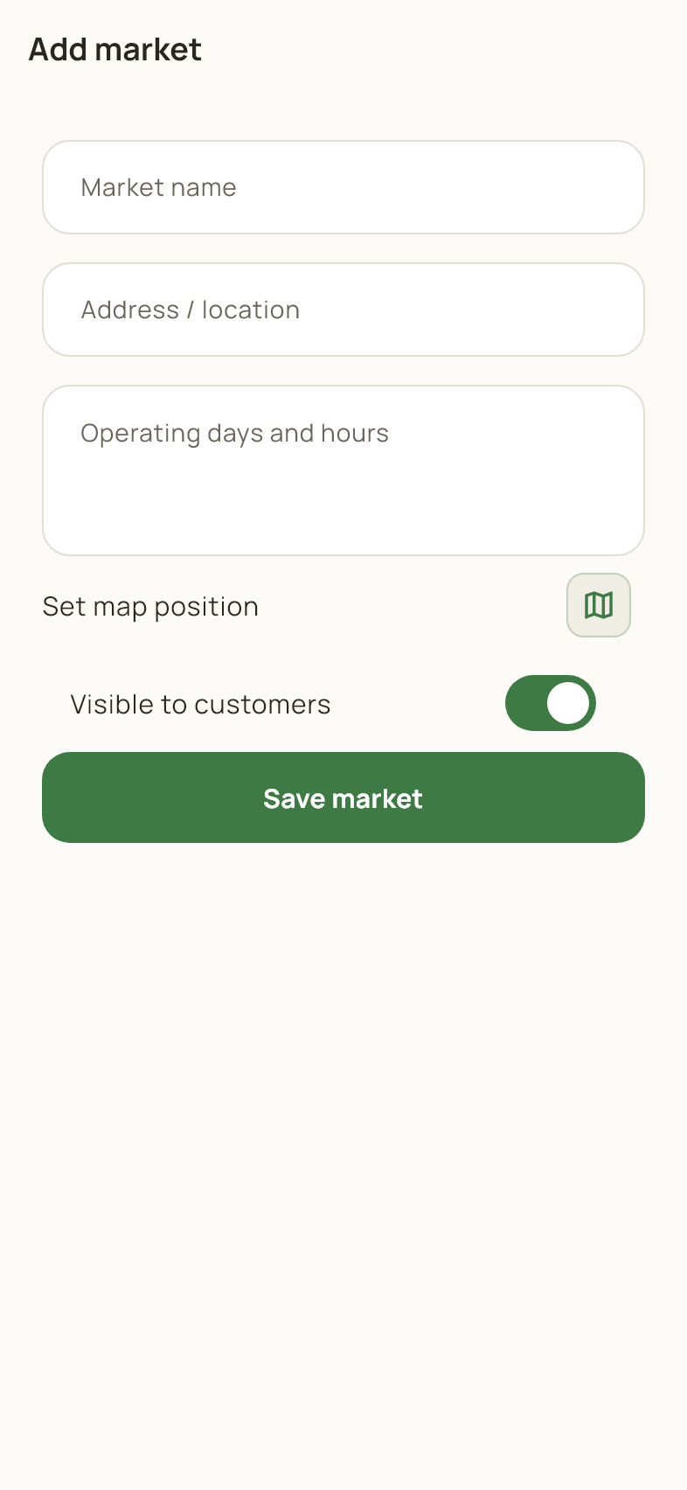
Admin workspace
Enter the market name, address or location, and opening hours. Use Set map position to select coordinates when needed. The visibility switch controls whether customers can see the market entry. Save the form to update the directory, then check its public listing. Farmers associated with the market appear under its entry.

59 Edit personal details
Profile > My Addresses or personal details
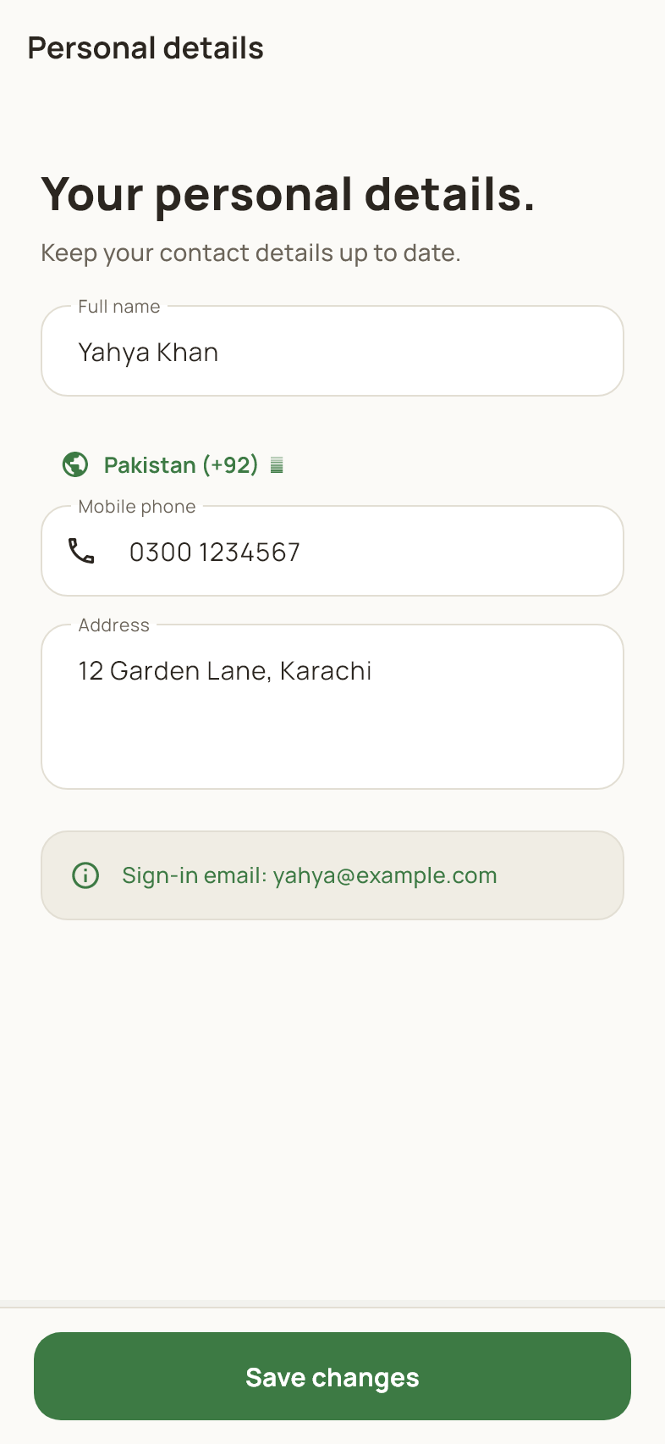
Shared account and support pages
Update the account name, mobile number and saved street address, then tap Save changes. Review validation messages before leaving the page. Personal details are separate from a farmer's public farm profile. Customers should still review the recipient and address shown at checkout for each order.

60 App preferences
Customer or Farmer Profile > App settings
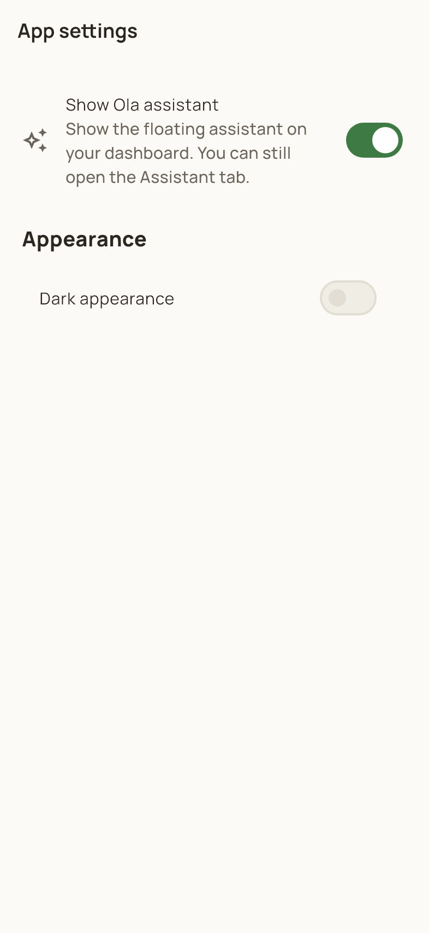
Shared account and support pages
Use the appearance control to switch the app theme. Customers can also show or hide the floating Ola assistant. The account security area is available to signed in live accounts and includes two-step verification. Preference changes do not alter your products or orders; reopen the page to review the current choices.

61 Change a password
Profile > Password & Security
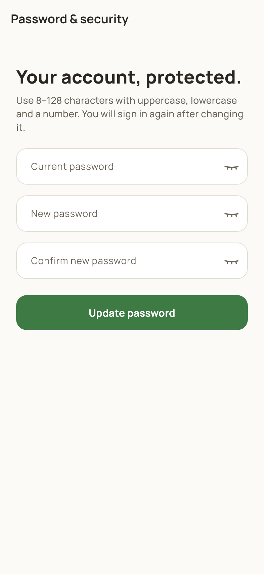
Shared account and support pages
Enter the current password, a different new password and its confirmation. Follow the strength requirements, then tap Update password. After a successful password change, sign in again with the new credentials. Scroll on this page for email verification and email address controls when available for the signed in account.

62 Two step verification enabled
App settings or Password & Security > Email two-step verification
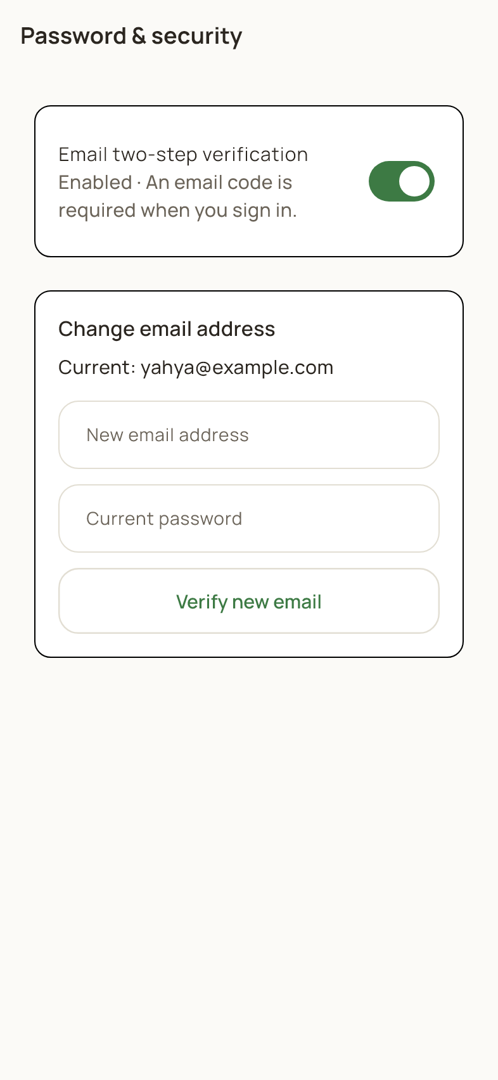
Shared account and support pages
The enabled state means future sign ins require your password and an email code. To disable it, turn the switch off, confirm your current password and complete the email code verification. The change takes effect only after verification succeeds. The email address controls below are a separate account action.

63 Confirm disabling two step verification
Enabled verification switch > Turn off
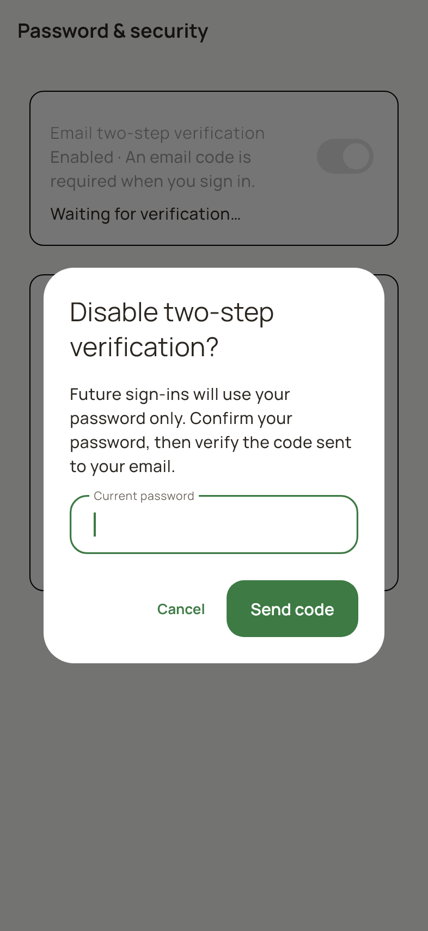
Shared account and support pages
This dialog explains that future sign ins will use the password only after the change is verified. Enter your current password and continue to request the email code. Complete the verification screen to finish. Cancel closes the dialog without changing the setting, and an incorrect password or code prevents the change.

64 Two step verification disabled
App settings or Password & Security > Disabled state
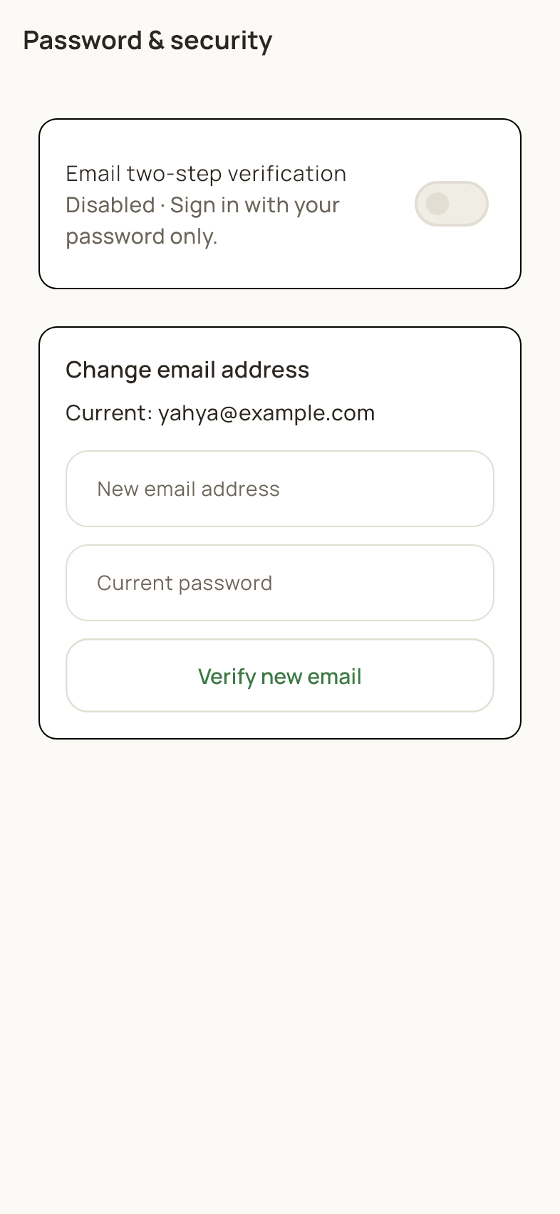
Shared account and support pages
The disabled state means a normal sign in uses your password without the extra email code. To enable the additional step, turn the switch on and follow password and email verification. The Change email address section accepts a new email and your current password; follow the app's verification instructions to complete that separate change.

65 Confirm enabling two step verification
Disabled verification switch > Turn on
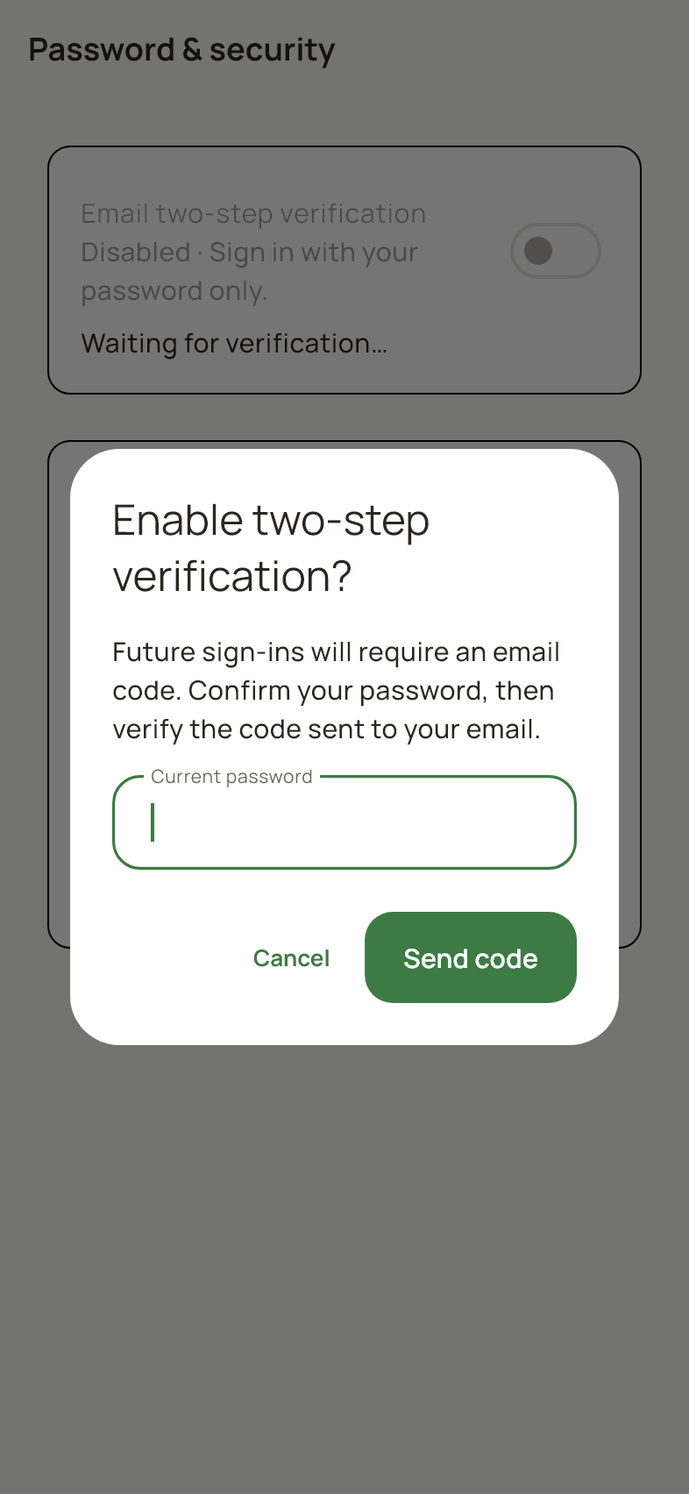
Shared account and support pages
Enter your current password to request a verification code for your email. Continue to the code screen, enter the six digit code and complete verification. The switch shows Enabled after the successful change. Canceling the dialog or leaving verification unfinished keeps the previous security setting.

66 Notifications and updates
Header bell or Profile > Notifications
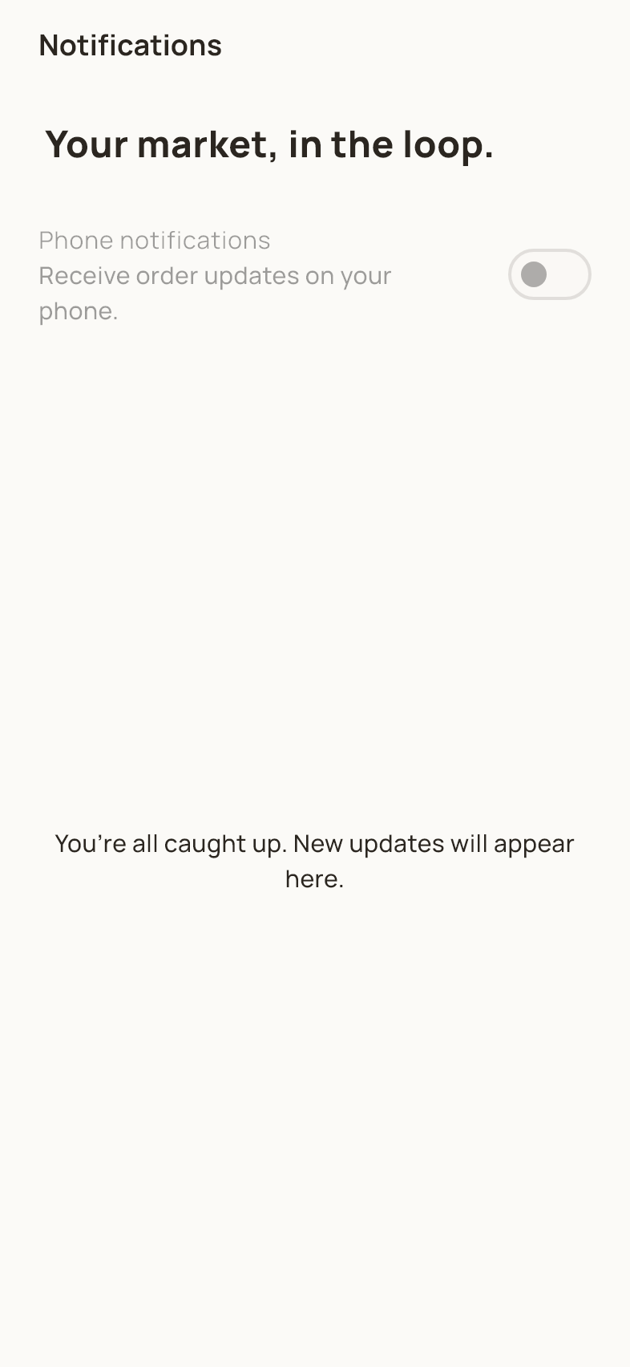
Shared account and support pages
The notifications page shows account updates such as order and pickup activity when available. Open a relevant notification to inspect its associated information. The phone notification control depends on device permission and service availability. An empty inbox means there are no updates to display; it does not indicate that an order has been placed.

67 Farmers market directory
Profile > Farmers markets
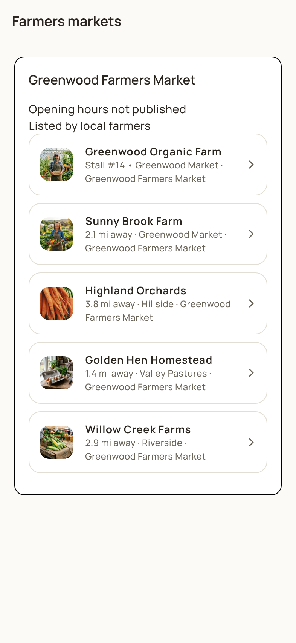
Shared account and support pages
Browse market locations, opening information and participating farms. Open a farm from the list to see its products. Published market entries and the market information associated with farms help organize the directory. Administrators see additional add or edit controls; customers use the public listing to explore growers.

68 Choose a map location
Address or search filter > Location control
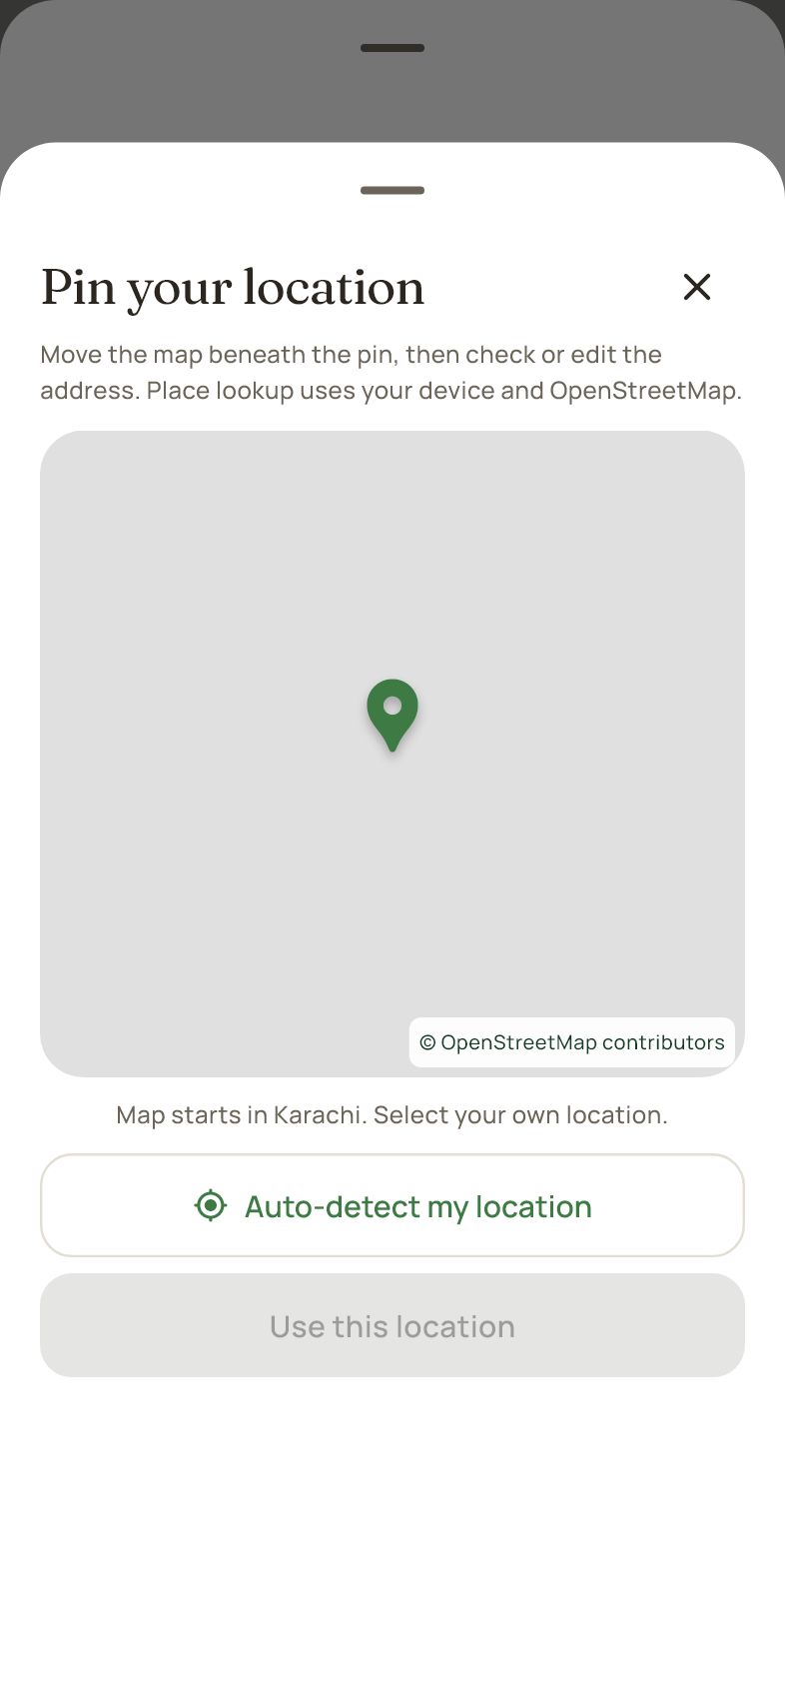
Shared account and support pages
Move the map beneath the pin or use your device location when permitted. After selecting a point, check or type its street address. Review the selected address and confirm it to return to the form. Map tiles and place lookup need a working connection. If the map cannot load, retry after reconnecting or use the available address entry fields.

69 About HarvestHub
Profile > About HarvestHub
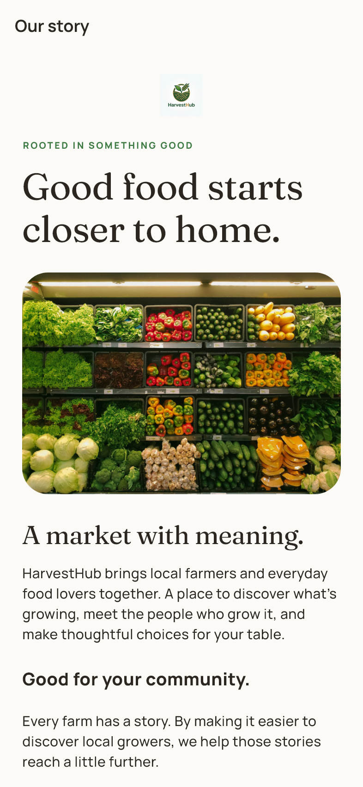
Shared account and support pages
The About page explains the marketplace story and its connection to local farmers. Scroll to read the full public content and supporting information. The text can be maintained by an administrator through the public content editor. This page provides background information; shopping and account actions remain in their respective workspaces.

70 Contact and feedback
Profile > Help & Support
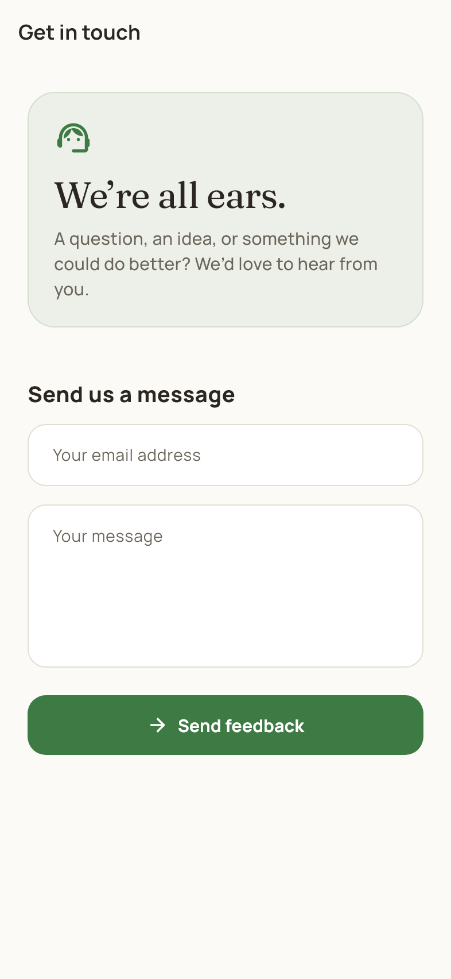
Shared account and support pages
Enter the requested contact information and write your message, then tap Send feedback. Review any validation or submission message to confirm the result. Submitted feedback appears in the admin feedback area. Use this form for app questions and issues, and avoid including passwords or email verification codes.

71 Loading empty and error screens
Shared interface states
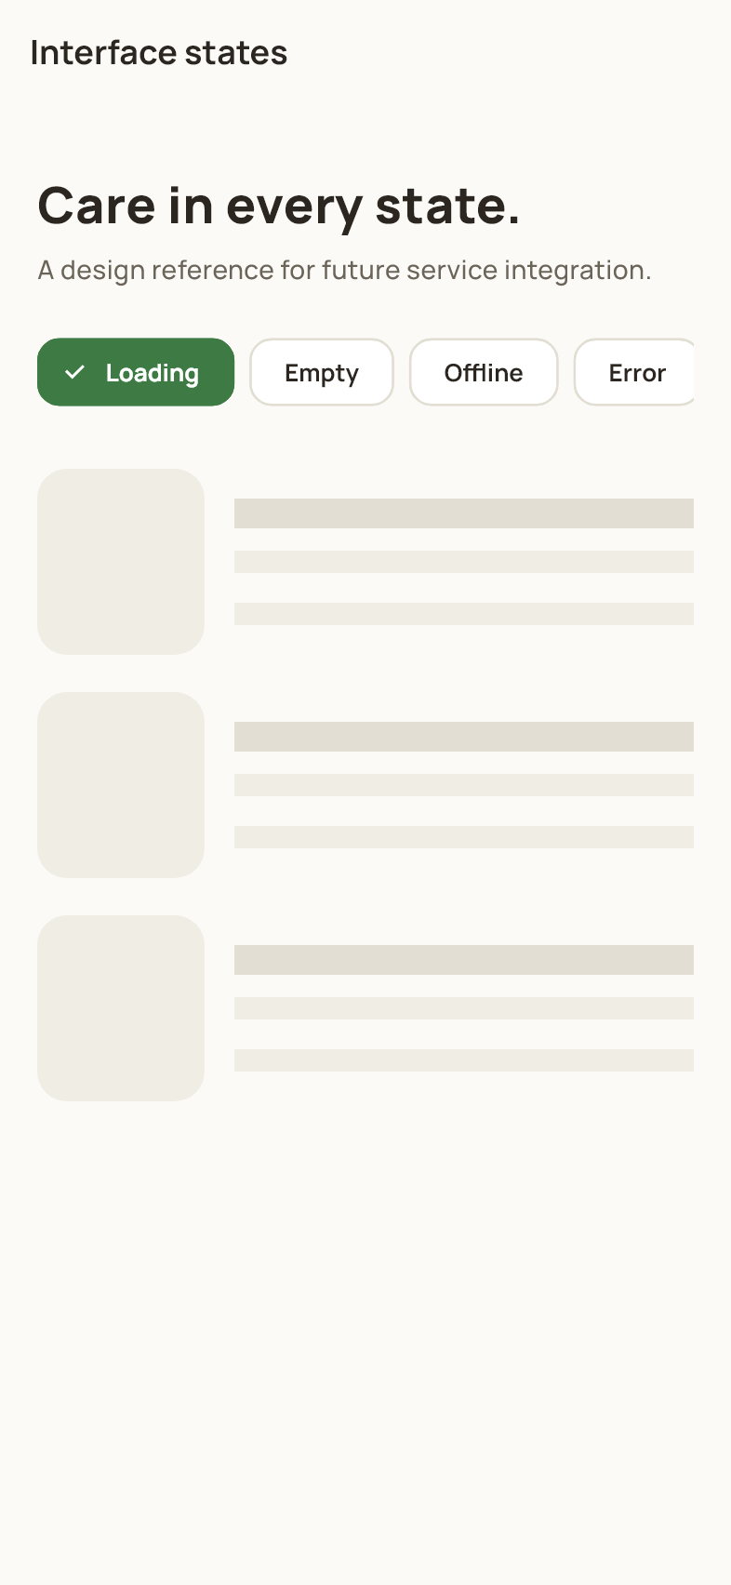
Shared account and support pages
Loading placeholders appear while data is being fetched. An empty state explains that no matching content is available. An error state provides a message and may offer a retry action. Wait briefly during loading, adjust filters for empty results, and check your connection before retrying an error. These states can appear within several app pages.

