Building First API endpoint

Submitted By: Anum Fatima

Terminal:
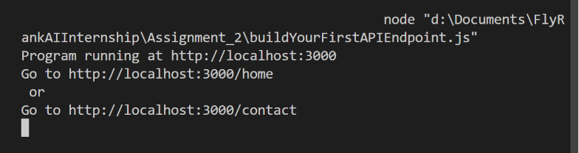
Output in curl:
http://localhost:3000/home
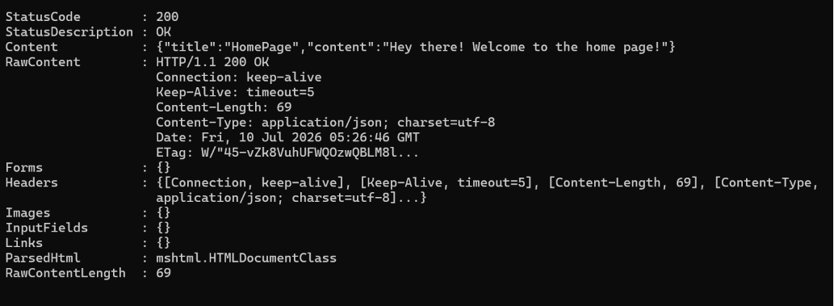
http://localhost:3000/contact
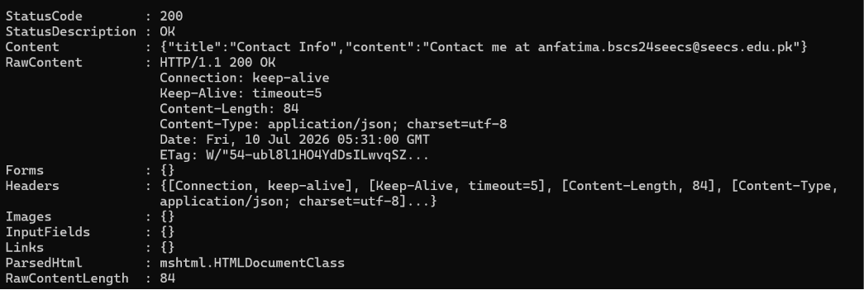

Output in browser:
