Summer Internship Report on
TOXIGUARD: An NLP Based Machine Learning Framework for Cyberbullying and Toxic Comment Detection
Submitted in partial fulfillment of the requirements for the award of the degree of
MASTER OF COMPUTER APPLICATIONS
Submitted By
Anumathi Singh
Roll no: 160125862006
Under the Esteemed Internal Guidance of
Dr. B. Indira
Associate Professor
Department of MCA, CBIT (A)

Department of MCA
Chaitanya Bharathi Institute of Technology (Autonomous)
Gandipet, Hyderabad — Telangana
Academic Year: 2026–27


CERTIFICATE
This is to certify that the Internship Report titled “ToxiGuard: An NLP Based Machine Learning Framework for Cyberbullying and Toxic Comment Detection” is a bona fide record of work carried out by Anumathi Singh (Hall Ticket No. 160125862006), in partial fulfillment of the requirements for the award of the degree of Master of Computer Applications (MCA).
The report presents the ToxiGuard project as part of the summer internship requirement following the Artificial Intelligence program at EduExpose.
[Internship period: 04-07-2026 – 15-08-2026]

Internship Internal Guide  Dr. B. Indira  Associate Professor  Dept. of MCA, CBIT (A), Hyderabad | Head of the Department  Dr. B. Indira  Associate Professor  Dept. of MCA, CBIT (A), Hyderabad

ORGANIZATION CERTIFICATE
The completion certificate issued by EduExpose for the Artificial Intelligence internship program is reproduced below.


DECLARATION
I, Anumathi Singh, bearing Hall Ticket No. 160125862006, hereby declare that the internship project report entitled “ToxiGuard: An NLP Based Machine Learning Framework for Cyberbullying and Toxic Comment Detection”, submitted as part of the requirements of the Master of Computer Applications (MCA) program, is an original work carried out by me under the guidance of my internal guide, Dr. B. Indira.
I further declare that this report presents the design, implementation, testing, and documentation of the ToxiGuard toxic-comment detection system. The report has not been previously submitted, either in whole or in part, to any institution or university for the award of any degree, diploma, certification, or academic credit.
All tools, libraries, datasets, and technical references used in the preparation of this report have been acknowledged to the best of my knowledge and belief.
Anumathi Singh
Roll No: 160125862006
Date: ____________________

ACKNOWLEDGEMENT
I would like to express my sincere gratitude to everyone who supported and guided me in completing my internship project titled “ToxiGuard: An NLP Based Machine Learning Framework for Cyberbullying and Toxic Comment Detection”.
I also thank Dr. C. V. Narasimhulu, Principal, Chaitanya Bharathi Institute of Technology, for his support in this endeavor.
I am deeply grateful to Dr. B. Indira, my Internal Guide and Head of the MCA Department at Chaitanya Bharathi Institute of Technology (CBIT), for her guidance, continuous encouragement, and valuable suggestions throughout the project.
I extend my heartfelt thanks to EduExpose for the guidance and learning support provided during the Artificial Intelligence internship program.
Finally, I thank the faculty members of the Department of MCA, and my family and friends, for their constant encouragement and support throughout the project.
Anumathi Singh
Roll No: 160125862006

ABSTRACT
ToxiGuard is a machine learning application that classifies online comments as toxic or non-toxic to support the review of harmful language. It combines natural language processing, supervised text classification, and an interactive Streamlit interface. The project uses the Jigsaw toxic-comment dataset, with the published toxic label as its binary target. After missing and duplicate comments were removed and text was cleaned, 159,556 comments remained. A stratified sample of 30,000 comments was used for the experiment, comprising 24,000 training comments and 6,000 test comments.
The system converts cleaned text into 15,000 TF-IDF unigram and bigram features. Six classifiers are compared on the same held-out split: Multinomial Naive Bayes, Complement Naive Bayes, Logistic Regression, calibrated Linear SVM, SGD Classifier, and Random Forest. Evaluation uses accuracy, precision, recall, F1-score, and ROC-AUC. Logistic Regression achieved the highest toxic-class F1 score, with 93.23% accuracy, 61.02% precision, 81.39% recall, 69.75% F1, and 0.9576 ROC-AUC.
The selected model and fitted vectorizer are saved and integrated into a Streamlit application. Users can analyse individual comments, upload batches of comments, download predictions, and inspect dataset statistics and model performance. The interface presents a predicted class and toxic probability to help prioritise review. Context, intent, and repeated abusive behaviour require human assessment; the current model evaluates individual comments. This report presents the system analysis, design, implementation, testing, results, limitations, and future scope of ToxiGuard.

TABLE OF CONTENTS
1. INTRODUCTION 1
1.1 Introduction to ToxiGuard 1
1.2 Project Objectives 1
1.3 Scope of the Project 2
2. ORGANIZATION PROFILE 3
2.1 Internship Program 3
2.2 Academic Setting 3
2.3 Relevance of the Program 3
3. LITERATURE REVIEW 4
3.1 Automated Analysis of Harmful Comments 4
3.2 Distinguishing Toxicity and Offensive Language 4
3.3 Bias in Text Classification 4
3.4 Relevance to the Proposed System 4
4. SYSTEM ANALYSIS 5
4.1 Problem Statement 5
4.2 Existing System and Limitations 5
4.3 Proposed System 5
4.4 Functional Requirements 5
4.5 Non-Functional Requirements 6
4.6 Hardware and Software Requirements 6
4.7 System Boundaries 6
5. TECHNOLOGIES AND TOOLS USED 7
6. SYSTEM DESIGN 8
6.1 Data Flow Diagram 8
6.2 Entity Relationship Diagram 10
7. IMPLEMENTATION 11
7.1 Modules 11
7.2 Data Preparation 11
7.3 Feature Extraction and Training 11
7.4 Selection and Serialization 11
7.5 Streamlit Application 12
8. TESTING AND VALIDATION 13
8.1 Test Strategy 13
8.2 Functional Checks 13
8.3 Interpretation 13
9. RESULTS AND DISCUSSION 14
9.1 Dataset and Experiment 14
9.2 Model Comparison 15
9.3 Application Output 18
9.4 Limitations 19
10. CHALLENGES AND SOLUTIONS 20
10.1 Class Imbalance 20
10.2 Training and Inference Consistency 20
10.3 Interpretation and Context 20
11. LEARNING OUTCOMES 21
11.1 Technical Skills Acquired 21
11.2 Practical Experience Gained 21
11.3 Technical Communication 21
12. CONCLUSION AND FUTURE SCOPE 22
12.1 Conclusion 22
12.2 Limitations 22
12.3 Future Enhancements 22
REFERENCES 23
Appendix A — Source Code 24
Appendix B — Paper Presentation Certificate 28
Appendix C — Project Outputs 29

LIST OF FIGURES
Figure 6.1: DFD Level 0 — ToxiGuard Context 8
Figure 6.2: DFD Level 1 — Training and Prediction 9
Figure 6.3: Logical Entity Relationship Model 10
Figure 7.1: Streamlit Application Overview 12
Figure 9.1: Exploratory Data Analysis 14
Figure 9.2: Comparison of Classifier Performance 16
Figure 9.3: Logistic Regression Confusion Matrix 17
Figure 9.4: Single-Comment Prediction Output 18

LIST OF TABLES
Table 4.1: Functional Requirements 5
Table 5.1: Technologies and Tools Used 7
Table 7.1: Main Project Modules 11
Table 8.1: Functional Test Cases 13
Table 9.1: Model Comparison 15
Table 9.2: Sample Prediction Results 19
Table C.1: Project Output Files 29

1. INTRODUCTION

1.1 Introduction to ToxiGuard
ToxiGuard is a natural language processing and machine learning system that identifies potentially toxic language in online comments. It accepts a comment as text and predicts whether it belongs to the toxic or non-toxic class. Online discussions may contain insults, hostile remarks, and other harmful expressions that are difficult to review individually when comment volumes are large. ToxiGuard provides a consistent first-stage screening tool that helps a reviewer identify comments requiring closer attention.
The project implements a complete text-classification workflow in Python. Labelled comments from the Jigsaw dataset are cleaned and converted into numerical features using Term Frequency–Inverse Document Frequency (TF-IDF). Six machine learning classifiers are compared using the same training and test split. The selected Logistic Regression model is integrated into a Streamlit application that supports individual comment analysis, CSV batch predictions, dataset exploration, and model-performance review.
ToxiGuard addresses harmful language at the comment level. Its toxic-class probability can help prioritise moderation, but a single comment does not establish a pattern of cyberbullying or reveal the full context of a conversation. The application therefore presents predictions as support for human review. The work documented here includes dataset preparation, model comparison, system design, implementation, evaluation, and the application interface.

1.2 Project Objectives
- Prepare a labelled English toxic-comment dataset and examine class balance.
- Implement consistent text preprocessing and TF-IDF feature extraction.
- Compare six classifiers using accuracy, precision, recall, F1-score, and ROC-AUC.
- Integrate the selected model into Streamlit for single-comment and batch analysis.
- Present predictions, evaluation results, and model limitations clearly.

1.3 Scope of the Project
The current scope is English-language binary classification. It does not classify the separate Jigsaw categories in the user interface, use conversation history, or automate content removal.
The deliverables include the cleaned dataset, preprocessing and training code, a training notebook, saved model and vectorizer, evaluation tables and charts, prediction exports, and the Streamlit application. The measured results describe a stratified sample from the source dataset; testing with comments from other platforms is part of future work.

2. ORGANIZATION PROFILE

2.1 Internship Program
EduExpose provided the Artificial Intelligence program completed by Anumathi Singh from 4 July 2026 to 15 August 2026. The program forms the internship context for this academic submission. ToxiGuard applies machine learning concepts to the practical problem of identifying toxic online comments.

2.2 Academic Setting
The work is submitted to the Department of MCA, Chaitanya Bharathi Institute of Technology (Autonomous), Gandipet, Hyderabad. Dr. B. Indira serves as both the Internal Guide and Head of Department for this submission. The project connects natural language processing, experimental model comparison, and a working web interface.

2.3 Relevance of the Program
The Artificial Intelligence program is directly relevant to text classification. ToxiGuard demonstrates data cleaning, feature extraction, supervised learning, metric selection, and deployment. The report emphasizes what is present in the project repository and what the measured outputs actually show.

3. LITERATURE REVIEW

3.1 Automated Analysis of Harmful Comments
Wulczyn, Thain, and Dixon combined crowdsourced labels with machine learning to study personal attacks in English Wikipedia discussions [6]. Their work demonstrates how labelled comments can support automated analysis at a scale that is difficult to achieve through manual review alone. This provides relevant background for ToxiGuard's use of supervised learning on online comments.

3.2 Distinguishing Toxicity and Offensive Language
Davidson and colleagues studied the distinction between hate speech, offensive language, and comments belonging to neither category [7]. Their analysis shows why the presence of a flagged word alone is an inadequate basis for classifying a message. ToxiGuard uses the dataset's binary toxic label, so its output must not be interpreted as a separate determination of hate speech, threat, or repeated cyberbullying.

3.3 Bias in Text Classification
Dixon and colleagues examined unintended bias in toxicity classifiers and showed how imbalanced training examples can affect predictions associated with demographic identity terms [8]. Their work motivates evaluation beyond an overall accuracy score. ToxiGuard reports toxic-class precision, recall, and F1, but its current experiment does not establish fairness across demographic groups; targeted bias evaluation remains future work.

3.4 Relevance to the Proposed System
The reviewed work highlights the value of labelled data, careful interpretation of class definitions, and explicit analysis of model errors. ToxiGuard applies these ideas through a reproducible TF-IDF baseline, comparison of six classifiers, a confusion matrix, and a Streamlit interface for inspecting predictions. Its contribution is an implemented and evaluated academic application. Conversation-level analysis, cross-platform validation, and subgroup evaluation are outside the current experimental scope.

4. SYSTEM ANALYSIS

4.1 Problem Statement
The project addresses the need to screen English online comments for potentially toxic language. The system must accept text, apply the same processing used during training, and return an interpretable binary prediction. Because non-toxic comments form the majority of the dataset, evaluation must also show how well the model detects the smaller toxic class.

4.2 Existing System and Limitations
Manual moderation requires reviewers to inspect individual comments. This provides context, but becomes time consuming as comment volume grows. A simple keyword list is quick but cannot reliably handle variation in wording, negation, or benign uses of flagged terms.

4.3 Proposed System
ToxiGuard applies the same preprocessing used during training to a new comment, transforms it with the saved TF-IDF vectorizer, and produces a toxic-class probability from the selected Logistic Regression classifier. The dashboard displays the prediction, probability, and review priority. It also supports CSV-based batch analysis.

4.4 Functional Requirements
Table 4.1: Functional Requirements
Requirement | Implementation
Input | Accept one comment or a CSV batch in the dashboard
Preparation | Apply the same cleaning function to training and new text
Prediction | Return a binary class and toxic probability
Evaluation | Display model comparison and confusion matrix
Export | Save test predictions and allow batch download

4.5 Non-Functional Requirements
The interface should be legible and usable on a normal laptop. Training results should be reproducible from the documented CSV and fixed random seed. The application should load the same vectorizer and selected model that were saved by training. Predictions are decision support and should be accompanied by a human-review warning.

4.6 Hardware and Software Requirements
A standard Windows laptop with Python 3 and enough free storage for the CSV, model files, and generated charts is sufficient. The project requirements list Streamlit, pandas, NumPy, scikit-learn, joblib, matplotlib, seaborn, Jupyter, and ReportLab. The dashboard is launched with python -m streamlit run app.py from the ToxiGuard directory.

4.7 System Boundaries
The model learns from labelled Wikipedia comments rather than every social platform. Sarcasm, quotations, identity terms, code switching, and changing slang can produce errors. The reported test metrics describe performance on the selected held-out dataset, not guaranteed performance in deployment.

5. TECHNOLOGIES AND TOOLS USED
Table 5.1: Technologies and Tools Used
Component | Role in ToxiGuard
Python | Training script, preprocessing, and dashboard logic
pandas and NumPy | Tabular cleaning, analysis, and prediction export
scikit-learn | TF-IDF, train/test split, classifiers, and metrics
matplotlib and seaborn | EDA, comparison chart, and confusion matrix
joblib | Saving and loading the selected model and vectorizer
Streamlit | Interactive single and batch comment analysis
Jigsaw CSV | Labelled English comment source

The project uses files rather than a relational database. The source and cleaned records are CSV files; trained artifacts are serialized as PKL files. The application reads these outputs from the local project directory.

6. SYSTEM DESIGN

6.1 Data Flow Diagram
The context diagram shows the main inputs and outputs of the system. The level 1 diagram separates the training path from prediction. Both paths use the same cleaning rules; the prediction path loads the saved vectorizer and classifier.
Figure 6.1: DFD Level 0 — ToxiGuard Context
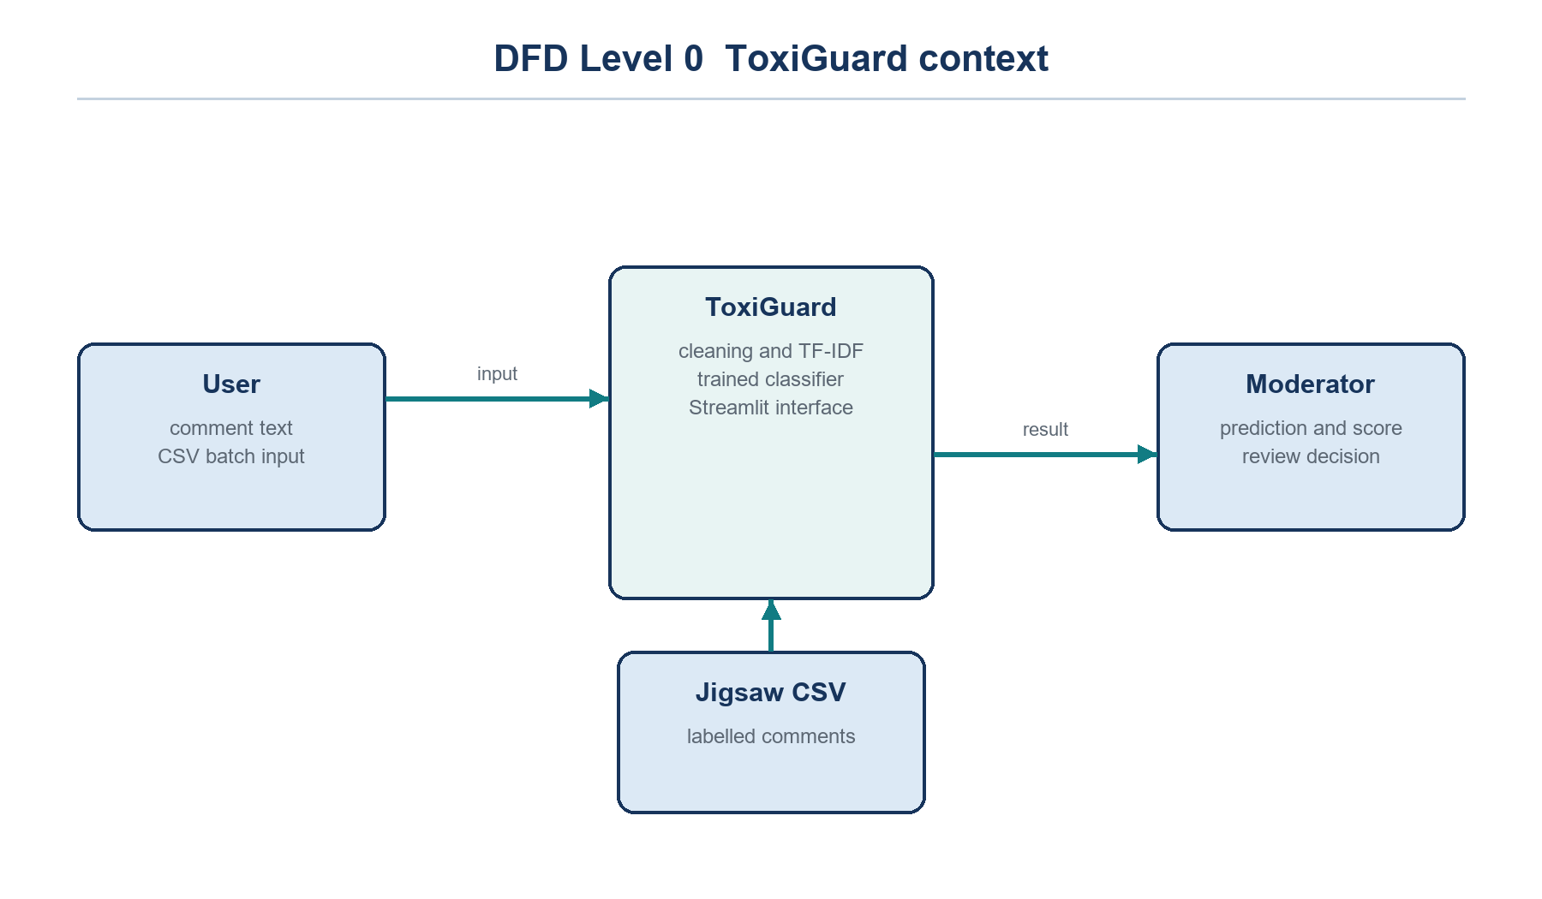
Figure 6.1 represents ToxiGuard as a single process. The user supplies a comment or a batch of comments, while the Jigsaw dataset supplies labelled training examples. The system returns a predicted class and probability to support a moderator's review.

Figure 6.2: DFD Level 1 — Training and Prediction
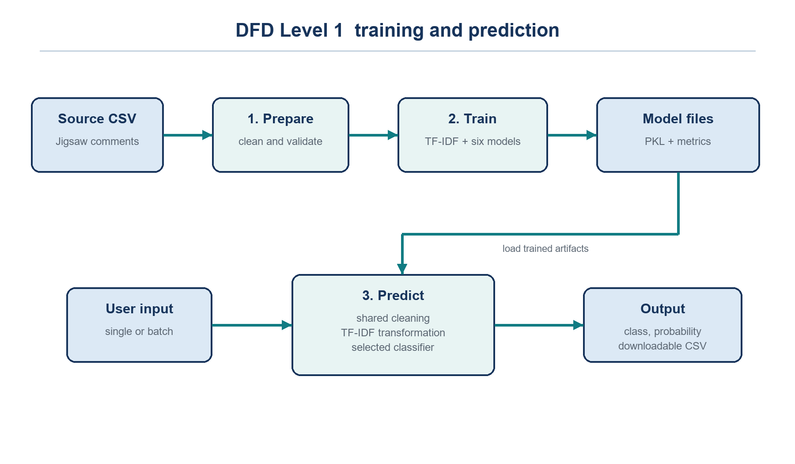
Figure 6.2 separates data preparation, model training, and prediction. The training path cleans the source comments, creates TF-IDF features, compares six classifiers, and saves the selected model. The prediction path applies the same cleaning rules to user input and loads the saved artifacts to generate a class and probability.

6.2 Entity Relationship Diagram
The ER diagram is a logical description of the data and evaluation records. It does not imply a database implementation. The project stores comments and predictions as CSV files and model artifacts as PKL files.
Figure 6.3: Logical Entity Relationship Model
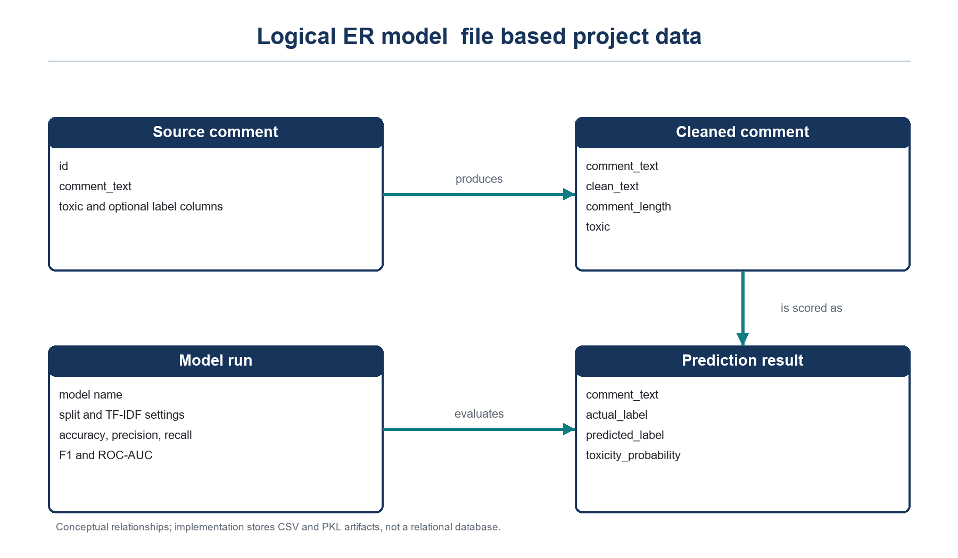
Figure 6.3 relates source comments, cleaned comments, model runs, and prediction results. Cleaning creates the text representation used by the classifier. A model run records evaluation metrics, and prediction records contain the actual label, predicted label, and toxic probability. These are conceptual entities represented by the project's files.

7. IMPLEMENTATION

7.1 Modules
Table 7.1: Main Project Modules
Module | Purpose
download_dataset.py | Obtains the public source CSV
src/text_utils.py | Provides text cleaning and label helpers
train_model.py | Cleans, trains, compares, and exports outputs
app.py | Loads saved artifacts and presents predictions

7.2 Data Preparation
The training script reads comment_text and toxic, removes rows with missing required values and duplicate comment text, applies the shared cleaning function, and removes records whose cleaned text is too short. It records comment length for EDA. The reported cleaned dataset contains 159,556 rows, including 15,293 toxic comments and 144,263 non-toxic comments.

7.3 Feature Extraction and Training
A stratified sample of 30,000 rows is split 80:20 with random state 42. The TF-IDF vectorizer is fitted on training text only and transforms the test text without refitting. It uses unigrams and bigrams, min_df=2, sublinear term frequency, and a 15,000-feature cap. Six classifiers receive the same feature matrix.

7.4 Selection and Serialization
Each model is assessed with accuracy, toxic-class precision, recall, F1, and ROC-AUC. The comparison is sorted by toxic-class F1, then recall, then accuracy. The selected Logistic Regression model and TF-IDF vectorizer are saved separately with joblib. The output folder holds the comparison table, confusion matrix, classification report, prediction export, EDA plots, and metadata.

7.5 Streamlit Application
The dashboard offers Overview, Analyze comment, Batch analysis, Model performance, Dataset insights, and About the project pages. Its Analyze comment page takes a text input and displays a class, toxic probability, model confidence, and review priority. The Batch analysis page accepts comments in a CSV and exports predicted results.
Figure 7.1: Streamlit Application Overview
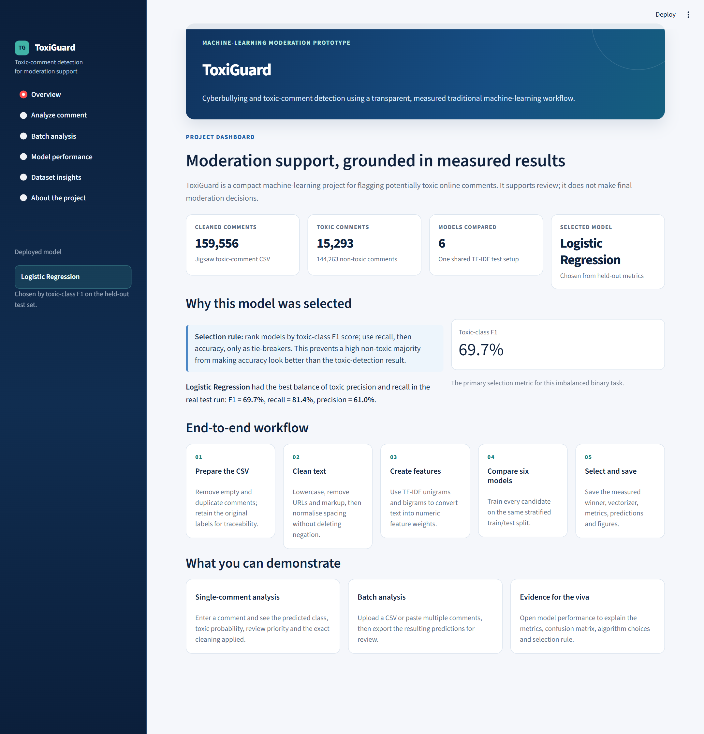
Figure 7.1 shows the dashboard overview, including the cleaned dataset size, toxic-comment count, six-model comparison, and selected Logistic Regression model. The sidebar provides access to comment analysis, batch analysis, model performance, and dataset insights.

8. TESTING AND VALIDATION

8.1 Test Strategy
The training script was run against the local Jigsaw CSV and completed with six measured model results. The dashboard was started locally and its Overview, Analyze comment, and Model performance pages were inspected. Sample comments were evaluated through the saved artifacts using the same cleaning and vectorization path.

8.2 Functional Checks
Table 8.1: Functional Test Cases
ID | Input or action | Observed result
T01 | Start Streamlit dashboard | Application loaded with Logistic Regression selected
T02 | Insulting sample comment | Toxic, probability 0.9915
T03 | Appreciative sample comment | Non-toxic, probability 0.1427
T04 | Polite disagreement | Non-toxic, probability 0.0501
T05 | Open model performance | Six-model comparison and selected metrics displayed

8.3 Interpretation
These checks confirm that the saved artifacts load and the interface produces a result for representative input. Three sample comments are not a statistical validation set; the 6,000-row held-out evaluation provides the quantitative evidence. A future acceptance test should include human-reviewed comments from the intended deployment setting.

9. RESULTS AND DISCUSSION

9.1 Dataset and Experiment
The cleaned dataset contains 159,556 comments, with the toxic class representing about 9.6% of rows. A stratified 30,000-row subset was divided into 24,000 training comments and 6,000 test comments. This imbalance is why accuracy alone is insufficient for model selection.
Figure 9.1: Exploratory Data Analysis
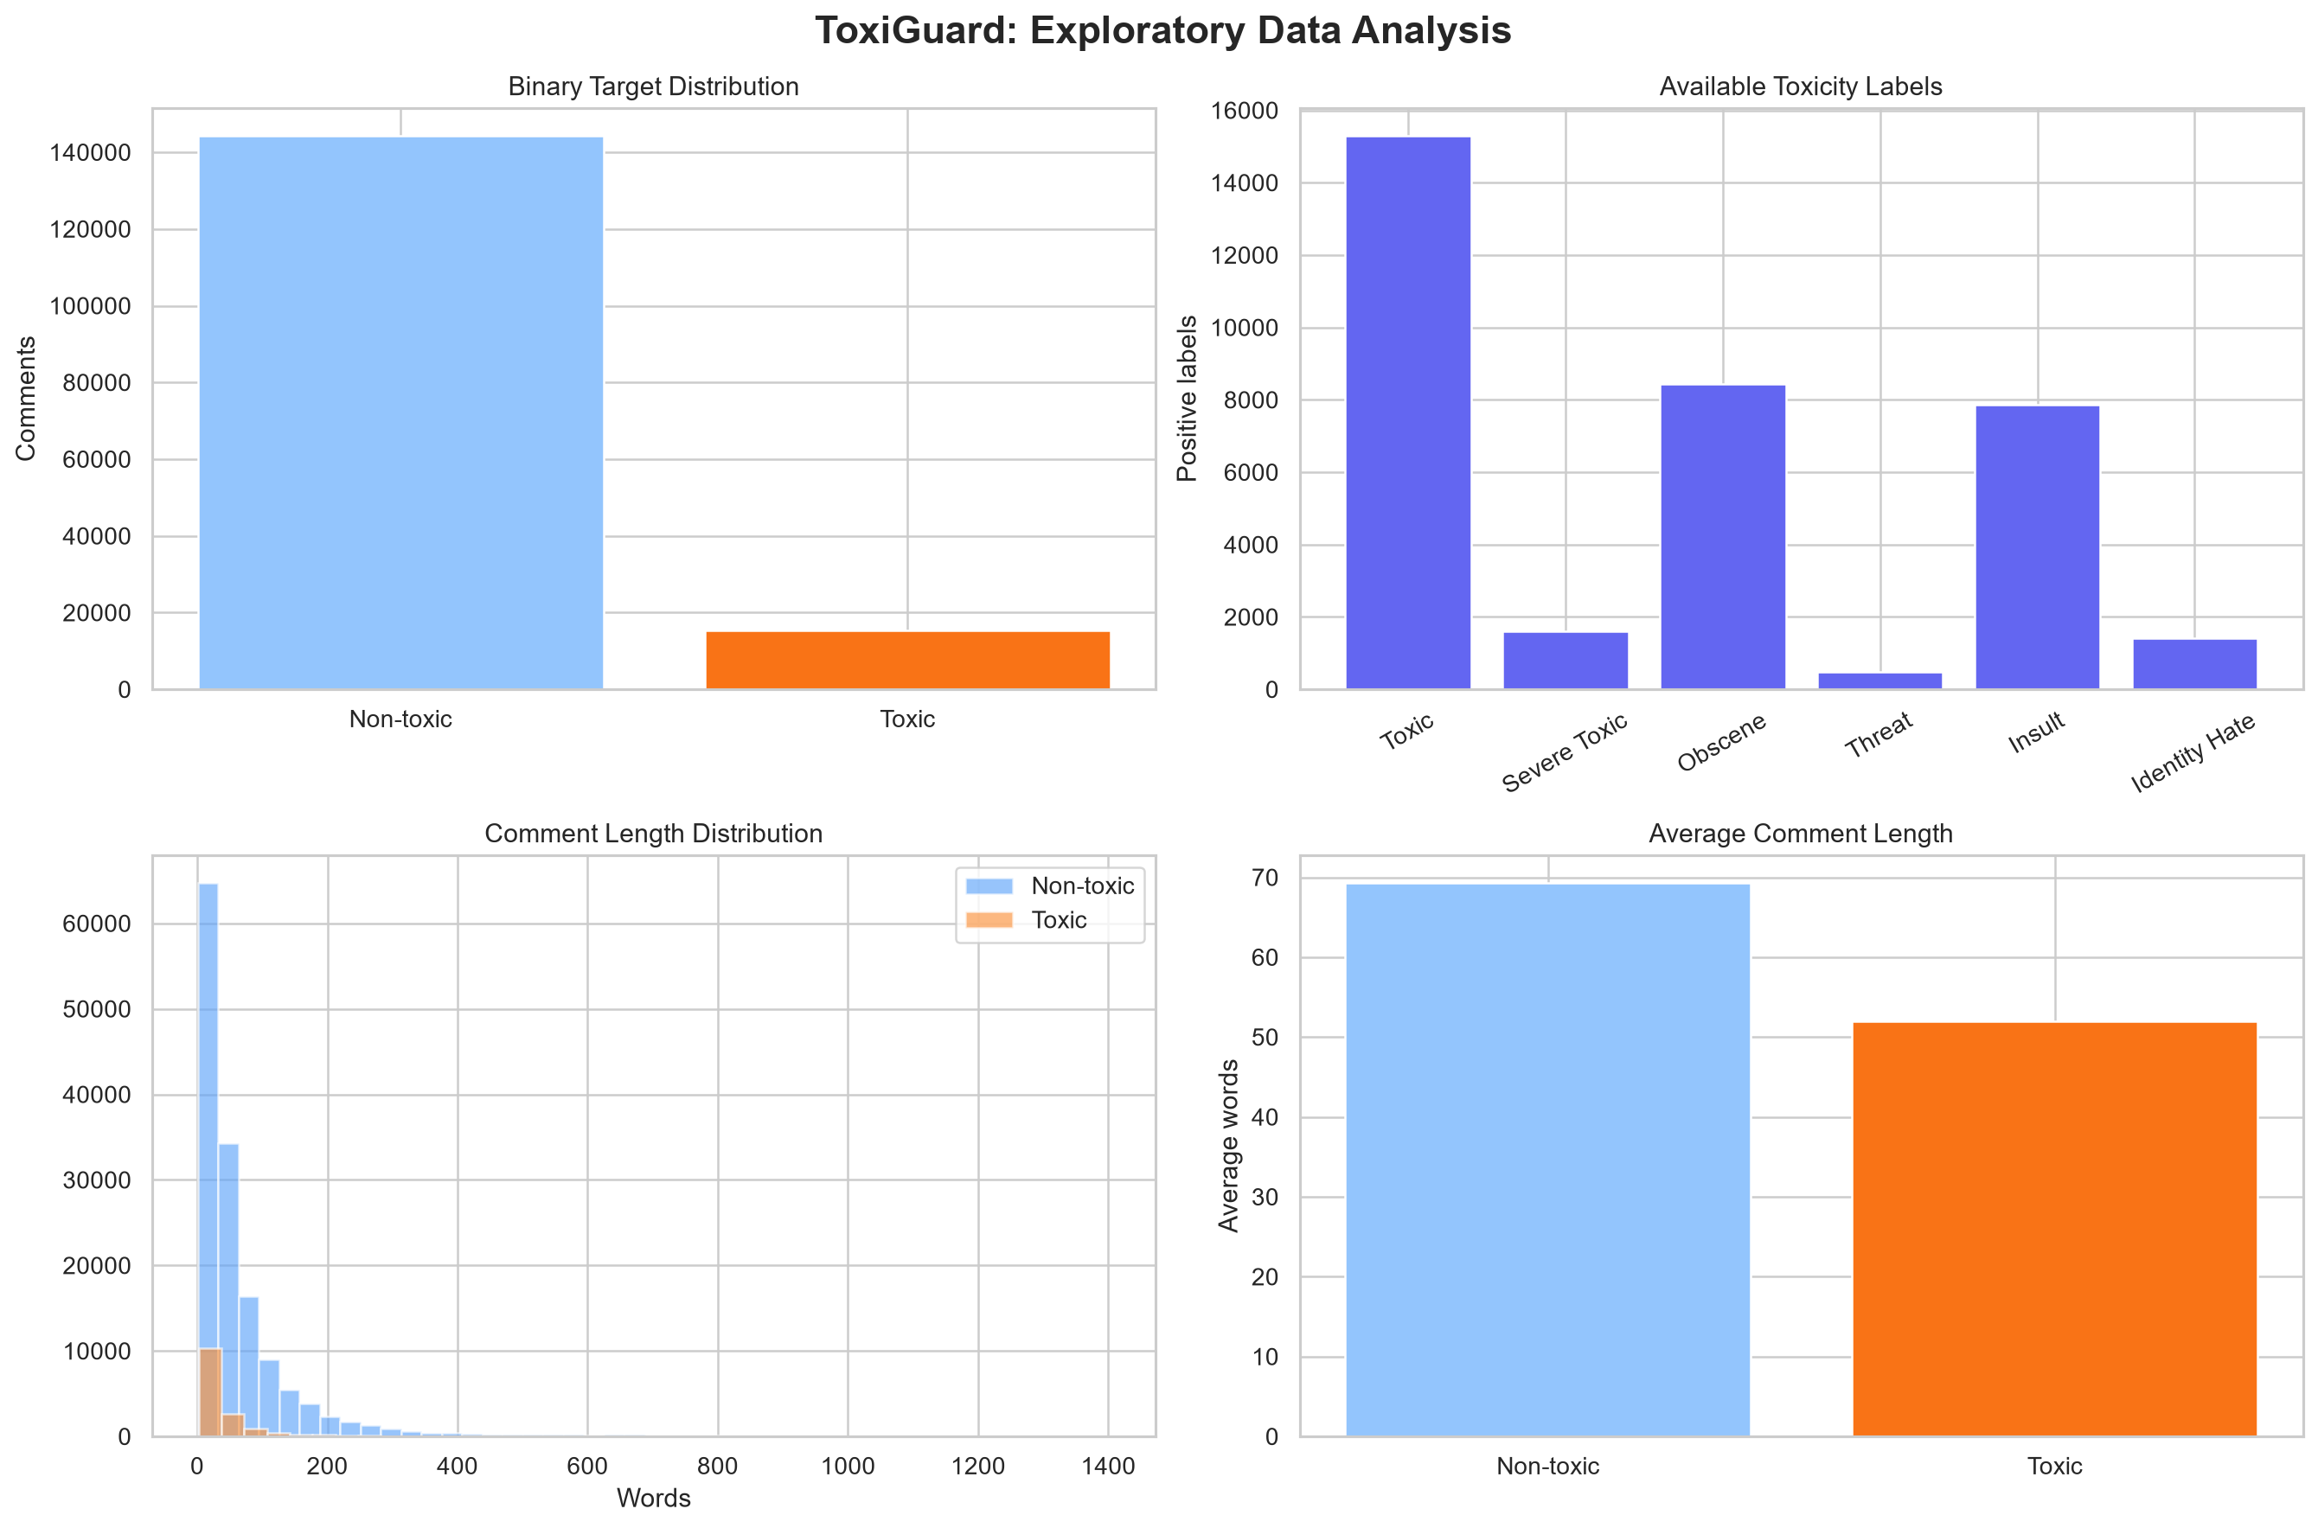
Figure 9.1 shows four views of the cleaned dataset: binary class counts, counts for the available toxicity labels, comment-length distributions, and average comment length. Non-toxic comments greatly outnumber toxic comments. The skewed length distribution and unequal class sizes provide context for preprocessing and minority-class evaluation.

9.2 Model Comparison
Table 9.1: Model Comparison
Model | Acc | Prec | Recall | F1 | AUC
Logistic Regression | 0.932 | 0.610 | 0.814 | 0.697 | 0.958
SGD Classifier | 0.932 | 0.613 | 0.795 | 0.692 | 0.953
Linear SVM (Calibrated) | 0.950 | 0.855 | 0.574 | 0.687 | 0.956
Multinomial Naive Bayes | 0.945 | 0.926 | 0.459 | 0.614 | 0.945
Complement Naive Bayes | 0.892 | 0.467 | 0.864 | 0.606 | 0.945
Random Forest | 0.917 | 0.558 | 0.628 | 0.591 | 0.914

Table 9.1 reports held-out accuracy (Acc), toxic precision (Prec), toxic recall, toxic F1, and ROC-AUC (AUC). Logistic Regression achieved the highest toxic-class F1 of 0.6975. It recovered about 81.4% of toxic comments at a toxic precision of about 61.0%. The calibrated Linear SVM had higher overall accuracy and precision, but lower toxic recall. The choice therefore reflects the documented F1-first selection rule.
Figure 9.2: Comparison of Classifier Performance
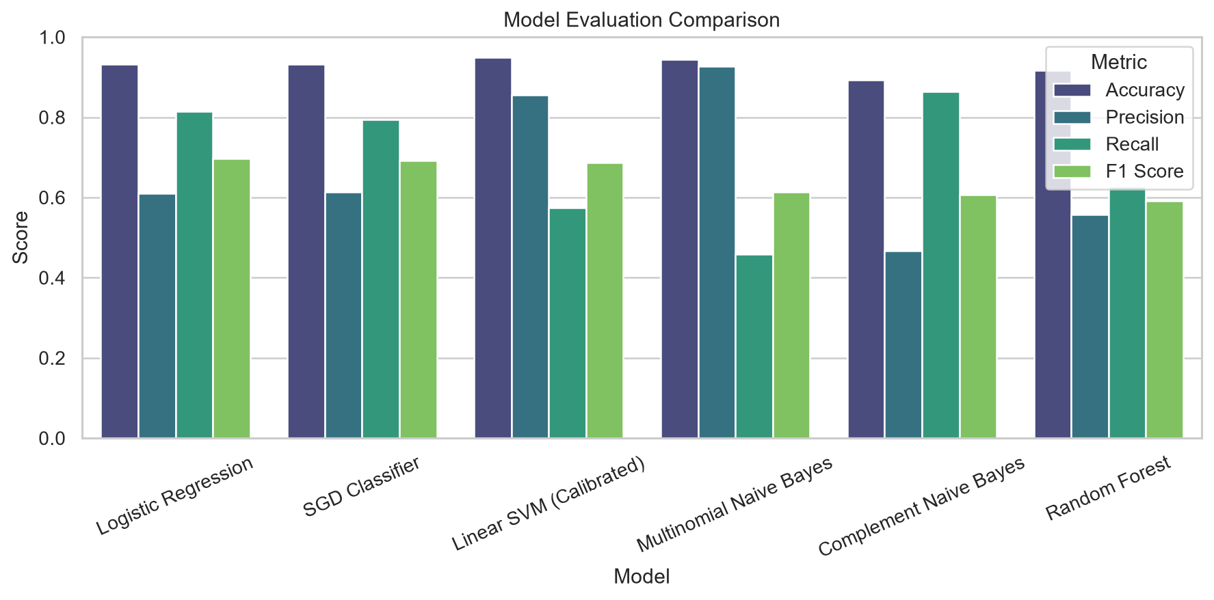
Figure 9.2 compares accuracy, toxic precision, recall, and F1 across six classifiers. Logistic Regression achieves the highest toxic F1. Complement Naive Bayes has higher recall but more false positives, while Multinomial Naive Bayes misses more toxic comments.

Figure 9.3: Logistic Regression Confusion Matrix
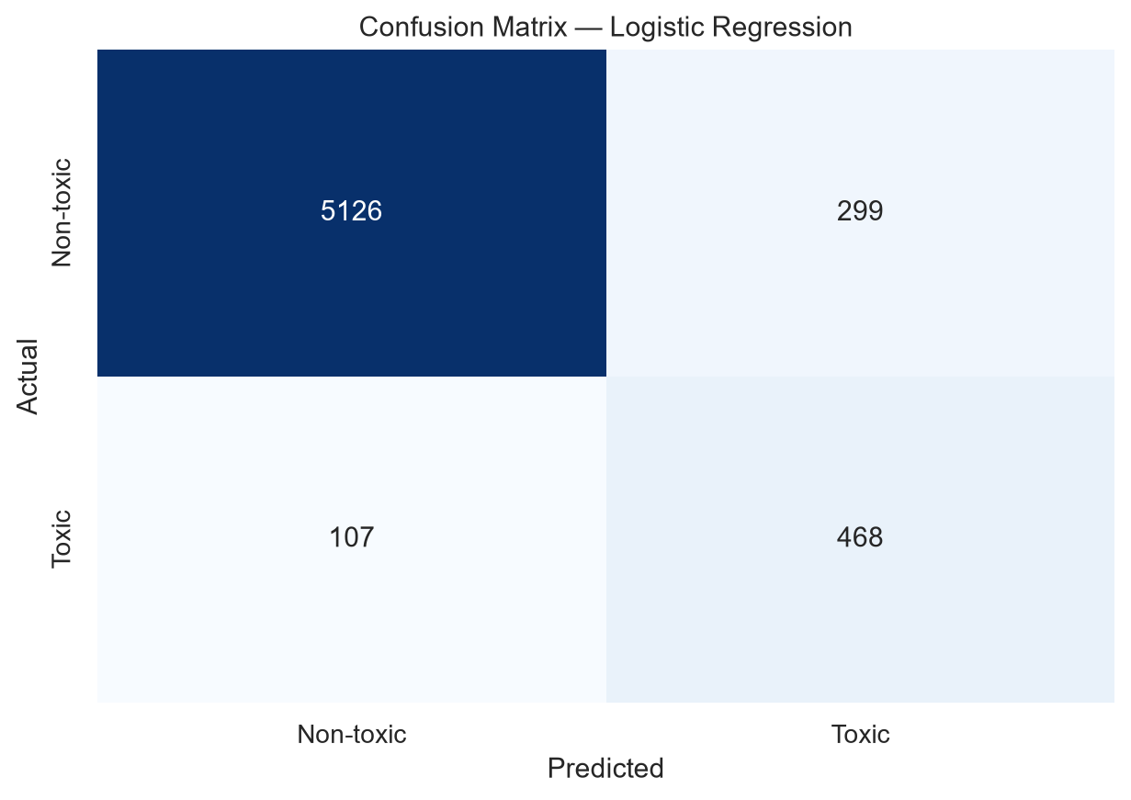
Figure 9.3 summarizes predictions for 6,000 test comments. The classifier correctly identifies 5,126 non-toxic comments and 468 toxic comments. It incorrectly flags 299 non-toxic comments and misses 107 toxic comments. These errors explain why automated flags still require human review.

9.3 Application Output
The running Streamlit application loaded Logistic Regression from the saved model files. For the test sentence “You are an idiot and nobody wants you here,” it displayed a Toxic prediction with a toxic probability of about 99.1%. This example demonstrates the interface output, not the accuracy of the model on the wider population.
Figure 9.4: Single-Comment Prediction Output
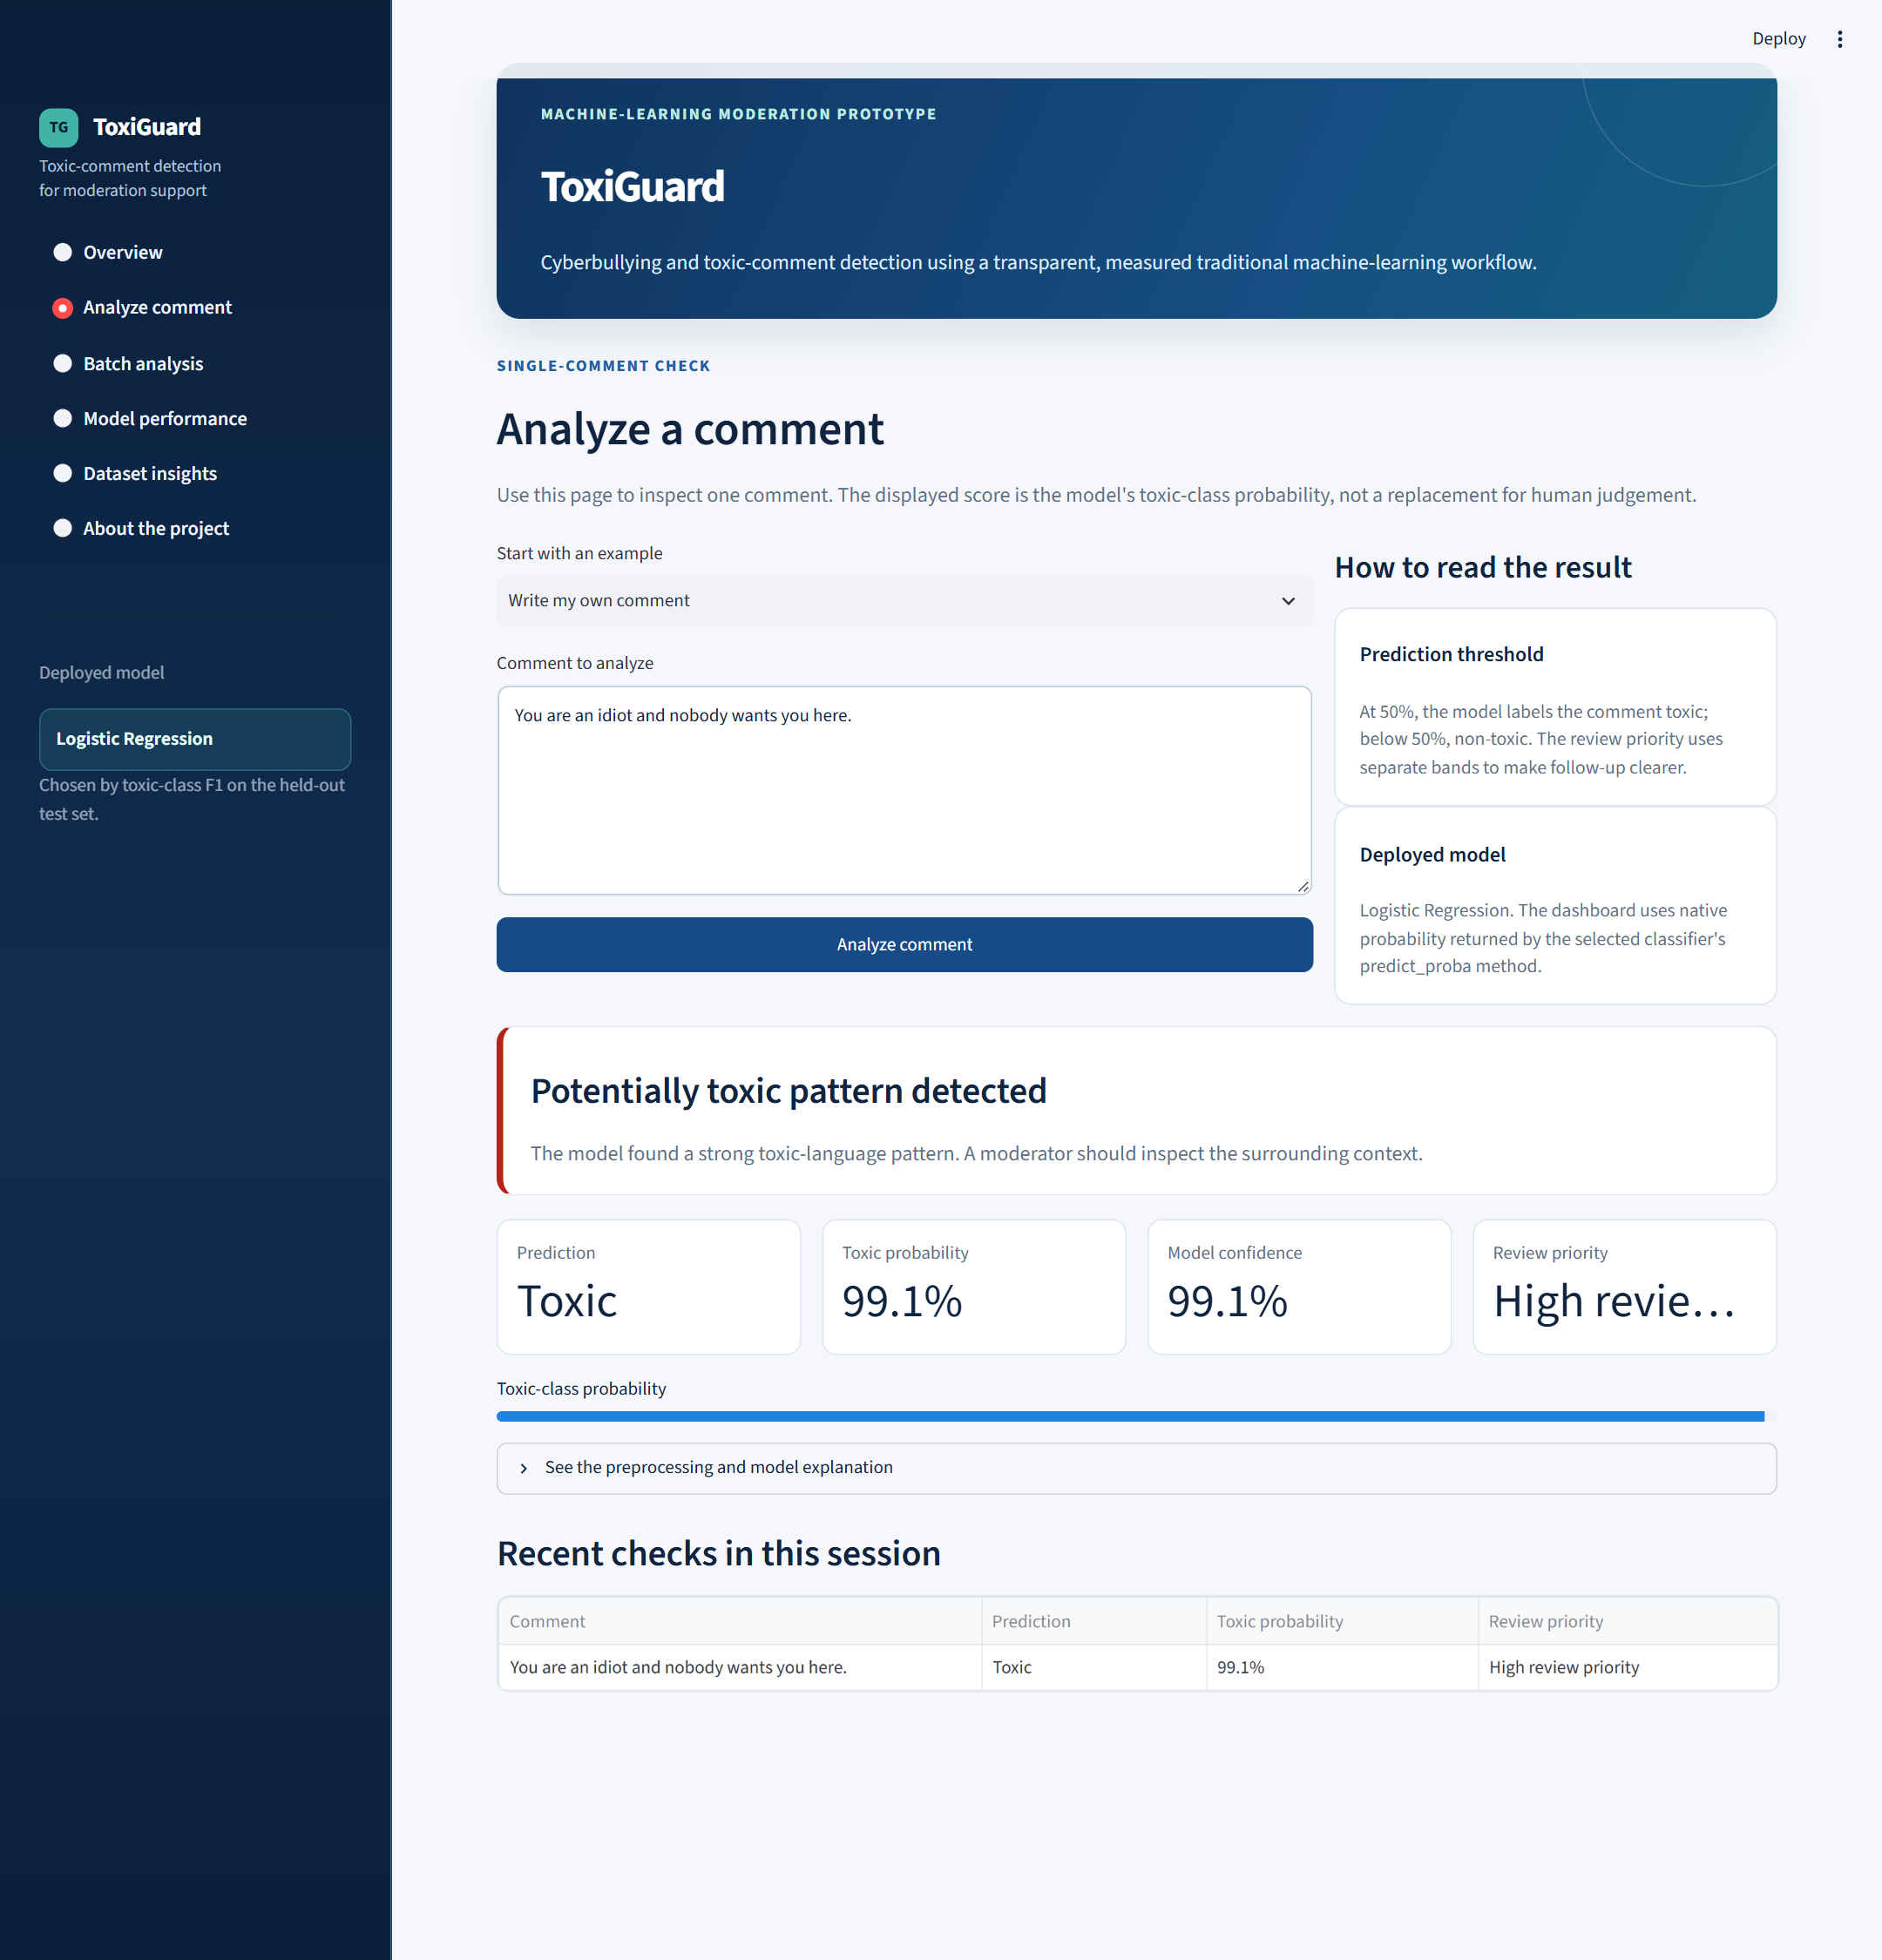
Figure 9.4 shows the entered comment, Toxic prediction, 99.1% toxic probability, and session history. The result cards communicate the model output; the review message prompts the user to consider the surrounding context before making a moderation decision.

Table 9.2: Sample Prediction Results
Sample | Toxic probability | Predicted class
Insulting sample | 0.9915 | Toxic
Appreciative sample | 0.1427 | Non-toxic
Polite disagreement | 0.0501 | Non-toxic

9.4 Limitations
The measured metrics arise from the held-out Jigsaw subset. The model can miss toxic comments and flag benign comments; precision 0.6102 means many flags still require review. Dataset bias, unfamiliar languages, obfuscation, quotations, and conversation context are not resolved by this binary TF-IDF model. The confidence value is a model estimate and should not be treated as a guarantee.
The same test split was used to compare and select the six models. The reported scores are therefore comparative experiment results; an independent final test set or nested validation is needed for a less biased estimate after model selection.

10. CHALLENGES AND SOLUTIONS

10.1 Class Imbalance
Only 15,293 of the 159,556 cleaned comments carry the toxic label. The split and experiment subset were stratified to retain the class ratio. The selection rule uses toxic F1 first, which reduces the chance of choosing a model solely because it predicts the majority class well.

10.2 Training and Inference Consistency
A different cleaning path in the dashboard would change the feature values presented to the trained model. ToxiGuard imports the same clean_text helper in training and inference and loads the exact vectorizer saved by training.

10.3 Interpretation and Context
Text classification cannot reliably infer intent or the full conversation context from one comment. The dashboard labels results as moderation support and describes the prediction as a prompt for human inspection. A future study should test false positives and false negatives with reviewers from the intended environment.

11. LEARNING OUTCOMES

11.1 Technical Skills Acquired
The project required a complete path from raw text to a working application. It reinforced the need to inspect class balance, fit text features only on training data, compare models using metrics that reflect the minority class, and keep preprocessing consistent between training and inference.

11.2 Practical Experience Gained
The implementation brought together CSV data preparation, feature extraction, model training, artifact serialization, and application development. Working with the saved model and vectorizer demonstrated how training outputs become reusable components of an interactive prediction system.

11.3 Technical Communication
The report and dashboard also required presenting technical results clearly. A reviewer can see the selected model, its measured tradeoffs, the confusion matrix, and examples of the interface. The paper-presentation certificate included in Appendix B records an additional opportunity to communicate related work to an academic audience.

12. CONCLUSION AND FUTURE SCOPE

12.1 Conclusion
ToxiGuard delivers a working binary toxic-comment classifier and Streamlit dashboard. In the reproduced run, six models were compared on the same 6,000-comment test set, and Logistic Regression ranked first by toxic-class F1. Its test results were 93.23% accuracy, 61.02% toxic precision, 81.39% toxic recall, 69.75% toxic F1, and 0.9576 ROC-AUC.
The project demonstrates data preparation, TF-IDF feature extraction, measured model selection, artifact serialization, and application deployment. Its outputs can help prioritize review, while human judgment remains necessary because the model makes both false positive and false negative errors.

12.2 Limitations
Evaluation is limited to a sampled English-language dataset and a shared hold-out set used for model comparison. The system does not model conversation history or repeated behaviour. It has not been independently validated on other platforms, languages, or demographic subgroups.

12.3 Future Enhancements
- Collect feedback from human reviewers and tune the classification threshold for the intended moderation workload.
- Evaluate on comments from other platforms and languages before broader use.
- Add context-aware models and compare them with the current transparent linear baseline.
- Extend the interface to Jigsaw's separate toxicity categories after multi-label evaluation.
- Monitor model drift and document performance across different groups and language patterns.

REFERENCES
[1] Jigsaw and Conversation AI, Toxic Comment Classification Challenge, https://www.kaggle.com/c/jigsaw-toxic-comment-classification-challenge (accessed 29 September 2026).
[2] scikit-learn Developers, Text feature extraction and classification documentation, https://scikit-learn.org/stable/ (accessed 29 September 2026).
[3] Streamlit, Streamlit documentation, https://docs.streamlit.io/ (accessed 29 September 2026).
[4] Python Software Foundation, Python documentation, https://docs.python.org/3/ (accessed 29 September 2026).
[5] ToxiGuard project repository, train_model.py, app.py, source data, and generated outputs, local project files examined 29 September 2026.
[6] E. Wulczyn, N. Thain, and L. Dixon, Ex Machina: Personal Attacks Seen at Scale, WWW, 2017. https://arxiv.org/abs/1610.08914
[7] T. Davidson, D. Warmsley, M. Macy, and I. Weber, Automated Hate Speech Detection and the Problem of Offensive Language, ICWSM, 2017. https://arxiv.org/abs/1703.04009
[8] L. Dixon, J. Li, J. Sorensen, N. Thain, and L. Vasserman, Measuring and Mitigating Unintended Bias in Text Classification, AIES, 2018. https://research.google/pubs/measuring-and-mitigating-unintended-bias-in-text-classification/

Appendix A — Source Code
The following images show selected parts of the actual source files. The complete editable code remains in the ToxiGuard project directory.
Code Listing A.1: Shared Text-Cleaning Function
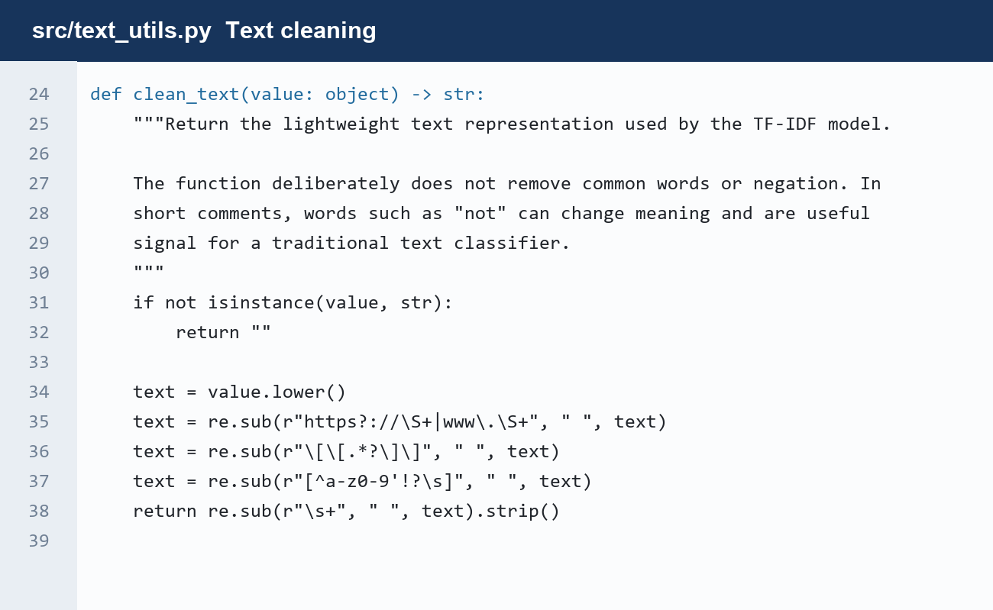
The clean_text function lowercases comments, removes URLs and selected markup, replaces unsupported characters, and normalizes whitespace. The same helper is imported during training and application inference.

Code Listing A.2: Feature Extraction and Model Candidates
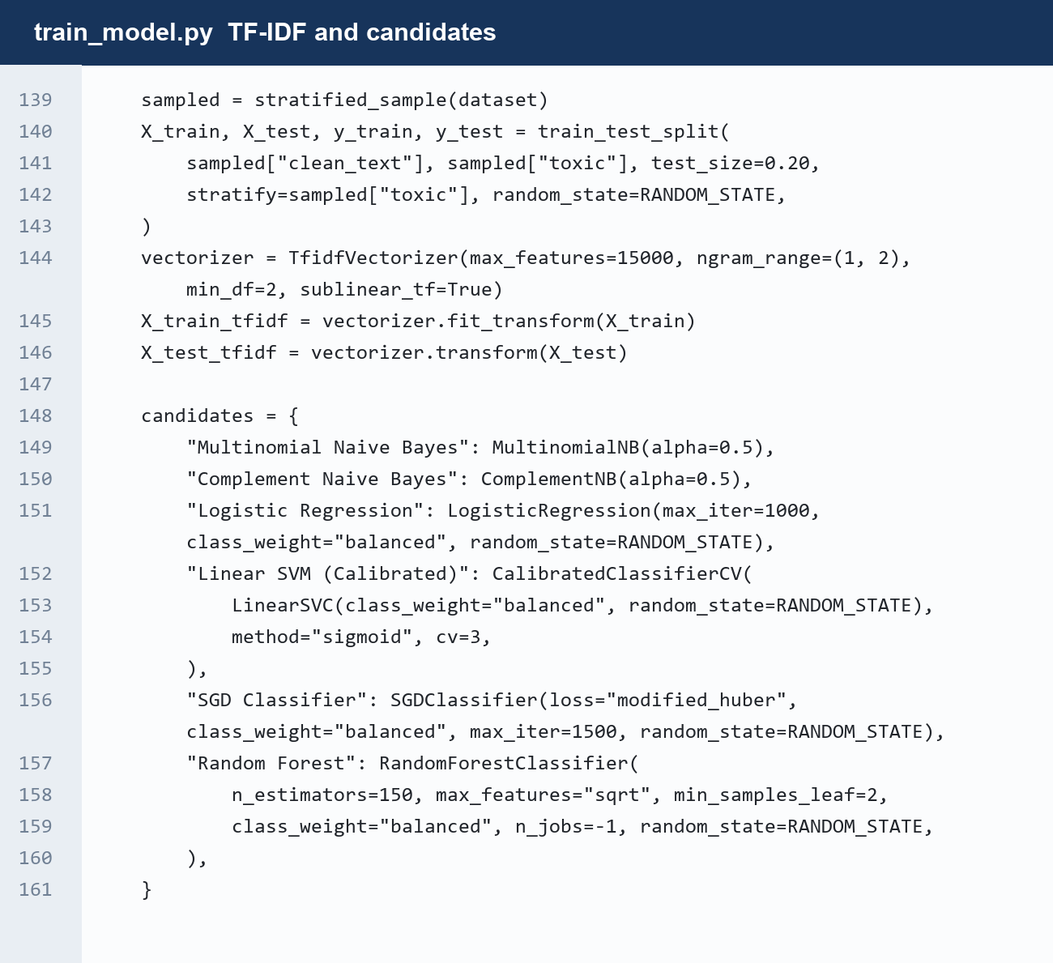
The training script uses a stratified split and fits the TF-IDF vectorizer only on the training subset. The candidate dictionary defines the six classifiers compared in the experiment. Long source lines wrap visually in this listing.

Code Listing A.3: Model Selection and Serialization
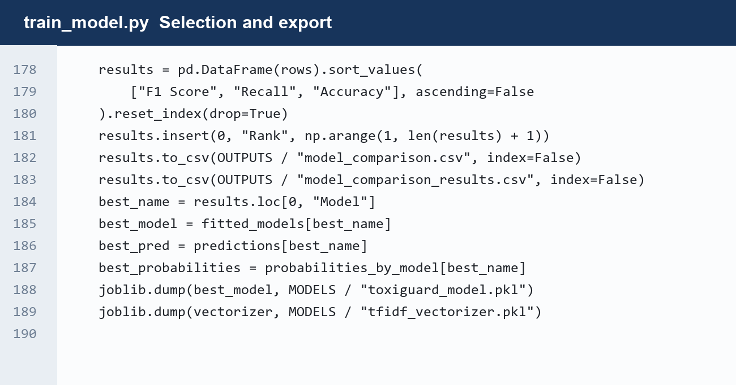
The results are ranked by toxic F1, recall, and accuracy. The script exports the comparison metrics and saves the selected classifier and TF-IDF vectorizer with joblib.

Code Listing A.4: Loading Application Artifacts
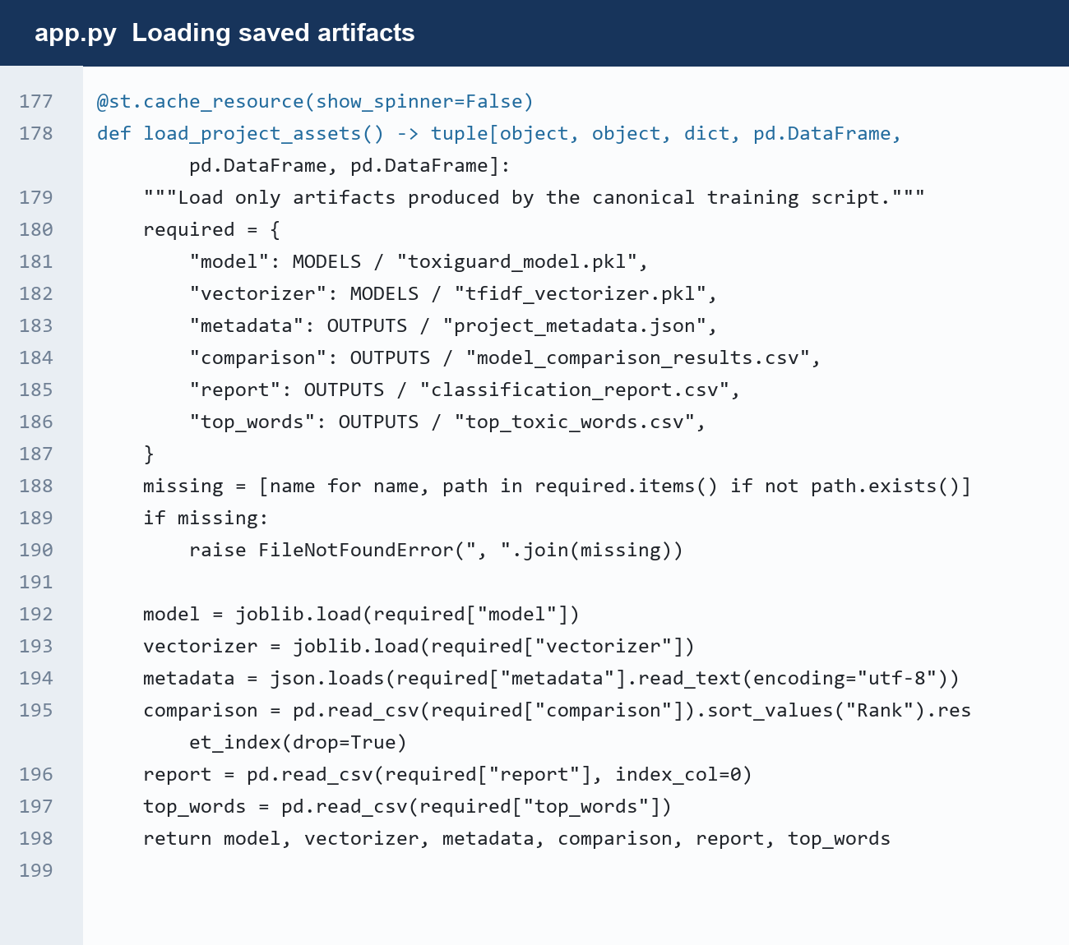
The cached loading function checks for the model, vectorizer, metadata, and evaluation files. It loads these artifacts for reuse by the Streamlit interface, avoiding retraining during a user session.

Appendix B — Paper Presentation Certificate
The presentation certificate is reproduced as issued. It records participation at ICFC-AIDI 2026 on 5 September 2026.


Appendix C — Project Outputs
The files below are the direct outputs of the reproduced training run. They can be inspected in the ToxiGuard project directory.
Table C.1: Project Output Files
File | Purpose
project_metadata.json | Run settings and selected-model summary
model_comparison.csv | Six-model held-out comparison
classification_report.csv | Per-class precision, recall, F1, and support
predictions_output.csv | Row-level test predictions and probabilities
eda_plots.png | Dataset exploration figures
model_comparison.png | Model performance chart
confusion_matrix.png | Errors for the selected classifier

The output files are in D:\ToxiGuard\outputs. The saved classifier and TF-IDF vectorizer are in D:\ToxiGuard\models.
Recorded training command: python train_model.py
Dashboard command: python -m streamlit run app.py

