

**MTN NIGERIA**

**STRUCTURAL INTEGRITY AUDIT AND APPRAISAL OF EXISTING 45M MTN TOWER**

**MTN SITE ID: KN0125**

**MTN SITE NAME: HAWADAN BONGO**

**LOCATION: HAWADAN BONGO, KANO STATE**

**REPORT PREPARED AND SUBMITTED BY:**

**VESSELNET**



**SUBMISSION DATE:** JANUARY 2025

Contents

1: Introduction 1

1.1 MTN Site Information 1

1.2 Site and Tower Aerial View 2

1.3 General Literature Review 3

1.3.1 The Aims and Objectives 3

2: Scope of Structural Integrity Audit & Appraisal 5

2.1 Scope definition 5

2.2 Tower Audit and Assessment 5

2.2.1 Description of Tower Members 6

2.2.2 Loads and ancillary Installation Details 8

2.2.3 Tower Geometry Determination 9

2.2.4 Foundation Condition and Concrete Strength Checks 10

2.2.4.1 Tower Leg orientation 10

2.2.4.2 Stub Level Reading 10

2.2.4.3 Compressive Strength Readings 11

2.2.4.4 Torque Checks on Base Plate and Last Legs 12

2.2.4.5 Ground/Earth Resistance Checks 13

2.2.5 Tower Mapping/Tower Line Drawing 14

2.2.6 Tower Snags List – Summary of Missing Members and Parts 15

2.2.7 Other Observations/Snags 15

**4: Tower Modelling, Analysis & Design** 21

**4.1 Scope of modelling, analysis and design** 21

**4.1.1 Modelling and Analysis** 21

**4.1.2 Modelling method and software used** 21

**4.1.3 Results of the Modelling and Structural Tower Analysis** 23

**4.1.3 Deductions of the structural analysis on other parts of the tower** 24

**4.2 Computation of Wind Loads on Tower** 24

**4.2.1 The relation in calculating Wind Load on Bare Tower** 25

**4.2.2 The relation used in calculating at Various *VZ* Height of Tower** 25

**4.2.3 Computation of Gust Response Factor Gꚍ** 26

**4.2.4 Computation of Effective Projected Area due to bare Tower and other Appurtenances** 26

**4.2.5 Computation of Wind loading on Tower** 27

**4.3 Load Combination on Tower** 28

**4.3.1 Computation of Dead Load on Tower** 29

**5: Design and Analysis Output** 30

**5.1 Analysis and Results** 30

**5.1.1 Analysis** 30

**5.1.2 Result** 31

**5.1.3 Tower Utilization Analysis (Existing height EPA)** 32

**6: Conclusion Recommendation and Limitation** 33

**6.1 Conclusion** 33

**6.2.1** **Recommendation** 33

**6.3** **Limitations** 35

# 1: Introduction

**VESSELNET** has been commissioned by MTN Nigeria to carry out a structural assessment of an existing **45M Tower** located in an MTN Base Transceiver Station with details below.

In relation to a detailed on-site audit of the existing tower, the aim of this structural survey is to ascertain the state of the tower in relation to its structural stability. It is also aimed at determining the ability of the existing tower to support the antenna and equipment supported on it.

## 1.1 MTN Site Information

|  |  |  |  |  |
| --- | --- | --- | --- | --- |
| SITE ID. | KN0125 | | | |
| SITE NAME | HAWADAN BONGO | | | |
| TOWER TYPE | ANGULAR | | | |
| TOWER HEIGHT | HEIGHT | 45M | NO. OF LEGS | 3 |
| BUILDING HEIGHT | NA |
| SITE ENGR. | YUSUF DANJUMA | | | |
| SITE COORD. | LATTITUDE | 11.88928N | LONGITUDE | 8.26932E |
| DATE/TIME | DATE | 27/01/2025 | TIME | 11:35AM |

Table 1.0

## 1.2 Site and Tower Aerial View

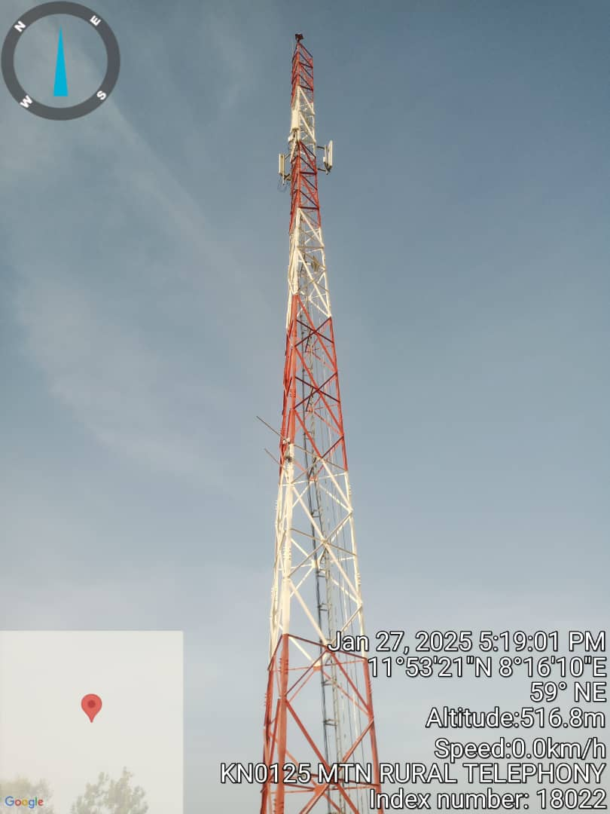

Picture 1.0

## 1.3 General Literature Review

A detailed on-site physical assessment of the current status of the tower, which involved a detailed measurement of the tower members, documentation of the loads on it and important features were carried out so as to determine the physical condition of the tower structure.

The site audit of the tower entailed assessing if the members of the tower structure are deformed, displaced or if the members are warped. The ancillaries installed on the tower were also determined including their dimensions, an inventory of their height of installation on the tower as well their azimuth among others. The site audit was also carried out in relation to the available manufacturer’s drawing of the tower.

Using the foregoing information, the existing tower structure was modelled and analysed using TNX software, following the modelling of the tower geometry, universal angle properties under the ANSI/TIA-222-H were assigned to all the tower members. Also, tower loading is applied to tower model with the same design code.

### 1.3.1 The Aims and Objectives

As a result of a detailed on-site audit of the existing tower carried out by TUGEHEIGTH, the aims and objectives of this structural appraisal are as follows;

1. To physically collect information and clear geo tagged time stamped pictures regarding the Tower i.e., Tower member sizes (including member thickness), Ancillary count and dimensions any other information/data pertinent to investigating the integrity of the tower structure.
2. To determine the foundation conditions by physical examination, carrying out Non-Destructive Tests on the concrete elements of the foundation to determine its concrete strength and Earth Resistivity Measurements.
3. To determine the geometry of the Tower.
4. To assess the effect of the Tower Loadings on the Tower structure and the exact height of occurrence.
5. To establish the as-built condition of the tower in relation to determining its structural stability.
6. To identify and list any missing Tower members and items pertinent to its structural stability and geometry.
7. To perform structural integrity calculations and simulation checks using the existing loadings to determine the ability of the tower to safely support those loadings.

# 2: Scope of Structural Integrity Audit & Appraisal

## 2.1 Scope definition

An on-site physical assessment of the status of the Tower, which involved a detailed measurement of the Tower members, the loads on it and important features was carried out to determine the physical characteristics of the Tower structure.

The site audit of the Tower entailed;

* Auditing and measuring each member of the Tower structure and noting if any of those members are missing, deformed, twisted, displaced or warped.
* Appraising the characteristics of the ancillaries installed on the Tower which includes their dimensions, an inventory of their height of installation on the Tower as well as their azimuth, among others.
* Assessing the Tower foundation to ascertain its capability to support the Tower structure.

## 2.2 Tower Audit and Assessment

Carrying out a structural audit of the tower through a detailed on-site physical assessment of the tower. The site audit of the tower involves the assessment of the tower and corresponding members in order to ascertain if the tower structure is deformed, displaced or if the members are warped. The ancillaries installed on the tower were also checked, with details of height, dimensions and azimuth taken.

The carrying out of a review of the existing details received from the tower on-site measurement as well as the manufacturer’s details. Foundation condition and concrete strength were checked with the aid of a Schmidt hammer and also earth reading was determined with the aid of an earth tester.

Furthermore, the information contained in the as-built drawings as well as the outcome of the site-based measurement was used to develop a model of the tower structure and thereafter appropriate structural analyses and design checks on the tower structure was carried out.

The preparation and issuance of the report on the structural survey of the existing tower including the findings, conclusions and recommendations arising from the assessment.

## 2.2.1 Description of Tower Members

|  |  |  |  |  |  |  |  |  |  |  |  |  |  |  |  |  |
| --- | --- | --- | --- | --- | --- | --- | --- | --- | --- | --- | --- | --- | --- | --- | --- | --- |
| **Tower Height (m)** | **Tower Member** | | | **Member Section (mm)** | | **Tower Height (m)** | | **Tower Member** | | **Member Section (mm)** | | **Tower Height (m)** | | **Tower Member** | **Member Section (mm)** | |
| **0 - 3** | **Leg** | | | EA150X150X10 | | **3 - 6** | | **Leg** | | EA150X150X10 | | **6 - 9** | | **Leg** | EA150X150X10 | |
| **Main Horizontal** | | | EA60X60X5 | | **Main Horizontal** | | EA60X60X5 | | **Main Horizontal** | EA60X60X5 | |
| **Diagonal** | | | EA80X80X6 | | **Diagonal** | | EA80X80X6 | | **Diagonal** | EA80X80X6 | |
| **Plan Bracing** | | | NA | | **Plan Bracing** | | NA | | **Plan Bracing** | NA | |
| **Secondary Diagonal** | | | NA | | **Secondary Diagonal** | | NA | | **Secondary Diagonal** | NA | |
| **9 - 12** | **Leg** | | | EA150X150X10 | | **12 - 15** | | **Leg** | | EA130X130X12 | | **15 - 18** | | **Leg** | EA130X130X12 | |
| **Main Horizontal** | | | EA60X60X5 | | **Main Horizontal** | | EA50X50X5 | | **Main Horizontal** | EA50X50X5 | |
| **Diagonal** | | | EA80X80X6 | | **Diagonal** | | EA80X80X6 | | **Diagonal** | EA80X80X6 | |
| **Plan Bracing** | | | NA | | **Plan Bracing** | | NA | | **Plan Bracing** | NA | |
| **Secondary Diagonal** | | | NA | | **Secondary Diagonal** | | NA | | **Secondary Diagonal** | NA | |
| **18 - 21** | **Leg** | | | EA130X130X12 | | **21 - 24** | | **Leg** | | EA130X130X12 | | **24 - 27** | | **Leg** | EA120X120X12 | |
| **Main Horizontal** | | | EA50X50X5 | | **Main Horizontal** | | EA50X50X5 | | **Main Horizontal** | EA50X50X5 | |
| **Diagonal** | | | EA80X80X6 | | **Diagonal** | | EA80X80X6 | | **Diagonal** | EA80X80X6 | |
| **Plan Bracing** | | | NA | | **Plan Bracing** | | NA | | **Plan Bracing** | NA | |
| **Secondary Diagonal** | | | NA | | **Secondary Diagonal** | | NA | | **Secondary Diagonal** | NA | |
| **27 - 30** | **Leg** | | | EA120X120X12 | | **30 - 33** | | **Leg** | | EA120X120X12 | | **33- 36** | | **Leg** | EA100X100X10 | |
| **Main Horizontal** | | | EA50X50X5 | | **Main Horizontal** | | EA50X50X5 | | **Main Horizontal** | EA50X50X5 | |
| **Diagonal** | | | EA80X80X6 | | **Diagonal** | | EA80X80X6 | | **Diagonal** | EA70X70X6 | |
| **Plan Bracing** | | | NA | | **Plan Bracing** | | NA | | **Plan Bracing** | NA | |
| **Secondary Diagonal** | | | NA | | **Secondary Diagonal** | | NA | | **Secondary Diagonal** | NA | |
| **36-39** | | **Leg** | EA100X100X10 | | **39 -42** | | **Leg** | | EA80X80X8 | | **42- 45** | | **Leg** | | | EA80X80X8 |
| **Main Horizontal** | EA50X50X5 | | **Main Horizontal** | | EA45X45X4 | | **Main Horizontal** | | | EA45X45X4 |
| **Diagonal** | EA70X70X6 | | **Diagonal** | | EA60X60X5 | | **Diagonal** | | | EA60X60X5 |
| **Plan Bracing** | NA | | **Plan Bracing** | | NA | | **Plan Bracing** | | | NA |
| **Secondary Diagonal** | NA | | **Secondary Diagonal** | | NA | | **Secondary Diagonal** | | | NA |

Table 2.0

## 2.2.2 Loads and ancillary Installation Details

|  |  |  |  |  |  |  |  |  |  |  |
| --- | --- | --- | --- | --- | --- | --- | --- | --- | --- | --- |
| **TOWER ANCILLARY LOADING TABLE** | | | | | | | | | | |
|  |
| Site ID: | | KN0125 | | | | | | | | |  |
| Address: | | HAWADAN BONGO | | | | | | | | |  |
| Date | | 27/01/2024 | | | | | | | | |  |
| S/N | | LEG | RF TYPE | RF Antenna Type | Length(m) | Breadth(m) | Width(m) | Azimuth (deg) | Dish Dia (mm) | Installation Height (m) |  |
| 1 | | A | RF-ANDREWS | HUAWEI | 2.45 | 0.4 | 0.17 | 23 | 0.05 | 30.8 |  |
| 2 | | B | RF-ANDREWS | HUAWEI | 2.45 | 0.4 | 0.17 | 103 | N/A | 30.8 |  |
| 3 | | C | RF-ANDREWS | HUAWEI | 2.45 | 0.4 | 0.17 | 200 | N/A | 30.8 |  |
| 4 | | C | YAGI | HUAWEI | 0.28 | 0.17 | 0.01 | 221 | N/A | 15 |  |
| 5 | | C | YAGI | HUAWEI | 0.28 | 0.17 | 0.01 | 223 | N/A | 15 |  |
| 6 | | A | RRU | HUAWEI | 0.42 | 0.3 | 0.12 | 56 | 0.05 | 30.5 |  |
| 7 | | B | RRU | HUAWEI | 0.42 | 0.3 | 0.12 | 142 | 0.05 | 30.5 |  |
| 8 | | C | RRU | HUAWEI | 0.42 | 0.3 | 0.12 | 301 | 0.05 | 30.5 |  |
|  |
|  |
|  |
|  |
|  |
|  |
|  |
|  |
|  |

Table 2.1

## 2.2.3 Tower Geometry Determination

Brief description of the tower as seen on site;

* Number of Legs - **3**
* Member type - **ANGULAR**
* Does Tower taper in size with increase in height - **Yes**
* Are there Guy Wires – **No**

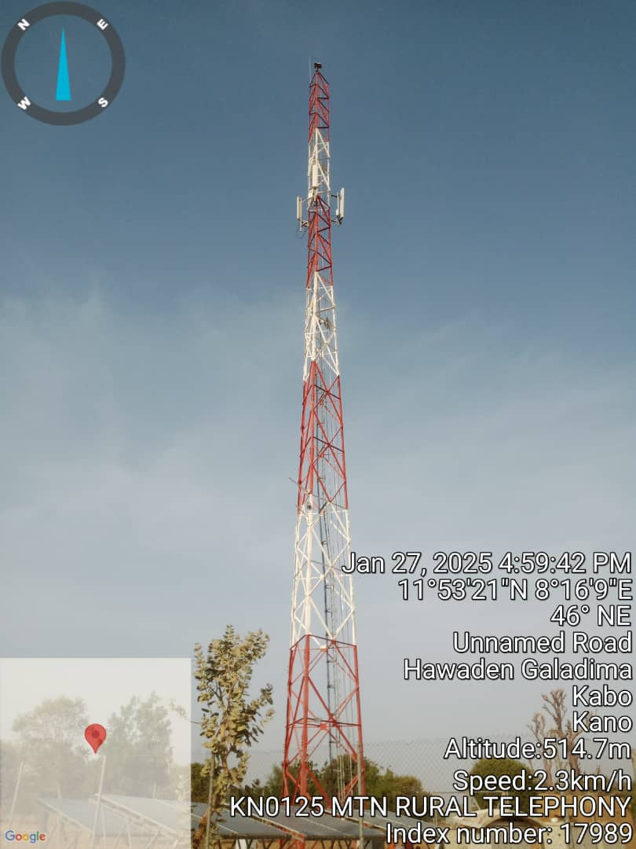

Picture 2.0

### 2.2.4 Foundation Condition and Concrete Strength Checks

### 2.2.4.1 Tower Leg orientation

Picture 2.1 Tower legs descriptions

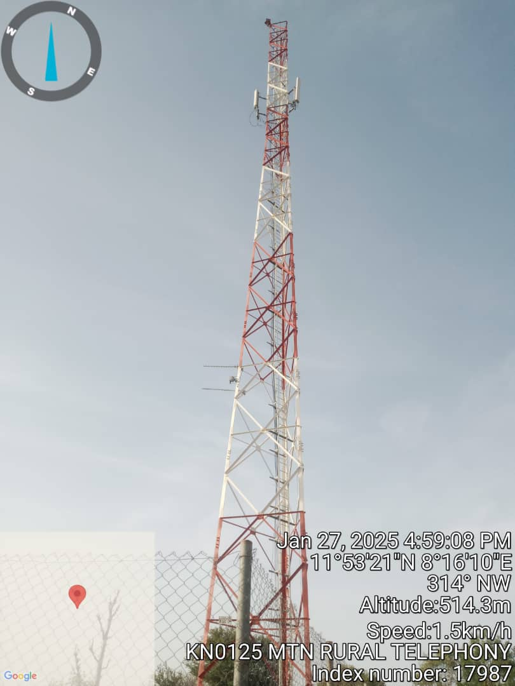

### 2.2.4.2 Stub Level Reading

|  |  |  |  |
| --- | --- | --- | --- |
| **LEG (STUB COL)** | **A** | **B** | **C** |
| READINGS (mm) | 1411 | 1410 | 1400 |
| Variance A-B(mm) | -1 | |
| Variance B-C(mm) |  | 1 | |
| Variance C-D(mm) |  |  |
| Av. Variance(mm) | 0 | | |

Table 2.2 Stub level readings.

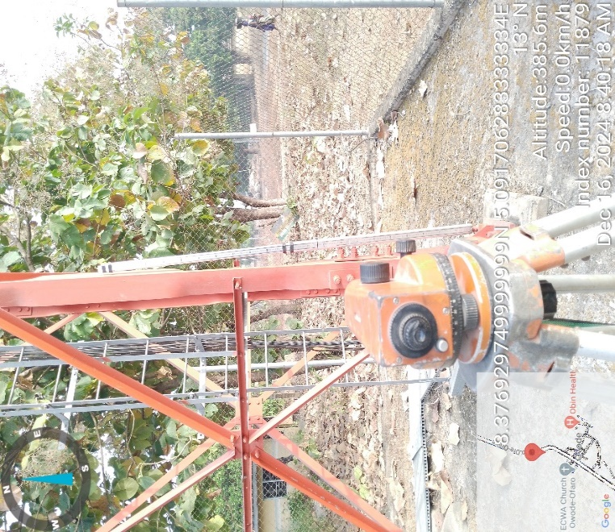

**Picture 2.2** Stub Level Reading using a Dumpy Level

### 2.2.4.3 Compressive Strength Readings

|  |  |  |  |  |  |
| --- | --- | --- | --- | --- | --- |
| **Structural Element** | **P1** | **P2** | **P3** | **Av. Compressive Strength (N/mm²)** | **Remarks** |
| **Stub Col. A** | **29** | **30** | **28** | **29** | **OK** |
| **Stub Col. B** | **33** | **34** | **32** | **34** | **OK** |
| **Stub Col. C** | **26** | **24** | **26** | **26** | **OK** |

Table 2.3 Compressive strength reading table.

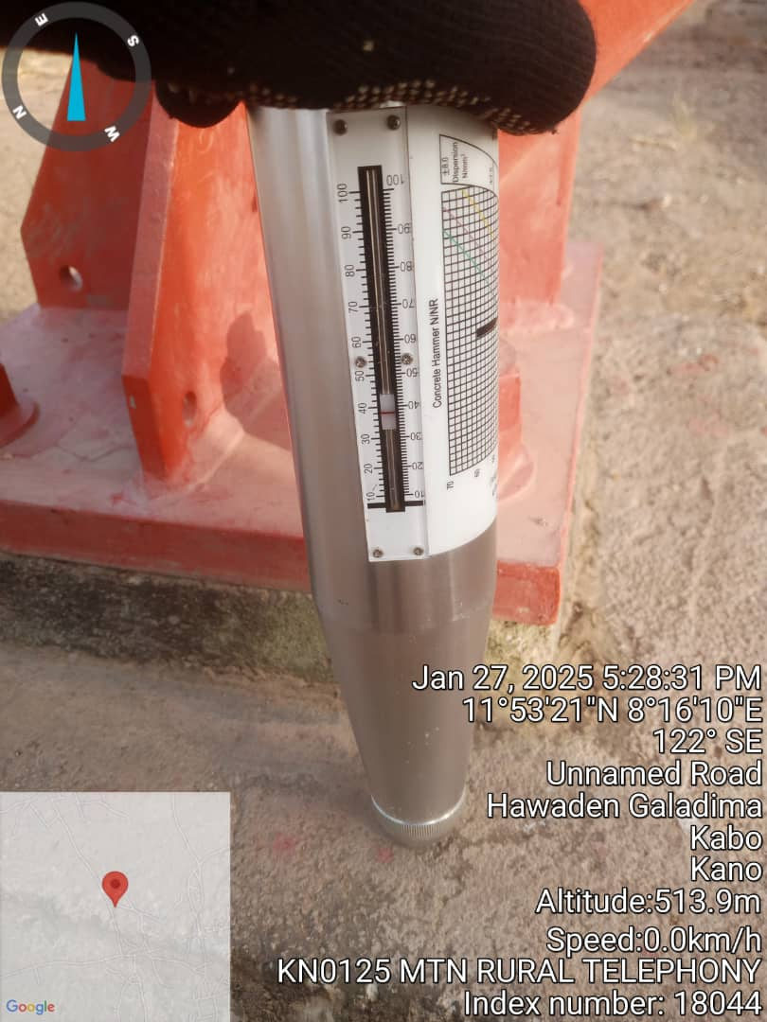

**Picture 2.3** 1st Reading–Leg A

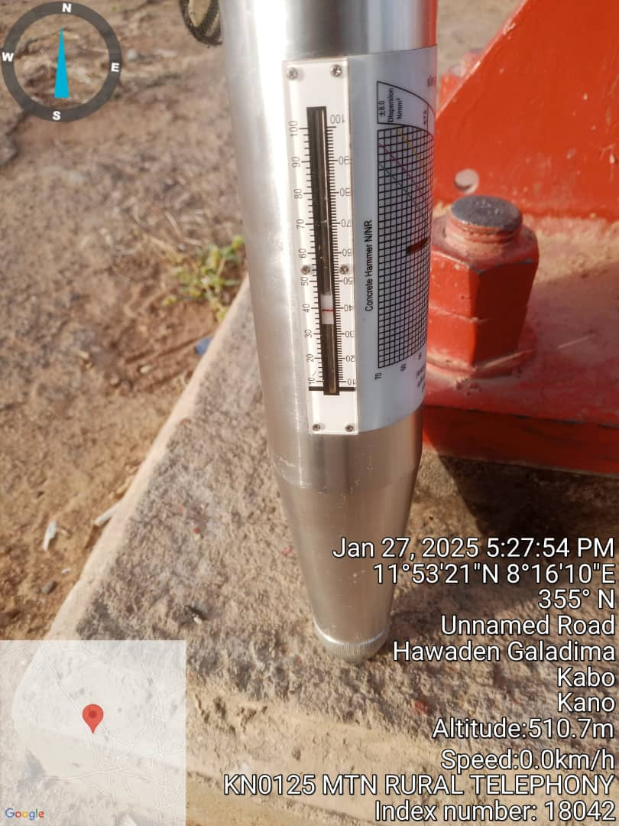

**Picture 2.5** 1st Reading –Leg B

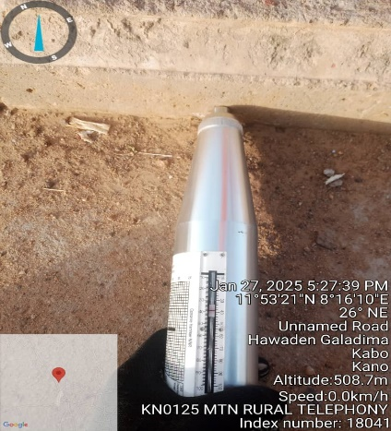

**Picture 2.7**1st Reading –Leg C

### 2.2.4.4 Torque Checks on Base Plate and Last Legs

|  |  |  |  |
| --- | --- | --- | --- |
| **Bolt Size** | **De-Rated Torque Value(N-m)** | **Current Torque Value (N-m)** | **Remarks/Comments** |
| **M20** | **400** | **400** | **OKAY** |
| **M16** | **200** | **200** | **OKAY** |

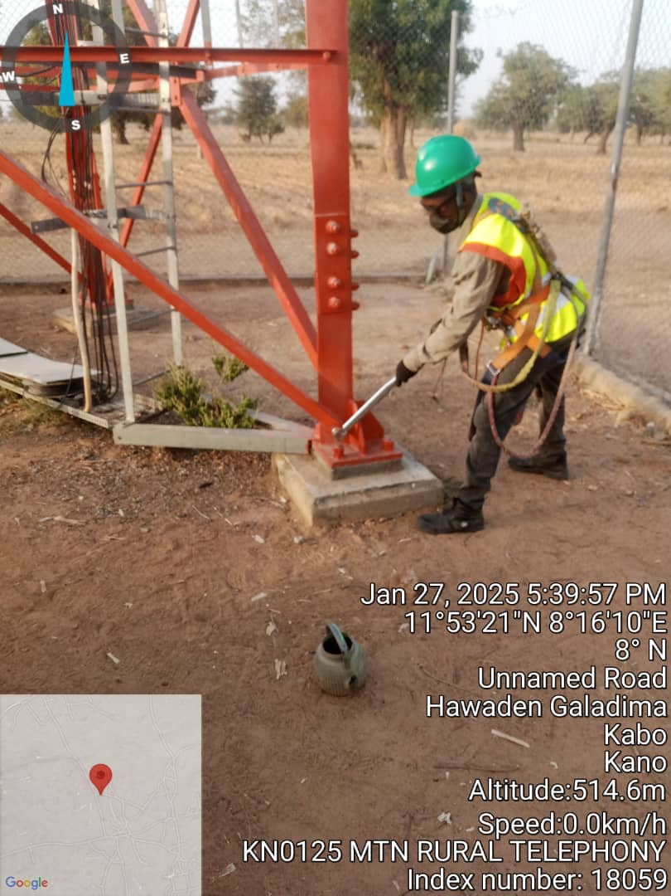**Table 2.4 Torque Test values**

**Picture 2.9** Torque checks using a Torque Wrench

### 2.2.4.5 Ground/Earth Resistance Checks

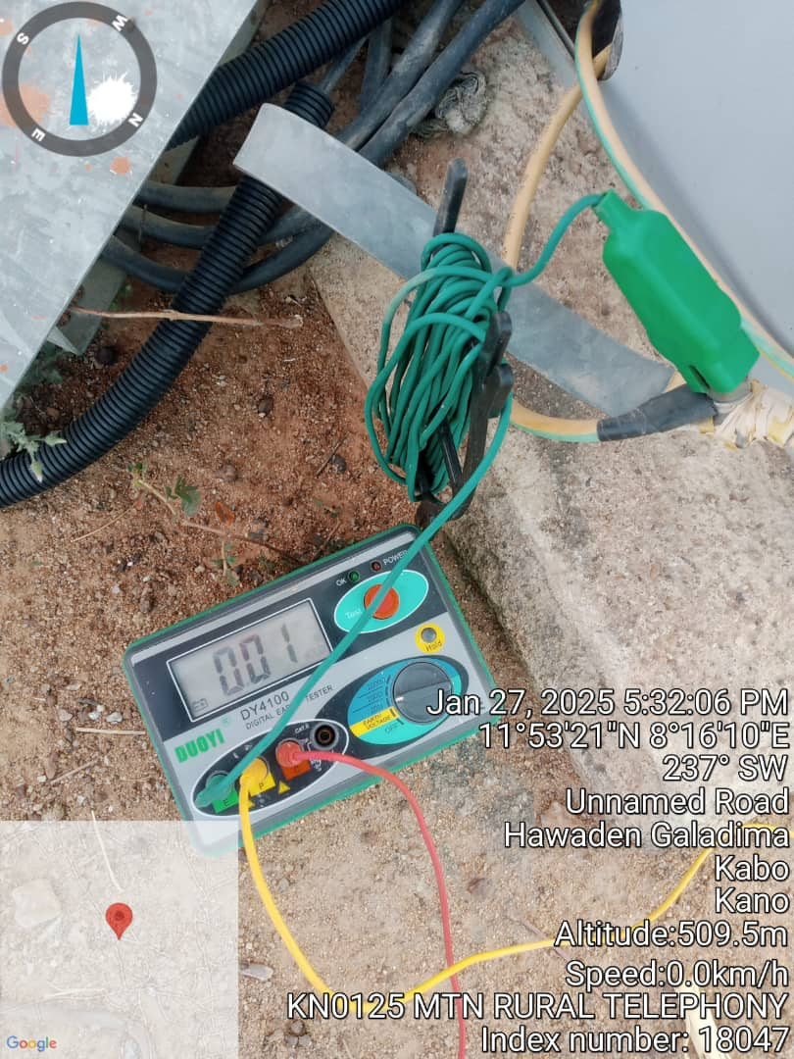

**Picture 2.10:** Earth Tester Reading

### 2.2.5 Tower Mapping/Tower Line Drawing

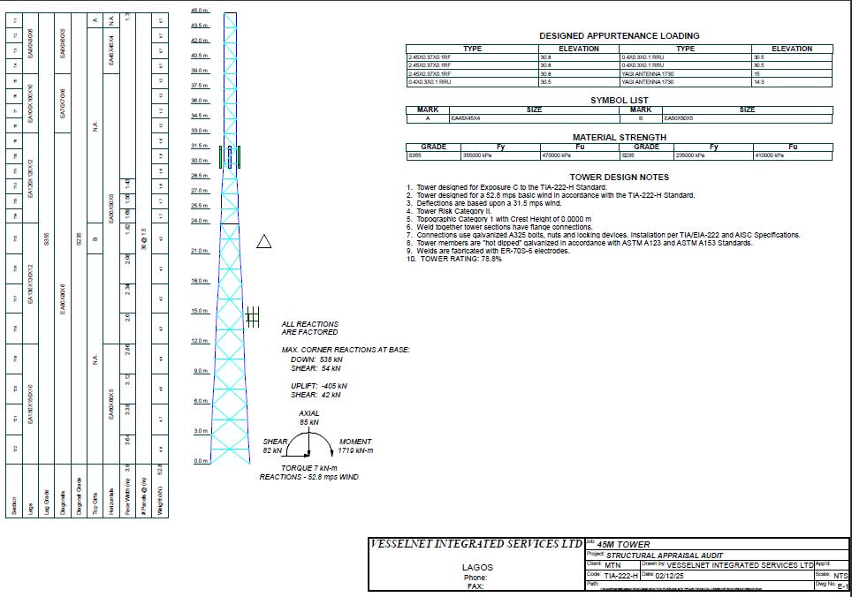

Drawing 1.

### 2.2.6 Tower Snags List – Summary of Missing Members and Parts

|  |  |  |  |  |  |
| --- | --- | --- | --- | --- | --- |
| **S/N** | **Missing Member Description** | **Qty.** | **Type** | **Panel/Section** | **Height (m)** |
|  |  |  |  |  |  |

### 2.2.7 Other Observations/Snags

• Aviation Warning Light available and working. YES

• Are their empty antenna brackets on the tower? NO

• Tower paint is faded. NO

• Are the loadings on the tower evenly distributed across all legs? YES or is one leg more loaded than the others?

NO

• Are there Tower members or parts lying around? NO

• Is the Cat/Access ladder in place and secured properly?

YES

• Are Guy Wires installed? NO

• Are the Earthing cables and connections in good order?

YES

• Are their visible foundation failure signs? NO

• Is the Tower very well secured? YES

• Is the fence structurally sound? YES

• No G/Y Cable installed on site.

**SNAG PICTURES**

**3: Picture Gallery**

|  |  |  |
| --- | --- | --- |
| **GALLERY** | | |
|  |  | |
| **Tower** | **Site Entrance** | |
|  |  |  |
| **Tower Spine A & B** | **Tower Spine C** |  |
|  |  |  |
| **Tower Face A – B** | **Tower Face B - C** | **Tower Face C – A** |
| N/A |  | |
| **AWL** | **THUNDER ARRESTOR** | |
|  |  | |
| **Aerial view** | **Internal view** | |
|  | | |
|  | | |
| **Tower Joints** | | |

|  |  |  |  |  |  |  |  |  |  |  |
| --- | --- | --- | --- | --- | --- | --- | --- | --- | --- | --- |
| **ANCILLARY PICTURE TEMPLATE** | | | | | | | | | |  |
| **Site ID:** | KN0125 | | | | | | | | |  |
| **Address:** | **HAWADAN BONGO** | | | | | | | | |  |
| **Date** | 27/01/2025 | | | | | | | | |  |
| **S/N** | **LEG** | **RF Antenna Type** | **Length (m)** | **Breadth (m)** | **Height (m)** | **Azimuth (deg)** | **Dish Dia (mm)** | **Installation Height (m)** | **Picture** |  |
| 1 | A | RF-ANDREWS | 2.45 | 0.4 | 0.17 | 23 | 0.05 | 30.8 |  |
| 2 | B | RF-ANDREWS | 2.45 | 0.4 | 0.17 | 103 | N/A | 30.8 |  |
| 3 | C | RF-ANDREWS | 2.45 | 0.4 | 0.17 | 200 | N/A | 30.8 |  |
| 4 | C | YAGI | 0.28 | 0.17 | 0.01 | 221 | N/A | 15 |  |
| 5 | C | YAGI | 0.28 | 0.17 | 0.01 | 223 | N/A | 15 |  |
| 6 | A | RRU | 0.42 | 0.3 | 0.12 | 56 | 0.05 | 30.5 |  |
| 7 | B | RRU | 0.42 | 0.3 | 0.12 | 142 | 0.05 | 30.5 |  |
| 8 | C | RRU | 0.42 | 0.3 | 0.12 | 301 | 0.05 | 30.5 |  |

**4: Tower Modelling, Analysis & Design**

**4.1 Scope of modelling, analysis and design**

A detailed tower structural analysis and design check on its members was carried out; the summary and interpretation are presented in this section. These details were used for generating design data, adopted in checking the strength of the tower’s structural steel members as well as the overall stability of the tower against the existing loading:

**4.1.1 Modelling and Analysis**

A detailed tower structural analysis and design check on the tower members was performed; the summary and interpretation are presented in this section. These details are used for generating design data, adopted in checking the strength of the tower’s structural steel members as well as the overall stability of the tower against the existing loading:

**4.1.2 Modelling method and software used**

Using the foregoing information, the existing tower structure was modelled and analysed using TNX. A 2-Dimensional view, side view and plan view of the tower generated by the software are shown below:

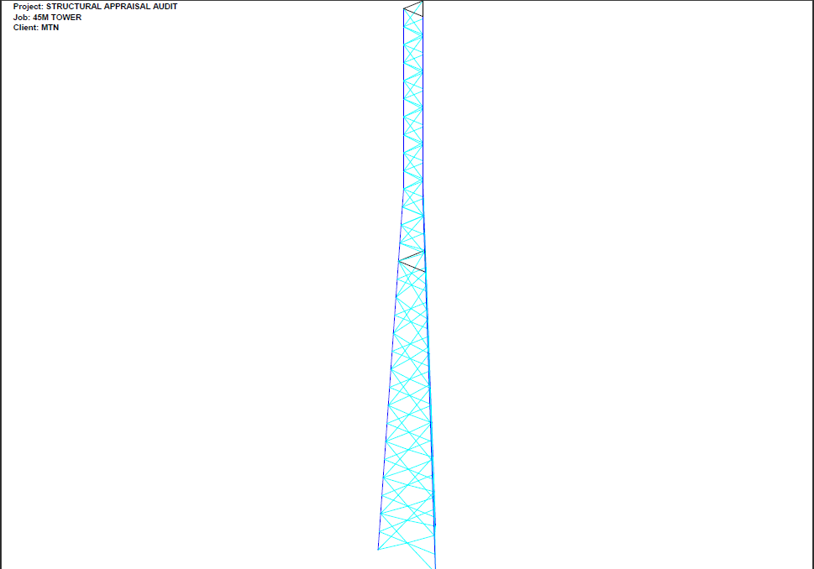

Picture 4.0 – Model of the Tower

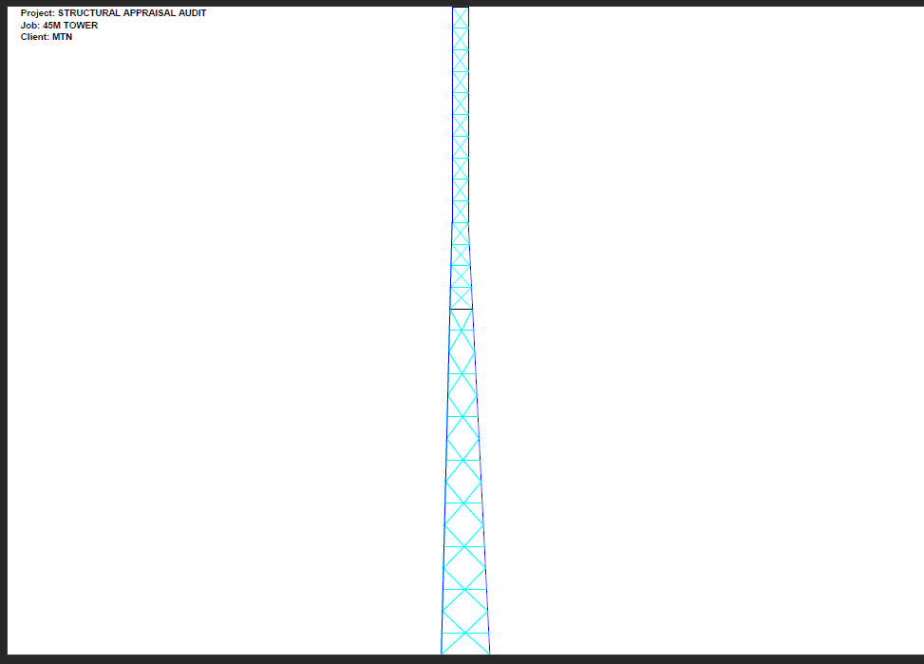

Picture 4.1 – Side View

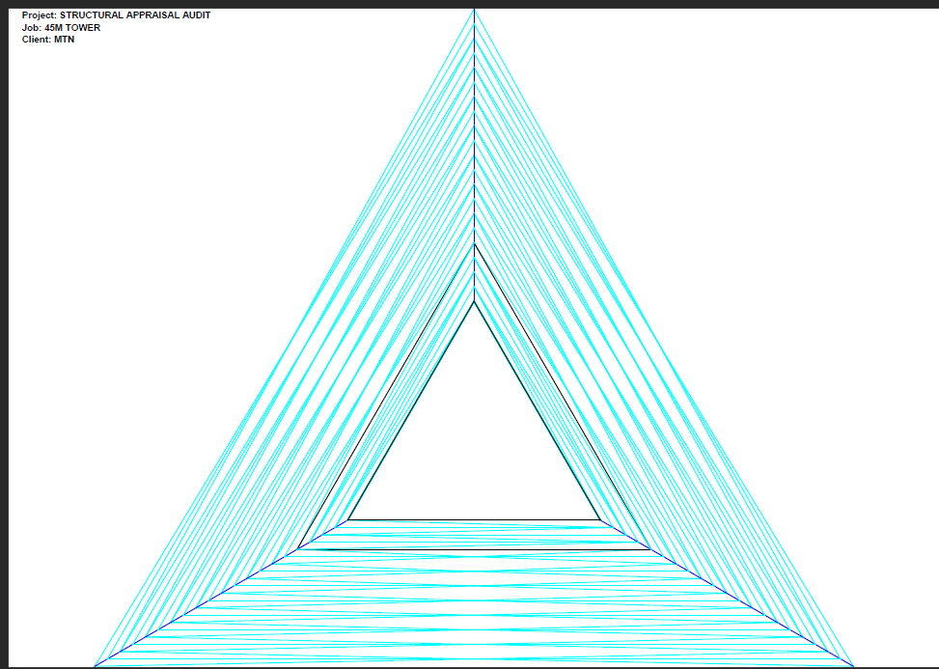

Picture 4.2 - Plan View

Analysis and design checks were carried out on the Tower putting into consideration the Self-weight and the wind speed within the terrain; combination loadings used are 0.9DLmin+ 1.2DL max+1.0WL where DL: dead Load, WL: wind load.

This analysis was done taking into consideration the wind coming from angle zero degrees 0, 30, 60, 90, 120, 150, 180, 210, 240, 270, 300, 330 and 360degrees. The most critical effect was observed and briefly summarized below:

From the analysis, it was clearly seen that the tower experienced the highest level of stress when the wind acted on it in the 0 degrees’ direction.

**4.1.3 Results of the Modelling and Structural Tower Analysis**

Following the structural analysis generated from the computer modeling of the existing tower, the members of the tower were assessed for their capacity to safely resist the applied wind loading.

From the results of our analysis and design checks, it was discovered that the tower is structurally satisfactory; the designs were carried out under Ultimate Limit State (ULS) and Serviceability Limit State (SLS) considering a wind speed of 42 m/s.

Also, attached herewith in this report is a summary of the designs considering ULS and SLS. It should be brought to your attention that TNX is a generally reliable and accepted Software for carrying out integrity checks on Towers;

However, it should be emphasized that this software is not a simulation software that can be used to simulate likely events that can take place in a tower over a length of time. It can do proper analysis using Finite Element Methods and design the tower members according to the design code selected, in this case it is TIA-222-H.

**4.1.3 Deductions of the structural analysis on other parts of the tower**

1. A basic wind speed of 42m/sec is adopted for MTN sites in this region of Nigeria and has been adopted in this structural appraisal. The tower structural appraisal exercise has been limited to its member’s only (superstructure) as the details of the foundations are not available during the appraisal. The other aspects of the tower are normally designed based on the reaction generated from a tower structural analysis.
2. Considering that broken or fractured bolts were not observed however, there are no cracks and defects along the foundation lines, it may be prudent to assume the foundations and connections would have passed according to their designed capacity.
3. The members were found to be sufficient in supporting the existing load.

Member stress ratio and slenderness of the members can be found in the appendix.

## 4.1.4 Tower deflection checks

The deflection of the tower (shown in the model below) was checked against the applied wind load at service limit and ultimate limit and this was found to be satisfactory and within safe limits as specified in TIA-222-H code of practice.

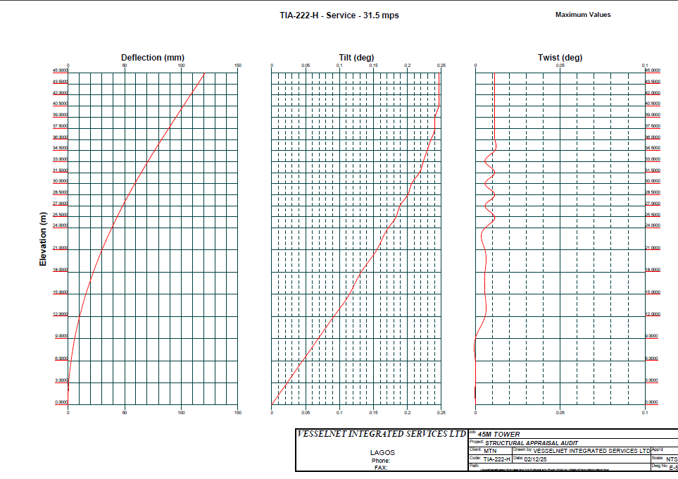

**Picture 4.3–Deflection**

Upon investigation of the tower for a check against deflection, the following were discovered:

This displacement is as a result of Max Dead Load + Wind Load at 180 degrees under service limit as specified above. The three nodes specified above refers to the top four points of the Tower i.e., 12m apex of the Tower.

In conclusion, the deflection is within acceptable deflection limit as the ultimate limit state was observed to be 0.0920< 1 degree and 0.0393< 0.5 degree for serviceability limit state as indicated in TIA-222-H; so, deflection check is satisfactory.

**4.2 Computation of Wind Loads on Tower**

There are three components of wind loads on symmetrical tower that need to be computed and applied on KW2364. Tower according to TIA-222-H They are as follows:

1. Wind load on the bare tower i.e., with no ancillaries.
2. Wind load on tower due to discrete ancillaries i.e. antennas
3. Wind load on tower due to linear ancillaries i.e. cables.

In addition, three load cases are usually considered in the analysis of towers.

The cases are:

* + - 1. Case 1: Maximum force (Compressive): Under this case the wind loads are applied at 0 degree normal to the face of the tower to create the maximum compressive force on the opposite leg.

1. Case 2: Maximum force (Uplift): Under this case the wind loads are applied at the corner of one of the legs at 0 degree to the normal of one of the tower faces.
2. Case 3: Maximum force on bracers: Under this case the wind loads are applied parallel to one of the faces of the tower i.e. 30degree angle to the normal of the face.

However, the wind loadings are applied at 0, 30, 60, 90, 120, 150, 180, 210, 240, 270, 300, 330 and 360deg to north of tower face. The computation of the various wind loads are as follows:

**4.2.1 The relation in calculating Wind Load on Bare Tower**

The maximum mean wind load on tower free of ancillaries in the direction of the wind per panel height is given by:

F = qz x GH x [EPA]s

Where

qz= velocity pressure

Gꚍ=Gust factor

EPA=Effective projected Area

**4.2.2 The relation used in calculating at Various *VZ* Height of Tower**

According to TIA222H, for all site on level terrain, the mean wind speed qz at a height z above the site ground level should be taken as:

qz = Velocity pressure = 0.613 KzKztKd V2 I (PA)

Where

KZ = velocity pressure coefficient from 2.6.5.2

KZt = topographic factor from 2.6.6.4

Kd = wind direction probability factor from Table 2-2

V2 = the basic wind speed for the loading condition under investigation, mph [m/s]

I = importance factor from Table 2-3

KZ = (z/10)2/7 for z in meters………………1.00<KZ<2.58

Find details of calculation in the appendix showing structural calculation details

**4.2.3 Computation of Gust Response Factor Gꚍ**

The gust response factor is as defined below

Gꚍ =0.85+0.15/((h/45.7 - 3)) for h in meters

Find details of calculation in the appendix showing structural calculation details

**4.2.4 Computation of Effective Projected Area due to bare Tower and other Appurtenances**

According to TIA 222H, details of EPA calculation are as defined below:

(EPA)S = Cf[Df Af+ Dr (ArRr)]

CF =3.4e2-4.7e+3.4 (triangular cross section)

e = Solidity Ratio = (AF+AR)/AG

AF = Projected area (m2) of flat structural components in one face of the section

AR = Projected area (m2) of round structural components in one face of the section

Ag = gross area of one face as if the face were solid

AE = DFAF+DRARRR (m2)

RR = 0.36 + 0.26ɛ + 0.97ɛ2- 0.63ɛ3 when C > 64 [8.7] for no-ice conditions (supercritical flow)

Where

C = [I KZ KZT]1/2 V D

I = importance factor from Table 2-3

KZ = velocity pressure coefficient from 2.6.5.2

KZT = topographic factor from 2.6.6.4

V = the basic wind speed for the loading condition under investigation, mph [m/s] D

= outside diameter of the structural component without ice, ft [m]

AG = Gross area of one tower face (m2)

DF = Wind direction factor (flat component) = 1.0 (for square cross section & normal)

DR = Wind direction factor (round component) = 1.0 (for square cross section & normal)

Effective Projected Area for Appurtenances

(EPA)A = Ka[(EPA)N cos2(θ) + (EPA)T sin2(θ)]

Where

Ka= 0.8 for antenna mounting configurations (when subcritical force coefficients are considered only) such as side arms, T-arms, stand-offs, etc. when 3 or more

Mounts are located at the same relative elevation (shielding from the mounting configuration and shielding of mounting members from antennas is excluded, refer to 2.6.9.4)

(EPA)N = effective projected area associated with the windward face normal to the azimuth of the appurtenance.

(EPA)T = effective projected area associated with the windward side face of the appurtenance.

(EPA)N = €(Ca AA)N

(EPA)T = €(Ca AA)T

Ca = force coefficient from Table 2-8

AA = projected area of a component of the appurtenance.

The above loads were calculated by TNX Software automatically. Find details of calculation of EPA on structural calculation page on the appendix

**4.2.5 Computation of Wind loading on Tower**

The effective projected area associated with the windward face normal to the azimuth of a mounting frame, (EPA)N, shall be determined from the equation:

(EPA)N = (EPA)MN + (EPA)FN

Where:

(EPA)MN = Effective projected area of the frame = Cas(Af + RrfAr)

Cas = 1.58 + 1.05 (0.6 - ɛ)1.8 for ε < 0.6

Cas = 1.58 + 2.63 (ɛ - 0.6)2.0 for ɛ > 0.6

Af = projected area of flat components of the mounting frame

Rrf = 0.6 + 0.4 ɛ2

(EPA)FN = the effective projected area in a plane parallel to the face of the mounting frame of all members supporting the mounting frame

= 0.5 [2.0(Afs) + 1.2(€Ars)]

Afs= projected area of flat components supporting the mounting frame without regard to shielding or overlapping members

Ars = projected area of round components supporting the mounting frame without regard to shielding or overlapping members

F = qzx GH x [EPA]s

The wind loads generated as a result of the antenna mounting device on the tower are calculated automatically by TNX and details of calculation shown in appendix

**4.3 Load Combination on Tower**

The primary wind loads and dead loads are combined based on the recommendations of the TIA-222-H. Thus, the following primary load cases and combination loads were defined and assigned on the tower.

**Description**

LC1 Design Wind 0 deg Dead load + 0 deg design wind Load

LC2 Design Wind 30 deg Dead load + 30 deg design wind Load

LC3 Design Wind 60 deg Dead load + 60 deg design wind Load

LC4 Design Wind 90 deg Dead load + 90 deg design wind Load

LC7 Design Wind 180 deg Dead load + 180 deg design wind Load

LC8 Operational Wind 0 deg Dead load + 0 deg deflection Wind Load

LC9 Operational Wind 30 deg Dead load + 30 deg deflection Wind Load

LC10 Operational Wind 60 deg Dead load + 60 deg Deflection Wind Load

LC11 Operational Wind 90 deg Dead load + 90 deg deflection Wind Load

LC14 Operational Wind 180 deg Dead load + 180 deg Deflection Wind Load

**4.3.1 Computation of Dead Load on Tower**

The dead load of the various antennas is computed and defined as a nodal point load at the various locations of the antennas. Other components i.e. cables, platform and ladders also have their weight estimated from the packing list and also assigned to the tower geometry as a point load. The summary of the estimated dead load of the various components are shown in details of structural calculation sheet.

**5: Design and Analysis Output**

**5.1 Analysis and Results**

The section of this report is split into two sections namely Analysis and Results.

**5.1.1 Analysis**

As discussed earlier, TNX was used to model and analyses the 3D Space frame tower structure.

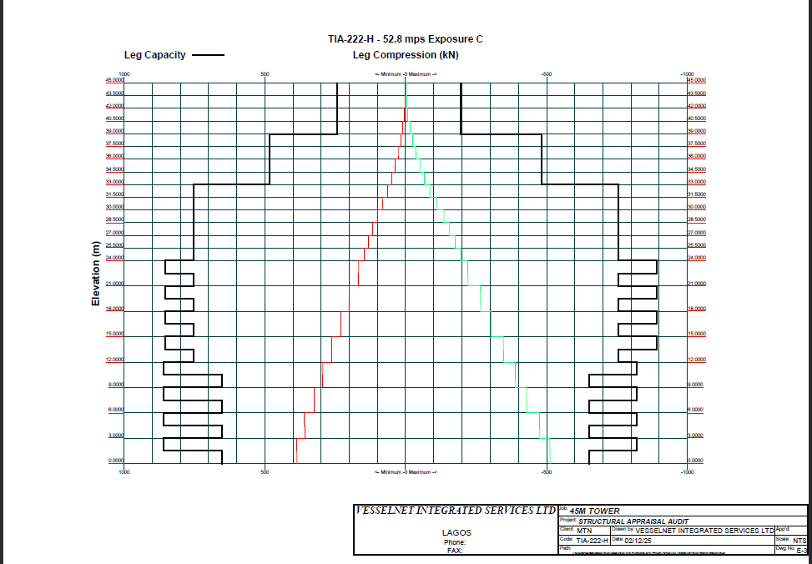

**Picture 5.0 –Axial Force**

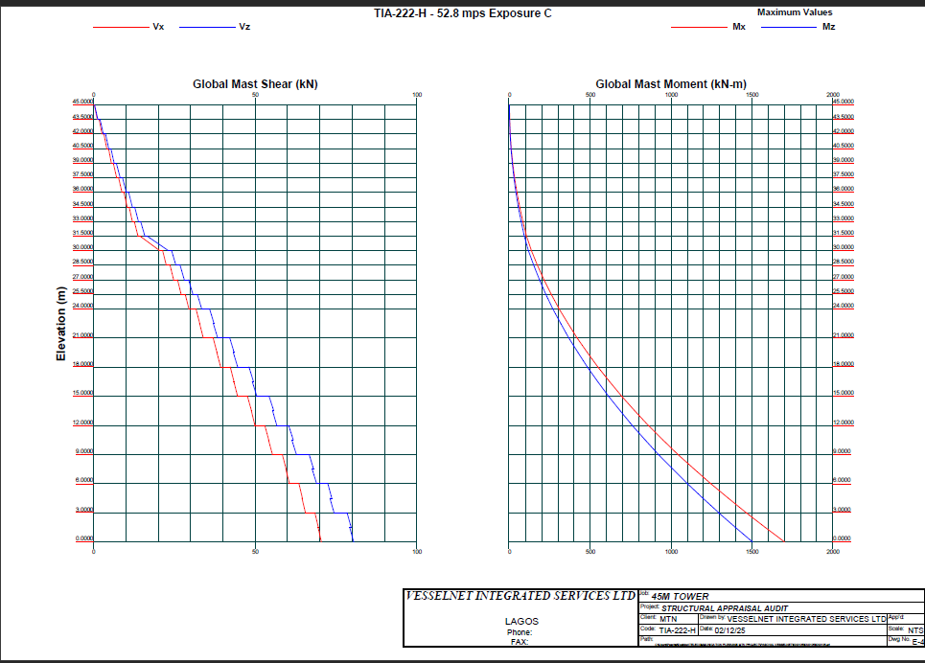

**Picture 5.1–Beam Stress**

The axial force, shear force and beam stress of the tower (results to be found in the appendix) was checked against the applied loads at ultimate condition and this was found to be satisfactory and within safe limits as specified in TIA-222-H code of practice.

**5.1.2 Result**

From the structural analysis conducted with TNX software, the following results were gotten.

* Under the current imposed loads, All of the members Passed
* The stress/failure of the members were less than one.
* Bending moment and axial load were within performance range.
* Deflection check is satisfactory.

**5.1.3 Tower Utilization Analysis (Existing height EPA)**

|  |  |  |  |  |  |  |  |  |
| --- | --- | --- | --- | --- | --- | --- | --- | --- |
| RF Antenna installation on Tower | | | | | | | | |
| S/N | LEG | RF Antenna Type | Length(m) | Breadth(m) | Width(m) | AZIMUTH | Installation Height(m) | FPA Wind Area(M2) |
| 1 | A | RF-ANDREWS | 2.45 | 0.4 | 0.17 | 23 | 30.8 | 0.1800 |
| 2 | B | RF-ANDREWS | 2.45 | 0.4 | 0.17 | 103 | 30.8 | 0.0540 |
| 3 | C | RF-ANDREWS | 2.45 | 0.4 | 0.17 | 200 | 30.8 | 0.0540 |
| 4 | C | YAGI | 0.28 | 0.17 | 0.01 | 221 | 15 | 0.4214 |
| 5 | C | YAGI | 0.28 | 0.17 | 0.01 | 223 | 15 |  |
| 6 | A | RRU | 0.42 | 0.3 | 0.12 | 56 | 30.5 |  |
| 7 | B | RRU | 0.42 | 0.3 | 0.12 | 142 | 30.5 |  |
| 8 | C | RRU | 0.42 | 0.3 | 0.12 | 301 | 30.5 |  |
|  | ESTIMATED WIND AREA for Antenna | | | | | | | 0.7094 |
| S/N | LEG | Microwave Type | Length(m) | Breadth(m) | Azimuth | Dish Diameter (m) | Installation Height(m) | EPA Wind Area(M2) |
|  |  |  |  |  |  |  |  |  |
|  | ESTIMATED WIND AREA for Microwave | | | | | |  | 0.000000 |
|  | ESTIMATED WIND AREA for Antenna | | | | | | | 0.709400 |
|  | TOTAL EPA | | | | | | | 0.709400 |
|  | Tower Design Wind Area FPA | | | | | | | 24 |
|  | Percentage Loading | | | | | | | 2.95583% |
|  | STATUS | | | | | | | OKAY |

**6: Conclusion Recommendation and Limitation**

**6.1 Conclusion**

Based on the structural analysis carried out on the existing tower, the following conclusions were reached:

|  |  |  |
| --- | --- | --- |
| **Tower Design loading** | **Existing Tower loading** | **% Tower Loading** |
| 24 | 0.7094 | 2.95583 |

* It can be established that all the tower members have passed in relation to their designed capacity at 42m/s, topography category 1, crest height 0, and site elevation of 427m.
* The deflection at tower top for this analysis gives 0.0920 deg < 1 deg for ULS (Ultimate limit state) and 0.0393deg< 0.5 deg for SLS (Serviceability limit state). This is within the stipulated limit as indicated in TIA-222-H.
* Tower passed required torque strength.
* Tower earth value is poor at 0.30ohm

**6.2.1 Recommendation**

Based on the structural analysis carried out on the existing tower, the following recommendations are essential:

* For the tower legs: The existing members are not over stressed and are adequate for intended use.
* For the horizontal bracers: The existing members are not over stressed and are adequate for intended use.
* For the diagonal bracers: The existing members are not over stressed and are adequate for intended use.
* Tower should be torqued to manufacture’s specification for future strengthening.
* Attached herewith in this report is a summary of the results obtained from TNX with these exact specifications and corresponding results.
* A tower inspection should always be carried out soon after erecting and prior to using the tower so as to establish that the tower has been erected and installed in accordance to the tower specifications. Records of such inspections should always be maintained as this will assist in assessing the behavior of the tower over its service life.
* During the service life of the tower appropriate maintenance and assessment should be carried out at regular intervals to ensure that any loose bolts or parts are identified and corrected. Tower structure preventive maintenance is very much dependent on the manufacturers or client’s specification though the general standard recommendation is usually every two years. Other frequency of recommendation that is closer than that would be dependent on the client requirement and/or usage. A closer frequency of maintenance than two years becomes necessary in a situation where the tower is excessively loaded or is in such a defective state that the tower is in immediate danger of collapse.

**6.3 Limitations**

The limitations on this investigation can be as follows:

1. There may be other factors that can contribute to failure which this investigation has not covered. Unusually extreme wind conditions beyond the design wind speed which is based on a 50-year return period may occur and thus rendering this analysis useless. Also, internal corrosion caused by dissimilar environments in a self-support tower base.

There may be additional loadings on the tower beyond what is used in this analysis in the future, thereby leading to failure.

**Appendix: Structural Calculation Report**