B.S. DETECTOR
Speaker Verification Module — Progress Report
Prepared by Anumay Pandey | August 11, 2026
Repository: github.com/Anumay1231/B.S-Detector

Executive Summary
Today's work focused on the speaker-verification component of the B.S. Detector. We finalized the system architecture, selected and validated a pretrained speaker-embedding model, completed the core verification pipeline end to end, and researched the right datasets for calibrating the system on English, Hindi, and Hinglish speech.
The component is roughly 65–70% complete. Architecture, model integration, and pipeline are done and fully tested (147 passing tests, no failures). What remains is real-world dataset calibration/evaluation and integration with the existing deepfake detector.

1. System Architecture
B.S. Detector runs as a sequential, two-stage pipeline rather than running both detectors in parallel. If the deepfake detector flags audio as FAKE, the pipeline stops immediately — speaker verification never runs. This avoids unnecessary GPU compute, gives a clear decision hierarchy, and keeps the two systems modular.
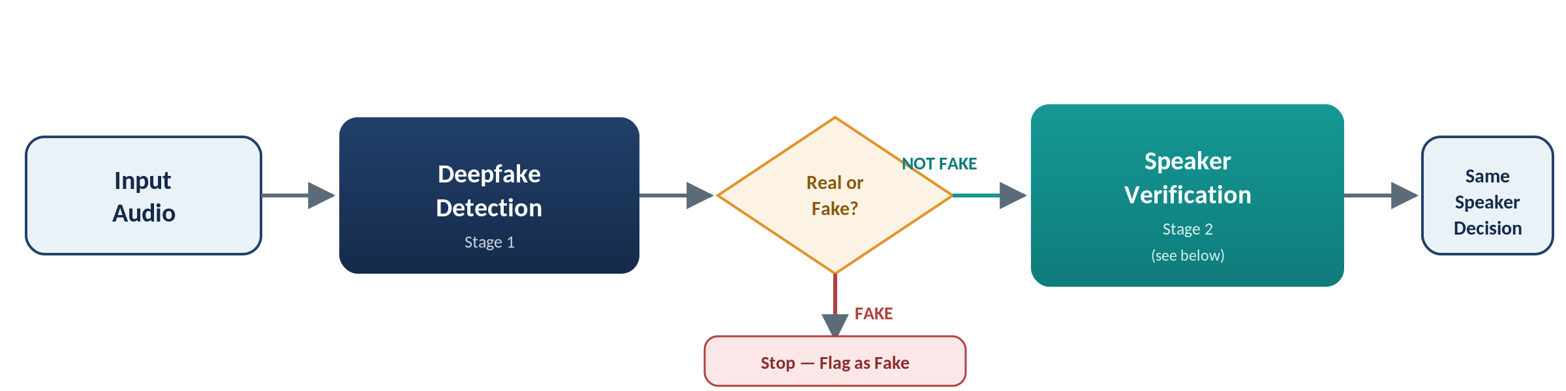
Figure 1 — Top-level integration: deepfake detection gates speaker verification.

1.1 Speaker-Verification Module Internals
Within Stage 2, reference and test audio are independently preprocessed and encoded, compared by cosine similarity, and passed through a calibrated threshold to reach a decision. The Phase 7 offline pipeline (dashed box) is what supplies that threshold — it is a separate, batch data pipeline, not part of the live request path.
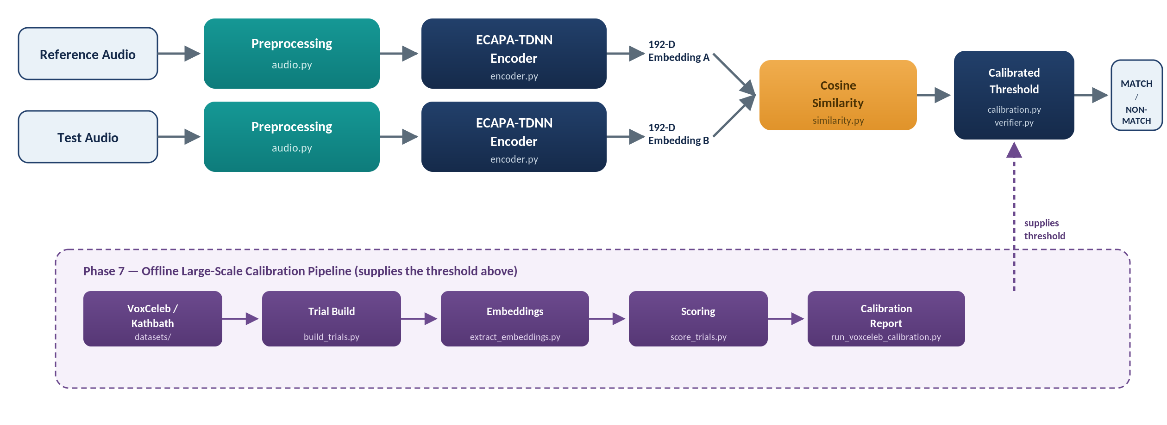
Figure 2 — Module-level pipeline with source files, plus the offline calibration pipeline that supplies the threshold.

2. Model & Pipeline
- Model: speechbrain/spkrec-ecapa-voxceleb (ECAPA-TDNN) — pretrained, frozen, no fine-tuning
- Output: 192-dimensional speaker embeddings
- Hardware: validated on the project's RTX 3060 Laptop GPU with CUDA inference confirmed
Implemented and tested: audio preprocessing, ECAPA integration, embedding generation, cosine similarity, input validation, FAR/FRR/EER/ROC-AUC, threshold calibration, decision logic, speaker-disjoint splitting, dataset/trial pipeline, and embedding caching — 147 tests passing, zero failures.

3. Dataset Strategy
We initially considered one large multilingual dataset, but decided a small set of language-matched datasets fits the project better than an unnecessarily broad corpus:
- English → VoxCeleb1 — an established speaker-verification benchmark with official trial lists.
- Hindi → Kathbath — already used for ASV benchmarking (cosine similarity, EER).
- Hinglish → IIITH Hindi-English Code-Mixed Database — 142 speakers, 3 sessions, promising but not yet confirmed (access, licensing, and file structure still need verification).
Alternatives reviewed and set aside: VoxCeleb2, LibriSpeech, SITW, IndicVoices, NISP, I-MSV, MUCS, HiACC, and IITG-HingCoS.

4. Calibration Approach
We avoided hard-coding a similarity threshold. Instead, the threshold is derived from real genuine/impostor data:
Genuine + impostor trials → Cosine similarity scores → FAR / FRR / EER → Data-derived threshold
Calibration and evaluation speakers are kept strictly separate (speaker-disjoint split) to prevent leakage and test real generalization. We also plan to compare language-specific thresholds against one global threshold. Fuzzy-logic decision mapping (confidence bands instead of a hard cutoff) was discussed as a future refinement, but is deliberately deferred until a conventional baseline exists to measure it against.

5. Progress Status
Roughly 65–70% complete.
Completed | Remaining Major Work
✓ Architecture | 1. Finalize dataset access (VoxCeleb1, Kathbath, IIITH)
✓ Model selection | 2. Implement/verify dataset adapters
✓ Audio pipeline | 3. Download controlled datasets
✓ ECAPA integration | 4. Generate real embeddings & trials
✓ GPU implementation | 5. Compute real EER / FAR / FRR / ROC-AUC
✓ Embedding generation | 6. Determine actual thresholds
✓ Similarity scoring | 7. Evaluate on held-out speakers
✓ Calibration framework | 8. Integrate with deepfake detector
✓ Verification logic | 9. Test Hinglish properly
✓ Testing (147 passing) | 10. Experiment with fuzzy mapping
✓ Dataset research & comparison
✓ Metadata audit

6. Why These Choices
The key point: we didn't default to the most popular model or the biggest dataset — every choice was narrowed against what B.S. Detector actually needs.
Decision | Choice | Why
Sequential architecture | Deepfake check first, verification second | Skips speaker verification on audio already rejected as fake — saves compute
ECAPA-TDNN | Pretrained SpeechBrain checkpoint | Best balance of accuracy, cost, and ease of integration; no training needed
Cosine similarity | Standard metric for embeddings | Scale-insensitive, cheap, and normalized (−1 to +1) for easy calibration
No hard-coded threshold | Threshold derived from calibration data | Right cutoff depends on model, dataset, language, and recording conditions
Speaker-disjoint evaluation | Calibration ≠ evaluation speakers | Prevents leakage; tests generalization to genuinely new speakers
VoxCeleb1 / Kathbath | Purpose-built ASV datasets | Both already have proven speaker-verification trial structures
English + Hindi + Hinglish only | No giant multilingual dataset | Matches our actual target languages; avoids unneeded storage/licensing/complexity
Hinglish not finalized | IIITH pending verification | Access/licensing/session structure unconfirmed — won't force an unproven dataset in
No cross-dataset trials | Genuine trials stay within one dataset | Speaker identity can't be assumed to match across different datasets
Fuzzy logic deferred | Hard threshold baseline first | Lets us later measure fuzzy logic's benefit against a known baseline

Bottom Line
We have completed the architecture and core implementation of a conditional, ECAPA-TDNN-based speaker-verification system. The remaining work is real-world dataset calibration and evaluation, followed by integration with the deepfake detector.

