Approach Document FOR

E-GMAT’S CODING ASSIGNMENT

**PROBLEM SOLUTION**

Implemented the user interface as shown in the JPG file (UI_assignment_1_19.jpg) and implement (using HTML, CSS & JS) the following functionalities-

As the page contains three horizontal bar graphs to represent three different scores.ie. Total score, Quant score and verbal score, with below **max scores**:

|  |  |
| --- | --- |
| **Heading** | **Max Score** |
| Total Score | 800 |
| Quant Score | 60 |
| Verbal Score | 60 |

I took the *current score* and *target score* out of respective maximum scores for quant and verbal sections and plot the graphs based on the inputs entered by the user.

Total score is being calculated based on the below formula:

**Total current score** = *200 + (current Verbal score + current Quant score) *5*

**Total target score** = *200 + (target Verbal score + target Quant score) *5*

Below are the color used:

|  |  |
| --- | --- |
| **Graph type** | **Color** |
| Base line (*Max score*) Bar | Grey (#f5f5f5) |
| Current Score Bar | Blue (#0fa2eb) |
| Difference Score Bar | Yellow (#ffe28a) |

The text below each bar graph is a feedback generated for the obtained scores. It indicates how near or far the candidate is from his target score.

***INPUT VALIDATIONS***

**Verbal score:** Verbal score should be an integer between 1 and 60.

**Quant score:** Quant score should be an integer between 1 and 60.

**WORKFLOW OF THE UI**

I have broken down the UI into two sections: **Score UI** and **Bar graphs UI**

The first view should be as below:

This view has **quant** and **verbal score input fields**.

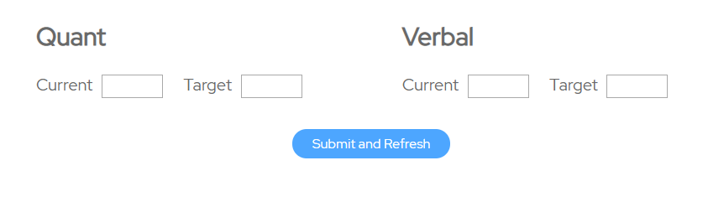

Once user enter the scores and click on the ***Submit and Refresh*** button, he can see the Graphs section on the same page below this button which shows his report in the graphs and appropriate feedback for the same.

Hence, the complete UI after submission should look like as shown in the image below:

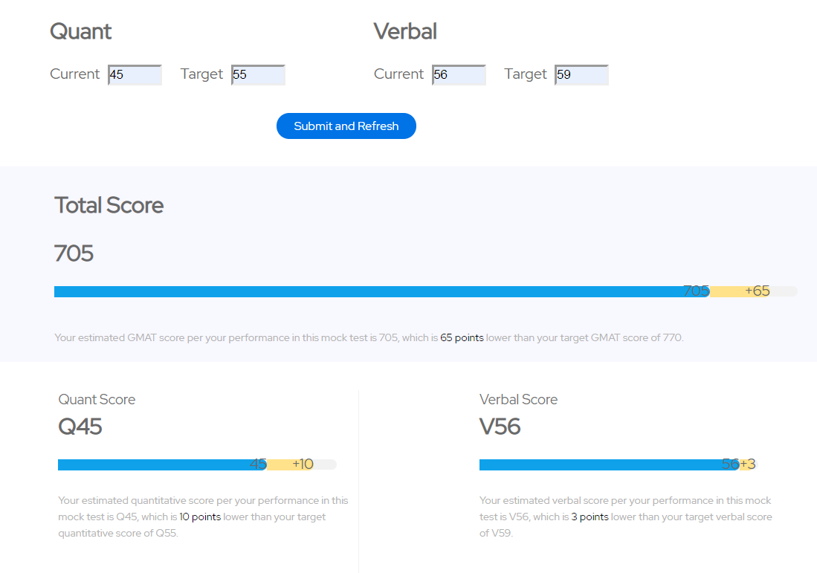

Changing the input value and submitting reflects in the corresponding graphs and feedback i.e. Total Score, Quant Score and Verbal Score will be refreshed.

**EXAMPLE CASES which are implemented**

1. **Current score is equal to Target score:**

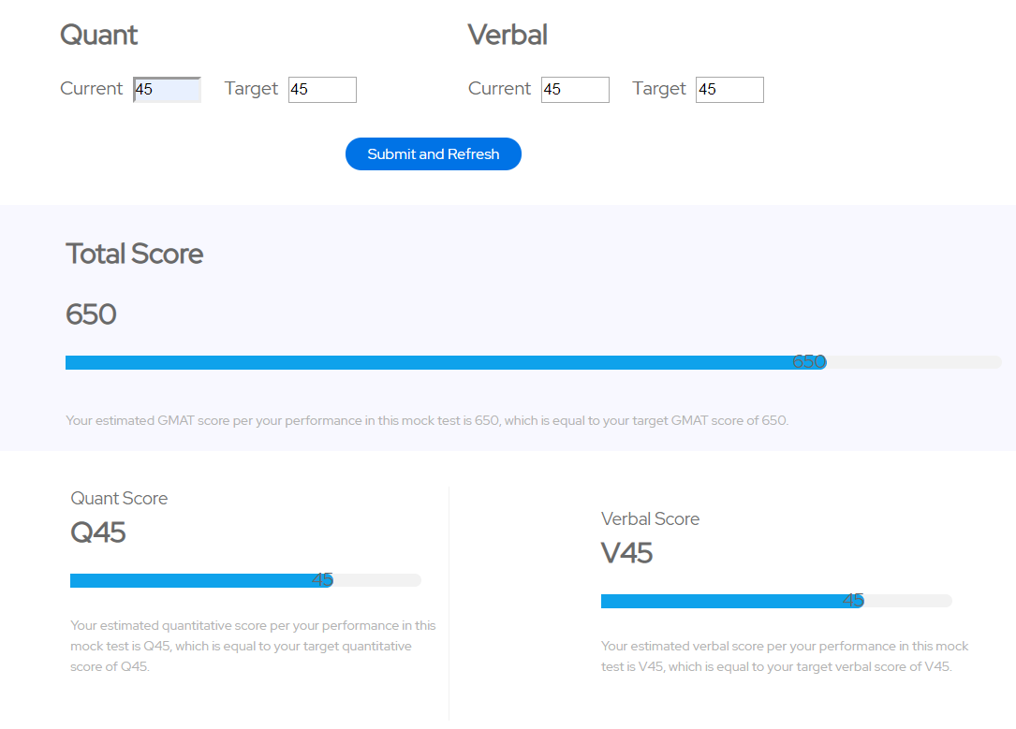

In the above example Total target and current scores are equal hence the yellow target score marker and blue score marker is aligned vertically opposite to each other. Pointer is not implemented. *Scores markers are not overlapping each other.*

1. **CURRENT SCORE IS NEAR TO TARGET SCORE**

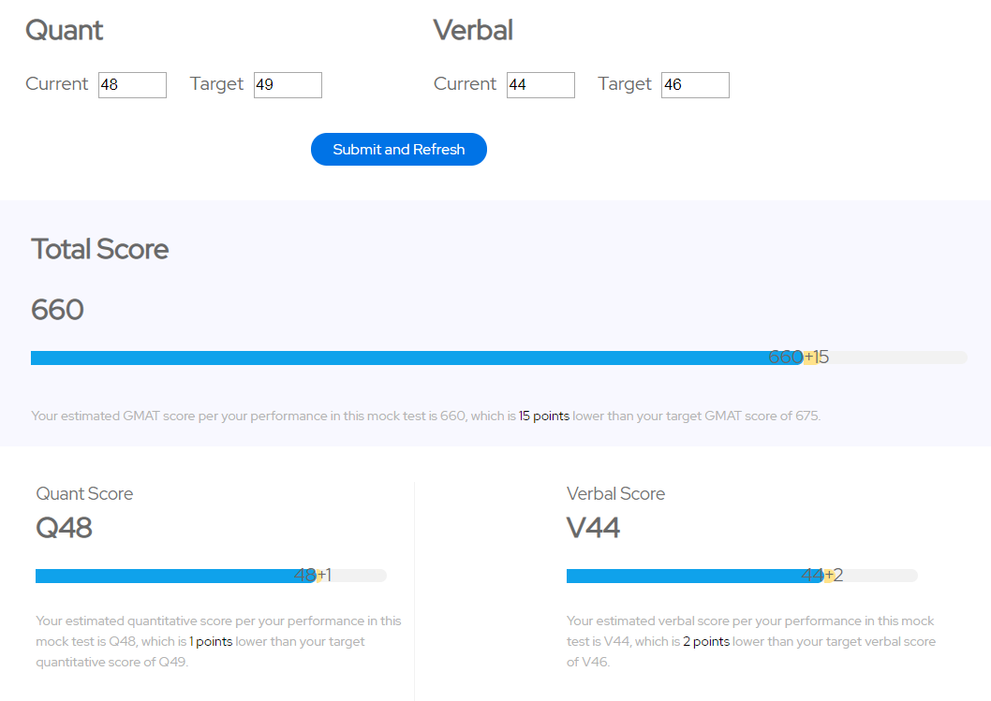

In above example current scores are near to target score hence the yellow target score marker and blue score marker is aligned vertically opposite to each other and the score difference between current and target is shown on grey bar.

1. **CURRENT SCORE IS HIGHER THAN TARGET SCORE**

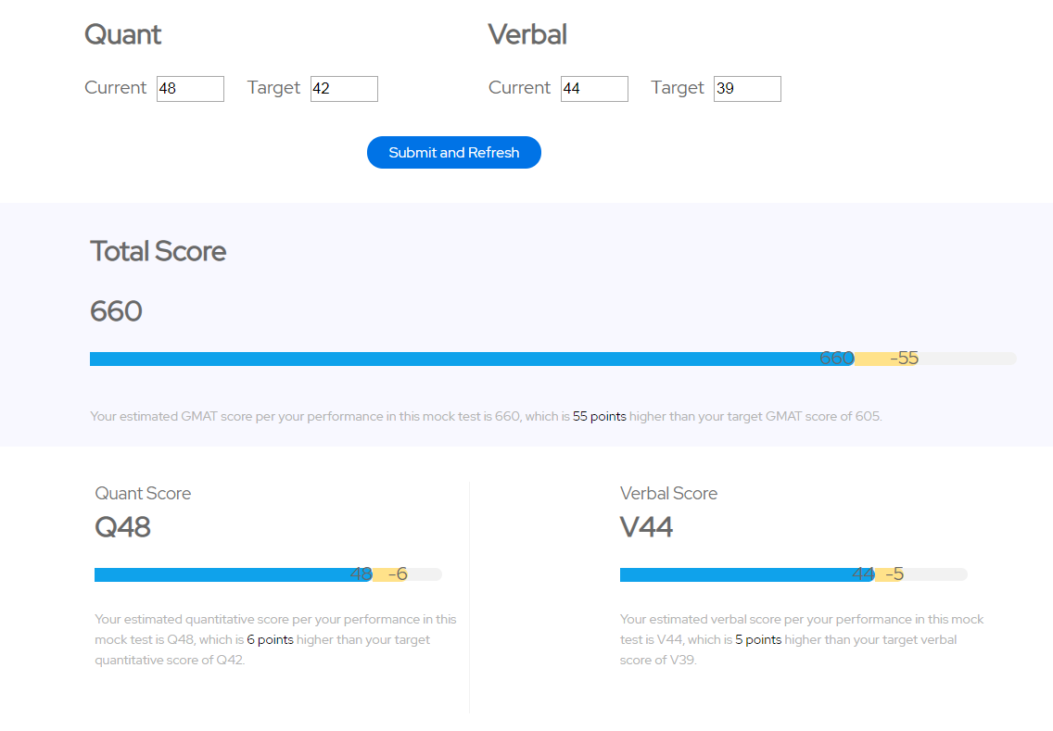

Here in above examples, Instead of hiding score difference, it’s **visible but with negative values** as the pointer functionality is not implemented.

1. **CURRENT SCORE IS LESS THAN TARGET SCORE**

