Shell script
Vim editor

Vim filename.sh \\ to create/open file

(\\type program

i // to enter insert mode)

num1=10
num2=20

num3=`expr $num1 + $num2`

echo "Sum is: $num3"

//escape to exit insert mode

:wq /to save and exit

chmod +x filename.sh
./filename.sh //execute

Program 1

echo “What is your name?”
read PERSON
echo “Hello, $PERSON”
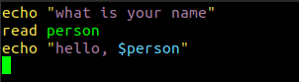
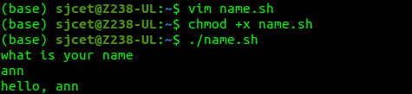

Shell script for odd or even

nums="1 2 3 4 5 6 7"
for n in $nums
do
q=`expr $n % 2`
if [ $q -eq 0 ]
then
echo "number is even"
continue
fi
echo "oddd number"
Done

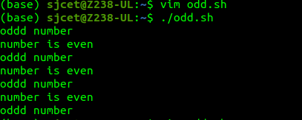

shell script for factorial of a number

echo "enter a number"
read num
fact=1
while [ $num -gt 1 ]
do
fact=$((fact * num))
num=$((num - 1))

done
echo $fact
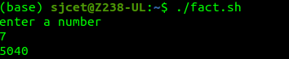

Using For loop

echo "enter a number"
read num
fact=1
for ((i=2;i<=num;i++))
{
fact=$((fact * i))
}
echo $fact

Sum of all digits - Shell Script

echo "Enter a number"
read num
sum=0
while [ $num -gt 0 ]
do
mod=$((num % 10))
sum=$((sum + mod))
num=$((num / 10))
done
echo $sum
~

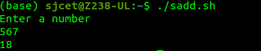

Shell script to print sum of all digit using expr

echo "Enter a number"
read num
sum=0
while [ $num -gt 0 ]

do
mod=`expr $num % 10`
sum=`expr $sum + $mod`
num=`expr $num / 10`
done
echo $sum

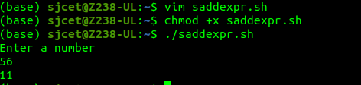

Print numbers 1 to 100 using while loop - Shell Script

i=1
while [ $i -le 100 ]
do
echo $i
i=$(($i+1))
done

Same program using expr
echo "Enter a number"
read num
sum=0
while [ $num -gt 0 ]

do
mod=`expr $num % 10`
sum=`expr $sum + $mod`
num=`expr $num / 10`
done
echo $sum

Print numbers 1 to 100 using while loop - Shell Script
i=1
while [ $i -le 100 ]
do
echo $i
i=$(($i+1))
done
using expr
i=1
while [ $i -le 100 ]
do
echo $i
i=`expr $i + 1`
done

using for loop
for((i=1;i&lt;=100;i++))
do
echo $i
done

Largest of n numbers
echo "enter size"
read n;
i=1
max=0
echo "enter numbers"
while [ $i -le $n ]
do
read num;
if [ $i -eq 1 ]
then
max=$num
else
if [ $num -gt $max ]
then
max=$num
fi

fi
i=$((i+1))
done
echo "largest is: $max"
~
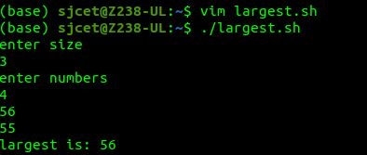
Multiplication of two numbers using expr in shell
script
num1=10
num2=20
ans=`expr $num1 \* $num2`
echo $ans

Average of n numbers
echo "enter size"
read n
i=1
sum=0
echo "enter numbers"
while [ $i -le $n ]
do
read num
sum=$((sum + num))
i=$((i + 1))
done
avg=$(echo `expr $sum / $n` )
echo "average is:$avg"
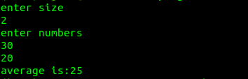

Sum of n numbers using while loop
echo "Enter Size(N)"
read N
i=1
sum=0
echo "Enter Numbers"
while [ $i -le $N ]
do
read num
sum=$((sum + num))
i=$((i + 1))
done
echo "sum is:$sum"
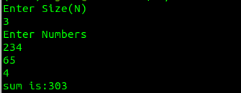

Sum of n numbers using for loop
echo "Enter Size(N)"
read N
sum=0
echo "Enter Numbes"
for((i=1;i<=N;i++))
do
read num
sum=$((sum + num))
done
echo $sum

finding greatest of three numbers
echo "Enter Num1"
read num1
echo "Enter Num2"
read num2
echo "Enter Num3"
read num3
if [ $num1 -gt $num2 ] && [ $num1 -gt $num3 ]
then
echo $num1
elif [ $num2 -gt $num1 ] && [ $num2 -gt $num3 ]
then
echo "greatest:$num2"
else
echo "greatest: $num3"
fi
~
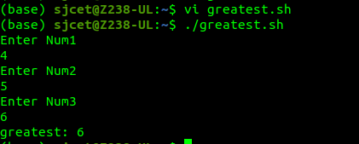

Add array elements
arr=(10 20 30 40 50)
sum=0
for i in ${arr[@]}
do
sum=`expr $sum + $i`
done
echo $sum
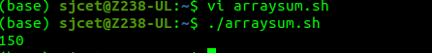

Shell script to compare two strings
read -p "Enter two strings:"str1 str2
if [ $str1 == $str2 ]
then
echo "Equal"
else
echo "Un Equal"
fi

