Shell programming

Nano editor
Shell programming

Nano editorShell programming

Nano editor

Program 1

@command prompt:
nano sum.sh
(for move to nano(text editor))

@nano text editoShell programming

Nano editor

Program 1

@command prompt:
nano sum.sh
(for move to nano(text editor))

@nano text editor :

#!/bin/bash

# Program name: "add_two_num.sh"
# Shell script program to add two numbers.

num1=10
num2=20

num3=`expr $num1 + $num2`

echo "Sum is: $num3"

(save and exit using ctrl+x as sum.sh)

@command prompt:
bash sum.sh

Program 2

#!/bin/bash
echo "enter first number"
read n1
echo "enter second number"
read n2
n3=$n1
n1=$n2
n2=$n3
echo "num 1 is:" $n1
echo "num2 is:" $n2

Program to find area and circumference of circle
#!/bin/bash
echo "enter radius :"
read r
echo "Area of the circle is:"
echo "3.14 * $r * $r" |bc
echo "Circumferebce of circle is:"
echo "3.14 * 2 * $r" |bc

Program to check weather a number is even or odd

#!/bin/bash
echo "enter a number:"
read n
if [ `expr $n % 2` == 0 ]
then
echo "number is even"
else
echo "number is odd"
fi

Program 4

echo "process id is:" $$

r :

#!/bin/bash

# Program name: "add_two_num.sh"
# Shell script program to add two numbers.

num1=10
num2=20

num3=`expr $num1 + $num2`

echo "Sum is: $num3"

(save and exit using ctrl+x as sum.sh)

@command prompt:
bash sum.sh

Program 2

#!/bin/bash
echo "enter first number"
read n1
echo "enter second number"
read n2
n3=$n1
n1=$n2
n2=$n3
echo "num 1 is:" $n1
echo "num2 is:" $n2

Program to find area and circumference of circle
#!/bin/bash
echo "enter radius :"
read r
echo "Area of the circle is:"
echo "3.14 * $r * $r" |bc
echo "Circumferebce of circle is:"
echo "3.14 * 2 * $r" |bc

Program to check weather a number is even or odd

#!/bin/bash
echo "enter a number:"
read n
if [ `expr $n % 2` == 0 ]
then
echo "number is even"
else
echo "number is odd"
fi

Program 4

echo "process id is:" $$

Program 1

@command prompt:
nano sum.sh
(for move to nano(text editor))

@nano text editor :

#!/bin/bash

# Program name: "add_two_num.sh"
# Shell script program to add two numbers.

num1=10
num2=20

num3=`expr $num1 + $num2`

echo "Sum is: $num3"

(save and exit using ctrl+x as sum.sh)

@command prompt:
bash sum.sh

Program 2

#!/bin/bash
echo "enter first number"
read n1
echo "enter second number"
read n2
n3=$n1
n1=$n2
n2=$n3
echo "num 1 is:" $n1
echo "num2 is:" $n2

Program to find area and circumference of circle
#!/bin/bash
echo "enter radius :"
read r
echo "Area of the circle is:"
echo "3.14 * $r * $r" |bc
echo "Circumferebce of circle is:"
echo "3.14 * 2 * $r" |bc

Program to check weather a number is even or odd

#!/bin/bash
echo "enter a number:"
read n
if [ `expr $n % 2` == 0 ]
then
echo "number is even"
else
echo "number is odd"
fi

Program 4

echo "process id is:" $$

Program 1

@command prompt:
nano sum.sh
(for move to nano(text editor))

@nano text editor :

#!/bin/bash

# Program name: "add_two_num.sh"
# Shell script program to add two numbers.

num1=10
num2=20

num3=`expr $num1 + $num2`

echo "Sum is: $num3"

(save and exit using ctrl+x as sum.sh)

@command prompt:
bash sum.sh

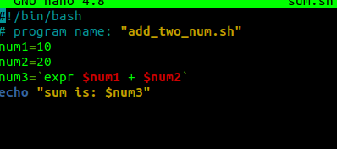
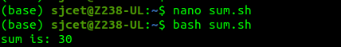

Program 2

#!/bin/bash
echo "enter first number"
read n1
echo "enter second number"
read n2
n3=$n1
n1=$n2
n2=$n3
echo "num 1 is:" $n1
echo "num2 is:" $n2
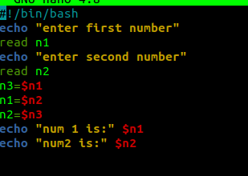
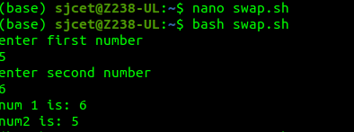

Program to find area and circumference of circle
#!/bin/bash
echo "enter radius :"
read r
echo "Area of the circle is:"
echo "3.14 * $r * $r" |bc
echo "Circumferebce of circle is:"
echo "3.14 * 2 * $r" |bc

Program to check weather a number is even or odd

#!/bin/bash
echo "enter a number:"
read n
if [ `expr $n % 2` == 0 ]
then
echo "number is even"
else
echo "number is odd"
fi

Program 4

echo "process id is:" $$

