PDF TO PODCAST CONVERTER
A GenAI-Powered Web Application for Converting PDFs into Podcast Audio
Project Report
Submitted by:
Anumula Gayathri
Teegala Krishna Reddy Engineering College
Department of Computer Science and Engineering
Academic Year: 2026 – 2027 [Final Year]
Guided by:
Raghavendra Rao

GitHub Repository:
PDF to Podcast Converter — Source Code & Project Files
URL:
https://github.com/AnumulaGayathri/PDF-to-Podcast-Converter

Index
S. No. | Section
1 | Introduction
2 | Problem Statement
3 | Objectives
4 | Project Scope
5 | Proposed System / Methodology
6 | System Architecture / Workflow
7 | Implementation
8 | User Interface / Application Screenshots
9 | Challenges and Limitations
10 | Conclusion
11 | Future Scope
12 | References

1. Introduction

1.1 Overview
The PDF to Podcast Converter is a web-based GenAI application that converts textual content from PDF documents into podcast-style audio. The system is designed to make lengthy documents easier to consume by allowing users to listen to their content instead of reading the entire document.
In the current digital environment, students, professionals, and other users frequently work with lengthy PDF files such as notes, reports, study materials, and documents. Reading such content requires time and continuous attention. The proposed system provides an alternative by converting the document into an audio-based listening experience.

1.2 Role of Generative AI
Generative AI is the main intelligent component of the application. Instead of directly sending extracted PDF text to a text-to-speech engine, the system first uses the Google Gemini API to transform the raw text into a more structured and conversational podcast script.
This makes the output more suitable for listening and helps avoid the monotonous experience of simply reading the original document word-for-word.

1.3 Main Features
Feature | Description
PDF Upload | Allows users to select and upload a PDF document
Text Extraction | Extracts readable text from the uploaded PDF
AI Script Generation | Gemini converts extracted text into a podcast-style script
Audio Generation | Converts the generated script into speech
Audio Playback | Allows the generated podcast to be played in the browser
Download | Generated audio can be accessed for offline listening

The system is particularly useful for students and professionals who want to consume information while travelling, exercising, or performing other activities.

2. Problem Statement

2.1 Existing Problem
Reading lengthy PDF documents can be time-consuming and inconvenient. Users must usually spend a significant amount of time continuously reading text, which becomes difficult when they are travelling, multitasking, or experiencing visual fatigue.
Traditional text-to-speech solutions provide a basic alternative, but they generally read the original text exactly as it appears. This can result in an unnatural and less engaging listening experience.

2.2 Existing System and Its Limitations
Existing systems mainly focus on direct text-to-speech conversion.

Common limitations
- Text is read almost exactly as written.
- Narration may sound robotic or monotonous.
- Long documents are difficult to follow in audio form.
- The content is not specifically structured for podcast-style listening.
- Users may lose interest while listening to lengthy material.

2.3 Need for the Proposed Solution
The project addresses this gap by introducing an intermediate AI script-generation stage.
Instead of:
PDF → Text → Speech
the proposed approach is:
PDF → Text Extraction → Gemini AI → Podcast Script → Speech
This allows Generative AI to improve the structure and conversational quality of the content before it is converted into audio.

2.4 Expected Outcome
The expected outcome is a simple application that allows users to convert a PDF into an easy-to-listen podcast-style audio file with minimum manual effort.

3. Objectives

3.1 Development Objective
To develop a functional web application that converts PDF documents into podcast-style audio.

3.2 AI Objective
To integrate the Google Gemini API for generating conversational and structured podcast scripts.

3.3 Automation Objective
To automate the complete process from PDF upload to audio generation.

3.4 Usability Objective
To provide a simple interface where users can upload documents and immediately access the generated podcast.

3.5 Accessibility Objective
To provide an alternative way of consuming written information through audio.

3.6 Evaluation Objective
To evaluate the system based on functionality, content accuracy, processing time, robustness, and audio quality.

4. Project Scope

4.1 Target Users
- Students
- Professionals
- Researchers
- People who prefer listening over reading
- Users who want to consume information while multitasking

4.2 Input and Output
Category | Description
Input | PDF document
Processing | Text extraction + AI script generation + speech conversion
AI Output | Conversational podcast script
Final Output | Audio/podcast file

4.3 Functional Scope
1. PDF file upload.
2. Text extraction from PDF.
3. Processing of extracted text.
4. Podcast script generation using Gemini.
5. Audio generation using text-to-speech.
6. Audio playback through the web interface.
7. Download/access to the generated audio.

4.4 Application Areas
- Education: converting notes and study materials into audio.
- Professional use: listening to reports and documents.
- Accessibility: providing an audio alternative to written information.
- Revision: listening to study content during travel or other activities.
- Content creation: using written material as the basis for podcast content.

4.5 Current Boundaries
The current version mainly focuses on PDF-based textual content. Documents with highly complex layouts, images, tables, or unusual formatting may require additional processing.

5. Proposed System / Methodology

5.1 Overall Approach
The proposed system follows a sequential pipeline that converts a PDF document into a podcast.

Overall Process
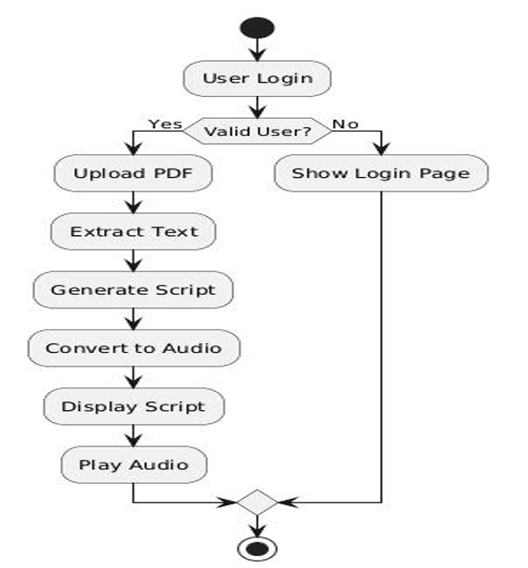
The system combines PDF processing, Generative AI, and text-to-speech into one workflow.

5.2 Step-by-Step Methodology

Step 1 – File Upload
The user selects a PDF document through the web interface.

Step 2 – File Validation
The application checks that the uploaded document is a supported PDF file.

Step 3 – Text Extraction
The PDF processing module reads each page and extracts available textual content.

Step 4 – AI Processing
The extracted text is provided to the Google Gemini API.

Step 5 – Podcast Script Generation
Gemini converts the extracted material into a structured and conversational script suitable for narration.

Step 6 – Audio Conversion
The generated script is passed to a text-to-speech engine such as gTTS.

Step 7 – Final Output
The generated MP3/audio output is displayed through the application interface so that the user can listen to it or access it for offline use.

5.3 Main Modules
Module | Responsibility
PDF Upload Module | Accepts and validates PDF files
Text Extraction Module | Extracts text from PDF pages
Podcast Script Generator | Uses Gemini to generate conversational content
Audio Generation Module | Converts script into speech
User Interface Module | Handles upload, display, playback, and interaction
Database/Storage | Stores user and file-related information where implemented

6. System Architecture / Workflow

6.1 Architecture
The architecture represents the movement of data from the user to the final podcast output.
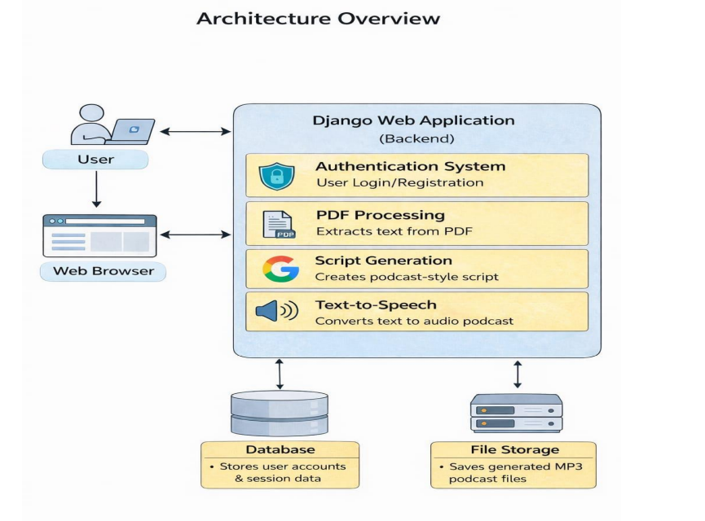
Figure 6.1: System Architecture / Workflow

6.2 Workflow Description
1. The user accesses the web application.
2. A PDF document is uploaded.
3. The application extracts textual content from the document.
4. The extracted content is sent to Gemini.
5. Gemini generates a conversational podcast-style script.
6. The script is passed to the text-to-speech module.
7. An audio file is generated.
8. The user can play the generated podcast through the application.

6.3 Module Interaction
The modules communicate sequentially, ensuring that the output of one module becomes the input of the next. This creates an automated end-to-end pipeline rather than requiring the user to manually perform each step.

7. Implementation

7.1 Technologies Used
Technology | Purpose
Python | Backend logic and processing
Django | Web application framework
HTML5 | Web page structure
CSS3 | Interface styling
JavaScript | Client-side interaction
PyPDF / PyPDF2 | PDF text extraction
Google Gemini API | AI-based podcast script generation
gTTS | Text-to-speech conversion
SQLite / PostgreSQL | Data storage
Git & GitHub | Version control
VS Code | Development environment

7.2 Backend Implementation
The backend is responsible for:
- Receiving the uploaded PDF.
- Extracting text.
- Processing the extracted content.
- Generating the podcast script.
- Converting the script into audio.
- Returning the output to the user interface.

7.3 PDF Text Extraction
A PDF reader is used to iterate through pages and collect available text.
reader = PdfReader(pdf_file)

for page in reader.pages:
if page.extract_text():
text += page.extract_text()

7.4 AI-Based Script Generation
The extracted text is processed by the Google Gemini API to produce a conversational podcast-style script.
Conceptually:
Extracted PDF Text
↓
Gemini API
↓
Conversational Podcast Script
The purpose of this stage is to make the content more suitable for listening rather than simply reading the original document aloud.

7.5 Audio Generation
The generated script is passed to gTTS and saved as an audio file.
Example implementation:
script = "Welcome to today's podcast. Here is a summary of the document. " + text[:1000]

tts = gTTS(script)
tts.save(audio_path)

7.6 Basic Algorithm
Step | Operation
1 | Start
2 | Accept PDF from user
3 | Validate PDF
4 | Extract text
5 | Send text to Gemini
6 | Generate podcast script
7 | Send script to text-to-speech engine
8 | Generate audio
9 | Display audio
10 | Allow playback/download
11 | End

8. User Interface / Application Screenshots
The application provides a simple interface for document upload and podcast generation.

8.1 Create Account Page
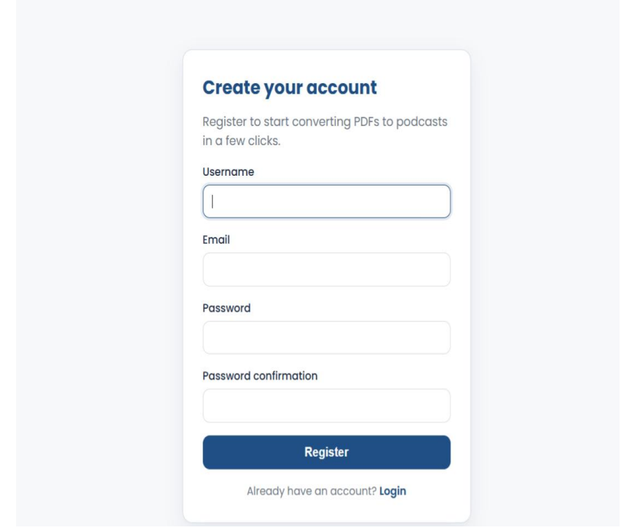
Figure 8.1: Create Account Page – Allows a user to register and access the application.

8.2 Login Page
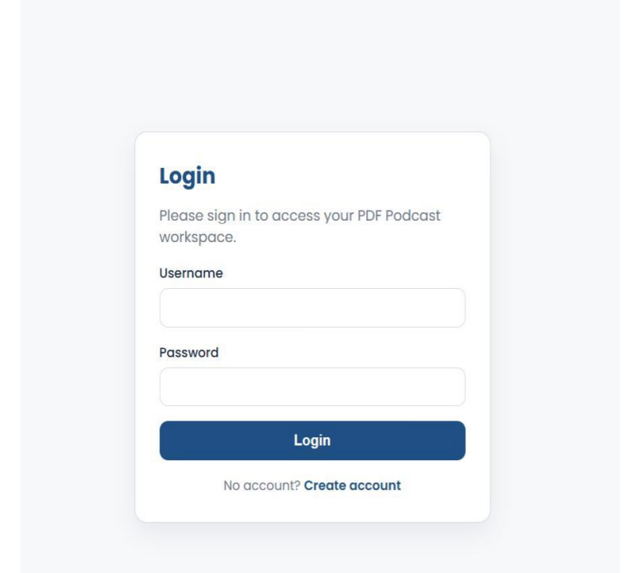
Figure 8.2: Login Page – Provides secure access to the application.

8.3 Dashboard
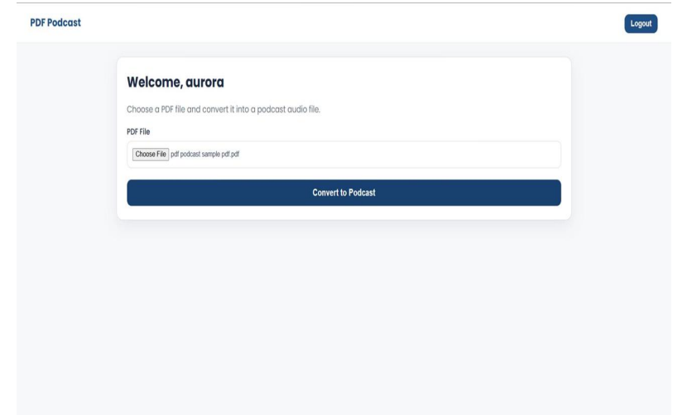
Figure 8.3: Dashboard – Main interface where the user can select a PDF for conversion.

8.4 PDF Upload Screen
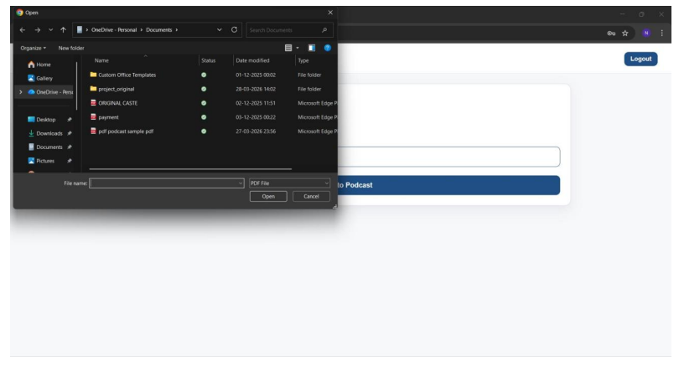
Figure 8.4: PDF Upload Screen – Allows the user to select and submit a PDF document.

8.5 Podcast Generation / Output
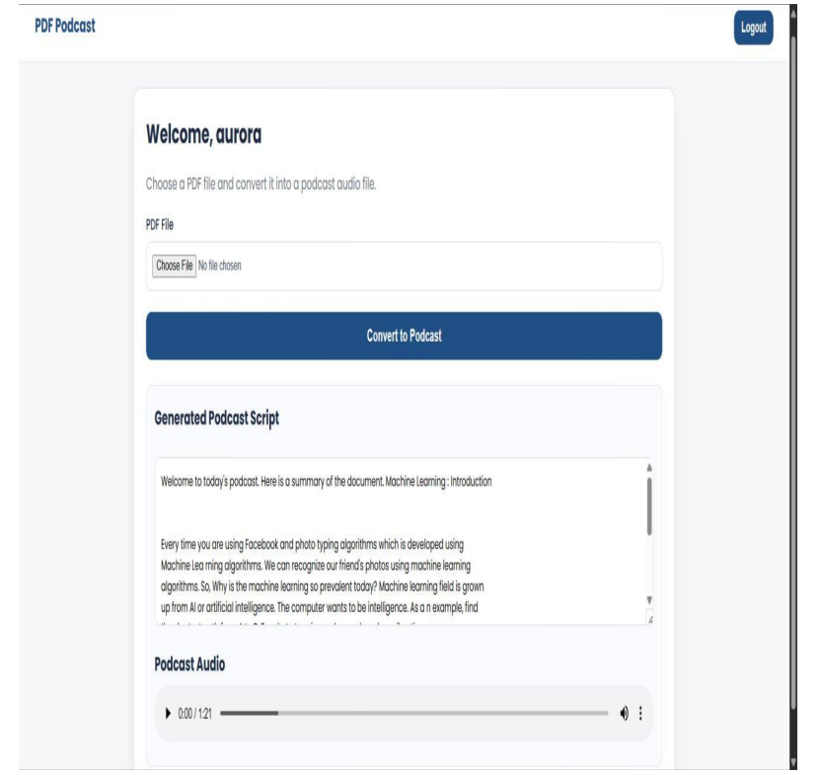
Figure 8.5: Podcast Generation – Displays the generated script and audio player.
The source report includes corresponding output screens for account creation, login, dashboard, PDF upload, and podcast generation.

9. Challenges and Limitations

9.1 Development Challenges

PDF Text Extraction
PDF documents can contain different layouts, formatting, and structures. Extracting clean and meaningful text can therefore be challenging.

AI Output Quality
The quality of the generated podcast depends on the quality and structure of the extracted text. Poorly extracted content can affect the AI-generated script.

API Integration
The project depends on communication with external services such as Gemini and text-to-speech systems. API failures or configuration problems can interrupt processing.

Large Documents
Large PDFs may produce a significant amount of text, which can increase processing time and create limitations related to API input size.

9.2 System Testing
Testing was used to verify the different stages of the system, from PDF upload to final audio generation. The original project describes both black-box and white-box testing approaches.

Sample Test Cases
Test Case | Input | Expected Output | Result
TC1 | Valid user login | Dashboard opens | Pass
TC2 | Valid 5-page PDF | Text extracted and script generated | Pass
TC3 | Generate audio | Playable MP3 appears | Pass
TC4 | Corrupted PDF | Error message displayed | Pass
TC5 | Logout | Session terminated | Pass

9.3 Performance Evaluation
The application can be evaluated using:
Parameter | Purpose
Accuracy | Checks whether the generated podcast reflects the source content
Processing Time | Measures time from upload to audio generation
Robustness | Checks handling of larger text inputs
Audio Quality | Evaluates clarity and naturalness of generated speech

The original report describes high content accuracy, efficient processing for smaller PDFs, reliable file mapping, and evaluation of audio quality as major performance factors.

9.4 Limitations
- Dependency on external APIs.
- Processing time may increase for large PDFs.
- Complex PDF layouts may affect text extraction.
- AI output may require checking for accuracy.
- Text-to-speech quality depends on the selected service.
- The current implementation focuses primarily on PDF documents.

10. Conclusion
The PDF to Podcast Converter successfully demonstrates the use of Generative AI to transform traditional PDF-based content into a more accessible audio format.
The application combines PDF text extraction, Google Gemini-based script generation, and text-to-speech conversion into a single workflow. Instead of simply reading the document word-for-word, the system first creates a podcast-style script and then converts it into audio.
The project provides a practical solution for students, professionals, and users who prefer listening over reading. It can also support multitasking and improve accessibility by providing another method of consuming written information.
Overall, the project demonstrates how Generative AI can be combined with conventional software technologies to create a useful, user-friendly, and practical application.

11. Future Scope

11.1 Multi-language Support
The application can be extended to generate podcast scripts and audio in multiple languages.

11.2 Voice Customization
Users could be given multiple voice, accent, and narration options.

11.3 Multi-Speaker Podcasts
Instead of a single narrator, the AI could generate conversations between two or more speakers to make the podcast more engaging.

11.4 Intelligent Summarization
Long documents could automatically be summarized before podcast generation, producing shorter versions that are easier to listen to.

11.5 Script Editing
Users could edit the AI-generated script before converting it into audio.

11.6 Additional File Formats
Future versions could support Word documents, web pages, and other document formats.

11.7 Mobile Application
The system could be developed as a mobile application for easier access.

11.8 Cloud Storage and History
Generated podcasts could be stored securely in the cloud, allowing users to access previous audio files whenever required.
These improvements can make the application more flexible, accessible, and suitable for real-world use.

12. References
1. Google Generative AI – Gemini API Documentation
https://ai.google.dev/
2. Python Official Documentation
https://docs.python.org/3/
3. PyPDF2 / PyPDF Documentation
https://pypdf2.readthedocs.io/
4. gTTS Documentation
https://gtts.readthedocs.io/
5. Django Framework Documentation
https://www.djangoproject.com/
6. Research papers and articles related to Text-to-Speech Synthesis.
7. Research papers related to Automatic Text Summarization.
8. Research material related to Natural Language Generation for Conversational Systems.
9. Research material related to Speech Synthesis and Assistive Technology.
10. ACM Digital Library resources related to AI-based Content Generation using Large Language Models.
11. Stack Overflow Developer Community
https://stackoverflow.com/
12. Technical blogs and tutorials related to PDF processing, Generative AI, web development, and speech synthesis.

