**OBJECTIVE:**

**Classification of the various types of landscape images under the following categories:**

* Buildings
* Forest
* Glacier
* Mountain
* Sea
* Street

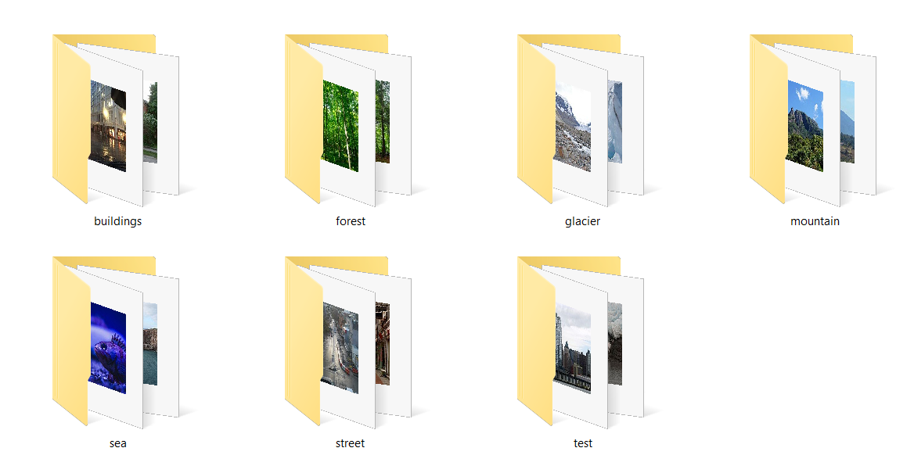

**EXAMPLE - DATA SET OF BUILDINGS:**

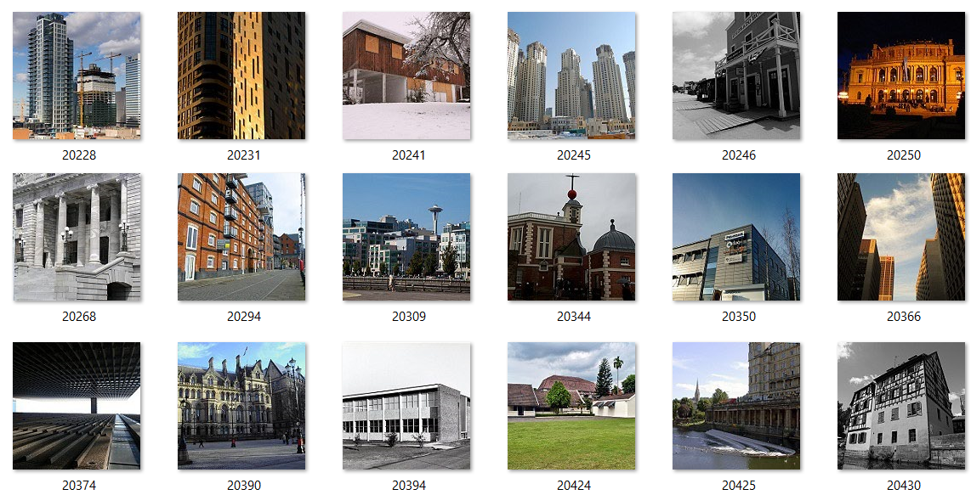

**TEST FOLDER:**

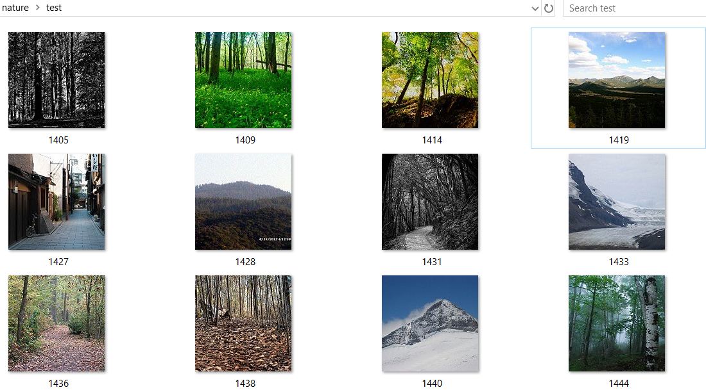

**COMMAND PROMPT:**

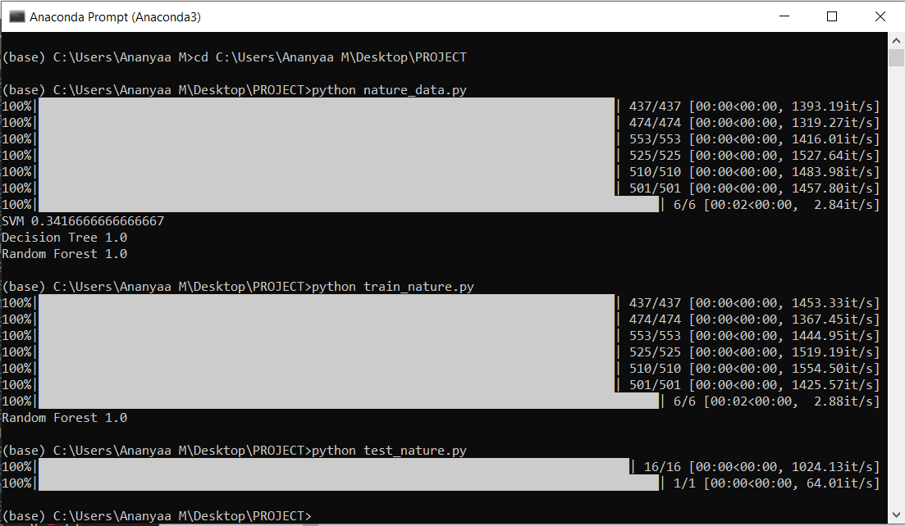

**Testing the category under which a particular image falls.**

**TEST IMAGE 1: TEST IMAGE 2:**

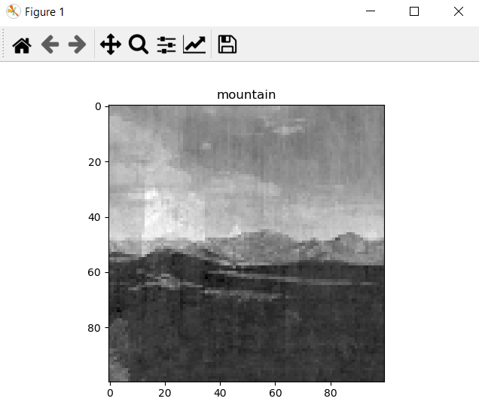 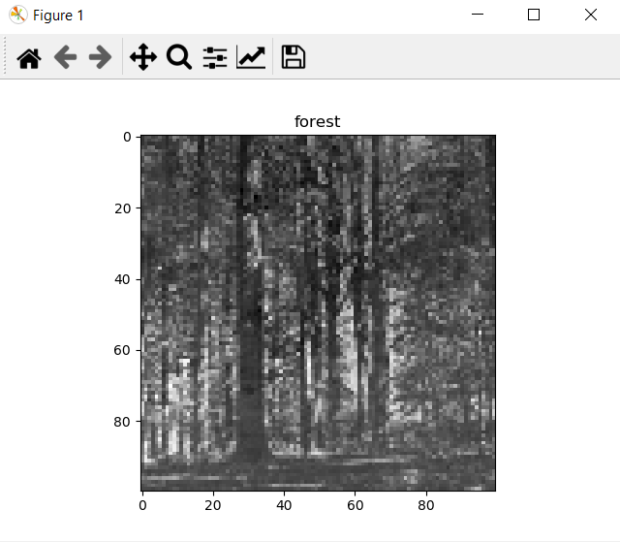

**TEST IMAGE 3:**

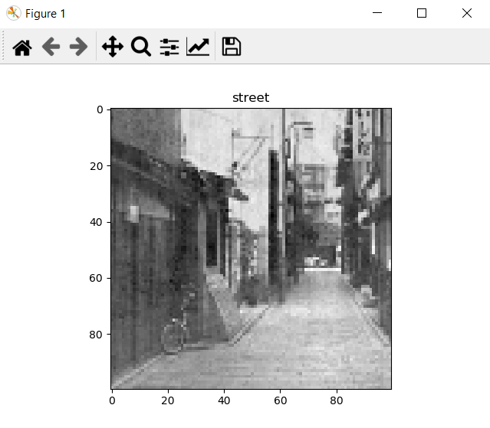

**EXPLAINATION:**

Initially we feed thousands of images that are relevant to the topic.Then those images will be analysed by the machine in order to learn and understand the shape,size and texture of the object.We then train the machine by feeding it with some more images keeping in mind the different circumstances and environments.Then the code is being executed in order to test if the machine was able to correctly identify the image by the usage of the past datas.

In this particular project, there is a database of images of nature categorized under 6 different categories, namely, buildings,forest,glacier,mountain,sea and street. Machine is allowed to learn and analyse the various images in the database. The images are taken in various backgrounds, angles, sizes,etc so as to make it efficient. Here all the images are processed to pixels of 100*100 and to grayscale. Now after the learning process is completed, the efficiency is computed using 3 different algorithm, namely

* SVM (support vector machine)
* Decision tree
* Random forest

Here random forest algorithm has the highest efficiency and it is better than decision tree because it is a collection of decision trees. So training and testing are further done with random forest.

Now when a test image is given, the image is classified under one of the 6 categories and the output is given in the format of code as grayscale and image pixels under 100*100. So this way an image is tested.

By,

ANANYAA M

[18I308]

[rmscbe75@gmail.com](mailto:rmscbe75@gmail.com)

9677762781

BTECH INFORMATION TECHNOLOGY

PSG COLLEGE OF TECHNOLOGY, COIMBATORE

[22.12.2019]