

**Logical Reasoning and Inequalities (18B12MA312)**

**Case Study Based Project**

**On**

**“Mathematical Puzzles and its Applications”**

**GROUP - MEMBERS**

| **1. Tarun Pratap** | **9920103118** |
| --- | --- |
| **2. Divyansh Rastogi** | **9920103116** |
| **3. Tanya Sharma** | **992010317** |
| **4. Akshat Shah** | **9920103105** |

| **5. Nikhil Raj** | **9920103106** |
| --- | --- |

**SUBMITTED TO: Dr. Lakhveer Kaur**



# Acknowledgment

**We would like to start this project by expressing our special thanks of gratitude to our mentor, *Dr. Lakhveer Kaur* for giving us the opportunity to study and present our findings on the topic “Mathematical Puzzles and its Applications”.**

**This project helped us to understand use of mathematical puzzles and different areas of its applications. We would like to extend our sincere and heartfelt gratitude towards our mentor who has helped us in this endeavor with her active guidance, cooperation and encouragement.**

**At last, we would like to thank all our friends and family who directly or indirectly helped us in completing this project report.**

# Index

1. **Introduction**
2. **Methodology**
3. **Classification of Methodological System**
   1. **Classical Lesson of Mathematics**
   2. **Creative Lesson in CFCT -Tips System**
   3. **Additional Mathematical Education of Pupils**
4. **Research**
5. **Applications**
6. **Conclusion**
7. **References**

## INTRODUCTION

Solving puzzles is a fun and effective way for students to enhance their mathematical skills and intelligence. Different types of puzzles, such as arithmetic puzzles, magic squares, Sudoku, and tangram, provide opportunities for students to apply their knowledge in a practical way.

Puzzles contribute to the development of crucial skills like problem-solving, logical reasoning, and spatial thinking. They offer an engaging way for students to understand and master various mathematical concepts. Additionally, puzzles play a significant role in improving memory, attention, creativity, analysis, and observation skills.

Using puzzles as a teaching tool helps students assimilate and consolidate their knowledge. It fosters a culture of mathematical thinking by emphasizing algorithms, logic, abstraction, and spatial reasoning. Solving puzzles encourages students to focus on tasks, complete them, and achieve educational goals.

Incorporating puzzles into the educational process is vital for achieving better results in mathematical learning. The study of mathematical puzzles aims to identify the best methods for integrating these puzzles into mathematics education, creating a systematic and effective approach for gaining additional mathematical knowledge.

## METHODOLOGY

## Our research approach centers on employing puzzles as an effective tool for teaching students both core and additional mathematics. The primary goal is to make the learning of mathematics more engaging and to cultivate crucial skills in students. These skills encompass logical thinking, the ability to think abstractly, understanding combinations, developing spatial imagination and manipulation skills, honing critical thinking, and enhancing the specific type of memory required for mathematical activities.

## Through a detailed analysis of various puzzles, we've formulated a teaching plan designed for junior high school students. This plan integrates both standard mathematics and supplementary topics, utilizing puzzles consistently as a teaching aid throughout the entire learning process. The aim is to create a more interactive and skill-building educational experience for students.

## CLASSIFICATION OF METHODOLOGICAL SYSTEM

The developed model of methodological system is intended to include puzzles in teaching mathematics to pupils:

1. at the stages of classical lesson of mathematics;
2. at the stages of creative lesson in CFCT-TIPS system, which are included in each studied topic of the course;
3. in extra - curricular activities of pupils (additional mathematical education)

### Puzzles as a Teaching Tool in a Classical Lesson of Mathematics

The teaching of math traditionally follows a specific structure, with defined steps. When new elements are introduced, it transforms the nature of the lesson, injecting innovation. Puzzles, however, play a role within the framework of a conventional math class as a strategy to enhance mathematical skills. According to our perspective, this integration can occur at three different stages of the lesson.

During the knowledge activation phase, there's an opportunity to engage students in activities that prepare them for upcoming topics. For instance, when delving into divisibility characteristics in the 6th grade, arithmetic puzzles can be employed. These puzzles serve not only to foster the development of logic, combinatorial abilities, critical thinking, and mathematical memory but also facilitate the application of addition and multiplication tables.

### Using Puzzles at a Special Stage of the Creative Lesson in Cfct-Tips System

In conducting non-traditional math lessons, we focus on the implementation of the CFCT-TIPS system (continuous formation of creative thinking based on the theory of inventive problem solving), developed by Professor Zinovkina (2008). Here the author describes the subsystems of creative pre-school, school, secondary vocational, higher and postgraduate education. The structure of these subsystems includes the stage of puzzle solving as one of the main ones. There is a so-called creative math lesson in *school education*. We recently published a report on the structure, content, and potential for pupil development during such lessons, which occur during the study of each school mathematics topic (Gorev & Kalimullin, 2017). It is important to highlight that selecting puzzles for the proper stage should be done with caution: they must not be out of context with the rest of the lesson and must have an educational effect. To accomplish so, the instructor who occasionally conducts creative math sessions must have a large collection of varied puzzles with methodological descriptions. Today we are doing a lot of work in this direction in the school museum of entertaining science, which was created a few years ago on the basis of Kirov city lyceum № 21, where puzzles have found their special decent place.

### Puzzles as a Didactic Tool in Additional Mathematical Education of Pupils

Perhaps the context in which one can most effectively use didactic methods linked with puzzles for the entire development of the student's personality, in particular for the development of mathematical abilities, is additional mathematical education of children and teenagers.

Basic structural unit of additional mathematical education for pupils is a *mathematical club* (elective, studio). During club activities we may consider puzzles as separate math problems and a series of puzzles. For example, the lesson can be devoted to the study of Mobius band properties or flexagons, topological puzzles with rope and buttons, or be constructed on effects of impossible figures and optical illusions. For children of a younger age, it is recommended that a series of classes be devoted to tangible puzzles such as "Tangram," pentomino, "Towers of

Hanoi," tracing figures with one stroke, and so on. It allows students to concentrate on the puzzle's problem and comprehend its structure. And these features enable students to improve not only their knowledge of the puzzle's mathematical essence, but also their logical and combinatorial abilities, their capacity for abstract thinking and functioning with spatial representations, their critical thinking, and their mathematical memory. It should be noted that our mathematical club program “Lessons of developmental mathematics”, worked out and tested for pupils of 3-6-th grades (Gorev et al., 2017), presents a technological model of club lessons by modules. Each module comprises units, based on solving puzzles.

In the article (Gorev & Novoselova, 2017), the process of adding the produced technical model in supplementary mathematical education for 5-6th grade students is discussed, and the didactic support of the technological model is offered in the books "Lessons of developmental mathematics. "Mathematical club assignments for 5-6th graders" (Gorev & Utemov, 2014) and "Twenty difficult riddles by Sovionok" (Gorev & Utemov, 2014). (Gorev & Utomov, 2015).

**\**

## RESEARCH

40 pupils of Kirov city lyceum № 21 aged 11 - 12 years (5-6-th grades) took part in the experiment. They were divided into two groups of 20 pupils who participated in all stages of the experiment. Pupils of 5-a class were Group A in the 2015 / 2016. They studied in the lyceum from the first grade and during the education process in 4-th grade they attended a mathematical club where the method “Lessons of developmental mathematics” worked out by the authors (Gorev et al., 2017) was used and puzzles were one of the main didactic tools. Pupils of 5-g class were Group B. They didn’t attend this mathematical club.

Diagnostics at all stages of the experiment was carried out using a battery of five tests in oreder to determine the level of cognitive development (intelligence quotient IQ): tests for abstract thinking (AT); tests to determine the mathematical abilities (MT); perceptual tests (PT); verbal tests (VT); tests to assess the ability to spatial-visual thinking (SV). Brief designations of tests are shown in tables and diagrams. Input diagnostics on IQ tests was conducted at the beginning of the 5th year of study in 2015 / 2016. Table 2 and Figure 1 show its results in a proportion of the number of pupils who have reached a certain level of certain types of abilities formation, and the average score (the conversion tables are presented in the book (Eysenk & Evans, 1998)) for each test category. Scoring was carried out on a scale for 11 year-old children; the average score is rounded up to the nearest whole number by the accepted rules of rounding.

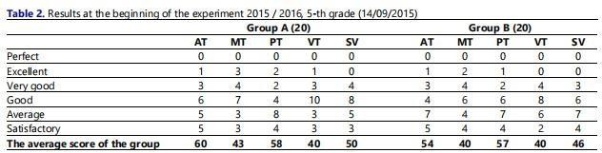

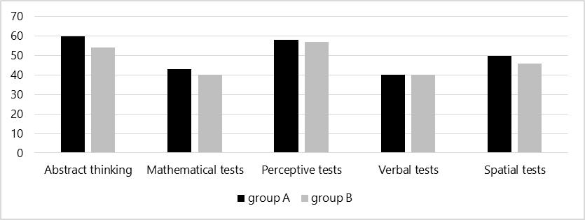

**Figure 1.** Comparison of average scores in the groups at the beginning of the experiment

As we can see from the chart, there is little difference in the results of perceptual and verbal tests. This is likely due to the fact that the pupils of the 5-th grade after 4 years of primary school have little distinction in perception and verbal presentation of information. The difference in solving mathematical tests, abstract tests and tests on spatial-visual thinking refers to the results of the work with group A in the previous period with the use of didactic tools, based on puzzles.

During the next academic year both groups had the same teacher and the same textbooks. Pupils of 5-а class attended a mathematical club based on the method “Lessons of developmental mathematics” (1 hour a week), where puzzles were used as a didactic tool. During the first two weeks of June, all students in both classrooms were urged to attend a mathematical camp titled "Mathematics. Creation. Intelligence." **Table 3** shows IQ results at the beginning of the shift (i.e. at the end of the analyzed academic year). Scoring was carried out on a scale for 12 year old pupils.

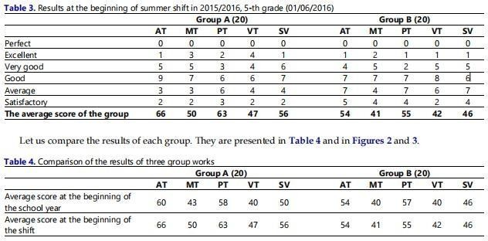

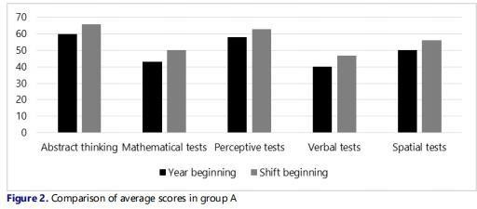

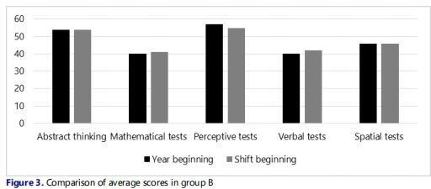

Let us note that group A had a significant increase in all indicators. We explain it by the fact that pupils of group A were taught by the program “Lessons of developmental mathematics”, and pupils of group B didn’t have this opportunity.Potentially both groups initially showed good capacity for intellectual activity, which was confirmed by the results of the check. Let us pay attention to the fact that the same type of materials (different options) were offered for tests. Нowever, the children did not purposefully solve the test tasks during the learning process. Instead of them different types of puzzles were used, the solution of which was very similar to certain tasks in IQ tests.

Thus, we came to the conclusion that the proposed methodology “Lessons of developmental mathematics”, which uses didactic tools based on puzzles, improves mathematical abilities of pupils: ability to think logically, ability to abstract thinking, combinatorial abilities, abilities at spatial representation and manipulation with spatial images, critical thinking abilities. Moreover, the influence of other teaching tools undoubtedly has an influence on the results. However, we have not seen such growth in similar classes earlier, when our worked out methodological model of using puzzles in the educational process has not been used.

## APPLICATIONS

By far the most important puzzle in the evolution of cognitive science has been the Tower of Hanoi. Herbert Simon dubbed it "the drosophila of cognition," according to Varma (2006). Despite the fact that Varma thought this claim was exaggerated, he nevertheless referred to this puzzle as "a trademark task of problem solving that has found wide applicability in fields like as working memory, intellect, executive function, and frontal lobe function". he also cataloged such applications in his PhD dissertation devoted to this problem. It's worth noting that modern cognitive science researchers rarely ask participants in their studies to build an algorithm for solving the Tower of Hanoi for any number of discs. Rather, they either ask subjects to solve the puzzle for a typically small number of disks or prescribe a particular procedure to follow, even allowing some training in its execution. While such arrangements may be suitable for gathering empirical data on the cognitive processes involved in solving individual instances of this issue, they are not suitable for developing a general solution for it.

The river crossing puzzle named Missionaries and Cannibals or Hobbits and Orcs is another algorithmic puzzle that has been utilised frequently in cognitive studies on problem solving; Water Jars, which asks to get a prescribed amount of water using three jars of given capacities; the Fifteen puzzle and its adaptations; and a few puzzles used in the tough area of insight research. We will concentrate on the latter in the remaining portion of this section. A sudden discovery of the solution to a problem that until that point had left the solver baffled. Puzzles of many types have been offered as instances of such difficulties, which is not surprising.

Surprisingly, the research on insight problem solving has been dominated by a small number of puzzles, dubbed "classic" by Chu and Macgregor (2011). Nine Dots, Cheap Necklace, Eight Coins, Ten-Coin Triangle, Mutilated Checkerboard, Socks, and Water Lilies are among the algorithmic puzzles available, as well as a number of additional verbal, spatial, and mathematical brain teasers. Newer additions to this limited repertoire include matchstick arithmetic with Roman numerals, compound remote associates (CRAs), and rebus puzzles. Despite the advantages of this enlargement of the insight issue universe, it's worth noting that CRAs and rebus puzzles, as well as other linguistic problems like anagrams and brainteasers based on alternative meanings of words in statements, all have the same flaw: their solutions require a

native-speaker command of a language used. Experiments employing language-dependent riddles presented to a heterogeneous student body can be affected in unforeseen ways if this is not taken into account. Algorithmic problems, on the other hand, do not have this flaw. Furthermore, the ability to change an algorithmic puzzle's input may give the researcher with a collection of similar problems of variable difficulty, which is a valuable feature for insight study.

Furthermore, a pure insight problem is defined as one in which restructuring is the only approach to address the problem; a hybrid insight problem is defined as one in which the problem can be solved both with and without restructuring. On the other hand, Ash, Cushen, and Wiley (2009) proposed that identifying insight difficulties directly by their impediments would be a preferable method. Recently, Weisberg (2015) suggested a more holistic model of the problem-solving process in which the traditional insight sequence of an impasse followed by a restructuring and an “Aha!'' The model was partly based on real data published by Fleck and Weisberg (2013) and its examination by the authors; the answer is simply one possible component of the process.

## CONCLUSION

In the course of studying various points of view on the development of mathematical abilities in children and adolescents, methodological approaches based on the teaching possibilities of a new teaching tool - mathematical puzzles - have been developed and applied in educational practice.Testing of various puzzles as a didactic tool in general and additional education of schoolchildren and preschool children for the development of their mathematical abilities allowed them to build methodological approaches to their inclusion in the process of teaching mathematics. As a result of studies and experienced teaching undertaken over the last three years by the creative group of mathematics and primary school teachers, methodological approaches have been established and significant concepts on the use of puzzles in the educational process have been recognized. Practical use of puzzles as a didactic tool allows to observe pupils’ progress in learning the subject.

Using puzzles as a tool improves pupils’ results in mastering program material. Monitoring of pupils’ learning results shows positive dynamics. When solving learning and extracurricular tasks students demonstrate creative thinking, initiative, resourcefulness, activity, ability to emotional perception of math problems and arguments, take responsibility for the choice of solving method and answer. So, puzzles may be the means to achieve not only learning, but also personal results. It should be also noted that during the last two years a school museum of entertaining sciences has been actively filled up with exhibits created by pupils, among them is a huge number of puzzles. Thus, the direct experience of puzzles used in additional education lets us come to the conclusion that their harmonious combination with the lessons activity provides realization of basic requirements for the results of mastering the basic educational program of basic general education, formulated in national educational standard. The indicators of this are participation and victories of our pupils in contests and Olympiads of various levels, and also the fact that students themselves are initiators of new mathematical activity based on solving and creating puzzles.

## REFERENCES

1. [https://scholar.google.com/scholar?hl=en&as_sdt=0%2C5&q=Mathematical+Puzzles+wi](https://scholar.google.com/scholar?hl=en&as_sdt=0%2C5&q=Mathematical%2BPuzzles%2Bwith%2Bapplications&oq=m) th+applications&oq=m
2. <https://ojs.aaai.org/index.php/aimagazine/article/view/2736>
3. <https://docs.lib.purdue.edu/jps/vol10/iss1/1/>