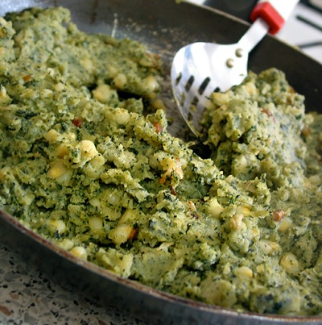

**Irio – Kikuyu and Meru Tradition**

1 1/2 cups ripe maize/corn (not dried)  
1/2 to 3/4 cup shelled peas  
3 medium potatoes  
2 Tbsp butter  
salt  
pepper

Place maize and peas in a pan with water and boil until almost soft. It should take about 1 hour, depending on the maize and peas. Add the potatoes and cook them until they readily mash. Add water as it is needed. When the mixture is soft mash it with a fork. Add salt, pepper, and the butter. Mix it and serve.

Makes 2 servings.