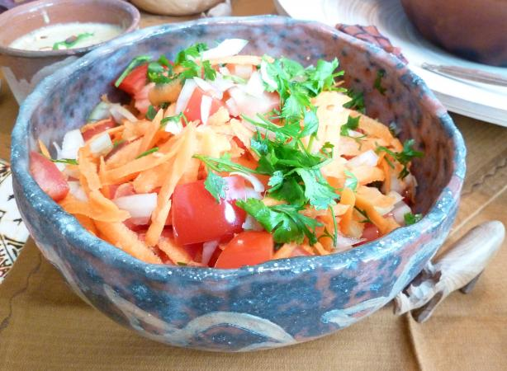

**Kachumbari**

**Recipe Ingredients**

* One Onion
* Two tomatoes
* One Bunch of Dhania
* Quater piece of cucumber
* Three tea spoons of vineger
* Salt to taste
* One pepper (Optional)

**Recipe Method**

* Cut the onion into very thin round pieces and put into a bowl
* Add two spoons of salt and mix with the cut onion then leave it for about five minutes.
* Cut the tomatoes into very thin round pieces and put into a bowl
* Cut the cucumber into thin round pieces and add to the bowl of tomatoes
* Cut the dhania into fine small pieces then add to the bowl of tomatoes and cucumber
* Wash the onions while squeezing them till they have no salt completely then add to the mixture.
* Cut the pepper into small pieces and add to the mixture
* Add the vineger to the mixture and some salt then mix everything with a spoon.
* Serve the kachumbari besides the main dish to be used as an appetizer or a salad