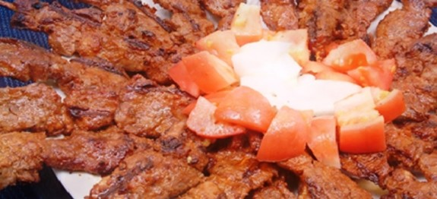

**Kilishi**

500g/llb top rump steak  
1 teaspoon ground chilli  
1 teaspoon ground peanuts  
with the ground chillies and peanuts,  
1 tablespoon groundnut oil  
salt to taste

**Method:**

Cut the meat into wafer thin slices. Season with the ground chillies and peanuts, mix in the oil and salt . Spread slices of meat on a flat tray, cover with a wire mesh and leave out in the hot sun for 2-3 days until completely dry. Alternatively, pieces of meat could be dried in the oven. Serve on its own as a snack.