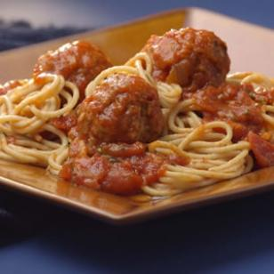

**Spaghetti & Meatballs**

Ingredients:

**Meatballs**

* 1/3 cup bulgur
* 1/2 cup hot water
* 115 grams lean ground beef
* 115 grams hot Italian sausage
* 1 medium onion, very finely chopped
* 2 large egg whites, lightly beaten
* 3 cloves garlic, very finely chopped
* 1 teaspoon dried oregano
* 1/2 teaspoon salt
* 1/2 teaspoon freshly ground pepper
* 1 cup fresh breadcrumbs, preferably whole-wheat (see Tip)

**Sauce & Spaghetti**

* 4 cups prepared marinara sauce
* 1/2 cup slivered fresh basil leaves, or chopped fresh parsley
* 1 pound whole-wheat spaghetti, or linguine
* 1/2 cup freshly grated Parmesan, or Romano cheese (1 ounce)

Method:

1. o prepare meatballs: Combine bulgur and water in a small bowl. Let stand until the bulgur is tender and the liquid is absorbed, about 30 minutes.
2. Preheat oven to 350°F. Coat a rack with cooking spray and place it over a baking sheet lined with foil.
3. Combine ground beef, sausage, onion, egg whites, garlic, oregano, salt, pepper, breadcrumbs and the soaked bulgur in a large bowl; mix well. Form the mixture into 1-inch meatballs (about 24). Place the meatballs on the rack and bake for 25 minutes. Blot well with paper towel.
4. To prepare sauce &amp; spaghetti: Put a large pot of lightly salted water on to boil. Bring sauce to a simmer in a Dutch oven. Add the meatballs to the sauce and simmer, covered, for 20 minutes. Stir in basil (or parsley).
5. Meanwhile, cook spaghetti (or linguine) until just tender, 8 to 10 minutes. Drain and transfer to a serving bowl. Top with the sauce and meatballs and serve with grated cheese.

**Tips & Notes**

* **Tip:** To make fresh breadcrumbs: Trim crusts from firm sandwich bread. Tear the bread into pieces and process in a food processor until coarse crumbs form. One slice makes about 1/3 cup