CS_HP_001
Positive
Verify Composition Service picks up the Pre-Processor event and begins processing — and only processes P records, never E records

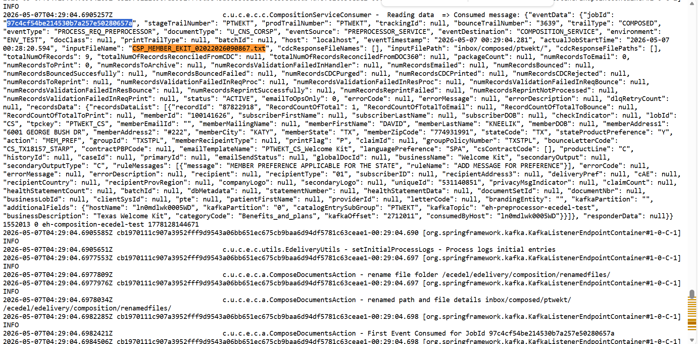

CS_HP_002
Positive
Verify output file contains ONLY P records, uses the exact same fixed-length layout as the input file, and excludes all E-routed records entirely

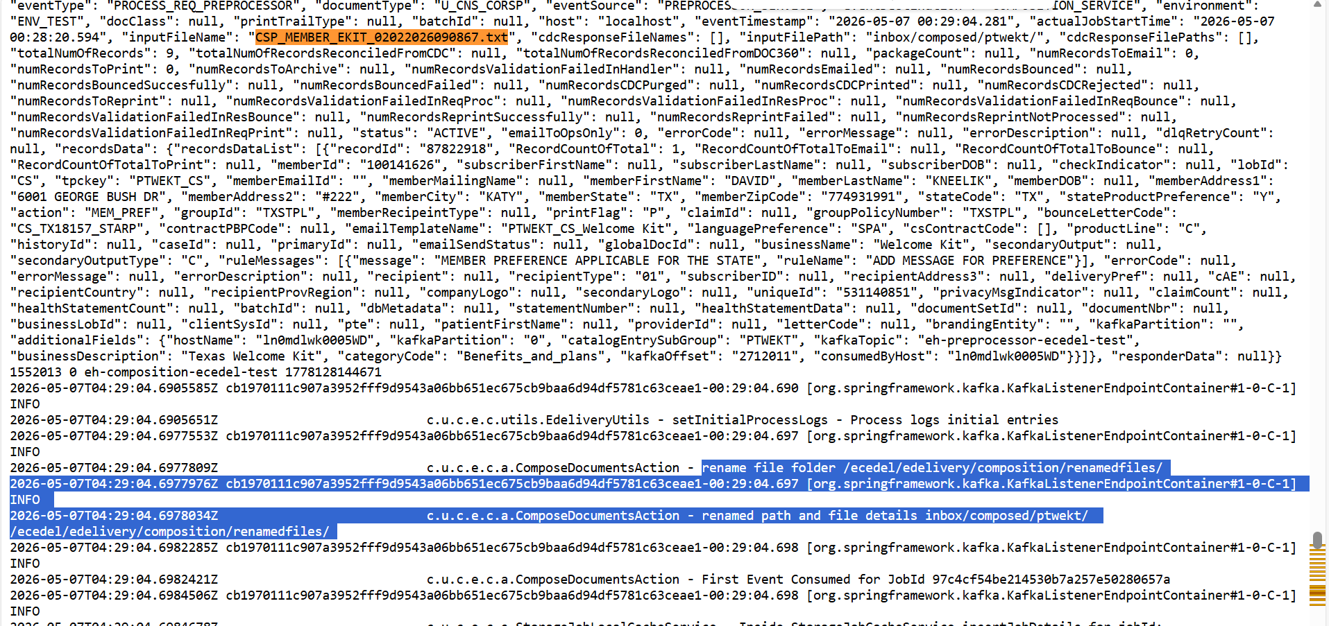

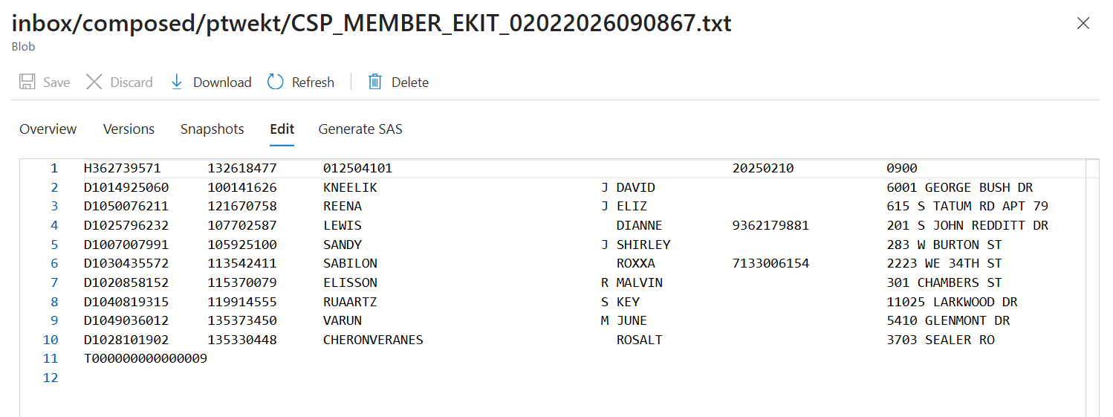

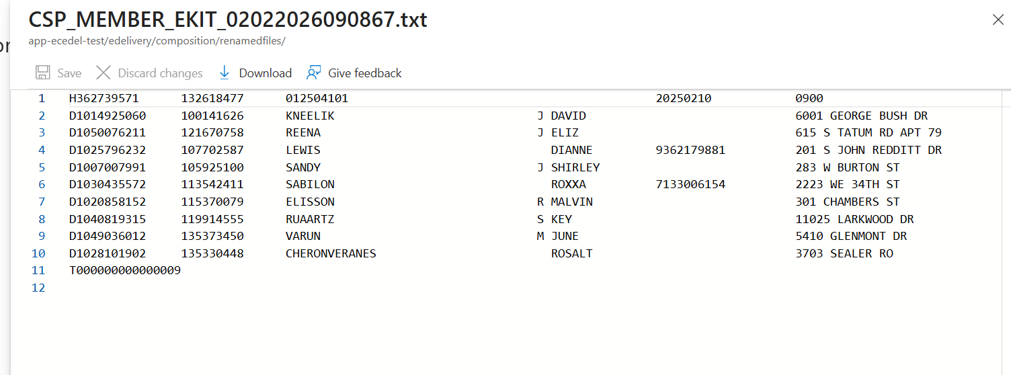

TEST 1 — Handler parsed 9 records


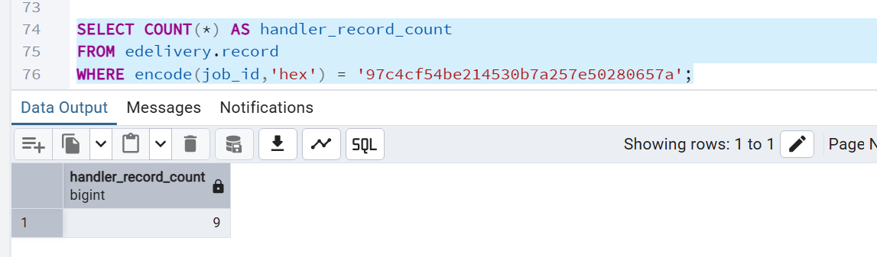
TEST 2 — Preprocessor made records P
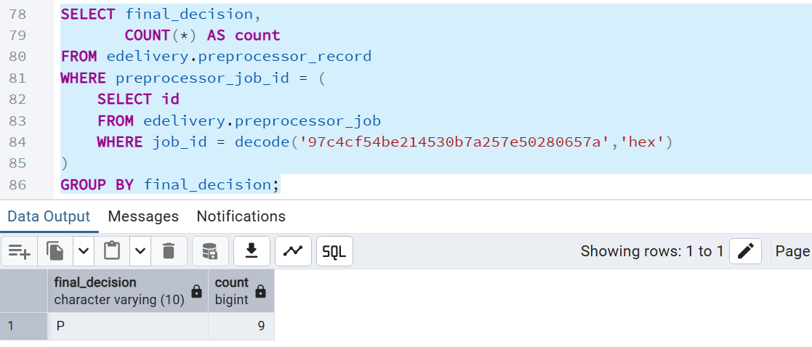

TEST 3 — Composition consumed and created storage job
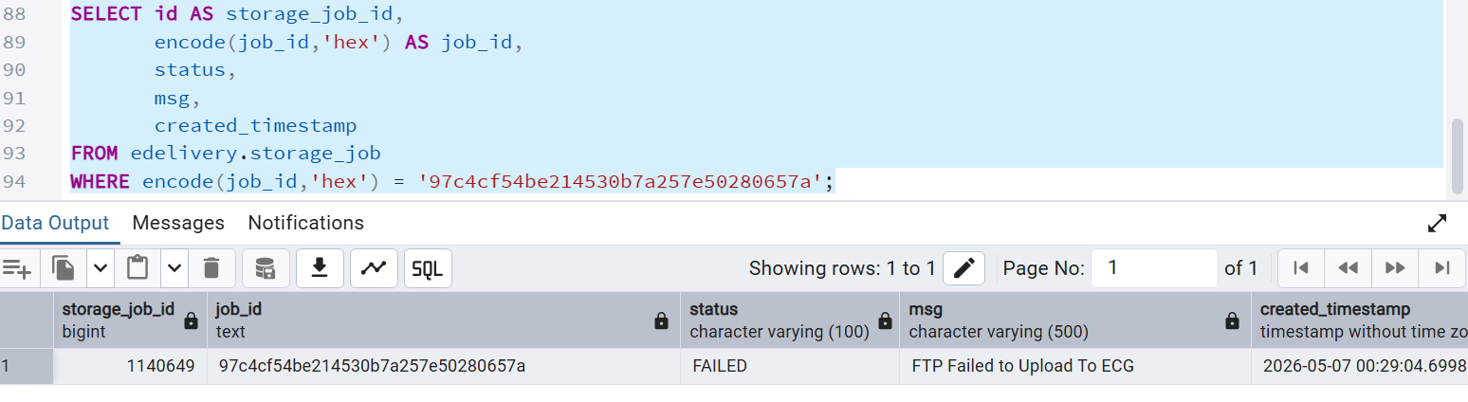

TEST 4 — Composition processed only P records
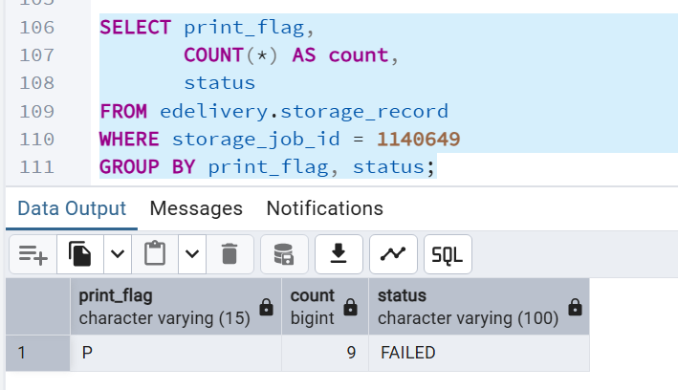

TEST 5 — Generated file exists
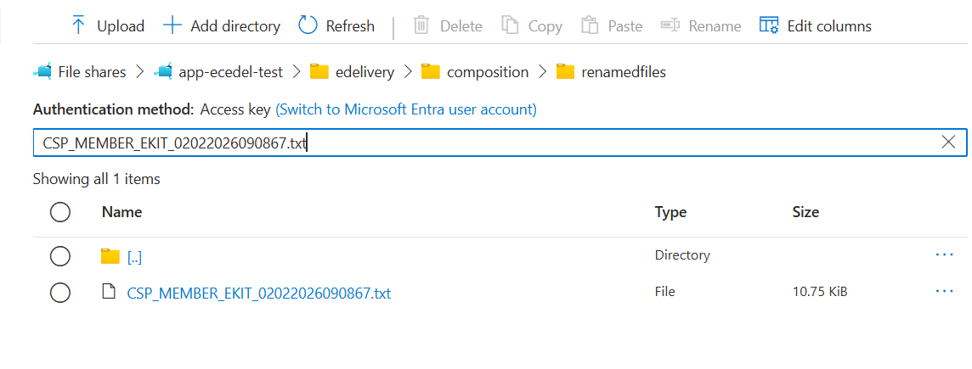
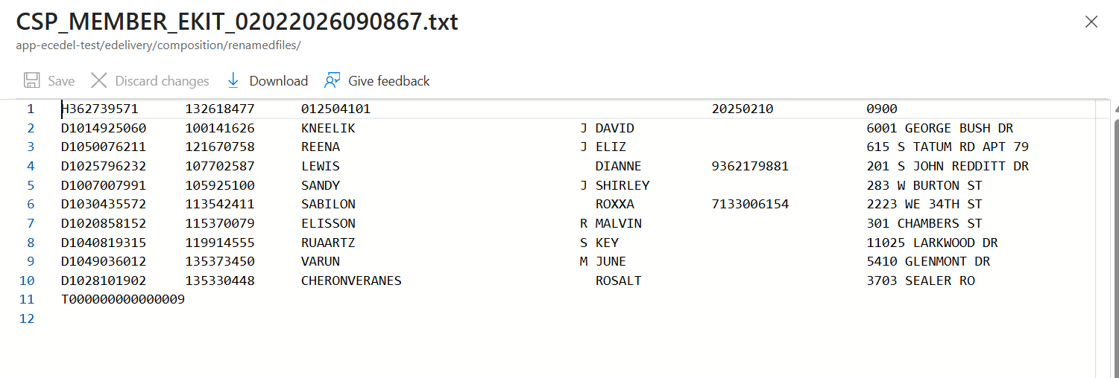

TEST 6 — Generated file layout and trailer

First line starts with H
Middle lines start with D
Last line starts with T
There are 9 D rows
T row has 000000000000009 at positions 2–16

TEST 7 — Offset validation

17–31 subscriberID
32–67 memberLastName
70–84 memberFirstName
105–144 memberAddress1
185–203 memberCity
204–205 memberState
206–216 memberZipCode
299–318 UniqueId
509–516 groupPolicyNumber
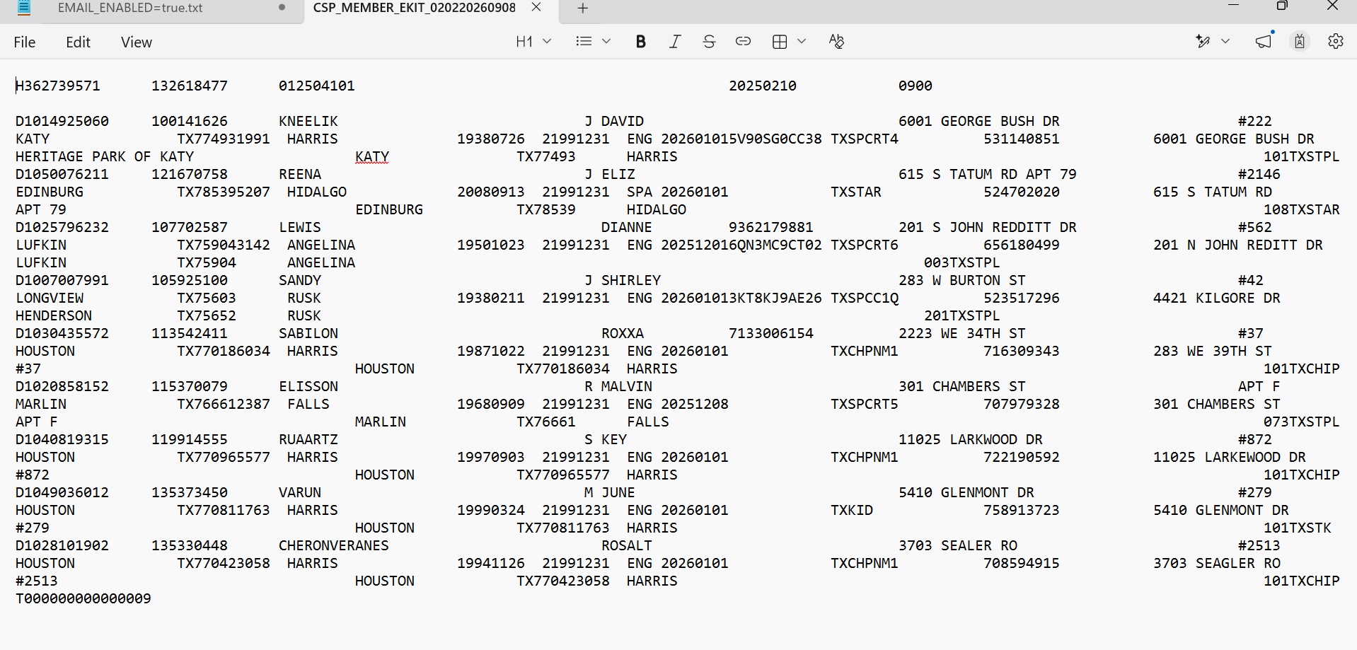
Test Case — CS_HP_MIXED_001
Test Case Name
Validate Composition processes only P records when input file contains both P and E decisions
