Document Name | Business Requirement Document
Trail ID | PTWEKT
Trail ID Name | Texas welcome kit
Created By | Dr. Swati Srivastava
Created Date | 04-13-2026

Trail Contacts:
Trail Owner
Product Owner | Max Rindels
Architect
Business Analyst | Marie Guthrie
Business Process Consultant | Renee Seran
Development Lead | Rajaram Kerkar

Revision History:
Date | Version | Description | Author | Reviewer
12/17/2025 | 1.0 | Initial Draft | Dr. Swati Srivastava

Table of Contents
1. Purpose 3
2. High level business flow-UCS Platform 3
3. Print Trail Specific information 4
4. Architecture Diagram 4
5. Involved Microservices 4
6. E-Delivery Detailed Architecture 5
6.1 Trail Listener (TL): 5
6.2 Handler 7
6.3 Pre-Processor Service 9
6.4 Composition Service 12
6.5 Processor Service 13
6.6 Invalid API Call EPMP 15
6.7 Bounce Service 15
6.8 Responder Service 16

E-Delivery Enablement for PTWEKT:

Purpose
The purpose of this Business Requirements Document (BRD) is to define the functional and integration requirements for the new trail that facilitates the generation, distribution, and delivery of member communication materials.
This trail ensures seamless connectivity between upstream and downstream systems, enabling accurate and timely delivery of both printed and digital member kits.
The process flow involves:
- Input Source: Member data originating from CSP FACETS.
- Processing: UCS retrieves member preferences from EPMP and generates appropriate material files (printed and e-materials).
- Distribution:
  - Printed materials are sent to the Materials Vendor (RRD) for physical fulfillment.
  - E-delivery materials are routed through Salesforce for email
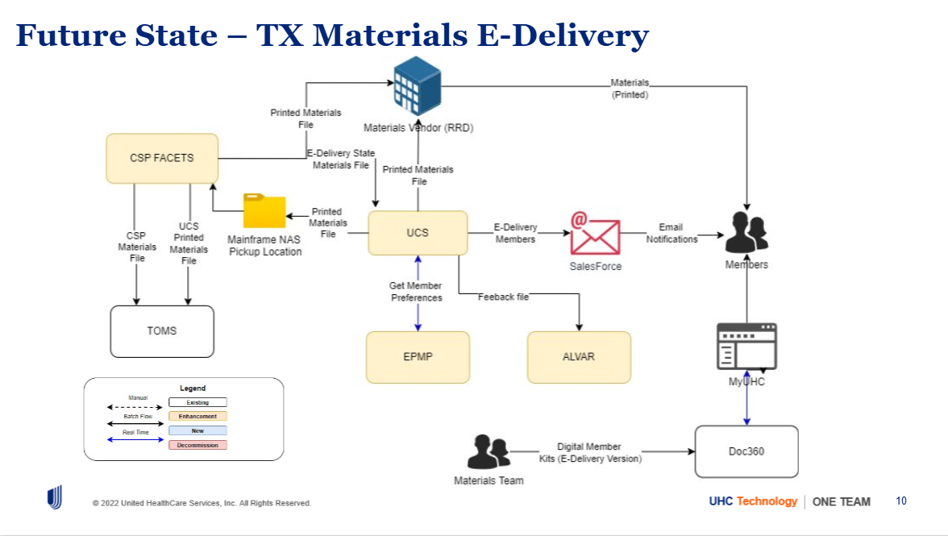
.

High level business flow-UCS Platform
UCS is a platform to process transactional communication like Letters, documents and facilitate their delivery to the member electronically or print mail based on Member’s preference.

UCS receives input file from the source system and executes rules housed in Rules Engine (IBM Operational Decision Manager) to determine state regulations and segmentation rules. It also looks up touch point catalog in the rules engine to determine Line of business (LOB) and LOB specific templates. Platform validates the member delivery preference. Based on the outcome of the rules, the engine determines if the document needs to be printed or emailed.
All P records will be sent to RRD and CSP Facets; RRD would then print and mail the letters to the member.

For all documents which need to be emailed, UCS would create a request file to be sent to Salesforce. for which Salesforce will have an automation process built to receive the request in files. Once Salesforce has received the requests. It will use the Templates housed in Salesforce to create and send email to the members. The engine will periodically check the email send status and will retrieve the status once the processing at Salesforce is completed. In case any email has not been delivered, a bounce letter request will be created and sent to CDC/Shutterfly to print a bounce letter to the member

The engine will aggregate all responses received from Salesforce and RRD and will send the response to the upstream application and Alvar.

Print Trail Specific information

Document type of communication | Texas Welcome kit
Type of Trail | Composed
Line of Business (LOB) | CS
Source System/Upstream application | CSP Facets
Service level agreement (SLA) | Standard: ~24 hours
Input file volume | Monthly Average 11k-12K  8,754 – 14,709 per month (min–max across the 6 months)
Input file size
File Frequency | 1 Daily file received from RRD
Doc Class | Not required-No Doc360 ingestion required from UCS application
Doc Type | Welcome Kit
Letter Code
Bounce Letter Code
E mail template name
TPC Key

Architecture Diagram
Architecture Diagram (Visio)
SharePoint URL :

Involved Microservices
E-delivery Engine’s Micro services affecting flow are as mentioned below:
- Trail Listener
- Handler
- Pre-Processor
- Composition
- Processor
- Bounce
- Responder
- Feedback file function

E-Delivery Detailed Architecture

6.1 Trail Listener (TL):
Goal- To intake all input files received from Shutterfly (Source system) via ECG cockpit

Listener specific requirement
6.1.1 Input Files will be received from upstream application Shutterfly through CDC to EE ECG connection.
6.1.2 The files will be dropped to blob storage at below Azure landing zone
ENV | Container | Path
CPTTSTAGE | cont-ecedel-cpttstage | inbox/composed/ptWEKT
PROD | cont-ecsp-prod | inbox/composed/ptWEKT

6.1.3 Input file specification:
- Fixed length text file
- CSP_MEMBER_EKIT_MMDDYYHHMMSS.txt
- Maximum file size-
- Number of records per file –
- Volumes
- 1) Monthly print volume table (baseline)
- Jun-25: Total 14,709
- Jul-25: Total 12,053
- Aug-25: Total 12,666
- Sep-25: Total 11,528
- Oct-25: Total 12,648
- Nov-25: Total 8,754
- 2) 6month averages (rounded)
- TX Star Kids: 437 / month
- Star: 5,016 / month
- CHIP: 599 / month
- Star +: 6,008 / month
- Total: 12,060 / month (baseline monthly print volume)
- 3) Total monthly range (for sizing)
- 8,754 – 14,709 per month (min–max across the 6 months)
6.1.4 After the file is dropped Listener will make a new entry in “job table” in database and generate a unique 16-digit job id for every file and update the status as “NEW”
For example- 3988e446ba66407a91e048192ea7ce56

id | source | trail_num | start_timestamp | data | msg | finish_timestamp | status | created_by | updated_by | filename | individual_filename

6.1.5 If input file is received with a duplicate name, the new file will override the existing file and a failed event will be sent to responder service, mail will be triggered by responder service to source system. Responder service will send an event to listener service for updating the” job table” with status as failed against that newly created job id.

6.1.6 If there is any database error, Listener service sends an event to Responder Service and responder service sends a mail to operations team for information and rectification.

6.1.7 Trail listener will update the Kafka event with information below and send the event to handler service.

Sample schema of event:
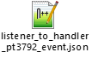
6.1.8 Listener will receive the event from handler after Parsing of the input file for updating the Status as “ACTIVE” in “job table”

6.1.9 Listener service will receive the events from Responder Service to mark the job as completed or failed based on the processing outcome of other microservices

6.2 Handler
Goal- Validate the intake request for data correctness, mandatory elements, run standardization request if required. Create entries on the tables.

Handler specific requirement
6.2.1 Handler service will receive events from listener service.
6.2.2 The received input files from the source system will be unzipped at the below share point location-file-share/edelivery/handler/downloads
6.2.3 Validate the name of file as per below naming convention, Zip file will contain text file
- CSP_MEMBER_EKIT_MMDDYYHHMMSS.txt
If the names do not match, reject the file. Handler service will send an event to Responder Service and responder service will send a mail to operations team for information and rectification. Responder service will send an event to listener service for updating the” job table” with status as failed against the job id.
6.2.4 Parse the mentioned values from input file and populate the event as per the mapping below.
Field Name | Engine Field Name | Needed by Engine Y/N | Sample Value | Start Location | Stop Location | Data Type/Field Length
Row Type |  | N |  | 1 | 1 | 0
SBSB_ID | subscriberID | Y | SUBSCRIBERID | 17 | 31 | 15
SBSB_NAME - LAST | memberLastName | Y | Jones | 32 | 67 | 36
SBSB_NAME - FIRST | memberFirstName | Y | Mary | 70 | 84 | 15
SBAD_ADDR1 | memberAddress1 | Y | 110 Main Street | 105 | 144 | 40
SBAD_ADDR2 | memberAddress2 | N | Apt. B | 145 | 184 | 40
SBAD_CITY | memberCity | Y | Charleston | 185 | 203 | 19
SBAD_STATE | memberState | Y | SC | 204 | 205 | 2
SBAD_ZIP | memberZipCode | Y | 29414 | 206 | 216 | 11
MEDICAID ID | UniqueId | Y |  | 299 | 318 | 20
Group_ID | groupPolicyNumber | Y | KSMCD01 | 509 | 516 | 8

6.2.5 Set the TPC key as PTWEKT_CS , LOBID-CS, Set state indicator as “TX”.
6.2.6 Verify that the input file begins with a Header record identified by Row Type “H” at start position 1, and that it is immediately followed by one or more Detail records identified by Row Type “D” at start position 1.
Acceptance Criteria:
- The first record in the file must have Row Type = “H” at position 1.
- The header record must be followed by at least one record with Row Type = “D” at position 1.
- If the header record is missing, misplaced, or not followed by a detail record, the file should be rejected .
6.2.7 Validate the record count in the trailer/footer by matching the number of Detail records (Row Type “D”) in the file with the count value present in the footer.
Validation Rules:
- Count all records in the file where Row Type = “D” at start position 1.
- Extract the trailer record count from the footer Row Type =”T”, located at Offset positions 2–16.
- The extracted trailer count must exactly match the total number of Detail (“D”) records.
- If there is a mismatch between the calculated count and the trailer count, the file should be rejected or for error handling.

6.2.8 If any mandatory field is missing in a record or if received blank record in input file:
- Skip processing that record.
- Log the error in an `error.csv` file. Log the record id, failed field name and error message in error file.
UCS sends an email notification to the source system via responder system and provides an error file containing details of the rejected records via Handler system.
NON-Prod -
PROD -
- The file is attached to the email notification and named:
<CSP_MEMBER_EKIT_MMDDYYHHMMSS.txt>_error.csv
Header of the Error File:
Line Number | Unique ID | Claim ID | Member ID | Field Name | Error Message
Sample Email notification:
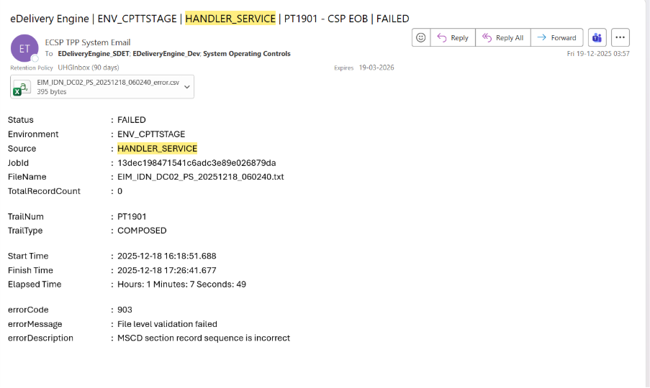

6.2.9 Handler will send an event to listener service to update “job table” with status “ACTIVE”.
6.2.10 Handler service will read the input file and insert corresponding records in the record table with STATUS ACTIVE. (Data column has JSON which includes RecordID)
job_id | start_timestamp | data | status | created_by

6.2.11 Send an event to Responder service.

6.3 Pre-Processor Service

6.3.1 Read the event from Handler service.
6.3.2 Make the ODM call for running TPC using below input attributes with appropriate values from event:
- {
"request": {
"header": {
"printTrailID": "PTWEKT"
},
"fields": {
"recordID": "61768382",
"tpcKey": "PTWEKT_CS",
"businessLobId": "EI",
"recipientType": "01",
"groupID": "TXSTPL",
"stateCode": "TX",
"memberID": "100141626"
}
}
}

6.3.4 Validate the ODM Response for below output parameters.
Response:
{
"__DecisionID__": "d4285bbf-175f-494d-894a-95b68fef43d40",
"response": {
"printTrailID": "PTWEKT",
"action": "MEM_PREF",
"stateProductPreference": "Y",
"memberID": "100141626",
"recipientType": "01",
"recordID": "61768382",
"groupIdName": "TEXAS STARPLUS",
"productType": "C",
"languagePreference": "SPA",
"bounceLetterCode": "CS_TX18157_STARP",
"csContractCode": [],
"ruleMessages": [
{
"message": "MEMBER PREFERENCE APPLICABLE FOR THE STATE",
"ruleName": "ADD MESSAGE FOR PREFERENCE"
}
],
"paperlessDocAvailableEmail": "",
"failedPaperlessDeliveryLetter": "",
"welcomeToPaperlessEmail": "",
"touchPointCatalog": {
"stagePrintTrailId": "PTWEKT",
"prodPrintTrailId": "",
"applicationOwner": "CSP Facets",
"businessOwner": "Kelly Swart",
"communicationOwner": "Kelly Swart",
"lobID": "CS",
"catalogEntrySubGroup": "PTWEKT",
"emailTemplateName": "PTWEKT_CS_Welcome Kit",
"businessName": "Welcome Kit",
"description": "Texas Welcome Kit",
"categoryCode": "Benefits_and_plans",
"documentType": "Welcome Kit",
"preferenceType": "Paperless_Settings",
"beginEffectiveDate": "2026-02-01T05:00:00.000+0000",
"endEffectiveDate": "9999-01-01T05:00:00.000+0000",
"defaultOutputType": "E",
"secondaryOutputType": "C",
"retryAttempts": 0

6.3.5 Only the below mentioned field values should be extracted from ODM Response against the corresponding fields in event:
- printTrailID,
- action
- stateProductPreference
- memberID
- recordID
- groupIdName
- productType
- languagePreference
- bounceLetterCode
- ruleMessages
- message
- ruleName
- lobID
- emailTemplateName
- businessName

6.3.6 The ACTION returned from ODM can be one of the following:
- PRINT
- EMAIL
- MEM_PREF

6.3.7 When ACTION from ODM is PRINT, Preprocessor to set the “printFlag” value to P for that record.

6.3.8 When ACTION from ODM is MEM_PREF, preprocessor to call EPMP Pref API and get the Member’s preference by using below input fields:
{
"user_id": "test_id",
"calling_app_name": "UHC_Edelivery",
"user_type": "member",
"customer_identifiers": [
{
"id": "100141626",
"type": "MBRGPS"
}
]
}

Set the “printFlag” value to ‘P’ if the retrieved member preference is “PM” in the EPMP response.
Set the “printFlag” value to ‘E’ if the retrieved member preference is “EM” in the EPMP response.
6.3.9 Record the Member’s preference in event and send event to Composition service
6.3.10 Send the P records event to Composition service.
6.3.11 Send the E records event to Processor Service .
6.2.13 Send an event to Responder service
6.3.14 Send a failed event to Responder when an internal to EE technical issue is encountered while calling ODM, Responder to report to Ops team by sending email with HIGH importance.
6.3.15 When ODM or stargate is down: Engine retries for 3 times. If the prob persists, then the records are sent to DLT topic

6.4 Composition Service
6.4.1 Consume the event emitted by the Preprocessor Service to initiate downstream processing.
6.4.2 Generate an output file using the same file layout and format as the input file, containing only records identified as Row Type = “P”.
6.4.3 Update the trailer record in the generated file with Row Type = “T”, ensuring the record count is populated at Offset positions 2–16. The trailer count must reflect the total number of records present in the generated output file.
6.4.4 Share the generated file with RRD via ECG using the configured environments for PROD and NON‑PROD.
6.4.5 Receive the standard response file from RRD. The response file naming convention will be:
CSP_MEMBER_EKIT_MMDDYYHHMMSS.txt_Response_ACCEPTED.txt
CSP_MEMBER_EKIT_MMDDYYHHMMSS.txt_Response_REJECTED.txt
6.4.6 The CDC response file will contain the following headers and corresponding values:
Headers: Field1, Field2, Status
Values: MemberID, UniqueID, Status
6.4.7 For RRD Accepted response files, the possible status is ACCEPTED. Update the status as “ACCEPTED” in the Composition Record table for all accepted records.
6.4.8 For RRD Rejected response files, the possible status is REJECTED. Update the status as “REJECTED” in the Composition Record table for all rejected records.
6.4.9 For a Rejected response file, send a failed event to the Responder Service. The Responder will mark the job as failed and report the failure back to the source system.
6.4.10 If the ECG file transfer fails, send an email notification to the DevOps team. DevOps will manually place the file at the ECG target location.
6.4.11 Send a success event to the Responder Service once RRD response reconciliation is completed successfully.

6.5 Processor Service
6.5.1 Consume E events from the Preprocessor Service.
6.5.2 On an hourly basis, consolidate different Salesforce request files based on Line of Business (LOB) (LOB value to be derived from the event‑CS) and Print Trail (PT), and generate the Salesforce request file.
6.5.3 Send the merged email request file to Salesforce.
6.5.4 The Processor Service will transfer the Salesforce request file with the following headers:
- GroupID
- RecordID
- MemberFirstName – Value must be mapped from the Member_First_Name event field
- EmailTemplateName – Value must be received from the ODM Response event
- EEjobID
- ProductType – Value must be received from the productType field in the ODM Response event
- Email – Value must be mapped from the memberemail event field
- LetterCode – Value must be received from the LetterCode event field
- BusinessName – Value must be received from the ODM Response event
6.5.5 Send an event to the Responder Service.
6.5.6 Salesforce will send two different reports back to the Engine, namely:
- Email Attempt report for all records sent to Salesforce
- Bounce report for only bounced records
6.5.7 Salesforce will process the request file and send a response file containing only bounced records to the Engine with the following headers:
- RecordID
- Email
- EmailTemplateName
- EEJobID
- DeliveryStatus
- BounceCategory
- StatusDateTime
6.5.8 After Salesforce sends the response file, send an event to the Bounce Service to initiate the bounce process.
6.5.9 As and when Salesforce sends the Email Attempt report to the Engine (hourly), the Engine shall update the processor_record database table by setting the delivery_status column to “Attempt” for the corresponding record ID and updating the status_timestamp.

6.6 Invalid API Call EPMP
Call the Invalid API from Processor service to report the bad email address

6.7 Bounce Service
6.7.1 For all members who receive a Bounce response from Salesforce, initiate the bounce process by generating and sending a Bounce Request file to Shutterfly using Print Trail PT3639.
Direction | PROD Config ID
Outbound (UCS → CDC) | 21B0F
Inbound (CDC → UCS) | 21D4A
6.7.2 While generating the Bounce Request file, map the memberEmail event field value to the EMAIL header in the file. The CDC Bounce Request file is a pipe-separated CSV file without a header.
File Naming Convention: <CS>_REQ_3639_<UCSBounceID>_<PART001>_YYYYMMDDHHmmss_prod.csv
6.7.3 Validate that the following fields are populated as per the mapping rules while generating the Bounce Request file. All listed fields are mandatory unless explicitly stated as Blank:
- LTR CODE – Map from bounceLetterCode
- STATE INDICATOR – Map from stateCode
- MEMBER FIRST NAME – Map from memberFirstName
- MEMBER LAST NAME – Map from memberLastName
- MEMBER MAIL ADDRESS 1 – Map from memberAddress1
- MEMBER MAIL ADDRESS 2 – Map from memberAddress2
- MEMBER MAIL ADDRESS CITY – Map from memberCity
- MEMBER MAIL ADDRESS STATE – Map from memberState
- MEMBER MAIL ADDRESS ZIP CODE – Map from memberZipCode
- MEMBER ID – Map from memberId
- GROUP ID – Map from groupId
- LANGUAGE PREFERENCE – Leave Blank
- CONTRACT PBP – Leave Blank
- JOB_ID – Map from jobId
- RECORD_ID – Map from recordId
- STATUS – Populate as per bounce processing rules
- PRINT_MAIL_DATE – Populate as per print processing requirements
- PRINT TRAIL ID – Map from prodTrailNumber
- BUSINESS_NAME – Map from businessName
- PASS_THRU INFO – Leave Blank
- MEMBER MAIL ADDRESS 3 – Map from recipientAddress3
- MEMBER MAIL ADDRESS COUNTRY – Map from recipientCountry
- MEMBER MAIL ADDRESS PROV REGION – Leave Blank
- EMAIL – Map from memberEmailId
6.7.4 Validate that the Business Name value is present in the incoming event before generating the Bounce Request file. If missing, the record must be flagged as invalid.
6.7.5 After successfully sending the Bounce Request file, publish an event to the Responder Service.
6.7.6 Perform bounce reconciliation using the Bounce Response file received from Shutterfly by validating record status and updating the system accordingly.

The CDC Bounce Response file is a pipe-separated CSV file and includes the following header fields in the specified order:
File Naming Convention: <CS>_RESP_3639_< UCSBounceID >_YYYYMMDDHHmmss_SUCCESS_prod.zip

6.8 Responder Service

6.8.1 Responder to send failure email notification to upstream for below error codes:
Error Codes | Error Description | Comments (Example scenarios when these errors will be triggered)
901 | FileNameValidationException. Filename doesn’t comply to standards | Thrown when filename is incorrect/not as per standard
903 | FileValidationException. File validation failed | For eg:  - If the sequence of the records is not as per layout, for eg: No EOB record followed by PKG layout
904 | RecordValidationException. Record validation failed | Any record level validation failure will have this error thrown.  For eg: Mandatory value not found
906 | Parsing Exception, parsing failed | Eg: when a field's offset is not as expected, unexpected Blank records in file
1401 | Received Rejected Zip from CDC | If CDC rejects the file
1102 | File Upload to ECG Failed | For this, ECG team will be involved to get the issue fixed

6.8.2 In case of any file rejection event from Handler, send an email notification to following DLs in below format to upstream.

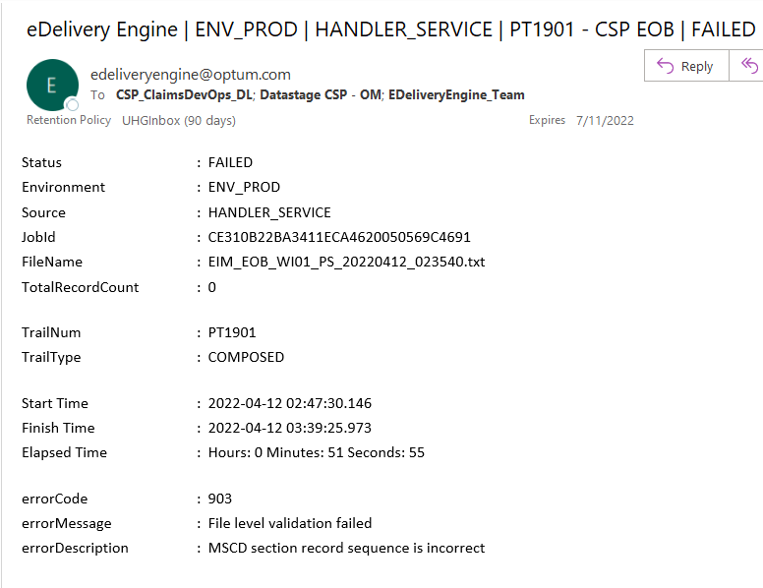

First email notification will be sent out once all records of a Job have “Attempt” status in Processor record table, processor will send an event to responder and Responder to send out an email notification in below format to EE Dev Ops, upstream (CSP).

Second email notification should be sent out for the same Job once the job is marked as completed in Responder.

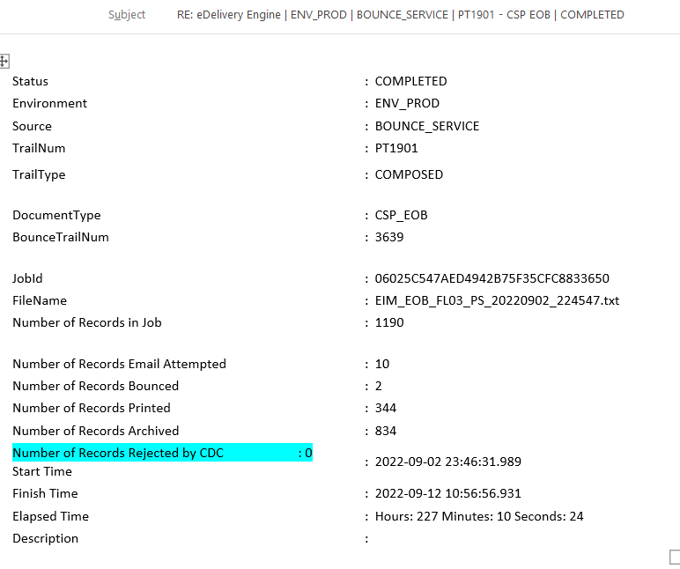

6.9 Feedback file function
6.9.1 After processing is complete, UCS generates a Feedback File to notify the source system about the status of records ingested and processed. This file provides confirmation and any relevant status updates for each record.
Non Prod: ECG Config ID - CAAAMEK
eDelivery_Feedback_PTWEKT_Record_YYYYMMDDHHmmss
S.No | JSON Attribute | Comments
1 | Print Trail | PTWEKT
2 | docType | Name of the letter being printed for the PT
3 | jobId | Engine's Job ID
4 | recordId | Engine's Record ID for Record level Processing only
5 | uniqueId1 | Unique ID (medicaidid)mapped to upstream
6 | source | Engine's Webservice Name
7 | environment | Test, Stage, Prod
8 | zipName | Input Zip filename
9 | fileName | Individual PDF file name for Record level Processing only
10 | recordCountTotal | Needed for File level response reporting
11 | recordCountEmailed | Needed for File level response reporting
12 | recordCountBounced | Needed for File level response reporting
13 | recordCountPrinted | Needed for File level response reporting
14 | recordCountArchived | Needed for File level response reporting
15 | startTimestamp | Timestamp when Engine starts the file processing
16 | finishTimestamp | Last Updated timestamp after the job is marked as completed
17 | elapsedTime | Difference between Start & Finish time
18 | deliveryMethod | Email
19 | fileStatus | Need for Job level reporting only
 |  | Status: Received, Success, Failed
20 | emailStatus | Need for Record level reporting only
 |  | Status: EmailAttempt
21 | bounceStatus | Need for Record level reporting only
 |  | Status: emailed Bounced
22 | printStatus | Need for Record level reporting only
 |  | Status: print
23 | fulfilledTimestamp | EmailAttempt: Date & time stamp from the Sales Force response file when the response is received for that record.
 |  | Bounce: Date & time stamp of, when the Bounce request file was sent from engine to Shutterfly
 |  | Print: Date & timestamp when Engine receives CDC response with accepted status for that record
 |  | Success: Date & time stamp when Engine marked the job as completed
 |  | Failed: DO NOT send any value in this field
24 | errorCode | Send the Engine's Error code
25 | errorDescription | Send the Error description of corresponding error code
26 | caseID
27 | emailStatus | Member email address

