In [1]: import os os.getcwd() os.chdir('C:\\Users\\anuoo\\Desktop')

In [2]:
import pandas as pd
In [3]:
pd.read_csv("Churn_Modelling.csv")
^{Out[3]:} RowNumber CustomerId Surname CreditScore Geography Gender Age Tenure Balance NumOfProducts HasCrCard IsActiveMember Es

0 1 15634602 Hargrave 619 France Female 42 2 0.00 1 1 1

1 2 15647311 Hill 608 Spain Female 41 1 83807.86 1 0 1
2 3 15619304 Onio 502 France Female 42 8 159660.80 3 1 0

3 4 15701354 Boni 699 France Female 39 1 0.00 2 0 0
4 5 15737888 Mitchell 850 Spain Female 43 2 125510.82 1 1 1 ... ... ... ... ... ... ... ... ... ... ... ... ...
- 9996 15606229 Obijiaku 771 France Male 39 5 0.00 2 1 0
- 9997 15569892 Johnstone 516 France Male 35 10 57369.61 1 1 1
- 9998 15584532 Liu 709 France Female 36 7 0.00 1 0 1
- 9999 15682355 Sabbatini 772 Germany Male 42 3 75075.31 2 1 0
- 10000 15628319 Walker 792 France Female 28 4 130142.79 1 1 0
- rows × 14 columns

In [4]:
#df.tail()
In [5]:
import numpy as np
In [6]:
import seaborn as sns import matplotlib.pyplot as plt from scipy import stats import warnings warnings.filterwarnings("ignore") sns.set(style="darkgrid",font_scale=1.5)
In [7]:
from sklearn.tree import DecisionTreeClassifier from sklearn.ensemble import RandomForestClassifier
In [8]:
0 1 15634602 Hargrave 619 France Female 42 2 0.00 1 1 1
1 2 15647311 Hill 608 Spain Female 41 1 83807.86 1 0 1
3 4 15701354 Boni 699 France Female 39 1 0.00 2 0 04 5 15737888 Mitchell 850 Spain Female 43 2 125510.82 1 1 1

from sklearn.preprocessing import LabelEncoder, OneHotEncoder from sklearn.model_selection import train_test_split, GridSearchCV from sklearn.metrics import accuracy_score, precision_score, recall_score ,f1_score from sklearn.metrics import confusion_matrix, roc_curve, roc_auc_score
In [9]:
df = pd.read_csv("Churn_Modelling.csv")
In [10]: df.head()
^{Out[10]:} RowNumber CustomerId Surname CreditScore Geography Gender Age Tenure Balance NumOfProducts HasCrCard IsActiveMember Estim
2 3 15619304 Onio 502 France Female 42 8 159660.80 3 1 0

In [11]: df.columns
Out[11]:Index(['RowNumber', 'CustomerId', 'Surname', 'CreditScore', 'Geography',
'Gender', 'Age', 'Tenure', 'Balance', 'NumOfProducts', 'HasCrCard',
'IsActiveMember', 'EstimatedSalary', 'Exited'], dtype='object')
In [12]: print("Total number of records/rows present in the dataset is:",df.shape[0]) print("Total number of attributes/columns present in the dataset is:",df.shape[1])
Total number of records/rows present in the dataset is: 10000 Total number of attributes/columns present in the dataset is: 14
In [13]:
df.info()
<class 'pandas.core.frame.DataFrame'>
RangeIndex: 10000 entries, 0 to 9999
Data columns (total 14 columns):
# Column Non-Null Count Dtype
--- ------ -------------- -----
- RowNumber 10000 non-null int64
- CustomerId 10000 non-null int64
- Surname 10000 non-null object
- CreditScore 10000 non-null int64
- Geography 10000 non-null object
- Gender 10000 non-null object
- Age 10000 non-null int64
- Tenure 10000 non-null int64
- Balance 10000 non-null float64
- NumOfProducts 10000 non-null int64
- HasCrCard 10000 non-null int64
- IsActiveMember 10000 non-null int64
- EstimatedSalary 10000 non-null float64 13 Exited 10000 non-null int64 dtypes: float64(2), int64(9), object(3) memory usage: 1.1+ MB
In [14]: df.isnull().sum().to_frame().rename(columns={0:"Total No. of Missing Values"})
^{Out[14]:} Total No. of Missing
Values
RowNumber 0
CustomerId 0
Surname 0
CreditScore 0
Geography 0
Gender 0
Age 0
Tenure 0
Balance 0
NumOfProducts 0
HasCrCard 0
IsActiveMember 0
EstimatedSalary 0
Exited 0
In [15]: df[df.duplicated()]
In [16]:  df.describe(include=  Out[16]: _{count}  Surname 10000  Geography 10000  Gender 10000  In [17]:  df.sample(5)  Out[17]: RowNumber  4713 4714  7119 7120  2496 2497  6107 6108  770 771 |  | "object").T  unique top freq  2921 Lo 33  3 France 5014  2 Male 5457  CustomerId Surname  15764448 Mackenzie  15636478 Williams  15625623 Stevenson  15737910 Houghton  15584091 Pitts | CreditScore  837  621  567  703  742 | Geography  Germany  France  France  Germany  Germany | Gender Male  Male  Female  Male Female | Age  35  31  45  35  36 | Tenure  0  7  4  5  2 | Balance  144037.60  136658.61  0.00 140691.08  129748.54 | NumOfProducts  1  1  2  2  2 | HasCrCard  1  1  0  1  0 |  |  | IsActiveMember  0  1  1  0  0
 |  |  |  |  |  |  |  |  |  |  | 

^{Out[15]:} RowNumber CustomerId Surname CreditScore Geography Gender Age Tenure Balance NumOfProducts HasCrCard IsActiveMember Estimate
E
In [18]: df.drop(columns=["RowNumber","CustomerId","Surname"],inplace=True)
In [19]: df.rename(columns={"Exited":"Churned"},inplace=True)
In [20]:
df.head()
^{Out[20]:}
CreditScore Geography Gender Age Tenure Balance NumOfProducts HasCrCard IsActiveMember EstimatedSalary Churned
- 619 France Female 42 2 0.00 1 1 1 101348.88 1
- 608 Spain Female 41 1 83807.86 1 0 1 112542.58 0
- 502 France Female 42 8 159660.80 3 1 0 113931.57 1
- 699 France Female 39 1 0.00 2 0 0 93826.63 0
- 850 Spain Female 43 2 125510.82 1 1 1 79084.10 0
In [71]:
#Explorator Data Analysis
count = df["Churned"].value_counts()
plt.figure(figsize=(14,6)) plt.subplot(1,2,1) ax=sns.countplot(df["Churned"],palette="Set2") ax.bar_label(ax.containers[0],fontweight="black",size=15) plt.title("Customer Churned Disribution",fontweight="black",size=20,pad=20)
plt.subplot(1,2,2) plt.pie(count.values, labels=count.index, autopct="%1.1f%%",colors=sns.set_palette("Set2"), textprops={"fontweight":"black"},explode=[0,0.1]) plt.title("Customer Churned Disribution",fontweight="black",size=20,pad=20) plt.show()
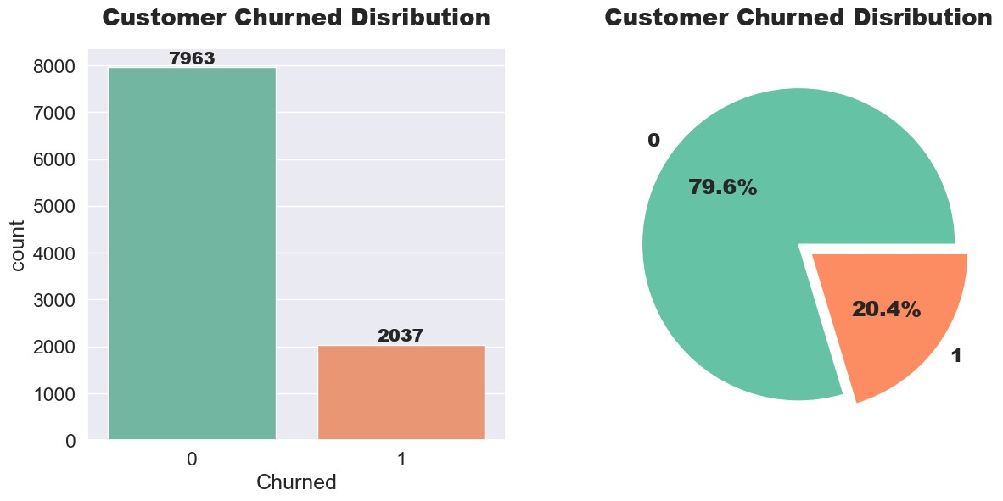
In [22]:
def countplot(column):
plt.figure(figsize=(15,5)) ax = sns.countplot(x=column, data=df, hue="Churned",palette="Set2") for value in ax.patches:
percentage = "{:.1f}%".format(100*value.get_height()/len(df[column])) x = value.get_x() + value.get_width() / 2 - 0.05 y = value.get_y() + value.get_height() ax.annotate(percentage, (x,y), fontweight="black",size=15)

plt.title(f"Customer Churned by {column}",fontweight="black",size=20,pad=20) plt.show()
In [23]:
countplot("Gender")
In [24]: countplot("Geography")
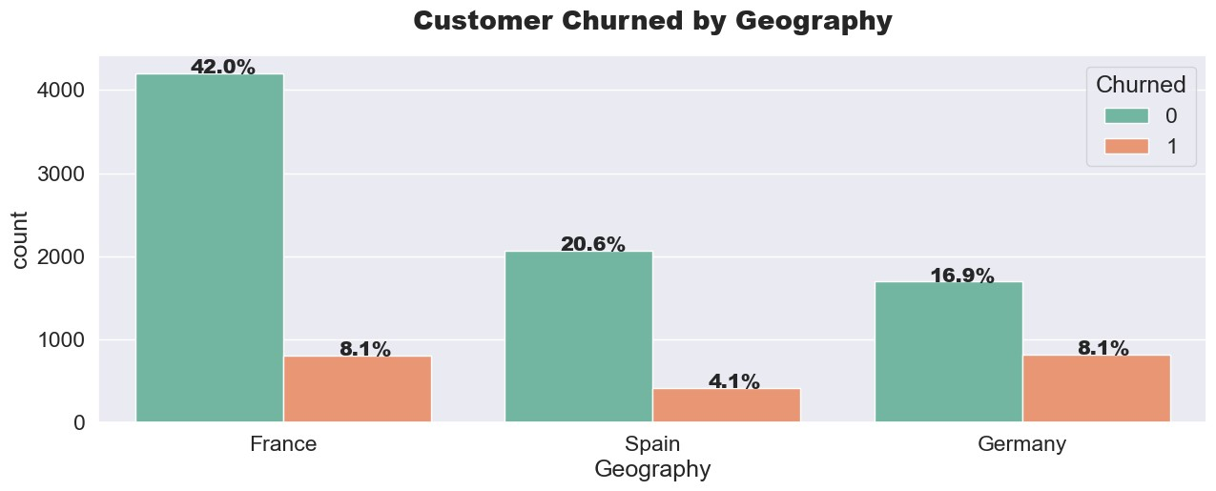
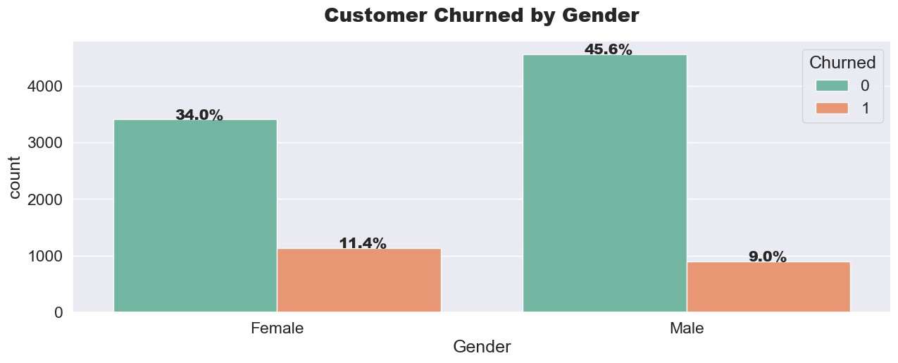
In [25]: countplot("HasCrCard")
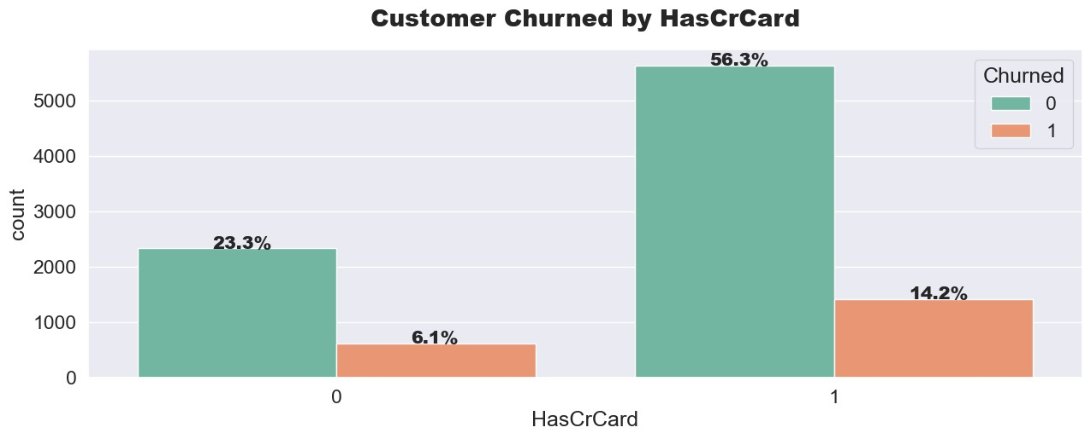
In [26]:
countplot("NumOfProducts")
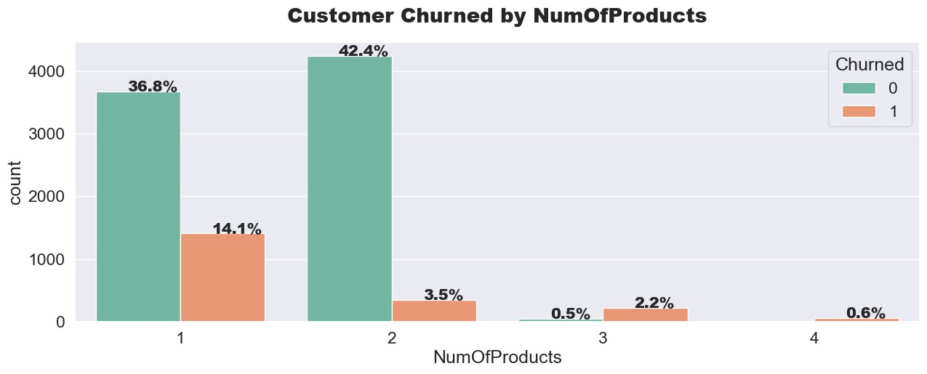
In [27]: countplot("IsActiveMember")
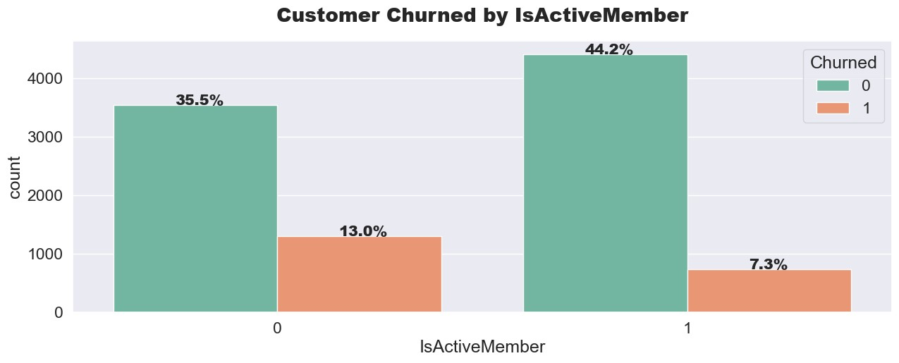
In [28]:
plt.figure(figsize=(15,5)) ax = sns.countplot(x="Tenure", data=df, hue="Churned",palette="Set2") for value in ax.patches:
percentage = "{:.1f}%".format(100*value.get_height()/len(df["Tenure"])) x = value.get_x() + value.get_width() / 2 - 0.05 y = value.get_y() + value.get_height() ax.annotate(percentage, (x,y), fontweight="black",size=12, ha="center")
plt.title("Customer Churned by Tenure",fontweight="black",size=20,pad=20) plt.show()
In [29]:
def continous_plot(column): plt.figure(figsize=(13,6)) plt.subplot(1,2,1) sns.histplot(x=column,hue="Churned",data=df,kde=True,palette="Set2") plt.title(f"Distribution of {column} by Churn Status",fontweight="black",pad=20,size=15)
plt.subplot(1,2,2) sns.boxplot(df["Churned"],df[column],palette="Set2") plt.title(f"Distribution of {column} by Churn Status",fontweight="black",pad=20,size=15) plt.tight_layout() plt.show()
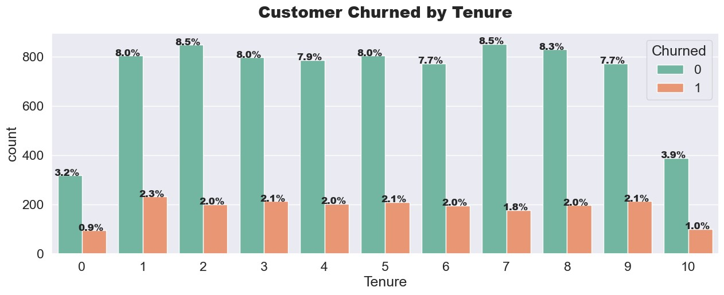
In [30]: continous_plot("CreditScore")
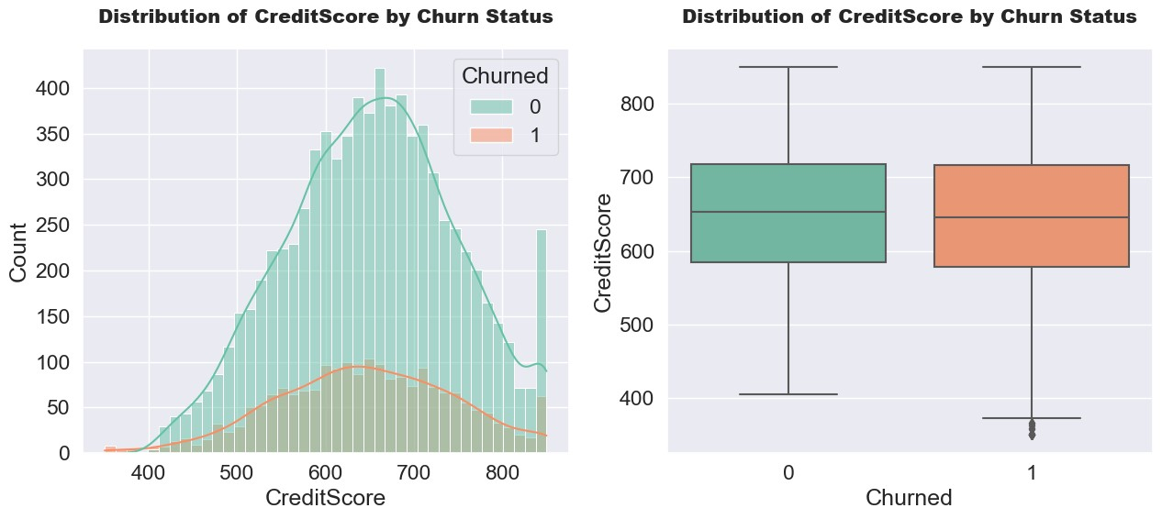
In [31]:
continous_plot("Age")
In [32]: continous_plot("Balance")
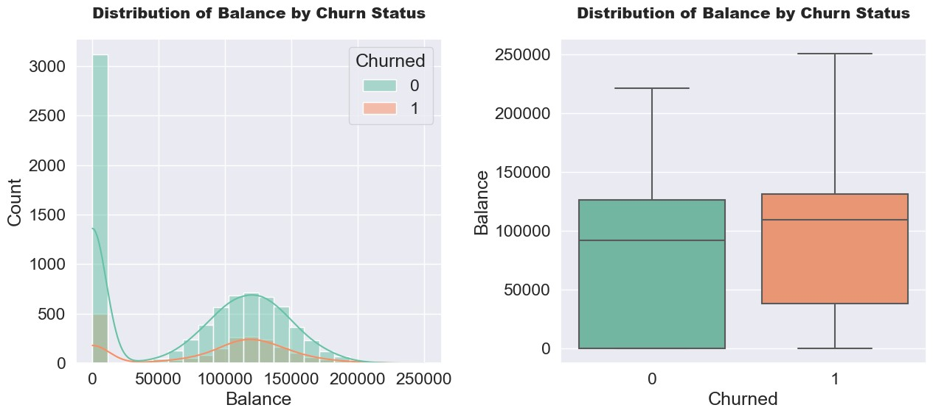
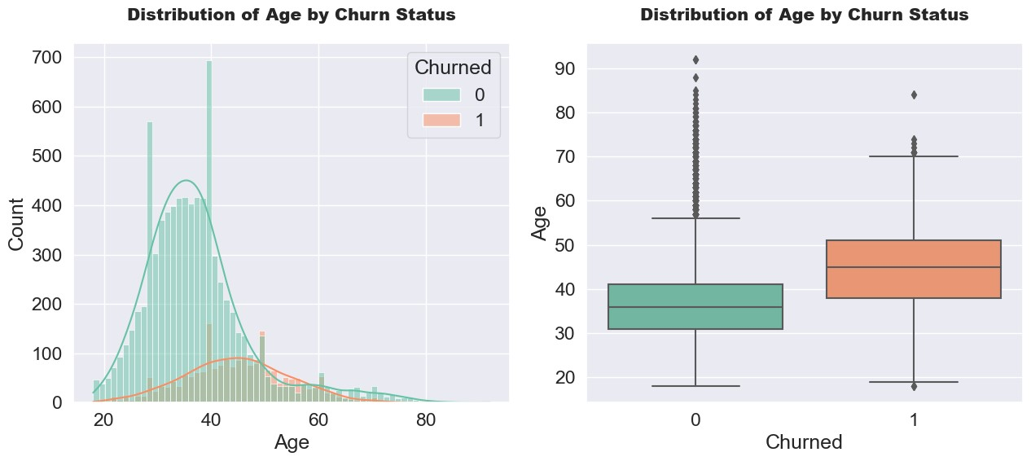
In [33]: continous_plot("EstimatedSalary")
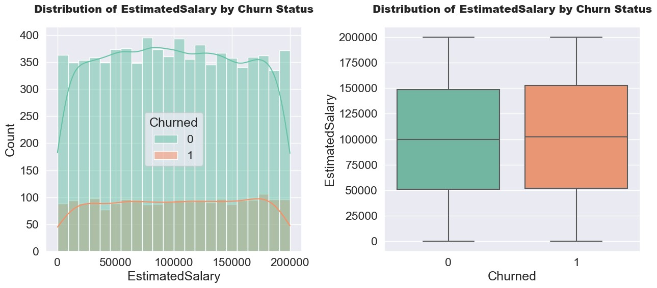
In [34]:
#Feature Engineering is the process of selecting, manipulating and transforming raw data into features that can be used in supervised learning conditions = [(df["NumOfProducts"]==1), (df["NumOfProducts"]==2), (df["NumOfProducts"]>2)] values = ["One product","Two Products","More Than 2 Products"]
In [35]: df["Total_Products"] = np.select(conditions,values)
In [36]:
df.drop(columns="NumOfProducts", inplace=True)
In [37]: countplot("Total_Products")
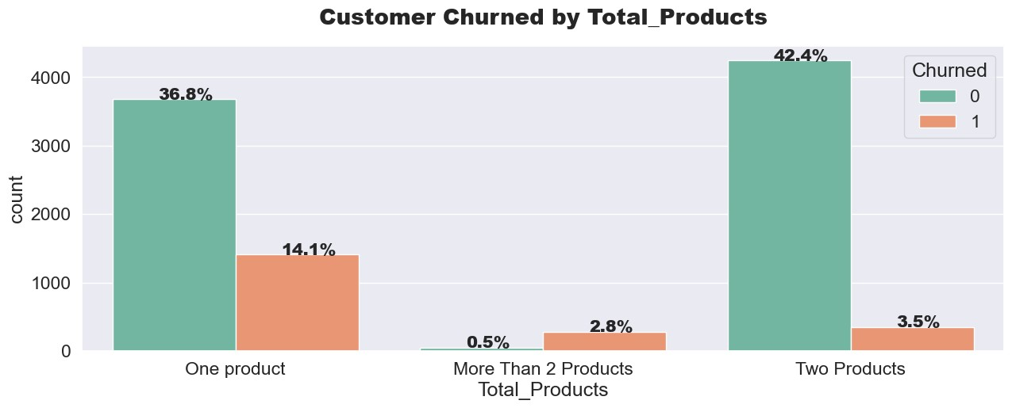
In [38]:
conditions = [(df["Balance"]==0), (df["Balance"]>0)] values = ["Zero Balance","More Than zero Balance"]
In [39]: df["Account_Balance"] = np.select(conditions, values)
In [40]: df.drop(columns="Balance",inplace=True)
In [41]: countplot("Account_Balance")
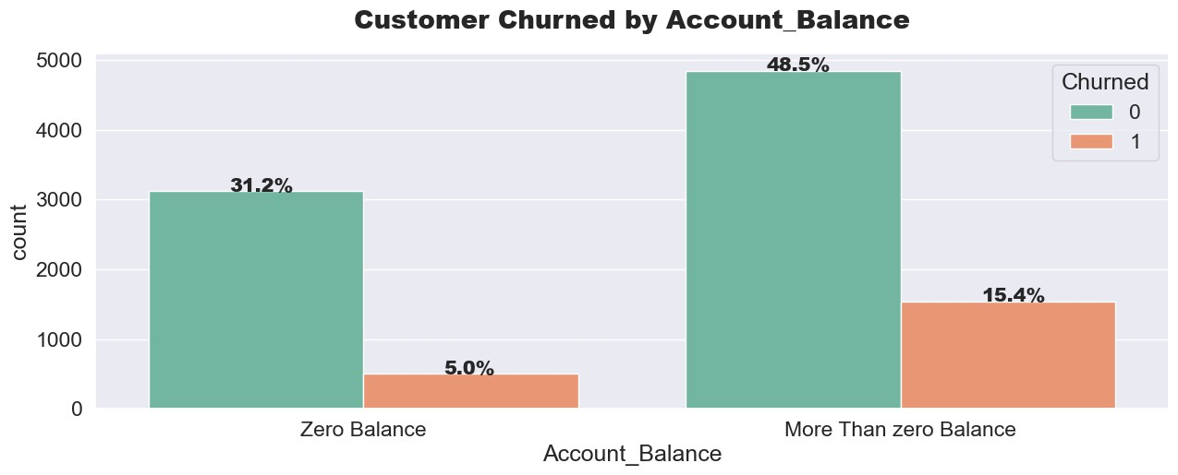
In [42]:
#Data Preprocessing is the process of detecting and correcting (or removing) corrupt or inaccurate records from a dataset
cat_cols = ["Geography","Gender","Total_Products","Account_Balance"]
for column in cat_cols: print(f"Unique Values in {column} column is:",df[column].unique()) print("-"*100,"\n")
Unique Values in Geography column is: ['France' 'Spain' 'Germany']
----------------------------------------------------------------------------------------------------
Unique Values in Gender column is: ['Female' 'Male']
----------------------------------------------------------------------------------------------------
Unique Values in Total_Products column is: ['One product' 'More Than 2 Products' 'Two Products']
----------------------------------------------------------------------------------------------------
Unique Values in Account_Balance column is: ['Zero Balance' 'More Than zero Balance']
----------------------------------------------------------------------------------------------------
In [43]: df = pd.get_dummies(columns=cat_cols, data=df)
In [44]: df["Churned"].replace({"No":0,"Yes":1},inplace=True)
In [45]: df.head()
Out[45]:
CreditScore Age Tenure HasCrCard IsActiveMember EstimatedSalary Churned Geography_France Geography_Germany Geography_Spain Gen
- 619 42 2 1 1 101348.88 1 1 0 0
- 608 41 1 0 1 112542.58 0 0 0 1
- 502 42 8 1 0 113931.57 1 1 0 0
- 699 39 1 0 0 93826.63 0 1 0 0
- 850 43 2 1 1 79084.10 0 0 0 1
In [46]: cols = ["CreditScore","Age","EstimatedSalary"]
In [47]:
df[cols].skew().to_frame().rename(columns={0:"Feature Skewness"})
^{Out[47]:} Feature Skewness
CreditScore -0.071607
Age 1.011320
EstimatedSalary 0.002085
In [48]: old_age = df["Age"] ##Storing the previous Age values to compare these values with the transformed values.
In [49]: df["Age"] = np.log(df["Age"])
In [50]: plt.figure(figsize=(13,6)) plt.subplot(1,2,1) sns.histplot(old_age, color="purple", kde=True) plt.title("Age Distribution Before Transformation",fontweight="black",size=18,pad=20)
plt.subplot(1,2,2) sns.histplot(df["Age"], color="purple", kde=True) plt.title("Age Distribution After Transformation",fontweight="black",size=18,pad=20) plt.tight_layout() plt.show()
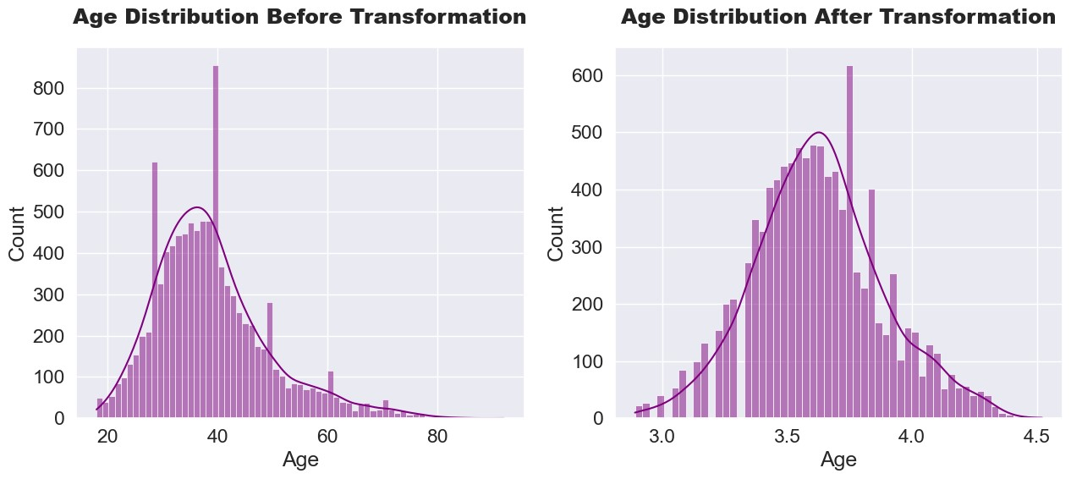
In [51]:
! pip install --upgrade imbalanced-learn scikit-learn
Requirement already satisfied: imbalanced-learn in c:\users\anuoo\.ipython\extensions\lib\site-packages (0.12.2)
Requirement already satisfied: scikit-learn in c:\users\anuoo\.ipython\extensions\lib\site-packages (1.4.2)
Requirement already satisfied: numpy>=1.17.3 in c:\users\anuoo\.ipython\extensions\lib\site-packages (from imbalanced-learn) (1.24.3)
Requirement already satisfied: scipy>=1.5.0 in c:\users\anuoo\.ipython\extensions\lib\site-packages (from imbalanced-learn) (1.11.1)
Requirement already satisfied: joblib>=1.1.1 in c:\users\anuoo\.ipython\extensions\lib\site-packages (from imbalanced-learn) (1.2.0) Requirement already satisfied: threadpoolctl>=2.0.0 in c:\users\anuoo\.ipython\extensions\lib\site-packages (from imbalanced-learn) (2.2.0)
In [52]:
from imblearn.over_sampling import SMOTE
In [53]:
X = df.drop(columns=["Churned"]) y = df["Churned"]
In [54]: x_train,x_test,y_train,y_test = train_test_split(X,y,test_size=0.2,random_state=0)
In [55]: print("Shape of x_train is:",x_train.shape) print("Shape of x_test is: ",x_test.shape) print("Shape of y_train is:",y_train.shape) print("Shape of y_test is: ",y_test.shape)
Shape of x_train is: (8000, 16)
Shape of x_test is: (2000, 16)
Shape of y_train is: (8000,)
Shape of y_test is: (2000,)
In [56]:
smt = SMOTE(random_state=42)
In [57]: x_train_resampled,y_train_resampled = smt.fit_resample(x_train,y_train)
In [58]:
print(x_train_resampled.shape ,y_train_resampled.shape)
(12736, 16) (12736,)
In [59]:
y_train_resampled.value_counts().to_frame()
Out[59]: Churned
- 6368
- 6368
In [60]: dtree = DecisionTreeClassifier()
In [61]:
param_grid = {"max_depth":[3,4,5,6,7,8,9,10],
"min_samples_split":[2,3,4,5,6,7,8],
"min_samples_leaf":[1,2,3,4,5,6,7,8],
"criterion":["gini","entropy"],
"splitter":["best","random"],
"max_features":["auto",None],
"random_state":[0,42]}
In [62]:
grid_search = GridSearchCV(dtree, param_grid, cv=5, n_jobs=-1)
grid_search.fit(x_train_resampled,y_train_resampled)
Out[62]: ▸ ^{i} ? GridSearchCV
▸ estimator: DecisionTreeClassifier
? DecisionTreeClassifier
▸
In [63]:
best_parameters = grid_search.best_params_
print("Best Parameters for DecisionTree Model is:\n\n") best_parameters
Best Parameters for DecisionTree Model is:
Out[63]:{'criterion': 'gini',
'max_depth': 8,
'max_features': None,
'min_samples_leaf': 1,
'min_samples_split': 7,
'random_state': 42,
'splitter': 'random'}
In [64]: dtree = DecisionTreeClassifier(**best_parameters)
dtree.fit(x_train_resampled,y_train_resampled)
Out[64]: ▾ i ?
DecisionTreeClassifier
DecisionTreeClassifier(max_depth=8, min_samples_split=7, random_state=42,
splitter='random')
In [65]: y_train_pred = dtree.predict(x_train_resampled) y_test_pred = dtree.predict(x_test)
print("Accuracy Score of Model on Training Data is =>",round(accuracy_score(y_train_resampled,y_train_pred)*100,2),"%") print("Accuracy Score of Model on Testing Data is =>",round(accuracy_score(y_test,y_test_pred)*100,2),"%")
Accuracy Score of Model on Training Data is => 89.51 %
Accuracy Score of Model on Testing Data is => 84.3 %
In [66]:
print("F1 Score of the Model is =>",f1_score(y_test,y_test_pred,average="micro")) print("Recall Score of the Model is =>",recall_score(y_test,y_test_pred,average="micro")) print("Precision Score of the Model is =>",precision_score(y_test,y_test_pred,average="micro"))
F1 Score of the Model is => 0.843
Recall Score of the Model is => 0.843 Precision Score of the Model is => 0.843
In [67]:
imp_df = pd.DataFrame({"Feature Name":x_train.columns,
"Importance":dtree.feature_importances_})
In [68]:
features = imp_df.sort_values(by="Importance",ascending=False)
plt.figure(figsize=(12,7)) sns.barplot(x="Importance", y="Feature Name", data=features, palette="plasma") plt.title("Feature Importance in the Model Prediction", fontweight="black", size=20, pad=20) plt.yticks(size=12) plt.show()
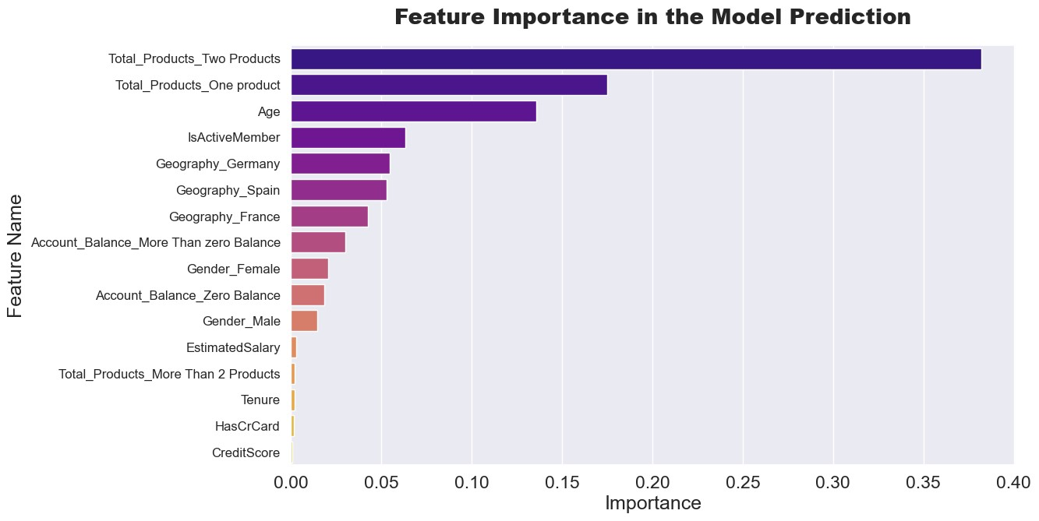
In [69]:
import pandas as pd from sklearn.model_selection import train_test_split from sklearn.preprocessing import StandardScaler from sklearn.linear_model import LogisticRegression from sklearn.tree import DecisionTreeClassifier from sklearn.ensemble import RandomForestClassifier, GradientBoostingClassifier from sklearn.metrics import accuracy_score, classification_report
# Load data data = pd.read_csv('Churn_Modelling.csv') # replace with your file path
# Feature selection and preprocessing
X = data[['CreditScore', 'Geography', 'Gender', 'Age', 'Tenure', 'Balance', 'NumOfProducts', 'HasCrCard', 'IsActiveMember', 'EstimatedSalary']] y = data['Exited']
# Convert categorical variables to dummy variables
X = pd.get_dummies(X, drop_first=True)
# Split data into training and testing sets
X_train, X_test, y_train, y_test = train_test_split(X, y, test_size=0.2, random_state=42)
# Standardize the data scaler = StandardScaler()
X_train = scaler.fit_transform(X_train)
X_test = scaler.transform(X_test)
# Logistic Regression log_reg = LogisticRegression(random_state=42) log_reg.fit(X_train, y_train) y_pred_log_reg = log_reg.predict(X_test) print("Logistic Regression Accuracy:", accuracy_score(y_test, y_pred_log_reg)) print("Logistic Regression Classification Report:\n", classification_report(y_test, y_pred_log_reg))
# Decision Tree dec_tree = DecisionTreeClassifier(random_state=42) dec_tree.fit(X_train, y_train) y_pred_dec_tree = dec_tree.predict(X_test) print("Decision Tree Accuracy:", accuracy_score(y_test, y_pred_dec_tree)) print("Decision Tree Classification Report:\n", classification_report(y_test, y_pred_dec_tree))
# Random Forest rand_forest = RandomForestClassifier(random_state=42) rand_forest.fit(X_train, y_train) y_pred_rand_forest = rand_forest.predict(X_test) print("Random Forest Accuracy:", accuracy_score(y_test, y_pred_rand_forest)) print("Random Forest Classification Report:\n", classification_report(y_test, y_pred_rand_forest))
# Gradient Boosting grad_boost = GradientBoostingClassifier(random_state=42) grad_boost.fit(X_train, y_train) y_pred_grad_boost = grad_boost.predict(X_test) print("Gradient Boosting Accuracy:", accuracy_score(y_test, y_pred_grad_boost)) print("Gradient Boosting Classification Report:\n", classification_report(y_test, y_pred_grad_boost))
Logistic Regression Accuracy: 0.811
Logistic Regression Classification Report: precision recall f1-score support
0 0.83 0.96 0.89 1607 1 0.55 0.20 0.29 393
accuracy 0.81 2000 macro avg 0.69 0.58 0.59 2000 weighted avg 0.78 0.81 0.77 2000
Decision Tree Accuracy: 0.781
Decision Tree Classification Report:
precision recall f1-score support
0 0.87 0.85 0.86 1607 1 0.45 0.50 0.47 393
accuracy 0.78 2000 macro avg 0.66 0.68 0.67 2000 weighted avg 0.79 0.78 0.79 2000
Random Forest Accuracy: 0.8665
Random Forest Classification Report:
precision recall f1-score support
0 0.88 0.96 0.92 1607 1 0.76 0.47 0.58 393
accuracy 0.87 2000 macro avg 0.82 0.72 0.75 2000 weighted avg 0.86 0.87 0.85 2000
Gradient Boosting Accuracy: 0.8675
Gradient Boosting Classification Report:
precision recall f1-score support
0 0.88 0.96 0.92 1607 1 0.75 0.49 0.59 393
accuracy 0.87 2000 macro avg 0.82 0.72 0.76 2000 weighted avg 0.86 0.87 0.86 2000
In [70]:
import pandas as pd from sklearn.model_selection import train_test_split, GridSearchCV from sklearn.preprocessing import StandardScaler from sklearn.linear_model import LogisticRegression from sklearn.tree import DecisionTreeClassifier from sklearn.ensemble import RandomForestClassifier, GradientBoostingClassifier from sklearn.metrics import accuracy_score, classification_report
# Load data data = pd.read_csv('Churn_Modelling.csv') # replace with your file path
# Feature selection and preprocessing
X = data[['CreditScore', 'Geography', 'Gender', 'Age', 'Tenure', 'Balance', 'NumOfProducts', 'HasCrCard', 'IsActiveMember', 'EstimatedSalary']] y = data['Exited']
# Convert categorical variables to dummy variables
X = pd.get_dummies(X, drop_first=True)
# Split data into training and testing sets
X_train, X_test, y_train, y_test = train_test_split(X, y, test_size=0.2, random_state=42)
# Standardize the data scaler = StandardScaler()
X_train = scaler.fit_transform(X_train)
X_test = scaler.transform(X_test)
# Logistic Regression hyperparameter tuning log_reg_params = {
'C': [0.01, 0.1, 1, 10, 100],
'penalty': ['l1', 'l2'],
'solver': ['liblinear', 'saga']
}
log_reg = LogisticRegression(random_state=42) log_reg_cv = GridSearchCV(log_reg, log_reg_params, cv=5) log_reg_cv.fit(X_train, y_train) print("Best Logistic Regression Parameters:", log_reg_cv.best_params_) y_pred_log_reg = log_reg_cv.predict(X_test) print("Logistic Regression Accuracy:", accuracy_score(y_test, y_pred_log_reg)) print("Logistic Regression Classification Report:\n", classification_report(y_test, y_pred_log_reg))
# Decision Tree hyperparameter tuning dec_tree_params = {
'max_depth': [None, 10, 20, 30, 40, 50],
'min_samples_split': [2, 5, 10],
'min_samples_leaf': [1, 2, 4],
'criterion': ['gini', 'entropy']
}
dec_tree = DecisionTreeClassifier(random_state=42) dec_tree_cv = GridSearchCV(dec_tree, dec_tree_params, cv=5) dec_tree_cv.fit(X_train, y_train) print("Best Decision Tree Parameters:", dec_tree_cv.best_params_) y_pred_dec_tree = dec_tree_cv.predict(X_test) print("Decision Tree Accuracy:", accuracy_score(y_test, y_pred_dec_tree)) print("Decision Tree Classification Report:\n", classification_report(y_test, y_pred_dec_tree))
# Random Forest hyperparameter tuning rand_forest_params = {
'n_estimators': [100, 200, 300],
'max_features': ['auto', 'sqrt'],
'max_depth': [None, 10, 20, 30],
'min_samples_split': [2, 5, 10],
'min_samples_leaf': [1, 2, 4],
'bootstrap': [True, False]
}
rand_forest = RandomForestClassifier(random_state=42) rand_forest_cv = GridSearchCV(rand_forest, rand_forest_params, cv=5) rand_forest_cv.fit(X_train, y_train) print("Best Random Forest Parameters:", rand_forest_cv.best_params_) y_pred_rand_forest = rand_forest_cv.predict(X_test) print("Random Forest Accuracy:", accuracy_score(y_test, y_pred_rand_forest)) print("Random Forest Classification Report:\n", classification_report(y_test, y_pred_rand_forest))
# Gradient Boosting hyperparameter tuning grad_boost_params = {
'n_estimators': [100, 200, 300],
'learning_rate': [0.01, 0.1, 0.2],
'max_depth': [3, 4, 5],
'subsample': [0.8, 0.9, 1.0],
'min_samples_split': [2, 5, 10],
'min_samples_leaf': [1, 2, 4]
}
grad_boost = GradientBoostingClassifier(random_state=42) grad_boost_cv = GridSearchCV(grad_boost, grad_boost_params, cv=5) grad_boost_cv.fit(X_train, y_train) print("Best Gradient Boosting Parameters:", grad_boost_cv.best_params_) y_pred_grad_boost = grad_boost_cv.predict(X_test) print("Gradient Boosting Accuracy:", accuracy_score(y_test, y_pred_grad_boost)) print("Gradient Boosting Classification Report:\n", classification_report(y_test, y_pred_grad_boost)) Best Logistic Regression Parameters: {'C': 10, 'penalty': 'l2', 'solver': 'liblinear'}
Logistic Regression Accuracy: 0.811
Logistic Regression Classification Report:
precision recall f1-score support
0 0.83 0.96 0.89 1607 1 0.55 0.20 0.29 393
accuracy 0.81 2000 macro avg 0.69 0.58 0.59 2000 weighted avg 0.78 0.81 0.77 2000
Best Decision Tree Parameters: {'criterion': 'gini', 'max_depth': 10, 'min_samples_leaf': 1, 'min_samples_split': 10} Decision Tree Accuracy: 0.844
Decision Tree Classification Report:
precision recall f1-score support
0 0.88 0.93 0.91 1607 1 0.63 0.50 0.56 393
accuracy 0.84 2000 macro avg 0.76 0.71 0.73 2000 weighted avg 0.83 0.84 0.84 2000
Best Random Forest Parameters: {'bootstrap': True, 'max_depth': None, 'max_features': 'sqrt', 'min_samples_leaf': 1, 'min_samples_split': 10, 'n_estimators':
300}
Random Forest Accuracy: 0.865
Random Forest Classification Report:
precision recall f1-score support
0 0.88 0.96 0.92 1607 1 0.75 0.47 0.58 393
accuracy 0.86 2000 macro avg 0.82 0.72 0.75 2000 weighted avg 0.86 0.86 0.85 2000
Best Gradient Boosting Parameters: {'learning_rate': 0.1, 'max_depth': 4, 'min_samples_leaf': 1, 'min_samples_split': 10, 'n_estimators': 100, 'subsample': 1.0} Gradient Boosting Accuracy: 0.868
Gradient Boosting Classification Report:
precision recall f1-score support
0 0.89 0.96 0.92 1607 1 0.74 0.50 0.60 393
accuracy 0.87 2000 macro avg 0.82 0.73 0.76 2000 weighted avg 0.86 0.87 0.86 2000
In [ ]:

In [ ]:

In [ ]:

In [ ]:

In [ ]:

In [ ]:

In [ ]:

In [ ]:

In [ ]:

In [ ]:

In [ ]:

In [ ]:

In [ ]:

In [ ]:

