**Programming Assignment Solutions**

Q1.

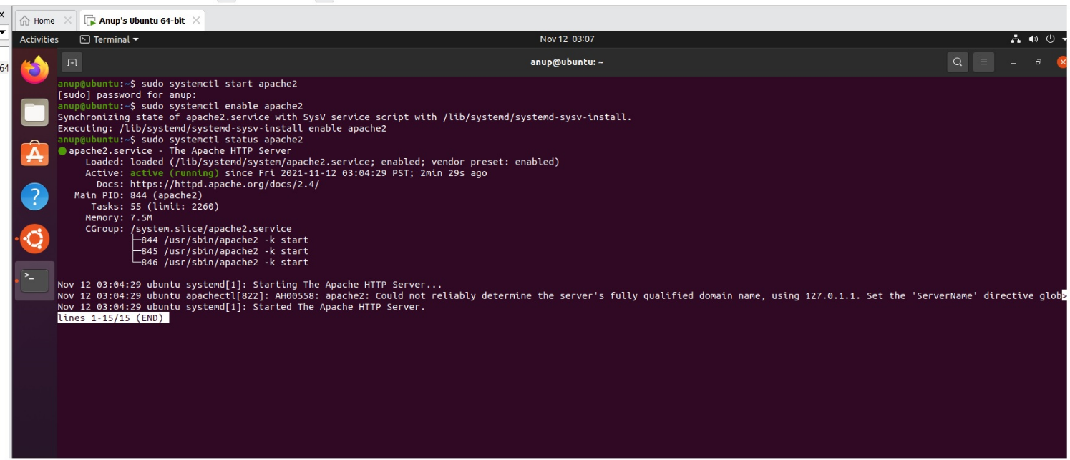

Status of Apache after zooming – See below:

