**Programming Assignment Solutions**

Q3.

Note: Here both username and password are asked for input at run time for security purposes (Not harcoded in the python code)

Fig 1: VM ip address as fetched from terminal

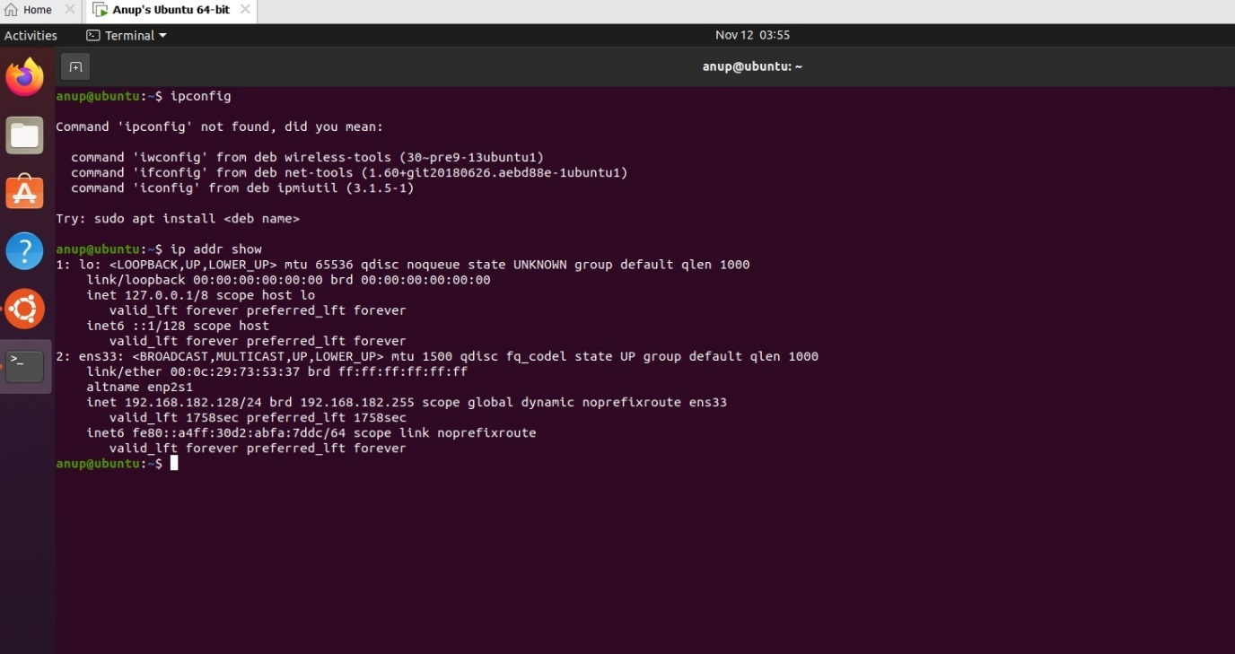

Fig 2: Correct username with incorrect password for SSH connection

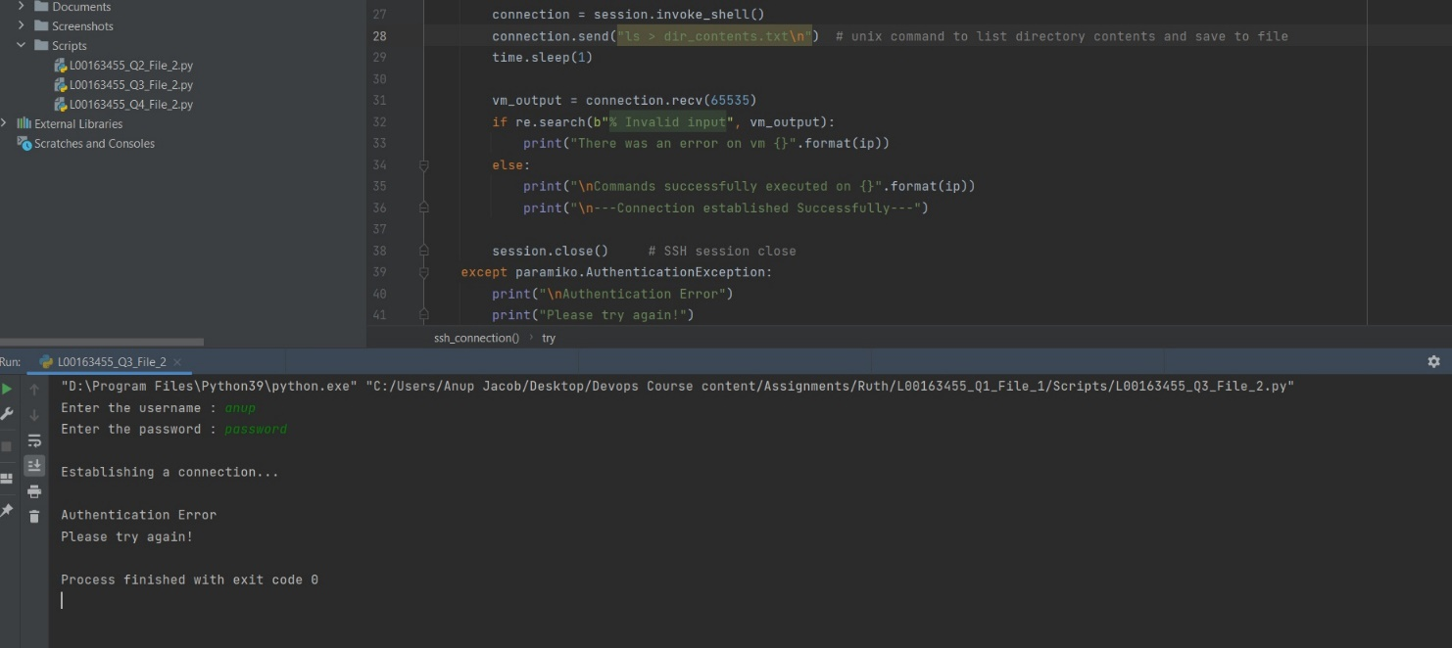

Fig 2: Incorrect Username with correct password for SSH connection

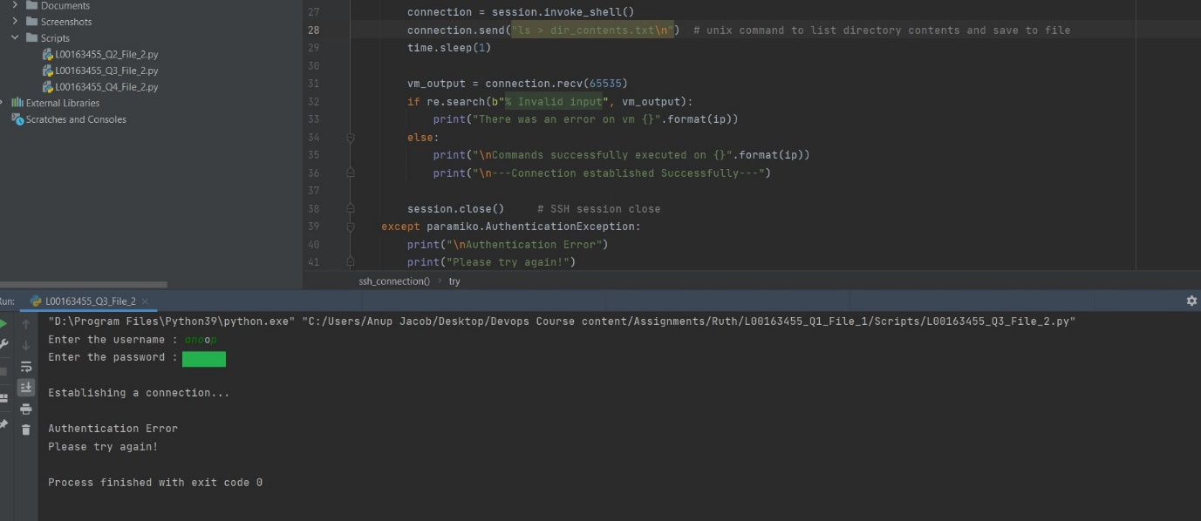

Fig 3: Correct username and password showing successful SSH connection establishment.

