**Programming Assignment Solutions**

Q5.

Q a) Command executed to install curl

Q b) Script written in python format for connecting to the remote Linux server and create folder Labs with sub-folders Lab1 and Lab2.

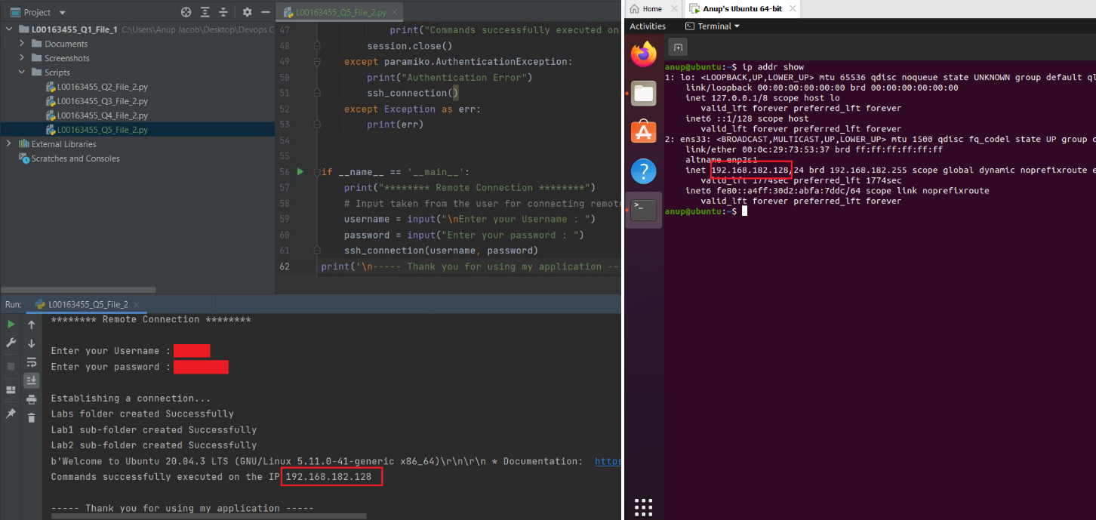

Below shows the folders created after running the script in sudo mode

Q c) List command ‘ls -l --time=atime’ run to check the last accessed time

