**Programming Assignment Solutions**

Q6.

Figure 1: Terraform initialization from the folder created for AWS actions.

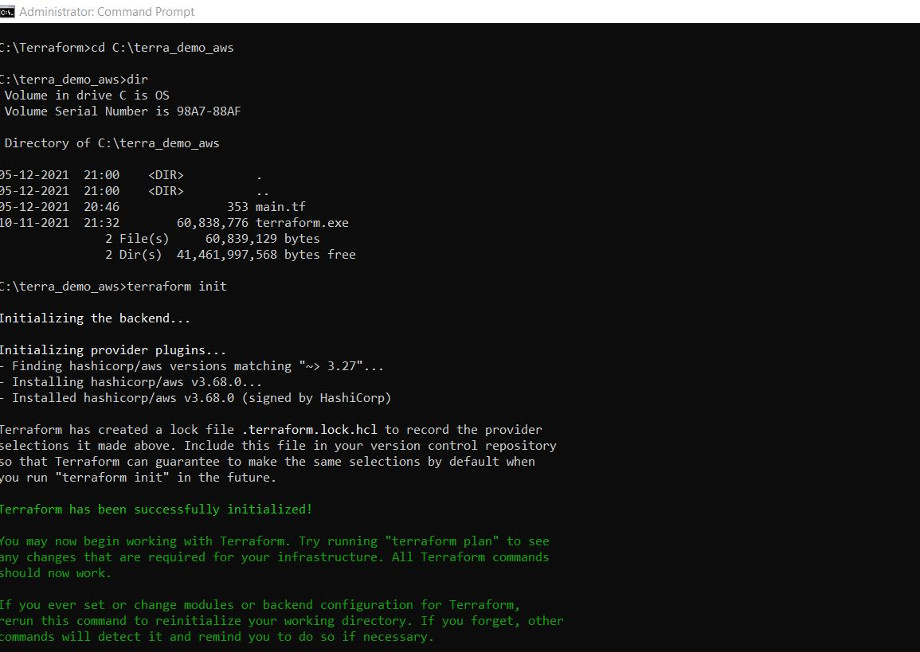

Figure 2: Terraform apply command parts can be seen below:

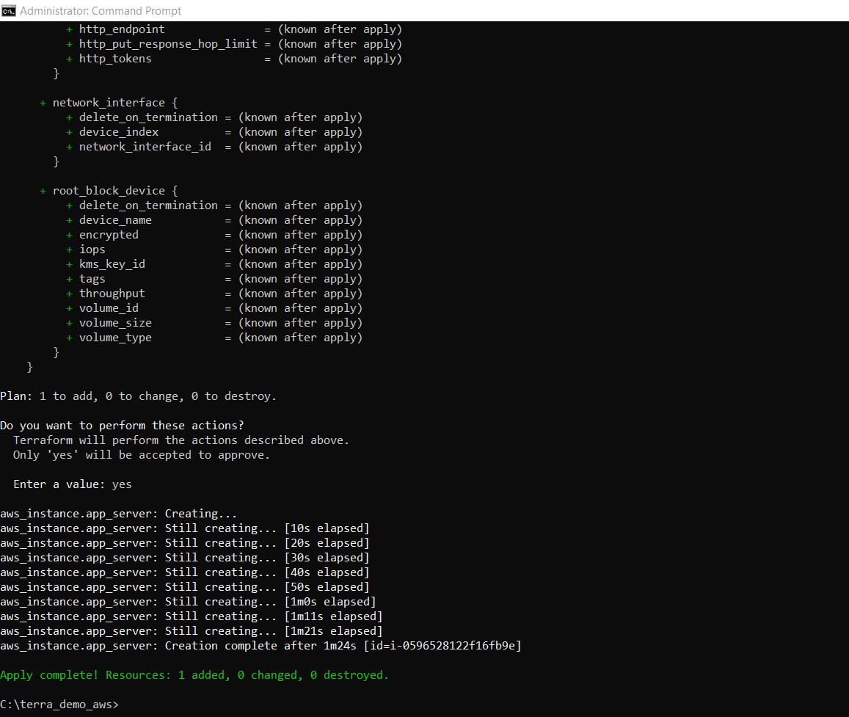

Figure 3: Terrafrom graphs showing the details of the instance created.

Figure 4: AWS instance created up and running from AWS services

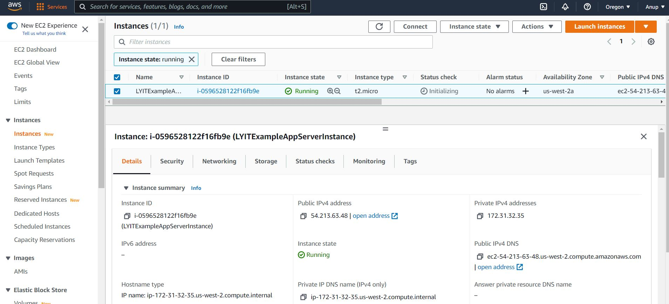

Figure 5: AWS instance summary details from AWS services

Figure 6: Executing the terraform destroy command to stop the AWS instance from running.

Figure 7: AWS Instance stopped after terraform destroy command has been executed.

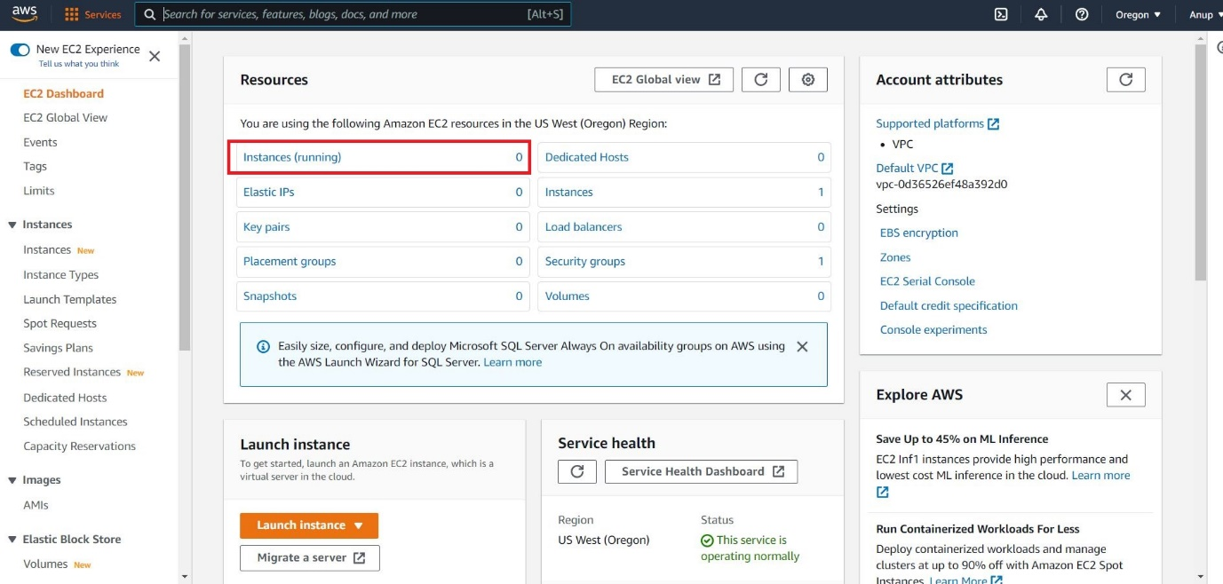

Figure 8: Summary details of terminated AWS instance created using terraform.

