|  |  |  |  |
| --- | --- | --- | --- |
|  | **Index** |  | |
| **Contents No** |  | **Page** | |
| **1. Title of Project** |  | **2** | |
| **2. Introduction** |  | **3** | |
| **3. Objective** |  | **4** | |
| **4. Project Category** |  | **5** | |
| **5. SRS** |  | **6** | |
| **6. System Requirement** |  | **8** | |
| **7. System Analysis** |  | **11-** | |
| **20** |  |  | |
| * **Problem Definition** | |  | **11** |
| * **Primary investigation** | | **12** |  |
| * **Feasibility study** | | **13** |  |
| * **DFD** | | **16** |  |
| * **E-R Diagram** | | **20** |  |
| **8. Modular Design** | | **21** |  |
| **9. Table Design** | | **24** |  |
| **10. System Security** | | **28** |  |
| **11. Future Scope** | | **29** |  |
| **12. Bibliography** | | **30** |  |





ONLINE SHOPPING

# Project Synopsis for BCA

**SUBMITTED BY: GUIDED BY:**

ADITYA SRIVASTAVA

**Introduction**

“**On-Line Shopping System**” is a web-based project which is made for remote-shopping or shopping through Internet. As the technology is being advanced the way of life is changing accordance. Now a day’s we can place the order for any thing from our home. There is no need to go the shop of the things we want. The order can be placed online through Internet. The payment, the confirmation of purchasing; we can do every thing we want. Now we can think that how the days have been changed with time. People had to stand in rows to wait there terms to buy a particular thing from a popular shop. But what is happening now a day’s; we can extremely surprise that those things can be available on the door-step in few hours.

People had to suffer the rush of the market when they went for shopping. They used to think hundred times to buy any thing having the sufficient money for shopping. The problem was the rush; the quarrel at the time of buying the things. But the advancement of technology brought the new way for shopping. The way of shopping was completely changed with the coming of Internet Technology.

People have to fill a simple form on the internet to place their order on any popular shop or shopping-mall for the thing they want to buy. Now they can place their order from the home.

This project entitled “On-Line Shopping” is an implementation of the above description. It means, it implements the E-shopping or in other

word shopping through Internet. It lets the user to place their order online for any article.

**Objective**

Today the internet and its boom have created a new economic scenario that not only stresses on the classical concept of the “*product*” but also on the modern concept of “*service*”. It is this level of service that dictates whether a commercial venture will succeed or not in the market. To provide a high accessibility of service we will design the online shopping website, so that potential customers need not go to a physical shop to buy products or services.

There are several objective of this websites are following given bellows.

* This site is gives all the information about the e-shopping to provide better service for the customer.
* It provides the facility to the customers who want to shop on-line due to lock of time.
* It provides facility to the customer to payment by the cash and cheque and DD also.
* It’s providing the full details about the product and related information about the product like cost, size etc.
* With the help of it we can save the time and money also.
* It provides the remote shopping by the cash, or DD, or Debit card also.
* It provides better security and good delivery service to the customer.

# PROJECT-CATEGORY

### Web-Based Application Software with RDBMS:

This System i.e. “**On-Line Shopping”** is a web based application software which perform the activities like Administering, providing information to the shopping by the remote system or through internet. The nature of this software to handle a particular task that’s why it is the category of application software.

This project falls under The Category of **Internet Technologies with RDBMS,** since the project is mainly for providing on-line shopping of the different items. This project is utilizing Relational Databases as back-end. Having on-line services for the interested user it has great demand in market. As we know that Internet is huge client-server architecture. The client is a web browser; it is requesting a web based data, a file, or whatever, from the sever staying anywhere in the world. Server is nothing the service provider which provides services to the client. It holds almost all the information that client side wants.

I have uses .Net framework to develop the software. Asp.Net is rich set programming framework for building web-based application. It offers amazing support to both developer and administrator.

**SYSTEM REQUIREMENTS AND SPECIFICATIONS:**

Once the system analyst have identified the precise user requirements and analyzed these requirements to weed out inconsistencies, they proceed to write the document called the Software Requirement Specification (SRS). It is the final output of the requirements analysis and specification phase.

An SRS document should clearly document the following:

* Functional requirements of the system
* Non-functional requirements of the system
* Constraints of the system

A SRS should have characteristics like concise, unambiguous, consistent, complete, well structured etc.

SRS documentation for the findsjobs.com & its Service Management Program: -

## Environmental Characteristics

* + **Hardware*:*** The hardware at the organization is Pentium 500 MHz + computers.
  + **Peripherals*:*** The most common peripheral that is required for the program is Printer.
  + **People*:*** The users at the organization will be the entry operators at the Electronic Data Processing (EDP) section or various office clerks attached with Director, CGM, or GM or CEO s.

## Interfaces

* + **Interface with devices:** The website has just one peripheral device to deal with that is printer.
  + **Interface with the operating system:** The application will be an executable file and hence there is no need for an interface with the operating system.
  + **Interface with the Database used:** The application being developed in SQL server so the interface will be the ODBC driver.
  + **Interface with the user:** The application assumes its users to be novice and has an extremely simple and user friendly interface.

# REQUIREMENT SPECIFICATION

### Hardware Requirement:-

Processor : Pentium Processor ISA 32 Family

Secondary Storage : 80 GB HDD

ROM : 52X CD ROM Drive

Floppy Drive : 1.44 FDD

Memory : 1 GB RAM

Network Adapter : Ethernet Adapter

Modem : 128kbps Voice Fax Data

Others : 17" Color Monitor, Printer, Scanner,

: Keyboard, Mouse.

### Software Requirement

Platform : Windows

Operating System : Windows XP Professional Framework : ASP.NET Framework 2.0

Front-End Tool : ASP.Net with C#, AJAX

Back- End Tool : SQL Server 2005

Editing Tool : Microsoft FrontPage 2000

Scripting Tool : Java script, XML (style Sheet (.xsl))

Server : Internet Information Server

: (IIS Server)

### REASON FOR OPTING ASP.NET WITH C# AS FRONT-END

.Net Framework is of the most prevailed framework to develop the web based application. This is the outcome of Microsoft which was developed for competing java in the world market. It supports many programming languages like C++, C#, Visual Basic, XML etc.

I have used ASP.Net with C# to develop this software due to following reasons:

* It is Very easy to use ASP.net to develop web-based application because of its user-friendly functionalities.
* C# is the language that uses both CUI and GUI Interfaces thus more flexibility.
* Auto-generated and More Powerful IDE.
* Common to use Server; every language uses Internet Information Server

### REASON TO OPT SQL SERVER 2005 AS BACK-END

SQL Server is RDBMS tool which has been used by me as back-end due to following reason:

* In today’s competitive environment, an organization wants a comprehensive, secure, reliable, and productive data platform for its business applications. SQL Server provides all these facilities.
* SQL Server 2005 combines data analysis, reporting, integration, and notification services.
* The SQL Server database Engine provides a platform that allows managing data application very easily.
* Independently accepted standard
* High transaction processing
* Rational architecture: Independent of physical data storage
* Large database and space management
* Client/server (Distributed processing) environment
* Portability and connectivity
* Back and recovery facilities
* Full proof security management

# SYSTEM ANALYSIS:

**Problem Definition:** The e-shopping Administrator is the super user and has complete control over all the activities that can be performed. The application notifies the administrator of all shop creation requests, and the administrator can then approve or reject them. The administrator also manages the list of available product categories. The administrator can also view and delete entries in the guestbook.

**Shop Owner:** Any user can submit a shop creation request through the application. When the request is approved by the Mall Administrator, the requester is notified, and from there on is given the role of Shop Owner. The Shop Owner is responsible for setting up the shop and maintaining it. The job involves managing the sub-categories of the items in the shop. Also, the shop owner can add or remove items from his shop. The Shop Owner can view different reports that give details of the sales and orders specific to his shop. The Shop Owner can also decide to close shop and remove it from the mall.

**Employees:** Purchase department under a Purchase manager to overlook purchasing activities if warehousing needs arise.

Sales department under a Sales manager who will look after the sale of products and services, the most important activity.

Accounts department under an Accounts manager to look after the accounting activities of the enterprise.

**Requirement Specification:-** It is quite difficult and time consuming task to find the information as well as maintaining information manually. If all these information are to be kept at a single place it is also not possible in the manual system. Computerized system will upgrade and manage information very easily.

As it is a web-based application so it uses Internet technologies and its hardware/software requirement will also be more comprehensive than Desktop application system. Some Network devices will be required like modems, switches, Internet connection.

Software required for the system is also different from a normal desktop system. First of all a server software will be mandatory (here Internet Information Server (IIS)). A browser is also needed as a client process on the user side.

**Preliminary Investigation: -** System Analysis is not only time consuming but also a rigorous task. But it is crucial and most important phase of Software development process.

Preliminary Investigation is the process of gathering data for requirement analysis. It is more helpful for problem definition and requirement specification.

# FEASIBILITY STUDY

Feasibility is the determination of whether or not a project is worth doing. The process followed in making this determination is called a feasibility study. This type of study determines if a project can and should be taken. Once it has been determined that a project is feasible, the analyst can go ahead and prepare the project specification which finalizes project requirements.

### Different Type of Feasibility Study:-

In the conduct of the feasibility study, the analyst will usually consider seven distinct, but inter- related types of feasibility. They are

Technical Feasibility Operational Feasibility Economic Feasibility Social Feasibility Management Feasibility Legal Feasibility

Time Feasibility

### Technical Feasibility:

This is concerned with specifying equipment and software that will successfully satisfy the user requirement; the technical needs of the system may vary considerably, but might include:

The facility to produce outputs in a given time:

* + Response time under certain conditions.
  + Ability to process a certain volume of transaction at a Particular speed.
  + Facility to communicate data to distant location.

In examine technical feasibility; configuration of the system is given more importance than the actual make of hardware. The configuration should give the complete picture about the system’s requirement: How many workstations are required, how these units are interconnected so that they could operate and communicate smoothly. What speeds of input and output should be achieved at particular quality of printing.

This can be used as a basis for the tender document

### Operational Feasibility:-

It is mainly related to human organization and political aspects.

The points to be considered are:

* + What changes will be brought with the system?
  + What organizational structures are distributed?
  + What new skills will be required? Do the existing staff members have these skills? If not, can they be trained in due course of time?

Generally project will not be rejected simply because of operational infallibility but such considerations are likely to critically affect the nature and scope of the eventual recommendations.

### Economical Feasibility:-

Economic analysis is the most frequently used technique for evaluating the effectiveness of a proposed system. More frequently known as cost

/ benefit analysis; the procedure is to determine the benefits and saving that are expected from a proposed system and compare them with costs. If benefits outweigh costs, a decision is taken to design and implement the system. Otherwise, further justification or alternative in the proposed system will have to be made if it is to have a change of being approved. This is an ongoing effort that improves in accuracy at each phase of the system life cycle**.**

### Social Feasibility:

Social feasibility is a determination of whether a proposed project will be acceptable to the people or not. This determination typically examines the probability of the project accepted by the group directly affected by the proposed system change.

### Management Feasibility:-

It is a determination of whether a proposed project will be acceptable to management .if does not accept a project or gives a negligible support to it; the analyst will tend to view the project as a non-feasible one**.**

### Legal Feasibility:-

Legal feasibility is a determination of whether a proposed project infringes on known Acts Statutes, as well as any pending legislation. Although in some instances the project might appear sound, on closer investigation it may be found to infringe on several legal areas.

### Time Feasibility:

Time feasibility is a determination of whether a proposed project can be implemented fully within a stipulated time frame. If a project takes too much time it is likely to be rejected.

# DATA FLOW DIAGRAM OF THE PROPOSED SYSTEM

A data flow diagram is a primary graphic tool for the analysis phase of the system development life cycle. Analysts to show what happens to data items, as they flow through the system use it.

An information moves through software, it is modified by a series of transformations. Data flow diagram is a graphical technique that depicts information flow and the transforms the are as data move from input to output. The basic form of a DFD is also known as data flow graph or a bubble chart. The DFD serve two purposes:

1. To provide and indication of how data are transform as they move through the system.
2. To depict the functions that transforms that data flow.

The DFD provides additional information that is used during the analysis of information domain and serve as a basis for the modeling of function.

Basic notations, which used to create DFD, are as follows:

**RECTANGLE**

It is used to represent an external entity or another system element that produces information for transformation or receive information.

## CIRCLE

It used to represent any process or transform which applied on data

## ARROW

Arrow represents one or more data items or data objects.

## PARRALEL LINE

The parallel line used to represent any database

# DFD at 0 Level:

**Database**

**Online Shopping**

**Administrator**

**Bill Payment**

**Visitor**

**Credit Reading**

**Bill Searchin**

**Account status**

**User**

**Registratio n**

**Security**

# 1’ Level DFD:

**Administrato r**

**Customer**

**Employee**

**Auth. DB**

**Validatio n Check**

**Authentic ation Process** India

## Regist ration proces s

**DATABASE**

## Admin Process

**For New User or Visitor**

**User status and total bill**

## Payment

**Daily** 18

ADITYA SRIVAS**U**TA**p**V**d**A**ate**

**Order for the product**

## Mode

**Process**

**Check delivery status**

**DATABASE**

# 2’ Level DFD:

**User**

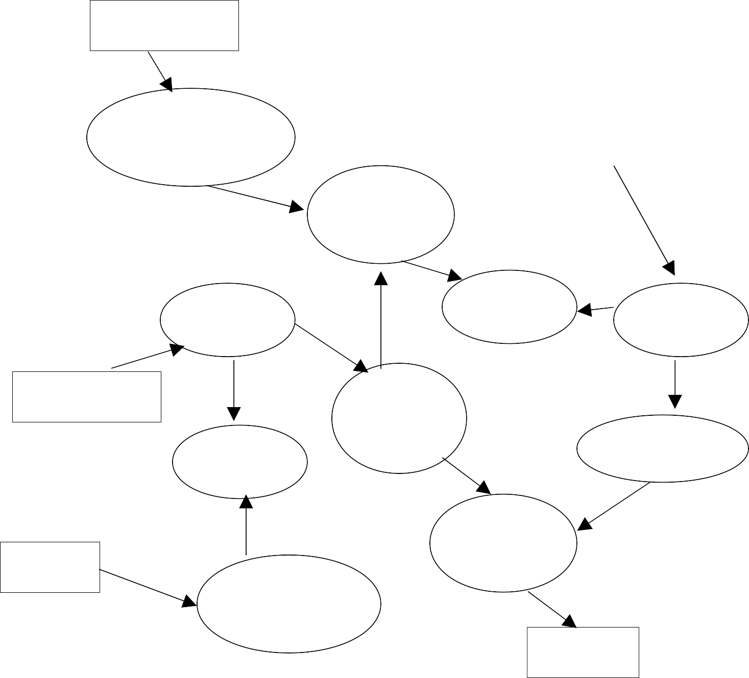

**Employee**

**Interaction to Account**

**Registra tion Process**

### Login

**Administrato r**

## Admin Proces s

**Listing of user**

## User Activity

**Add new produc t to sale**

## Listing of order Catego ry

**Login Proces s**

## Authorize d work

**Outside r Source**

## Payment Process

**Product selectio n**

### Product

ADITYA SRIVASTAVA 19

**Entity - Relationship Diagram:-**

.Category

Name

E.ID# Name ##

Nationalit y

C.ID #

Address

Addre ss

**Employee**

Phone No.

E.ID #

Service s

S. No. #

**Customer**

Phone No. No.

Category

Salary

Job

Type

Es ID #

Location

Shoppi ng

P_n m

**E-shopping Center**

Order for

P_id #

Type

C. Code#

Collectio n

Phone No.

B. ID #

Name

Qty

**Product**

Auth. person

Price

Paymen t

**Billing Counter**

ADITYA SRIVASTAVA 20

Collections slip No.

Location

C. Code

Phone No.

# MODULE DESCRIPTION

We know that it is quite difficult to do any thing of its whole part at a time.

So it is the task of the programmer to break/split the whole set of task into various small module so that one can handle them effectively. But it depends upon the software system that in which Extent it will be broken so that there is no inter-dependency among them.

This project developed for “**On-Line Shopping**” is broken into following module.

### Admin Module

1. **User Module**

### Customer Service Module

1. **Advertisement Module**

### Employee Module

1. **Payment Module**

### Purchase Module

1. **Product Tracking Module**

### Searching Module

1. **Report Module**

### Security

1. **ADMIN MODULE: -** Admin module is mainly for the owner of the system. This module performs the work of regular checking process. Every one needs current information about any thing. So, this module is responsible for updating the information continuously if any, in the system so that one can find timely information. But the main function of this module is to handle security of this system. Different types of authentication and authorization process is performed for this purpose. This module is also responsible for advertisement bid. Any organizations that are eager for advertisement can contact us for their ad. This module handles the entire task related to advertisement like specifying and allocating the space and related cost.
2. **USER PAGE MODULE:-** User page module is for front page of this system. It is the main page of the system in which all the links of this system are kept. Now the main thing is how to make the

home page interactive and user friendly so that there should not be any problem for the user. This is the task of the system administrator to make the home page Interactive.

1. **CUSTOMER SERVICE MODULE:-** In the customer service module, the customer will use this website to on-line shopping. And also the customer send the request to the shopping.
2. **ADVERTISEMENT MODULE:-** In any web based application advertisement is main thing. Any organization wants to give their advertisement on Internet. This module handle information about the advertisement related task. Interested Organization can

contact us for their advertisement. This module also calculates the cost of advertisement corresponding to their acquired space. The place for advertisement can be categorized into to parts i.e. the space on the home page and the space on other pages. The cost of the advertisement is also varied according to place of advertisement.

1. **EMPLOYEE MODULE:**- In employee module, all the employee related information stored and managed in this module. Employee will look all the demand of the customer and serve it.
2. **PAYMENT MODULE:-** In this module, the customer will payment in different mode like demand draft, or by credit card.
3. **PURCHASE MODULE:-** In this module, the all selected item could be purchased by the customer. And will payment by DD.
4. **PRODUCT TRACKING MODULE:-** In this module, the customer demand for the product and payment for that product and after that the customer will contact with the product tracking module.
5. **SEARCH MODULE:-** Search module provides search facilities to the search different product to the purchase.
6. **REPORT MODULE:-** This module generates various reports to higher authorities of the system. As we know that this system has additional functionality to act as a important for the website and also for the which may help in future.
7. **SECURITY MODULE:-** security module is concerned with security of the system. As this system is public website but it has provided security to the admin module only because this module

can update information of the system so to make sure that no any unauthorized user could change information. This module has various mechanisms to check the validity of the user.

# DATA STRUCTURE/TABLE DESIGN

Database is collection of data that can be treated as single unit. This Single or individual unit is called table. In relational database system Table is combination of rows and columns which show records and fields

Respectively. After great efforts we determine the main entities, there attribute and relationship among them. After determining all these entities, we design the table structure as follows:

### Login Table:

|  |  |  |  |  |
| --- | --- | --- | --- | --- |
| **S.R** | **Field Name** | **Data Type** | **Size** | **Validation** |
| 1. | S.No (auto-  increment) | Integer | 5 |  |
| 2. | U_name | Varchar | 20 | Primary Key |
| 3. | Password | Varchar | 20 |  |

**Employee Details Table:**

|  |  |  |  |  |
| --- | --- | --- | --- | --- |
| **S.R** | **Field Name** | **Data Type** | **Size** | **Validation** |
| 1. | E_Id | Varchar | 20 | Primary key |
| 2. | E_Name | Varchar | 20 |  |
| 3. | J_date | Date |  |  |
| 4. | Sex | Varchar | 6 |  |
| 5. | Address | Varchar | 50 |  |
| 6. | Phone No | Integer | 10 |  |
| 7. | DOB | Date |  |  |
| 8. | Salary | Integer | 10 |  |
| 9. | Specialization | Varchar | 20 |  |

### Customer Service Table:

|  |  |  |  |  |
| --- | --- | --- | --- | --- |
| **S.R** | **Field Name** | **Data type** | **Size** | **Validation** |
| 1. | Username | Varchar | 10 | Primary key |
| 2. | Password | Varchar | 30 |  |
| 3. | Name | Varchar | 101 |  |
| 4. | Address | Varchar | 300 |  |
| 5. | Contact_no | Varchar | 12 |  |
| 6. | Email | Varchar | 500 |  |

**Purchase Table:**

|  |  |  |  |  |
| --- | --- | --- | --- | --- |
| **S.R** | **Field Name** | **Data type** | **Size** | **Validation** |
| 1. | Pur_id | Varchar | 10 | Primary key |
| 2. | ItemName | Varchar | 300 |  |
| 3. | Rate | Varchar | 100 |  |
| 4. | Item_category | Varchar | 300 |  |
| 5. | Quantity | Integer | 5 |  |
| 6. | Date | Datetime |  |  |

### Advertisement Table:

|  |  |  |  |  |
| --- | --- | --- | --- | --- |
| **S.R** | **Field Name** | **Data type** | **Size** | **Validation** |
| 1. | Ad_id | Varchar | 10 | Primary key |
| 2. | Ad_name | Varchar | 30 |  |
| 3. | Image | Varchar | 79 |  |
| 4. | Ad_start_date | dateTime |  |  |
| 5. | ad_end_date | dateTime |  |  |
| 6. | Comp_name | Varchar | 89 |  |
| 7. | Address | Varchar | 78 |  |
| 8. | Contact_no | Varchar | 12 |  |
| 9. | Email | Varchar | 78 |  |

**Payment Table:**

|  |  |  |  |  |
| --- | --- | --- | --- | --- |
| **S.R** | **Field Name** | **Data Type** | **Size** | **Validation** |
| 1. | P_id | Varchar | 20 | Primary key |
| 2. | P_name | Varchar | 200 |  |
| 3. | P_date | Date |  |  |
| 4. | Cust_name | Varchar | 67 |  |
| 5. | Pay_mode | Varchar | 50 |  |
| 6. | Cash | Integer | 10 |  |
| 7. | DD | Integer | 23 |  |

**Product Tracking Table:**

|  |  |  |  |  |
| --- | --- | --- | --- | --- |
| **S.R** | **Field Name** | **Data Type** | **Size** | **Validation** |
| 1. | P_id | Varchar | 20 | Primary key |
| 2. | Cust_name | Varchar | 200 |  |
| 3. | Delvr_date | Date |  |  |
| 4. | Amount | Varchar | 67 |  |
| 5. | Contact_no | Varchar | 50 |  |
| 6. | Address | Varchar | 100 |  |
| 7. | Email | Varchar | 56 |  |

# PROCESS LOGIC

Process logic is concerned with how the system interact with users and fulfill there requirements? Being a web based system; user of this system can easily access this system through Internet. It provides various functionalities, attracts the user to use it, and makes the user comfortable to work on it.

Before providing access to the manipulating authorities, it first demands for user name and password based on user type. If the name and password entered are correct then one can enter the admin menu and can change any contents from this place. Note that it also works as a public website where one can see the information based on the purpose to access this website. There is no need for authentication here, because they has to only access the site not change or update any content and they also cannot change it because they have no authority to change. Here user finds various menus and sub menus and can select any one of them as there requirement.

Let I explain the process logic of admin module that how one can perform the task of administrator. First one has to give user name and password which should be checked by the system on the basis of information stored in the database.

# SYSTEM FLOW CHART

**SYSTEM SECURITY MEASURE**



Admin Module

Security is the most important part of any system. It can be either

Enter User Name &

the security of system program functionalities or underlying

Password

database. We have very cautious process of authentication of user

that no one could change its contents in unauthorized manner.

Security and inEtexgisrt?ity of database are very important for any software system because databases are the backbone of the system. Security need to be implemented at every level of the system so that onSlhyowauCtohnotrroilzed user can access the system for

Menu

updation and other significance process.

Entering correct password while opening the system or we can

Enter

say that entering the system is the process of authentication. If any

one is entering the pCahsosiwceord is wrong then he/she cannot access the system for any change purpose.

The main purposeIs ochfoictehe security is to save system from

accidentally

Update?

Records Update

changes or loss of information or also getting wrong information.

The

Is choice

systaedmveratisdemmeinnistrator is the person that can change the information

t? Advertisement

or update the information. He can also grant the permission that who

has to enter the system and what can he do. So security is the most

Is choice

impoPartyamnetntt?opic to be concerned.

Payment

ADITYA SRIVASTAVA 28

Exit

# FUTURE SCOPE OF THE PROJECT

“**On-Line Shopping**” is a web-based project which is made for remote-shopping or shopping through Internet. As the technology is being advanced the way of life is changing accordance. Now a day’s we can place the order for any thing from our home. There is no need to go the shop of the things we want. The order can be placed online through Internet. The payment, the confirmation of purchasing; we can do every thing we want. Now we can think that how the days have been changed with time. People had to stand in rows to wait there terms to buy a particular thing from a popular shop. But what is happening now a day’s; we can extremely surprise that those things can be available on the door-step in few hours.

In future we will try to make this website which work so flexible and beneficial for the customer and also try to make smooth service.

# BIBLIOGRAPHY

### Books:

* Software engineering by Roger s. Pressman
* An Introduction To Database Systems by **Bipin C Desai**
* **Asp.NET** (Beginning) 1.1 by vb.net 2003 BY **Wrox.**
* Professional C# 2nd edition by **Wrox.**
* Book on Indian culture
* A book of appress on Asp.Net through C#