* **GraphQL :-**
* GraphQL is a query language for API.
* GraphQL is an open-source server-side technology, now maintained by a large community of companies and individual all over the world.
* GraphQL is a runtime for fulfilling those queries with your existing data.
* GraphQL provides a complete and understandable description of the data in API, gives clients the power to ask for exactly what they need and noting more.
* **GraphQL Advantage:-**
* Fetching data with a single API call.
* Good fit for complex systems and microservices.
* No over-fetching and under-fetching problems.
* Hierarchical Structure: - GraphQL follows a hierarchical structure where relationships between objects are defined in a graphical structure.
* **GraphQL Support Concept: -**

1. **Mutation:-** Mutations are GraphQL way of applying data modification to resources.

1. **Subscription:-** Subscriptions are GraphQL way for clients to receive notification on data modifications.
2. **Query:-** When you want to get data from your GraphQL server.

* **GraphQL VS Rest :-**
* GraphQL and REST send HTTP request and receive HTTP response.
* Example:-

* GraphQL we specify the exact resources we want, and also which filed we want. The client decides what to include.
* Rest example, the API implementer decided for us that authors are included as related resources.
* GraphQL Apollo Server:-
* Apollo Server is an open-source, spec-compliant GraphQL server that's compatible with any GraphQL client, including Apollo Client.

# Started with Apollo Server:-

1. **Create new project:-**

1. **Install dependencies:-**

1. Define GraphQL schema:-

1. Define data set:-

1. Create an intance of ApolloServer:-

1. Start the server:-

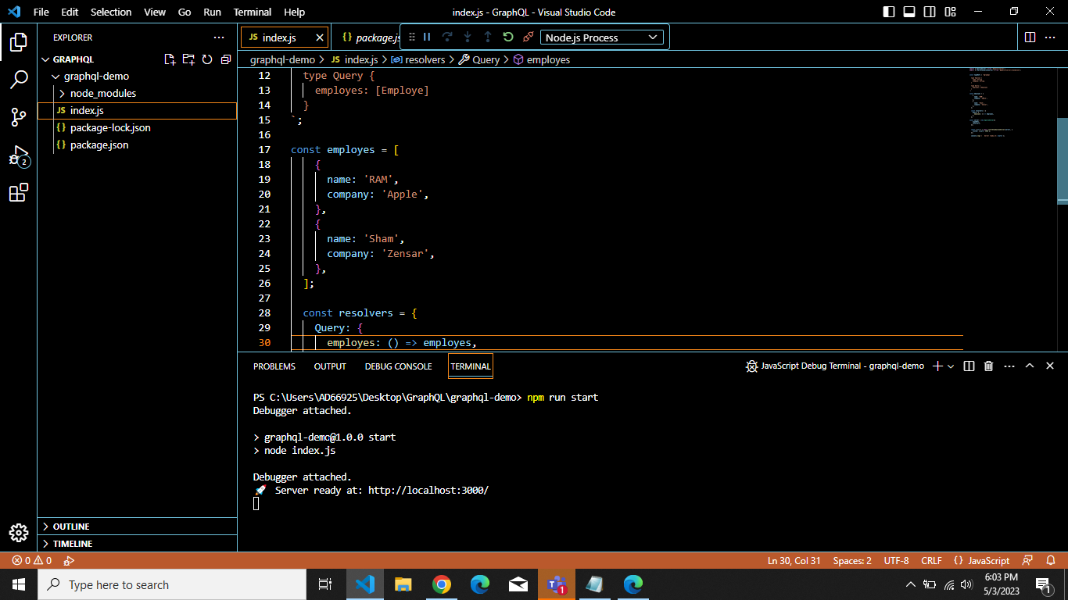

1. Execute first query:-

