# Inventory System:

* It is a process that tracks stock, supplies and sales through an entire supply chain.
* Companies use inventory systems to ensure they know exactly what items they have available and the location in which they reside.
* These systems can also track data such as the number of units, cost per unit, serial number, lot numbers, purchase dates and production dates.

It’s Importance:

1. Facilitates the completion of sales more effectively

* Identify what products a company may not have enough of and which products are selling well so that you can replenish a business's stock.

1. Allows for the provision of more accurate reports

* Tracking a company's stock with an inventory system can provide you with more accurate reports so that you can calculate cost values and develop precise financial plan.

1. Mitigates risks

* Implementing an inventory system can help you monitor a company's stock levels more closely & reduce the costs associated with theft, product loss, breakage and manual errors.

1. Increases profit margins

* It is used to prevent you from over-ordering items, reduce waste and save space in a warehouse.

**Stock:**

* Raw materials and components (for manufacturers)
* Finished goods for resale (for distributors)
* Indirect materials that support the daily operations of a business but not production (businesses of all kinds)

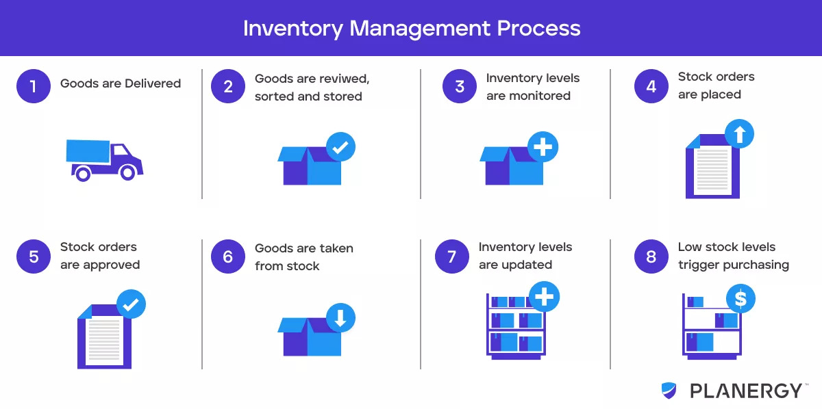

Important Type:

### Enterprise resource planning systems

Enterprise resource planning (ERP) systems offer an integrated approach to business operations and planning. These systems provide a holistic view of a company's finances, operations, inventory and logistics all in one location.

ERP systems are ideal for companies that manage large, complex supply chains, work with advanced data streams and oversee multiple warehouse locations. With an ERP system, you can automate repetitive tasks and oversee the entire workflow of a company. Multinational corporations and companies that operate across multiple sales channels may benefit the most from using this system.

an integrated system of software applications that allows an organization to manage its business processes using a centralized relational database. It allows a business to see a snapshot of how efficiently its key functions -- for example, inventory levels or sales, personnel -- are working together. By doing so, it can better plan how to use its centralized resources across the enterprise -- hence, ERP.

ERP systems typically contain dashboards connected to a central database that let users look at real-time data across different business units. Depending on the [sophistication of the ERP vendor](https://www.techtarget.com/searcherp/news/252464232/ERP-vendors-get-high-marks-in-Panorama-report), individual modules may have numerous submodules that can be added to reflect how your business operates.

Need?

because multiple applications are integrated in an ERP system, the sales team taking orders over the phone can see how many widgets are left in inventory at any given minute -- even accounting for online orders that bypass customer service reps. Manufacturing is looking at the same data and knows whether or not to ramp up assembly on the line. Your trusted suppliers are automatically notified when parts are low. And shipping can account for each item being shipped and when it arrives at its destination.

**Stock adjustment:**

A stock adjustment is the increase or reduction made to the stock so that the actual quantity on hand matches the stock shown in the system – basically, a correction in the records so that they agree with the physical count.

Inventory levels don’t always change because of sales; which is why it becomes necessary to update your records to reflect the difference in the physical inventory count that may not be in your system.

The three types of inventory adjustments commonly performed by businesses are:

### 1. Increasing Quantity

The physical count is greater than the recorded quantity, so the quantity will have to be increased in the records using the cost price or average cost as of present.

### 2. Decreasing Quantity

The physical count is lower than what is in the system, so the total value for that item will need to be adjusted.

### 3. Revaluating

The physical quantity as such is not different but the management changes the average cost and therefore the total value of a particular item.

Stock adjustment reasons can be positive or negative. Positive Inventory level changes take place due to several reasons – like when there is an excess stock that is as yet unsold but it can be sold, new merchandise comes in either through production or purchase – the company needs to update its records to reflect the increased quantity.

[Negative inventory](https://www.tranquilbs.com/negative-inventory/) adjustments are required because of:

* Wastage – obsolete or expired inventory (perishables, electronics, etc.)
* Shrinkage – stocks lost due to theft
* Breakage – damaged inventory that isn’t capable of being sold
* Internal consumption – stock that was not sold by consumed internally by the company

Fixed asset:

**"fixed asset"** refers to assets intended to **serve the activity** of a company in a **sustainable** manner. There are **three categories** of fixed assets:

* **Financial fixed assets:** these correspond to the monetary assets of a company. This concerns equity securities, loans granted directly by the company, deposits, and guarantees ...
* **Tangible fixed assets:** these are what a company owns and will continue to use after the end of the current financial year (land, buildings, vehicle fleet, machines, etc.)
* **Intangible fixed assets:** these are dematerialized assets (but which are not monetary). For example, there are patents, licenses, software, business assets, etc.

**Purchase order:**

A purchase order is a commercial [source document](https://corporatefinanceinstitute.com/resources/knowledge/accounting/source-documents/) that is issued by a business’ purchasing department when placing an order with its vendors or suppliers. The document indicates the details on the items that are to be purchased, such as the types of goods, quantity, and price. In simple terms, it is the contract drafted by the buyer when purchasing goods from the seller.

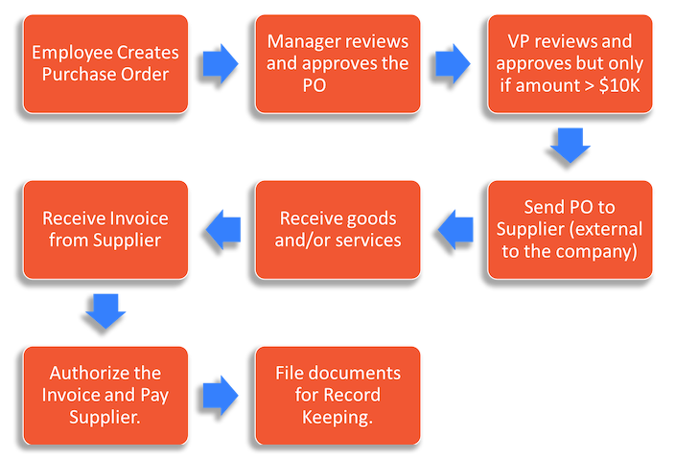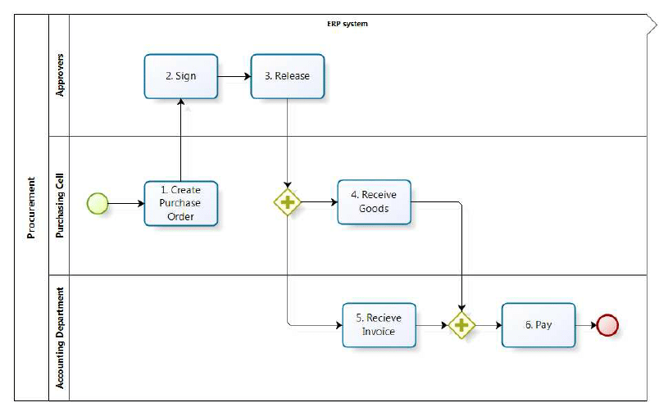

Note:

The PO is a contract of the sale while the invoice is the confirmation of the sale.

**Purchase Entry:**

A journal entry for inventory is a record in your accounting ledger that helps you track your inventory transactions. Depending on the type of inventory and how much your business carries, there are different kinds of journal entries that may help you organize your financial expenses and earnings. For example, some businesses maintain a periodic inventory accounting system, while others use a perpetual inventory system. Periodic inventory systems are less detailed and less time-consuming, so they work well for businesses with less inventory. Perpetual systems are typically electronic. They're in-depth and take time to set up and maintain.

### Inventory purchase entry

An inventory purchase entry is an initial entry made in your inventory accounting journal. Inventory purchases go through your accounts payable, which accounts for your short-term financial obligations to pay the supplier. It includes the purchases you made either for the raw materials to manufacture your business's products or the merchandise you purchased to sell through your organization.

Example:

Debit

Credit

Raw materials inventory$100

Merchandise inventory$100

Accounts payable  
$200

**Inventory report:**

An inventory report is a summary of a retailer’s existing stock. It distills details like how much stock you have, which products are selling fastest, category performance, and other information about the status and performance of inventory

Inventory reports are important to [monitor the biggest and most expensive asset of your business](https://www.vendhq.com/blog/inventory-management/),