This procedure will help you to learn how to use database for inserting json file and write simple and aggregate queries.

Program 1: Follow the steps you will get to know.

Program 2:

Query MongoDb with Conditions: [Create appropriate collection with necessary documents to answer the query]
a. Find any record where Name is Somu.
b. Find any record where total payment amount (Payment.Total) is 600.
c. Find any record where price (Transaction.price) is between 300 to 500.
All Queries for this program is given below:

//Before Writring Query make sure you connect your database
Step1: Connect To your mongodb database named MongoDB Compass if you don’t have it install it .from a simple google search

Link: https://www.mongodb.com/try/download/compass

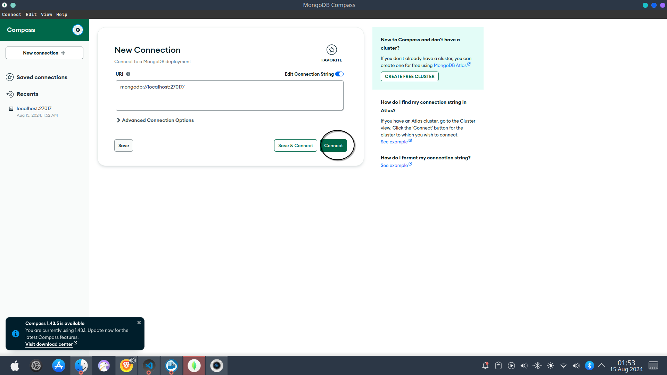

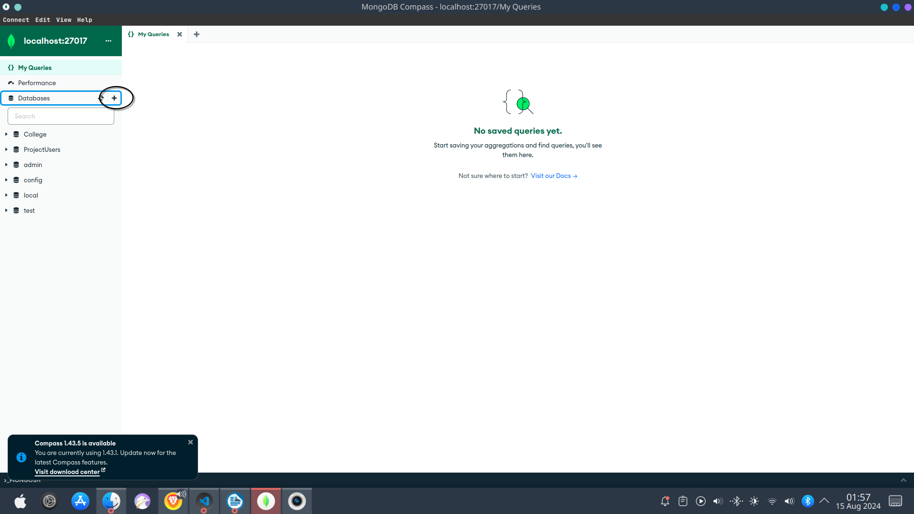

After this write the database and collection name and create it .
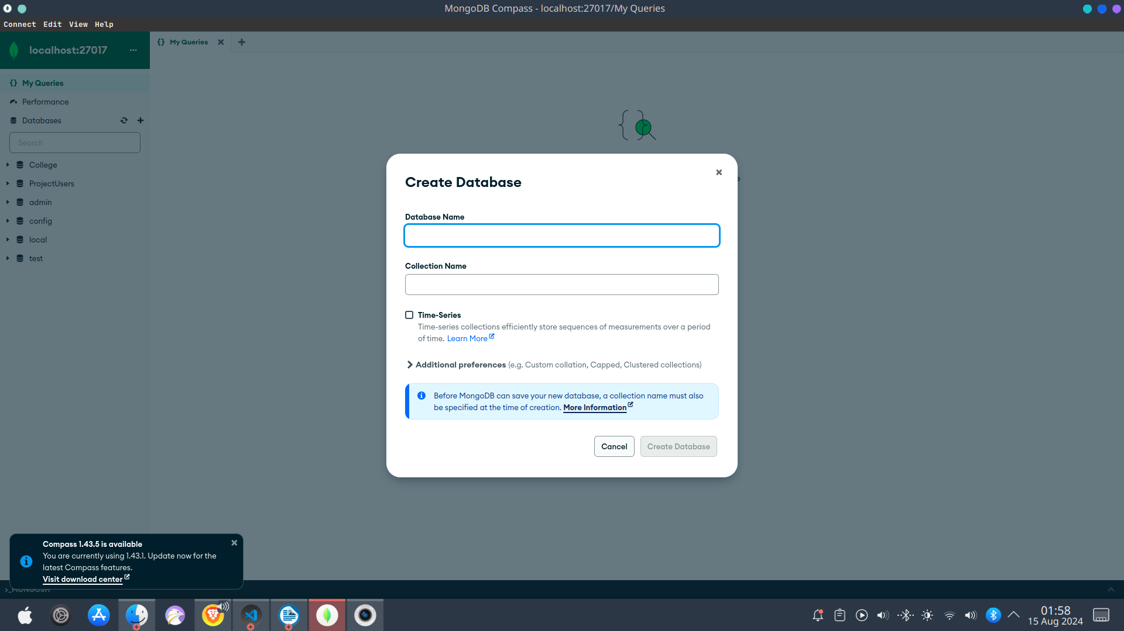

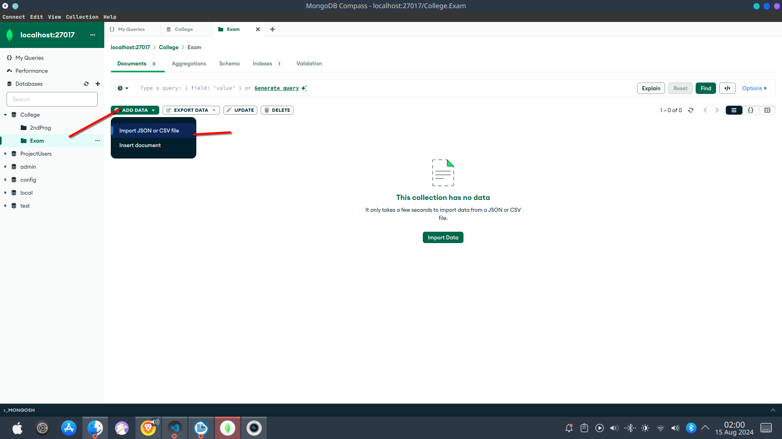

After inserting the json file then write the query given below.

a. Find any record where Name is Somu.
{“name”:”Somu”}

b.Find any record where total payment amount (Payment.Total) is 600.
{“Payment.Total”:600}

c. Find any record where price (Transaction.price) is between 300 to 500.
{Transaction.price:{$gte:300,$lte:500}}

d.Write a query to find the aggregate sum of the Payment Total by all the people

[{
$group: {
_id: null,
totalTranscation:{$sum: "$Payment.Total"}
}}
]

