Open **TFS Administration Console**and click **Configure Installed Features &**click on**Upgrade.**

[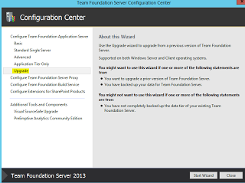](http://1.bp.blogspot.com/-gfj9JqNWj4w/Um4AwpmIxaI/AAAAAAAAE54/0INuwV-bkZU/s1600/TFS+2010+to+TFS+2013+Migration+01.PNG)

Click **Next**to start the upgrade process..

[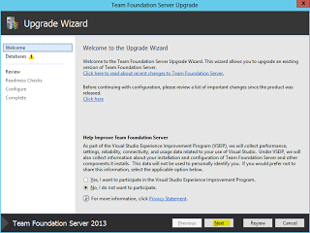](http://3.bp.blogspot.com/-Yqskm4IsaIE/Um4AwqbxKLI/AAAAAAAAE6A/kv-Fc2pLHlY/s1600/TFS+2010+to+TFS+2013+Migration+02.PNG)

Enter name of **SQL server instance** & click on**List Available Databases**to list all exiting database names which we restored from TFS 2010 SQl server to new SQL 2012 server**&**Click**Next.**

[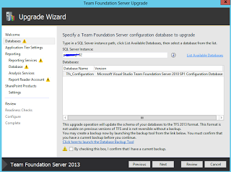](http://2.bp.blogspot.com/-Yt6W8jIWnAk/Um4Aw8clzmI/AAAAAAAAE58/Ve7YhKDdPBk/s1600/TFS+2010+to+TFS+2013+Migration+03.PNG)

Enter **Service account** details which we are going to use for TFS Application tier & click on **Test**to check the entered login credentials & click **Next**to proceed.

[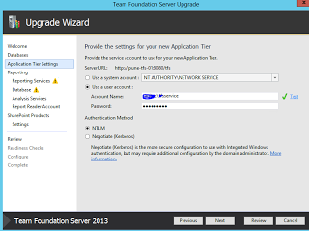](http://3.bp.blogspot.com/-vKE2c_LuBLk/Um4AxXAvspI/AAAAAAAAE6Y/PCN_70En0b8/s1600/TFS+2010+to+TFS+2013+Migration+04.PNG)

 Check **Configure Reporting for use with Team Foundation Server** & click **Next.**

[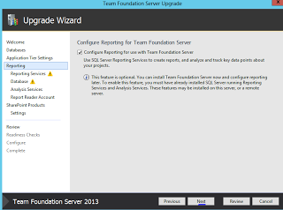](http://3.bp.blogspot.com/-djfqezPixwY/Um4Axuo8kRI/AAAAAAAAE6U/2WRPuuf4kPU/s1600/TFS+2010+to+TFS+2013+Migration+05.PNG)

Enter **Reporting Service Instance details**(i.e. SQL Server name) & click on **populate URL's**

[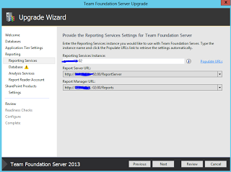](http://3.bp.blogspot.com/-X9YLii3wAKc/Um4Ax5MZmPI/AAAAAAAAE6Q/16nngXEP8vY/s1600/TFS+2010+to+TFS+2013+Migration+06.PNG)

Enter **Team Foundation Server Warehouse Database SQL instance name** & click on **Test**. Also clikc on **List Available Database** to list the database details.

[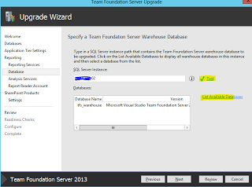](http://3.bp.blogspot.com/-_D8nsLbeIZI/Um4AypIykzI/AAAAAAAAE6s/WmKMPmKsYok/s1600/TFS+2010+to+TFS+2013+Migration+07.PNG)

Enter **Analysis Services SQL server instance** & click on **Test**. You will get error message if SQL client tools is not installed TFS 2013 server. So install SQL client tools if you get error if you click on test.

[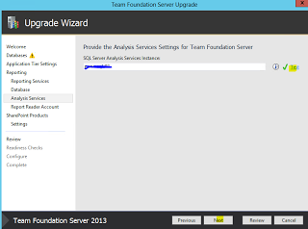](http://1.bp.blogspot.com/-JBzf5887Be8/Um4Ayucb9hI/AAAAAAAAE6o/zeceRmW_mVU/s1600/TFS+2010+to+TFS+2013+Migration+08.PNG)

Click **NEXT**to proceed.

[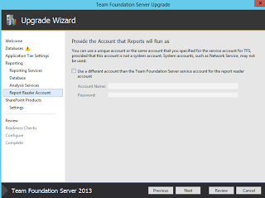](http://1.bp.blogspot.com/-Y2ivYNNtRno/Um4Ay7YCmmI/AAAAAAAAE6w/AfRvXEp-e9M/s1600/TFS+2010+to+TFS+2013+Migration+09.PNG)

[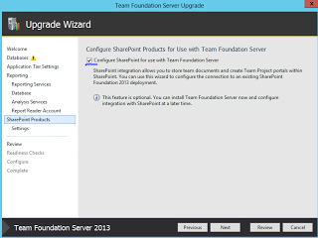](http://1.bp.blogspot.com/--yziQHiYrqM/Um4AzYRwR0I/AAAAAAAAE64/MGK0HoOynxI/s1600/TFS+2010+to+TFS+2013+Migration+10.PNG)

Select **Use Current SharePoint Settings** & click **Next**.

[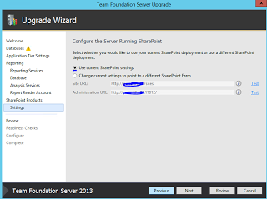](http://4.bp.blogspot.com/-Z1vKR-AdmJU/Um4Az7ukPeI/AAAAAAAAE7M/0xD1yY2TGhw/s1600/TFS+2010+to+TFS+2013+Migration+11.PNG)

Click on **Configure**.

[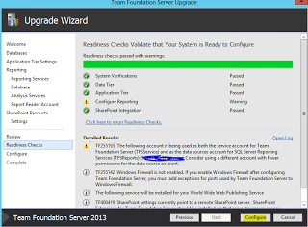](http://1.bp.blogspot.com/-DiC1CEHVvEM/Um4Az5bEQBI/AAAAAAAAE7I/fZdCW1iewXw/s1600/TFS+2010+to+TFS+2013+Migration+12.PNG)

Click **Next**to start the upgrade process.

[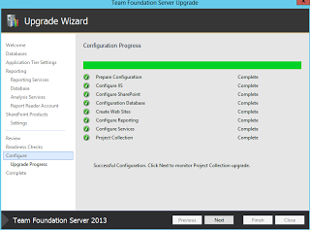](http://3.bp.blogspot.com/-jr6BP6HmjMA/Um4A0XIhLBI/AAAAAAAAE7Q/T4fzQmOWK9U/s1600/TFS+2010+to+TFS+2013+Migration+13.PNG)

[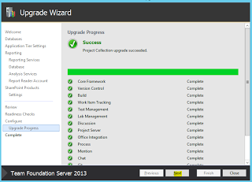](http://1.bp.blogspot.com/-2ChhkHGxFlo/Um4A0yVBBKI/AAAAAAAAE7Y/jZnOmCzYDIc/s1600/TFS+2010+to+TFS+2013+Migration+14.PNG)

Now **upgrade has been completed successfully.**

[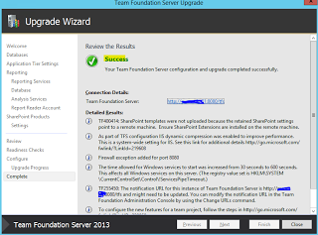](http://4.bp.blogspot.com/-y1v9G0Qb0HQ/Um4A1CW_AUI/AAAAAAAAE7s/S3mULK_EGvU/s1600/TFS+2010+to+TFS+2013+Migration+15.PNG)

Release Management Upgrade

https://blogs.msdn.microsoft.com/tfssetup/2015/10/01/upgrading-release-management-2013-to-2015-in-place/