Autoscaling:
- Go to instance and select Launch template.
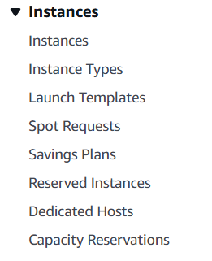
- Open Launch template.
-create launch template for Autoscaling.
-Select Operating System for the server.
-Default security group.
-Use script and make Template.
Enable All TCP and ALL Traffic in security grup.
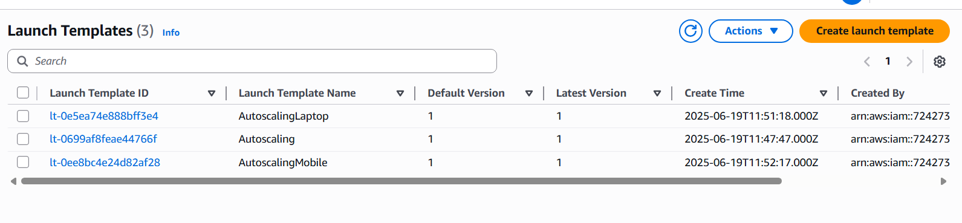
- Create Target Group.
We need make 3 target group for all Mobile, Laptop and Home.
- Now we can create Load balancer.
For all 3 Mobile , Laptop and Home just we will make single load balancer for Home and add rule .

After add Rule for all three we can go to autoscaling group.
- Autoscaling Group.
- 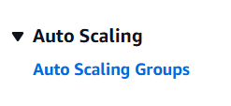
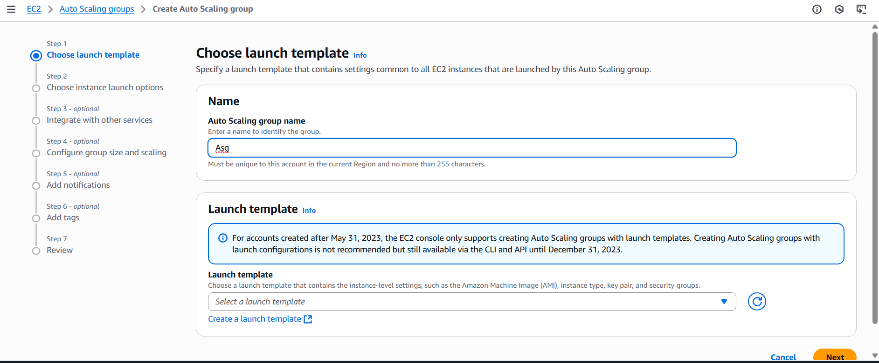

- Now check instances are created automatically for all Laptop, Home and Mobile.
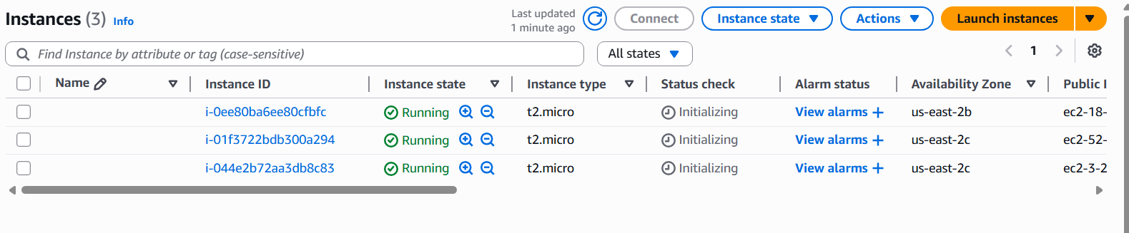

- We need to set metric in autoscaling group to define utilization threshold.
Go to autoscaling and select scaling group then select scaling policy. Click on Automatic Scaling.
There are 2 types: 1. Dynamic and 2. Predictive schedule policy.
Choose Dynamic Schedule policy-
Define percentage utilization limit.
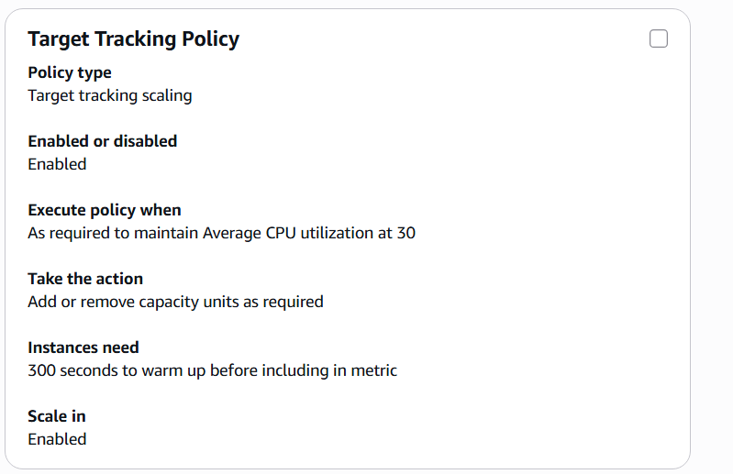
- Now give stress to Server and check if autoscaling created new server .
- Now copy DNS from Load balancer and paste it in search engine chrome.

