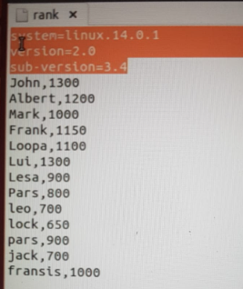

create table table1 (col1 string,col2 int) row format delimited fields terminated by ’,’ lines terminated by ‘\n’ stored as textfile tblproperties(“skip.header.line.count”=”3”);

load data local inpath ‘/home/cloudera/hive_files/log2.txt’ into table table1;

select * from table1;

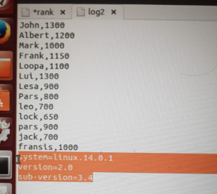

create table table2 (col1 string,col2 int) row format delimited fields terminated by ’,’ lines terminated by ‘\n’ stored as textfile tblproperties(“skip.footer.line.count”=”3”);

load data local inpath ‘/home/cloudera/hive_files/log2.txt’ into table table2;

select * from table2;