<DATA ANALYTICS WITH POWER BI> PROJECT REPORT
August 2025-January 2026

NFHS India Health Analytics and Visualization with Power BI

Submitted by

Anup Pandey Registration No. 12310363
Bachelor of Technology Computer Science and Engineering
Course Code INT374

Under the Guidance of

B Monica
UID: 32352

Discipline of CSE/IT Lovely School of Computer Science
Lovely Professional University, Phagwara

CERTIFICATE

This is to certify that Anup Pandey bearing Registration no. 12310363 has completed INT374 project titled, “NFHS India Health Analytics and Visualization with Power BI” under my guidance and supervision. To the best of my knowledge, the present work is the result of his/her original development, effort and study.

Signature and Name of the Supervisor Designation of the Supervisor
School of Computer Science and Engineering
Lovely Professional University Phagwara, Punjab.

Date: 19/12/2025

DECLARATION

I, Anup Pandey, student of Bachelor of Technology under CSE/IT Discipline at, Lovely Professional University, Punjab, hereby declare that all the information furnished in this project report is based on my own intensive work and is genuine.

Date: 19/12/2025 Signature
Registration No. 12310363 Anup Pandey

ACKNOWLEDGEMENT

I would like to express my sincere gratitude to everyone who contributed to the successful completion of this project titled “NFHS India Health Analytics and Visualization using Power BI.”

I am deeply thankful to my faculty guide for their continuous guidance, valuable suggestions, and encouragement throughout the course of this project. Their insights helped me understand the practical aspects of data analysis and dashboard design.

I also extend my gratitude to my institution for providing the necessary resources and learning environment to carry out this project effectively. Special thanks to the data providers whose publicly available datasets made this analysis possible.

Lastly, I would like to thank my friends and peers for their support, constructive feedback, and motivation during the development of this project.

Contents
ACKNOWLEDGEMENT 4
Introduction 6
Source of dataset 7
Data Preprocessing 8
Data Modeling 11
Dashboard Design & Pages 12
Conclusion 19
Future Enhancements 20
References 21

Introduction

Public health data plays a critical role in shaping national policies, healthcare programs, and social interventions. In India, the National Family Health Survey (NFHS) is one of the most comprehensive and authoritative datasets capturing health, nutrition, and demographic indicators across states and districts.
However, NFHS data is:

- Extremely wide (100+ indicators),

- Spread across multiple granularities (national, state, district, time),

- Difficult to analyze without robust preprocessing and modeling.

This project focuses on transforming raw NFHS datasets into a scalable, interactive, and insight-driven Power BI dashboard, emphasizing data preprocessing, dimensional modeling, and analytical storytelling rather than simple visualization.

The primary objectives of this project are:

- To preprocess and clean large-scale public health datasets.

- To design a proper star-schema data model for analytical use.

- To create a dynamic Power BI dashboard enabling multi-level analysis.

- To extract insights related to:
  - Maternal & child health
  - Nutrition and malnutrition
  - Non-communicable diseases (NCDs)
  - Household amenities and digital access

- To demonstrate end-to-end analytics skills, including Power Query, data modeling, and DAX.

Source of dataset

All datasets used in this project are official government sources obtained from data.gov.in.

Dataset 1: All-India & State/UT Factsheets (NFHS-5)

- Granularity: State / UT
- Rows: ~36
- Columns: ~134 indicators

🔗 https://www.data.gov.in/resource/all-india-and-stateut-wise-factsheets-national-family-health-survey-nfhs-5-2019-2021

Dataset 2: District-wise Factsheets (NFHS-5)

- Granularity: District
- Rows: ~13,900+
- Columns: ~134 indicators

🔗 https://www.data.gov.in/resource/india-districts-factsheets-national-family-health-survey-nfhs-5-2019-2021-provisional

Dataset 3: Year-wise Child Health Indicators (NFHS-1 to NFHS-5)

- Granularity: National, Time-series
- Covers surveys from 1992–93 to 2019–21
- Indicators: Stunting, Wasting, Underweight

🔗 https://www.data.gov.in/resource/year-wise-details-indicators-children-national-family-health-survey-nfhs-1-nfhs-5-1992-93

Data Preprocessing

Data preprocessing was the core foundation of this project.

Structural Challenges

- Extremely wide tables (100+ indicator columns)
- Inconsistent indicator naming
- Duplicate indicator definitions across datasets
- Non-standard column formatting
- Mixed metadata and data columns

Key Preprocessing Steps

a. Unpivoting

- Converted wide indicator columns into a long-format fact table
- Created:
  - indicator
  - value
- Enabled flexible filtering and analysis

b. Creation of DimIndicator

A dedicated Indicator Dimension Table was created to standardize and manage indicators.
Fields included:

- indicator_id
- indicator_full (original NFHS indicator name)
- indicator_short (clean, dashboard-friendly name)
- category (logical grouping)

This avoided:

- Repetitive renaming in fact tables
- Hard-coded logic in visuals
- Model complexity

c. Indicator Categorization

Indicators were grouped into meaningful analytical categories such as:

- Demographics & Basic Info
- Education & Awareness
- Household Amenities
- Family Planning
- Maternal Health
- Child Health & Nutrition
- Immunization
- Non-Communicable Diseases
- Social Indicators

This enabled category-level slicing across the entire dashboard.

d. Data Cleaning

- Removed extra spaces and hidden characters
- Fixed encoding issues (%, ≥, ≤ symbols)
- Ensured numeric columns were correctly typed
- Handled missing and blank values gracefully

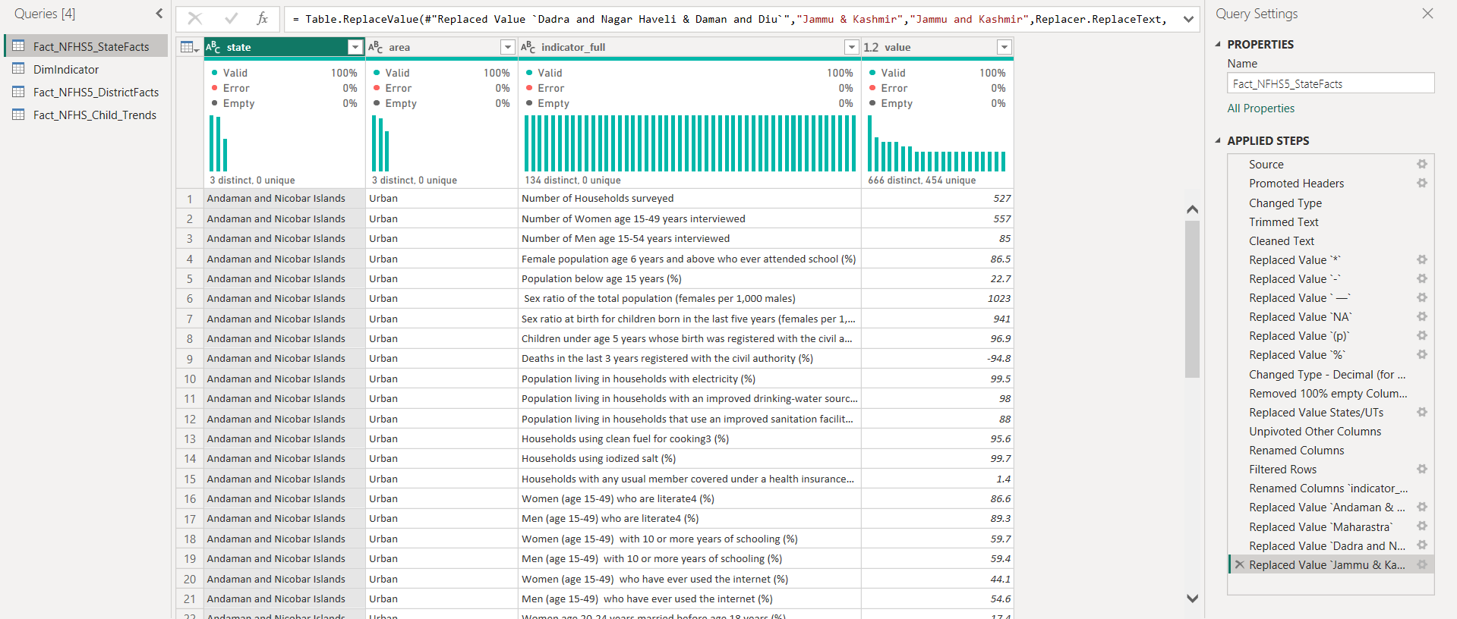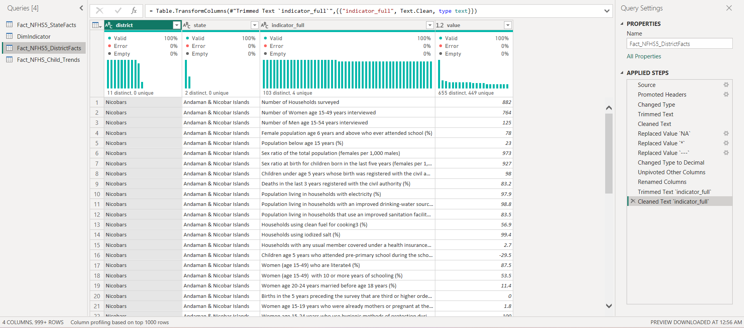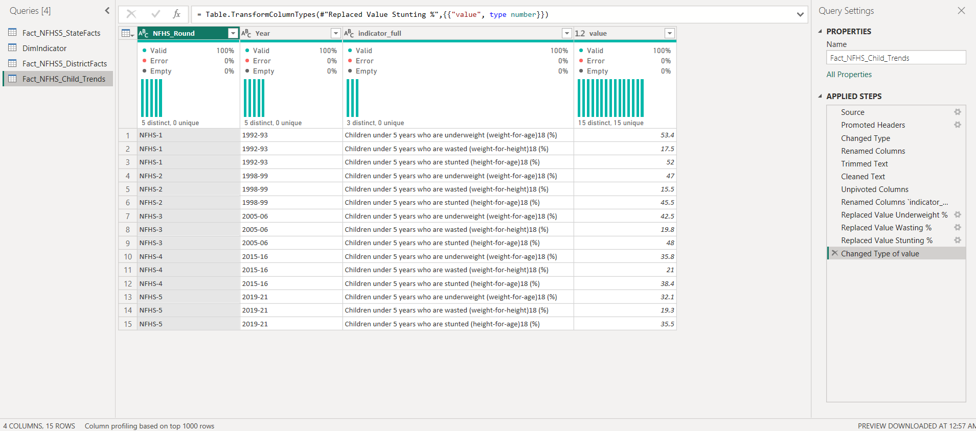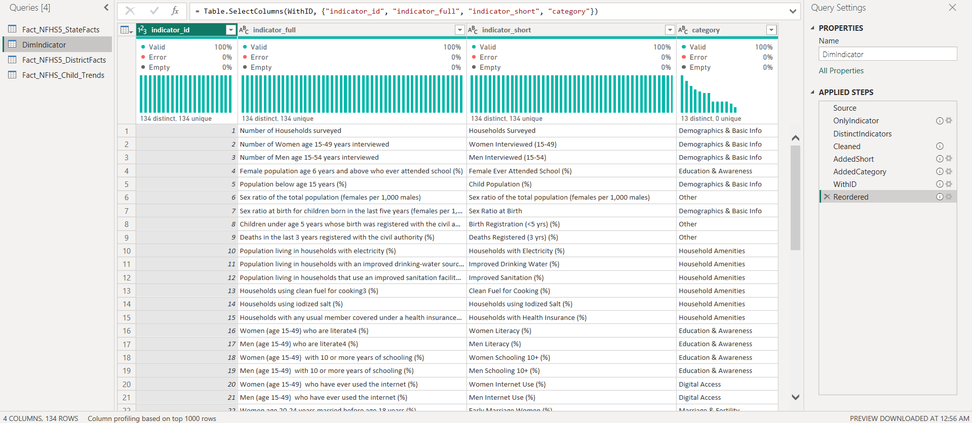

Data Modeling

A star schema was implemented for performance and scalability.
Fact Tables

- Fact_NFHS5_StateFacts
- Fact_NFHS5_DistrictFacts
- Fact_NFHS_TrendFacts

Dimension Tables

- DimIndicator
- DimState
- DimDistrict
- DimSurveyYear

Model Highlights

- One-to-many relationships
- Single-direction filtering
- Shared dimensions across multiple fact tables
- No circular dependencies

This model supports:

- Cross-filtering
- Drill-downs
- Multi-dataset integration

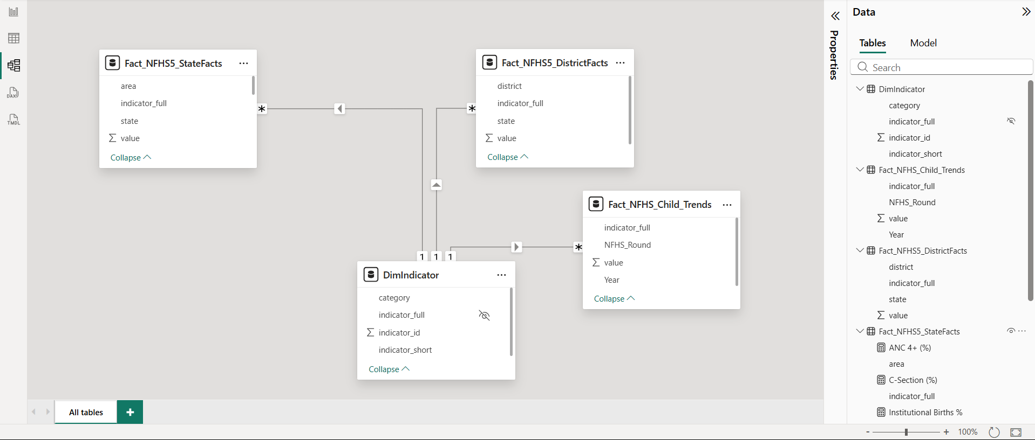

Dashboard Design & Pages

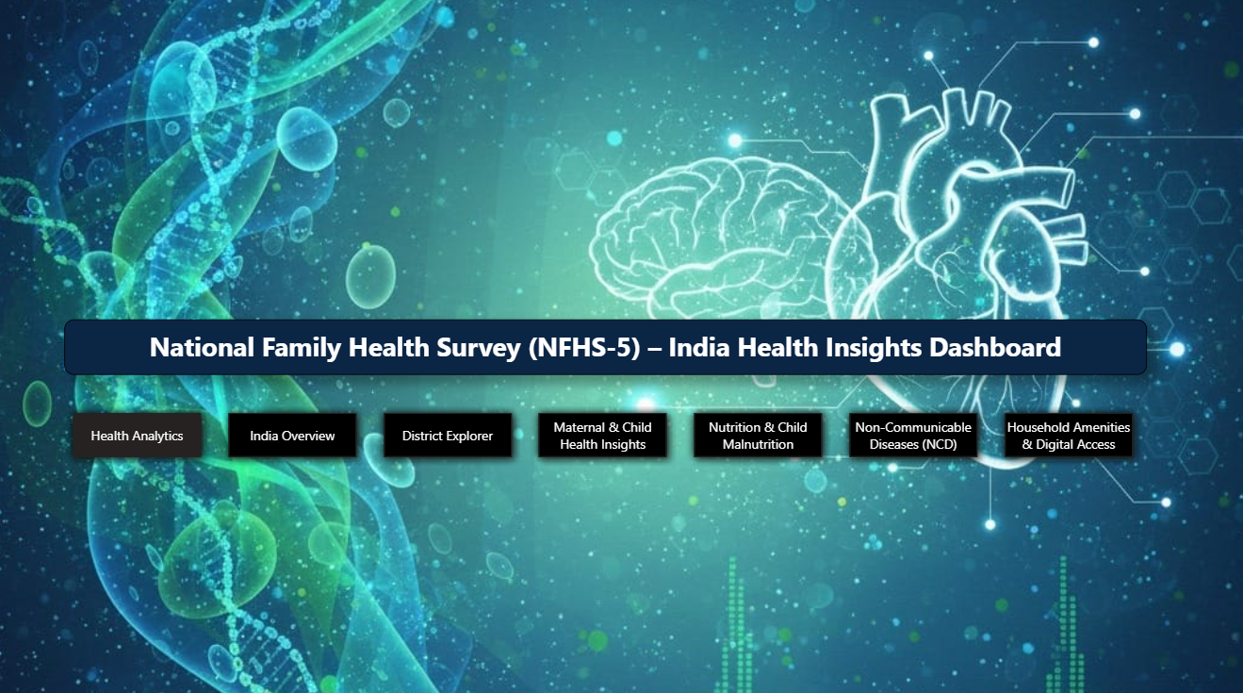

Page 1: National & State Overview

- KPI cards (key health indicators)
- Top N states comparison
- Interactive state slicer

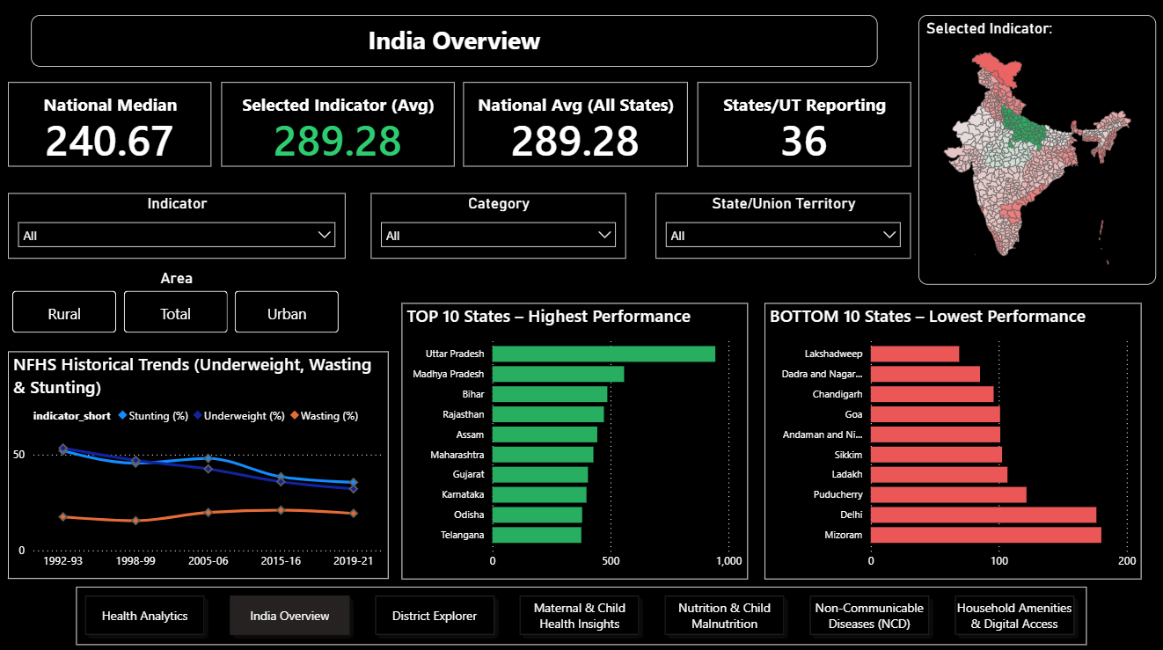
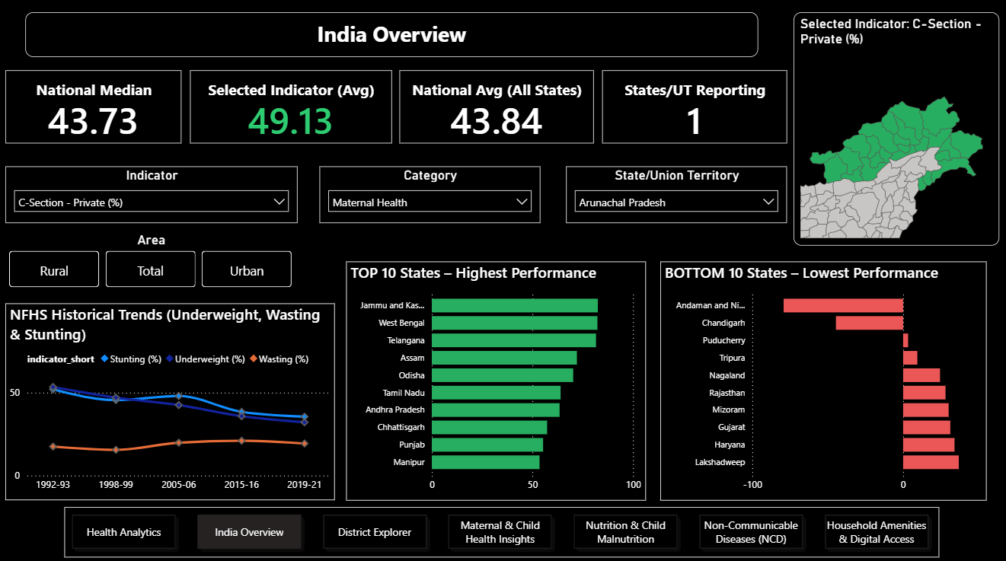

Page 2: District Explorer

- State-based district filtering
- District-level table view
- District heat maps
- Category-based bar charts

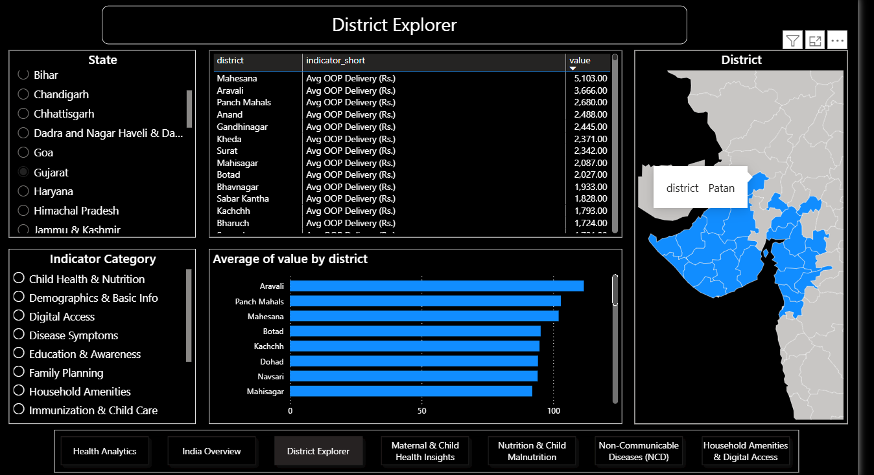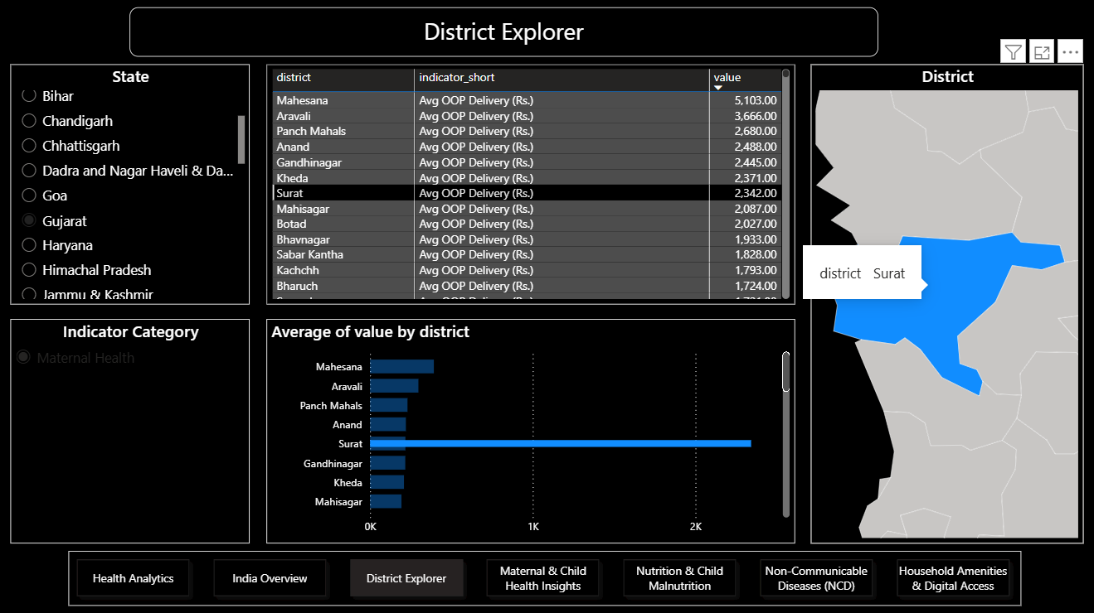

Page 3: Maternal & Child Health

- Institutional births
- ANC 4+ visits
- PNC coverage
- Public vs Private C-section comparison
- Teenage pregnancy indicators

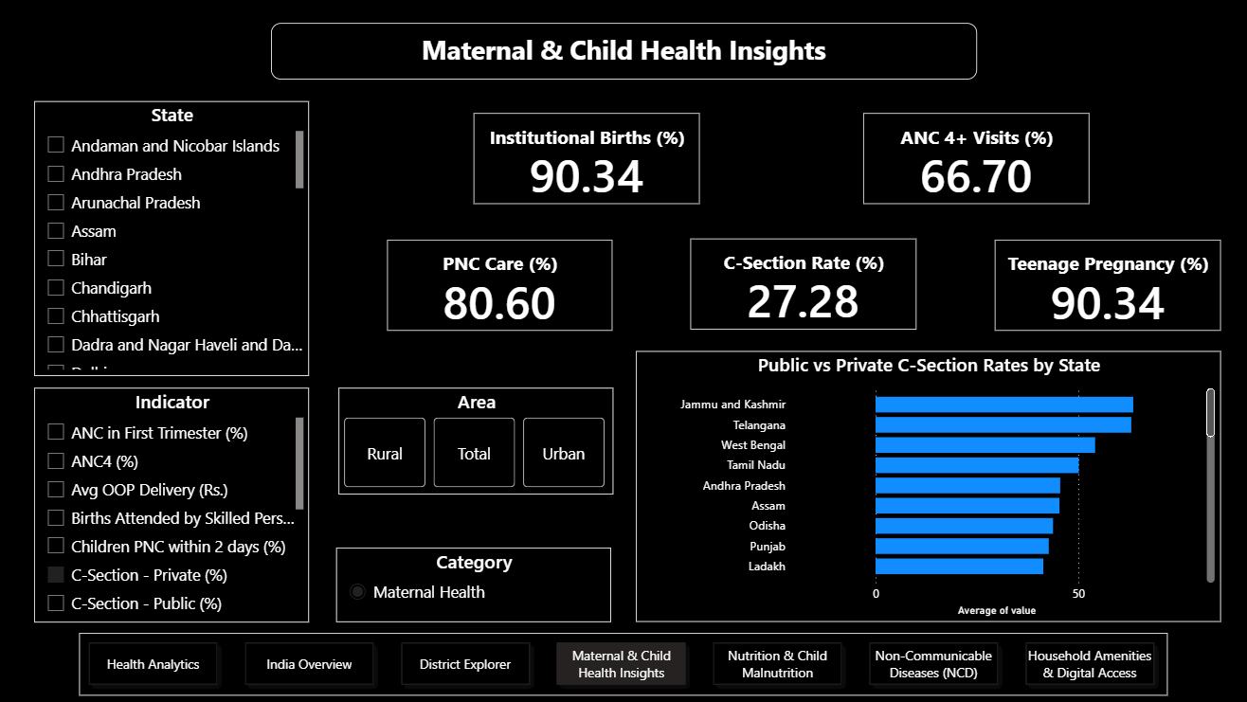
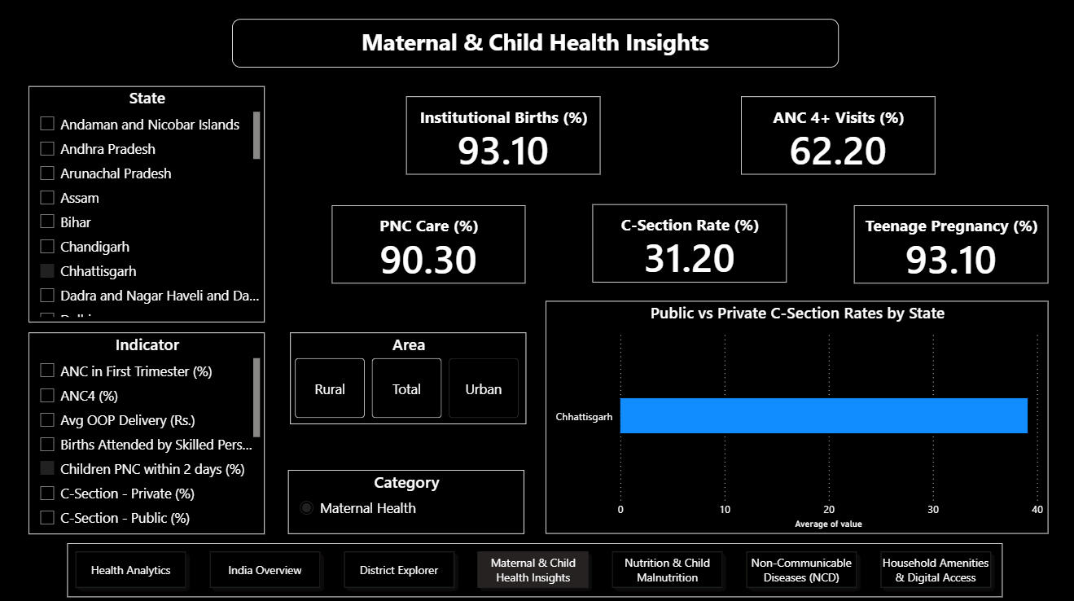

Page 4: Nutrition & Child Malnutrition

- Stunting, wasting, underweight by state
- Malnutrition hotspots (map)
- NFHS-1 to NFHS-5 trend analysis

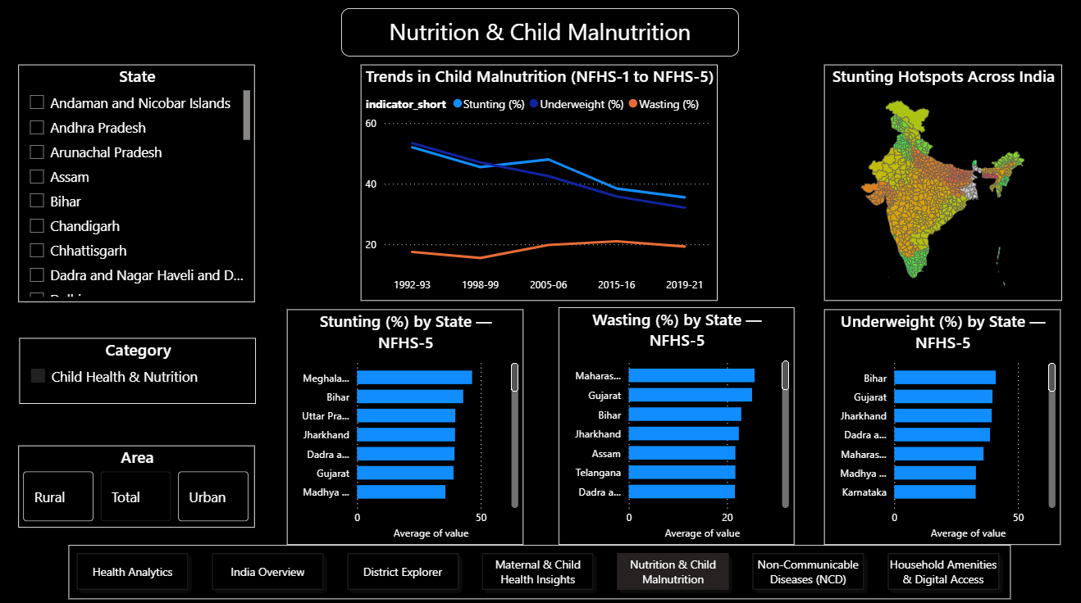
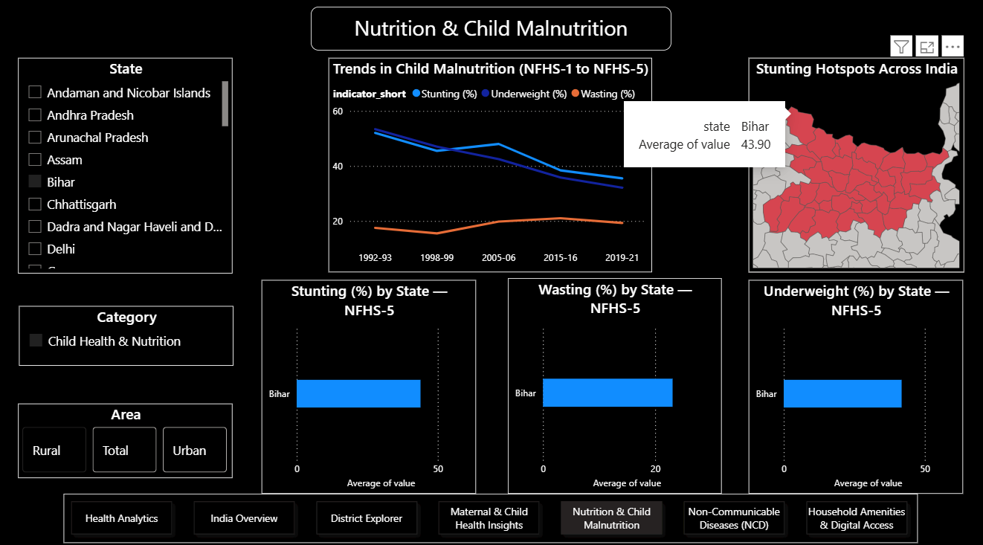

Page 5: Non-Communicable Diseases (NCD)

- Anaemia (women, men, children)
- BMI indicators
- Blood pressure and blood sugar levels
- State-level heatmaps

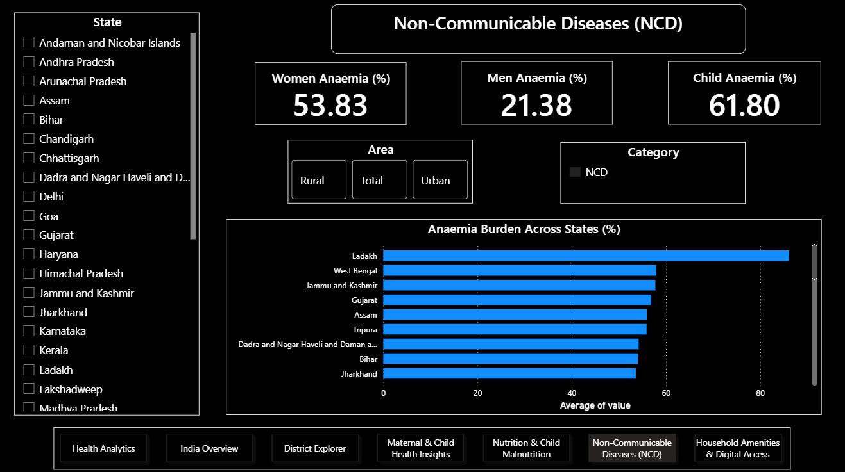
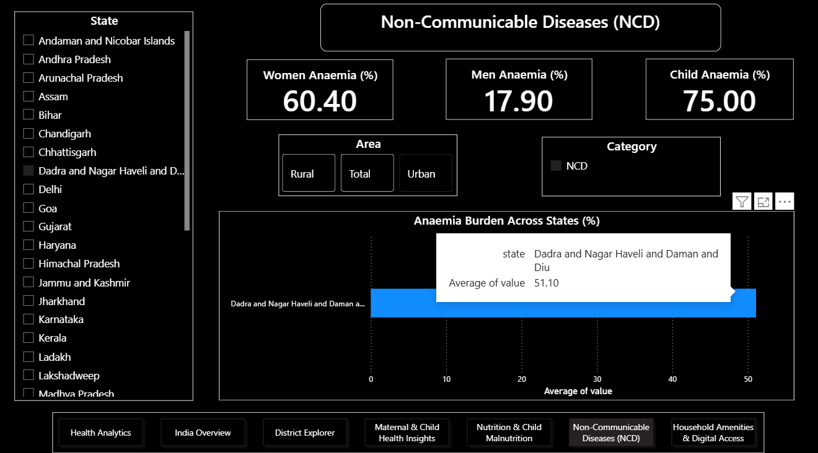

Page 6: Household Amenities & Digital Access

- Electricity, sanitation, drinking water
- Clean fuel usage
- Health insurance coverage
- Internet & mobile usage (gender gap)

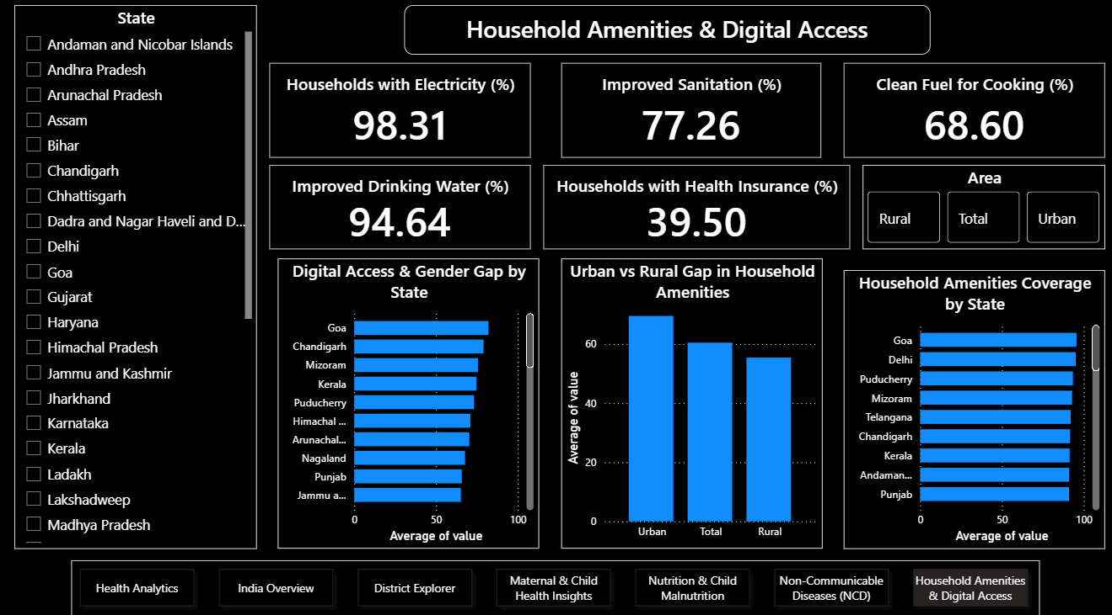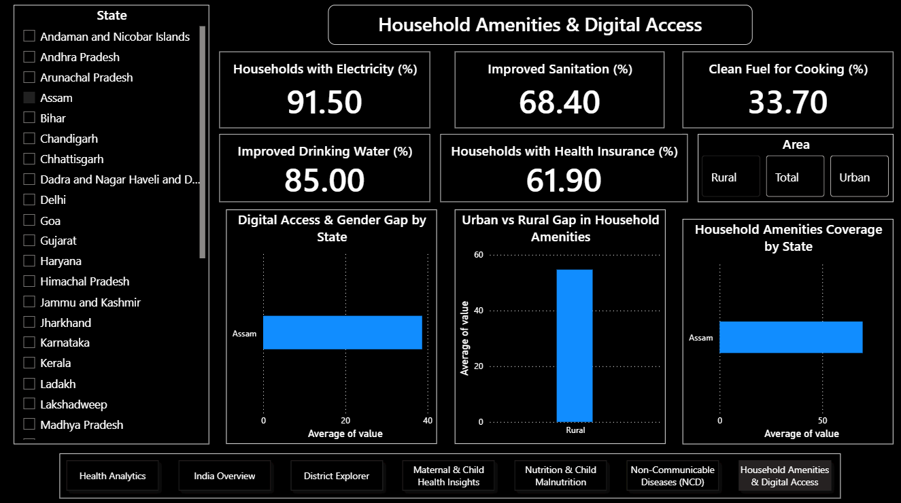

DAX & Measures

- Aggregations using AVERAGE, SUM, and CALCULATE
- Top N logic using visual-level filters
- Context-aware measures responding to slicers
- Time-series aggregation for NFHS trends

Key Insights

- Significant inter-state and inter-district disparities in health indicators
- Persistent child malnutrition, though improving over survey rounds
- Wide variation in C-section rates between public and private facilities
- Growing digital access, but with gender gaps
- Anaemia remains a major public health concern

Tools & Technologies Used

- Power BI Desktop
- Power Query (M Language)
- DAX
- Government Open Data (data.gov.in)

Conclusion

This project demonstrates how strong data preprocessing, clean modeling, and thoughtful visualization can transform complex public health datasets into meaningful insights.
Beyond dashboard creation, the project highlights:

- Analytical thinking

- Data engineering fundamentals

- Real-world problem solving

- Scalable BI design

The NFHS India Health Analytics Dashboard can support:

- Policy analysis

- Academic research

- Public health planning

- Data-driven decision-making

Future Enhancements

- Integration with NFHS-6 (when released)

- Urban vs Rural breakdown (if data available)

- Predictive modeling on health outcomes

- Automated data refresh pipelines

- Advanced statistical correlation analysis

References

- Ministry of Health and Family Welfare (MoHFW), Government of India.
National Family Health Survey (NFHS-5), 2019–2021: All-India and State/UT Factsheets.
Data.gov.in
Available at:
https://www.data.gov.in/resource/all-india-and-stateut-wise-factsheets-national-family-health-survey-nfhs-5-2019-2021

- Ministry of Health and Family Welfare (MoHFW), Government of India.
National Family Health Survey (NFHS-5), 2019–2021: District-wise Factsheets (Provisional).
Data.gov.in
Available at:
https://www.data.gov.in/resource/india-districts-factsheets-national-family-health-survey-nfhs-5-2019-2021-provisional

- Ministry of Health and Family Welfare (MoHFW), Government of India.
Year-wise Details of Indicators for Children from NFHS-1 to NFHS-5 (1992–93 to 2019–21).
Data.gov.in
Available at:
https://www.data.gov.in/resource/year-wise-details-indicators-children-national-family-health-survey-nfhs-1-nfhs-5-1992-93

- Udit-001 (GitHub Repository).
India Maps Data – TopoJSON Files for Indian States and Districts.
GitHub.
Available at:
https://github.com/udit-001/india-maps-data

- Microsoft Corporation.
Power BI Documentation: Data Modeling, DAX, and Visualization.
Available at:
https://learn.microsoft.com/power-bi

LinkedIn: https://www.linkedin.com/posts/anup-pandey-_powerbi-dataanalytics-datapreprocessing-activity-7405827960710107136-G7TO?utm_source=share&utm_medium=member_desktop&rcm=ACoAAEe82pUBIjI7B29DRyyNYg2YtUvvXHSsh-0
