The points in the map shows the stagnant water positions.

The points were derived from the FAPAR(Vegetation Index) and the NDWI(Water Index) map.

When a location hits a certain FAPAR and NDWI threshold it will be indicated the possibility of a stagnant water pool

(FAPAR MAP with greenness indices)

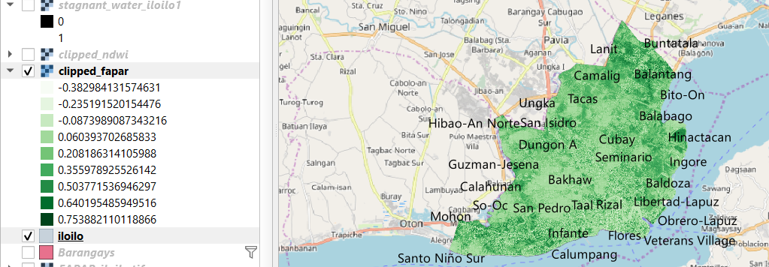

(NDWI MAP with blueness indices)

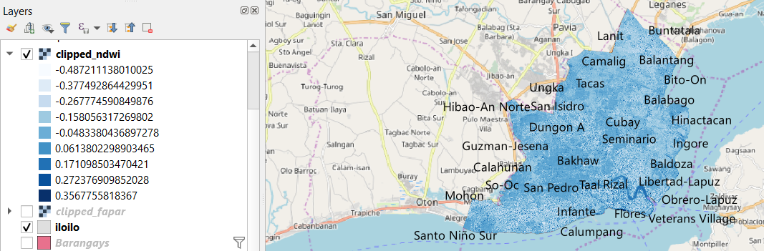

-1 to 0 - Bright surface with no vegetation or water content

+1 - represent water content

Formulas:

is_pixel_stagnant_water(boolean) = ((NDWIpixel>0.2) AND (FAPARpixel<0.1)) * 1

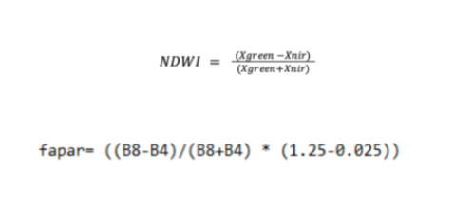

Xgreen = X green band of visible light

Xnir = X near infra red band

B8 = Landsat8

B4 = Landsat4

NDWI:

The NDWI index is most appropriate for water body mapping. The water body has strong absorbability and low radiation in the range from visible to infrared wavelengths. The index uses the green and Near Infra-red bands of remote sensing images based on this phenomenon. The NDWI can enhance the water information effectively in most cases. It is sensitive to built-up land and often results in over-estimated water bodies.

https://www.sentinel-hub.com/eoproducts/ndwi-normalized-difference-water-index

FAPAR:

The Fraction of Absorbed Photosynthetically Active Radiation (FAPAR, sometimes also noted fAPAR or fPAR) is the fraction of the incoming solar radiation in the Photosynthetically Active Radiation spectral region that is absorbed by a photosynthetic organism, typically describing the light absorption across an integrated plant canopy. This biophysical variable is directly related to the primary productivity of photosynthesis and some models use it to estimate the assimilation of carbon dioxide in vegetation.s

https://en.wikipedia.org/wiki/FAPAR