**Question 1:**

**Write a query to find the average count of transactions per day on polygon.**

**Data table: polygon.transactions**

**Answer:**

* **Query**

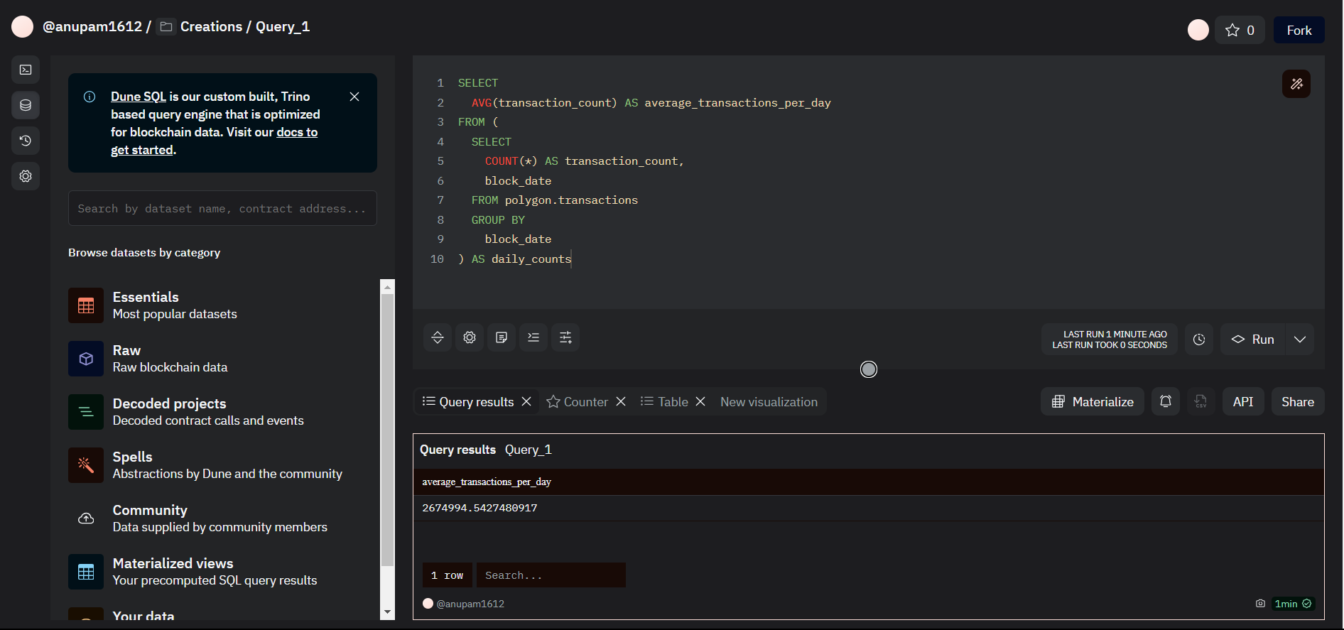

* **Dashboard**

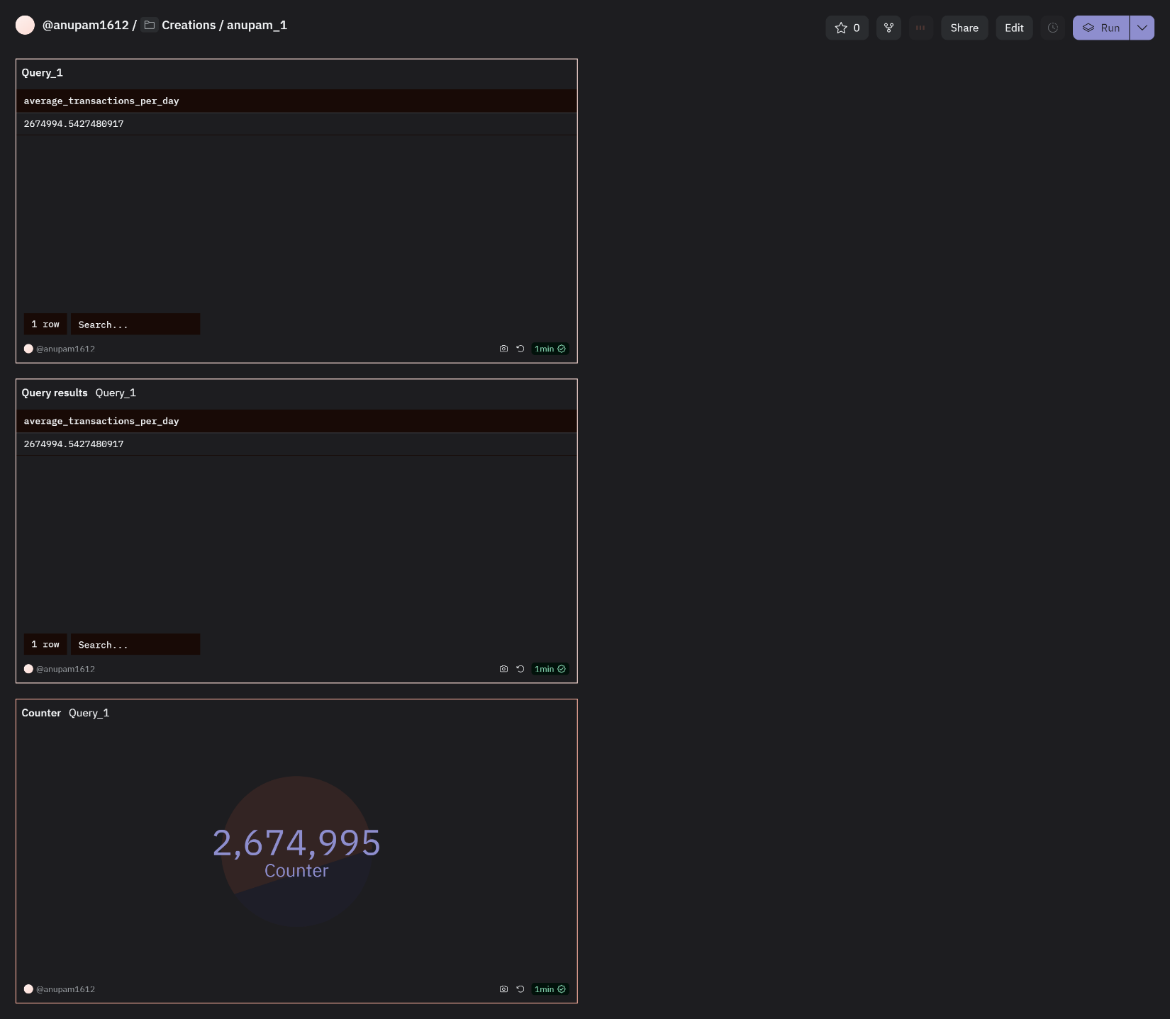

**Question 2:**

**Write a query to find the top 10 holders of OP token.**

**Data table: op_token_distributions_optimism.transfer_mapping**

**Answer:**

* **Query**

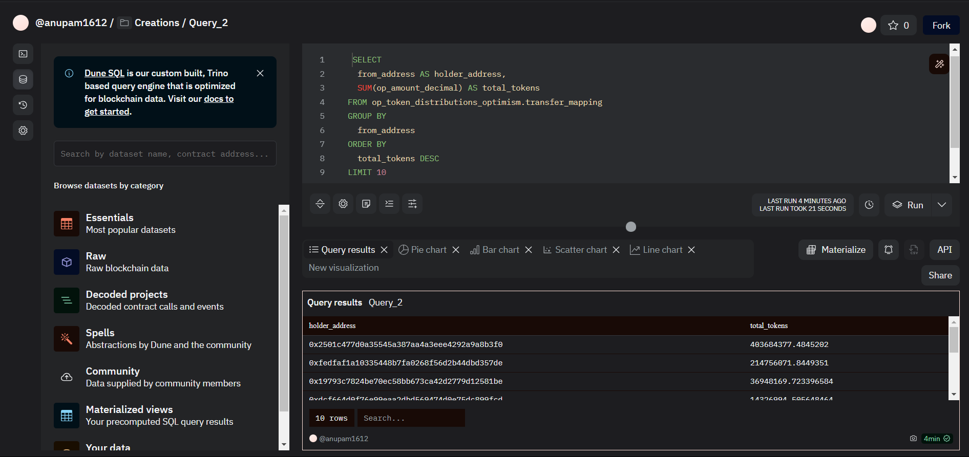

* **Dashboard**

