 Title: KAZ-Software Bangladesh

Course Code: CSE-0317

Course Title: Software Engineering

Semester: Summer 2021

Submitted To: Submitted By:

Khan Md. Hasib Anupam Ghosh

**Lecturer,                                 ID: UG02-40-15-021**

**Department of CSE, SUB**

Ab**stract:** Here, I Am surveying KAZ-Software Company. This report I have Tried To Highlight Everything About KAZ-Software- Company

**What is this company works for?**

MVP application for an innovative startup

Stock Exchange of Enterprise Tasks

Project tracking, M&E platform for CCDB

Iot based Agrotech App

Portal for Qatar Financial

ELearning Gamification

MIS for Swisscontact

Virtual Reality VR Game

Location based social networking platform

**Which type of Company they are?**

*KAZ-Software* teams help our customers build customized software - everything from web to desktop to enterprise to mobile and beyond.

**What is the main objective of this Company?**

The Main Objective of KAZ-Software is to provide our clients with expert guidance and to build software vital to their organizations.

**What are the departments and clients area of that Company?**

Because of our involvement with all kinds of projects our SQA teams are exposed to a variety of technology and business domains. This helps us to provide unique resources bringing in skills, experience and ideas from very different sectors.



AS a Candidate what type of requirements you need from fresher to senior level?

B.S.C or M.Sc. in Computer Science/Engineering or equivalent.

Proven experience of leading a team of software Engineers including performance, development and disciplinary issues.

Must have strong knowledge of any major programming language, like C/C++, C#, Java, PHP, Python, Ruby, JavaScript, etc.

Must be familiar with any relational database, like Microsoft SQL Server, MySQL, Oracle, etc.

Must have good knowledge of object oriented software development.

Must have strong communication skills in English, both written and spoken.

Must have very strong analysis and synthesis skills.

Must be able to learn new technologies, tools, and techniques quickly and with minimum supervision.

Experience Requirements:

3 years of experience in software development

**Advantages of that Company:**

Cue is what reminds us of the reward. Craving pushes us towards get the reward and our response makes us to achieve the reward. And we want the reward because we will either have satisfaction from it or we can learn something. And if anything is insufficient among these 4 steps, changing any habit won’t be possible properly.

**Disadvantages of that Company:**

The close, the many, the powerful. We are inspired by these three groups in general. Some people think that, they lack motivation. But actually, they lack clarity. They actually don’t know how to start things and how to proceed them. In real- environment is more important than motivation. For example- in case of buying a product, the things that are placed in front of a store, we tend to try them in the first place. So, in case of building a habit or leaving it, we have to setup proper environment for that.

Location of KAZ-Software:

Bangladesh 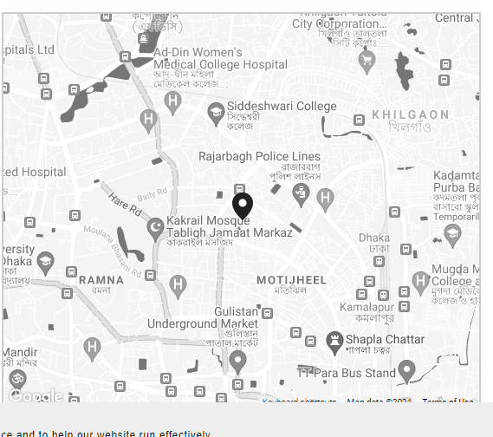

35/5 Shanti agar

Dhaka 1217

Bangladesh

[+880 248315727](https://www.google.com/search?q=kaz+software&rlz=1C1CHBF_enCA753CA753&oq=kaz+s&aqs=chrome.0.69i59j0i512j69i57j0i512l4j69i61.1392j0j7&sourceid=chrome&ie=UTF-8)

[info@kaz.com.bd](mailto:info@kaz.com.bd)

Google Map: <https://g.page/kazsoftware?share>

**Switzerland**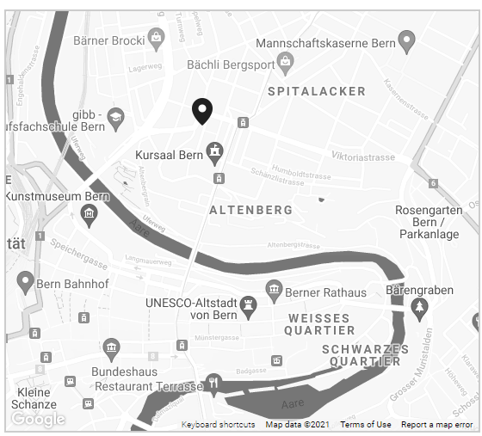

Greyerzstrasse 20

CH-3013 Bern

Switzerland

+41 (0) 76 321 79 63

[info@k-at-r.com](mailto:info@k-at-r.com)

**Acknowledgment**

**I would like to thank my honorable Khan Md. Hasib Sir for his time, generosity and critical insights into this project.**