Question 1:

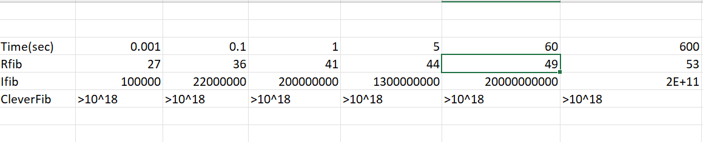

Question 2:

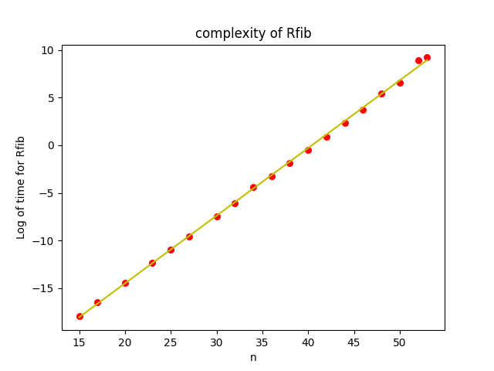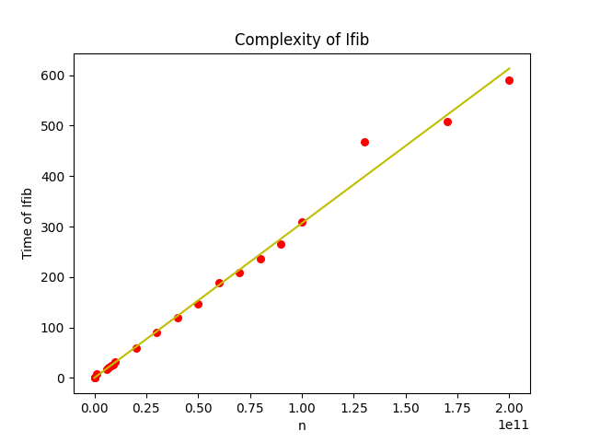

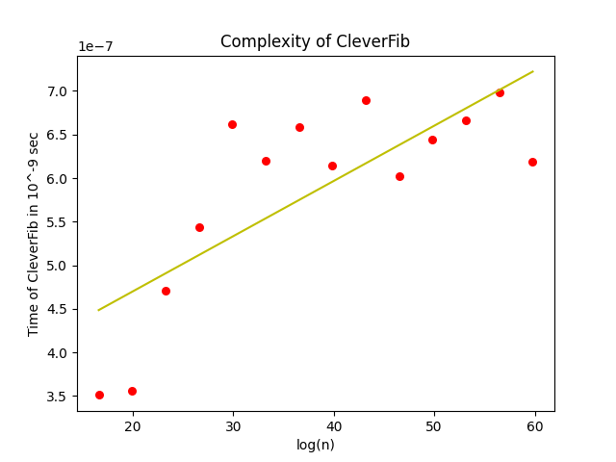

**a)**

Rfib has exponential iterations so in the graph we can see it fits nicely when taken log of the time taken.

Ifib has complexity O(n) so it makes sense that graph of n versus time taken is a straight line, and as we can see it fits perfectly.

Cleverfib has complexity of order O(log(n)) so taking log of n, the input, and plotting its graph against time should give us a straight line but as can be seen the values are quite scattered. This deviatiation is caused because of multiplication and the modulus operations as they are 'harder' to perform as compared to simple addition and have higher complexity depending on the algorithm used to perform them.

**b)**

slope of:

Rfib=0.71056796

Ifib=3.06534689e-09

Graph of cleverFib is not a line but the slope of best fit line is 6.33406807e-09

Depending on the number instructions inside the iteration the slope will naturally change. This was shown by the number of instructions performed.

**c)**

i) We can see that that CleverFib has more slope than Ifib which tells us that the number of instructions may have a hand in the slope and the fact that the graph is scattered, that it does not fit the line makes us realise that different operations will take different time and that the presence of these operation can significantly influence the time required for the program to perform.

ii) Yes as we can see from above these facts will influence the relative speed.

Question 3:

RAM model is based on the assumption that every instruction takes the same amount of time but as we have seen this not quite right.

Yes, on a larger scale they are quite accurate as they can tell us efficiancy of algorithm.