Hello there,

Me and my team, “The Coding Squad” developed an chatting app named “Web Chat”.

Web Chat have the following basic structure.

1). Splash screen :- with the logo of app and logo of our team name

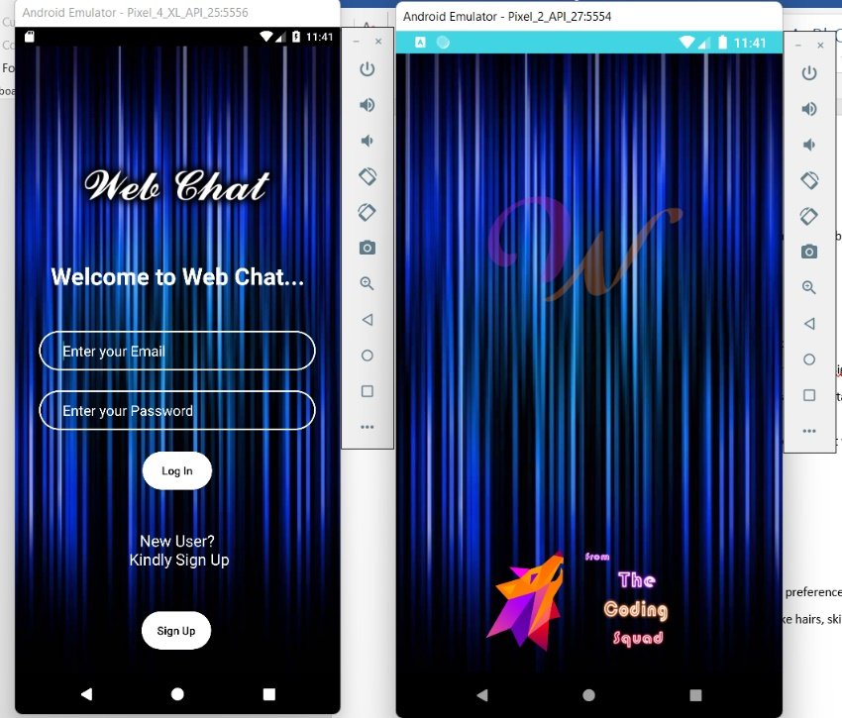

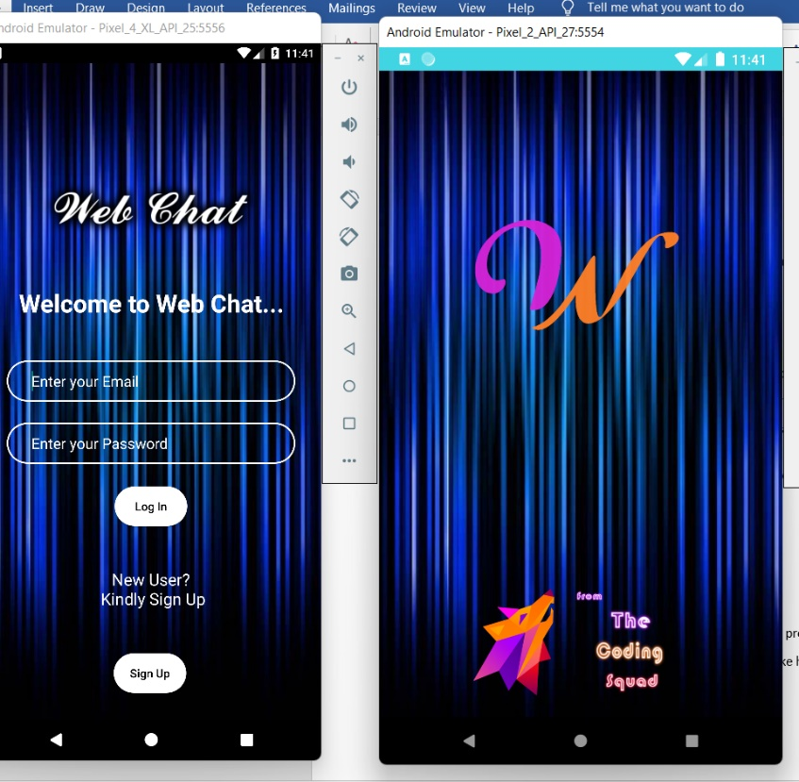

2). Login page:- You can authenticate yourself with email and password.

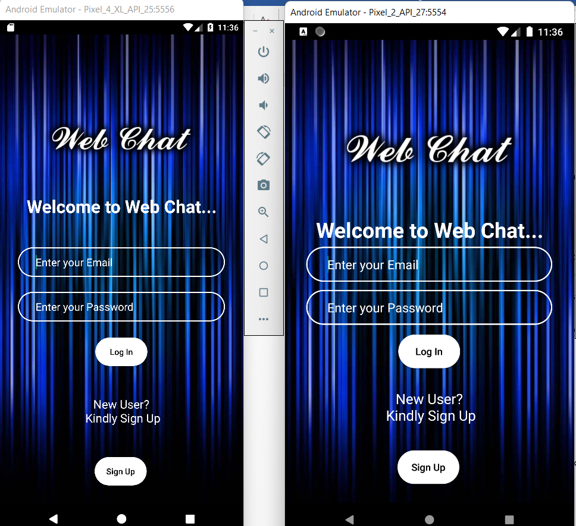

3). SignUp page:- you need to create an account before login , So here is your SignUp screen

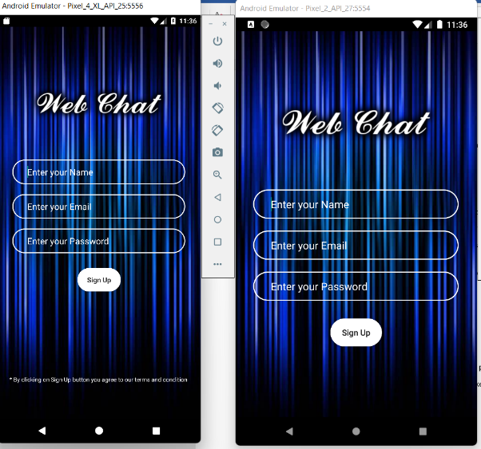

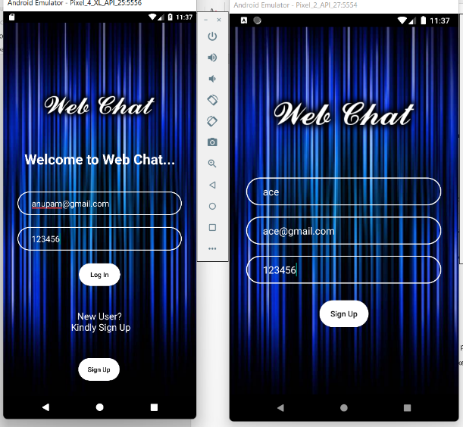

4). Chatting page:- here we have used recycler view in order to display user data stored at firebase database.

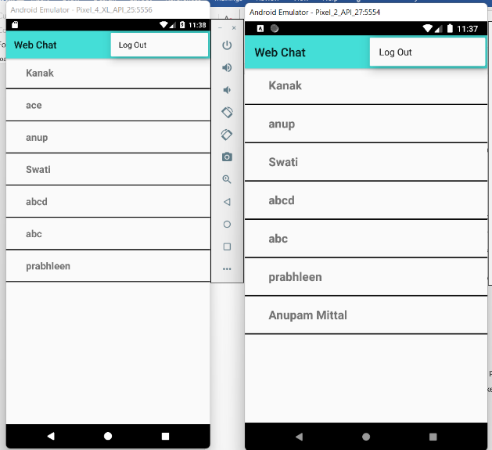

5). Logout button: on the top you will find the logout button which will redirect you to the login screen

6).Private Chat Rooms:- here you can chat with your friends

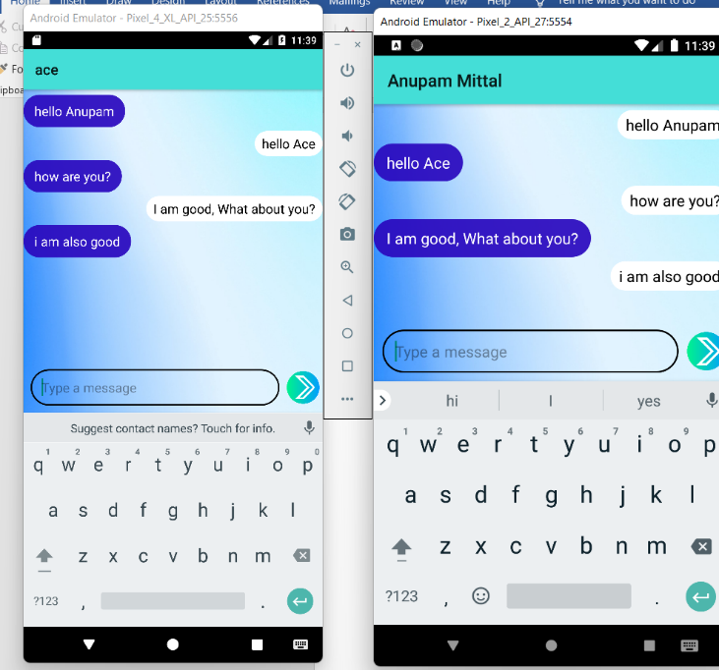

Further Vision of App :

1). To have features of video and voice calling.

2). To have different themes which user can select according to their preferences for full app

3). Virtual DP creater : here you can customise your own character like hairs, skin colour and much more

And much more…