1.Find out the number of transaction done by each customer (These should be taken up in module 8 itself)

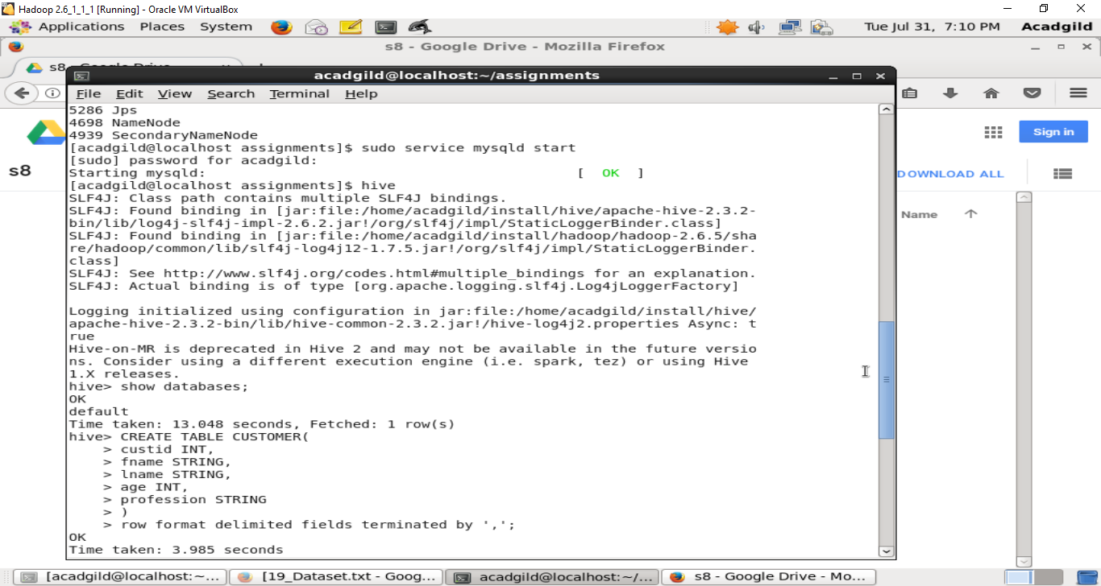

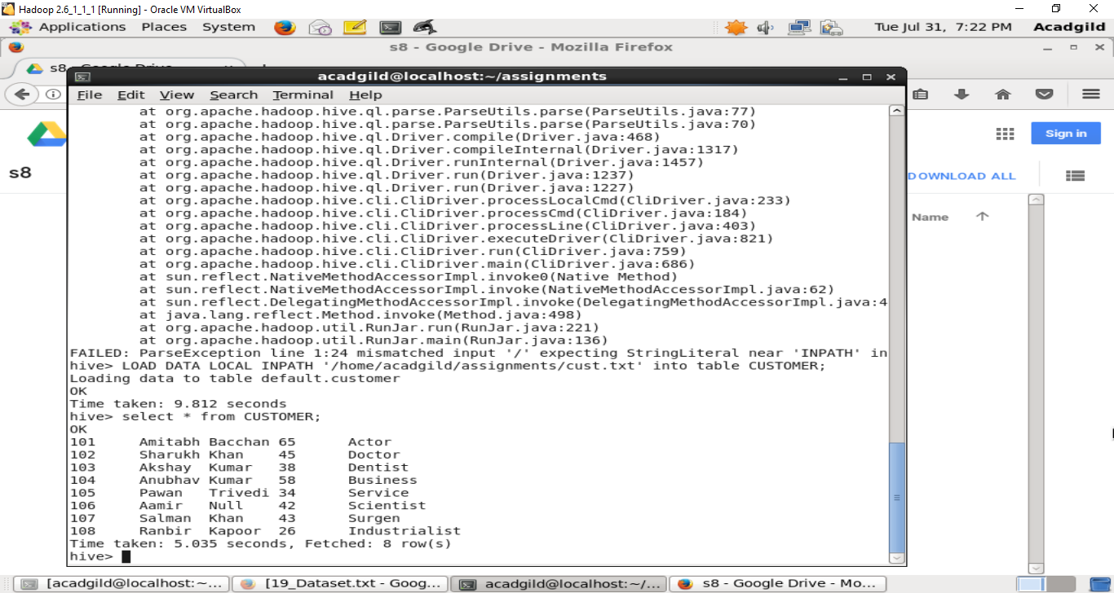

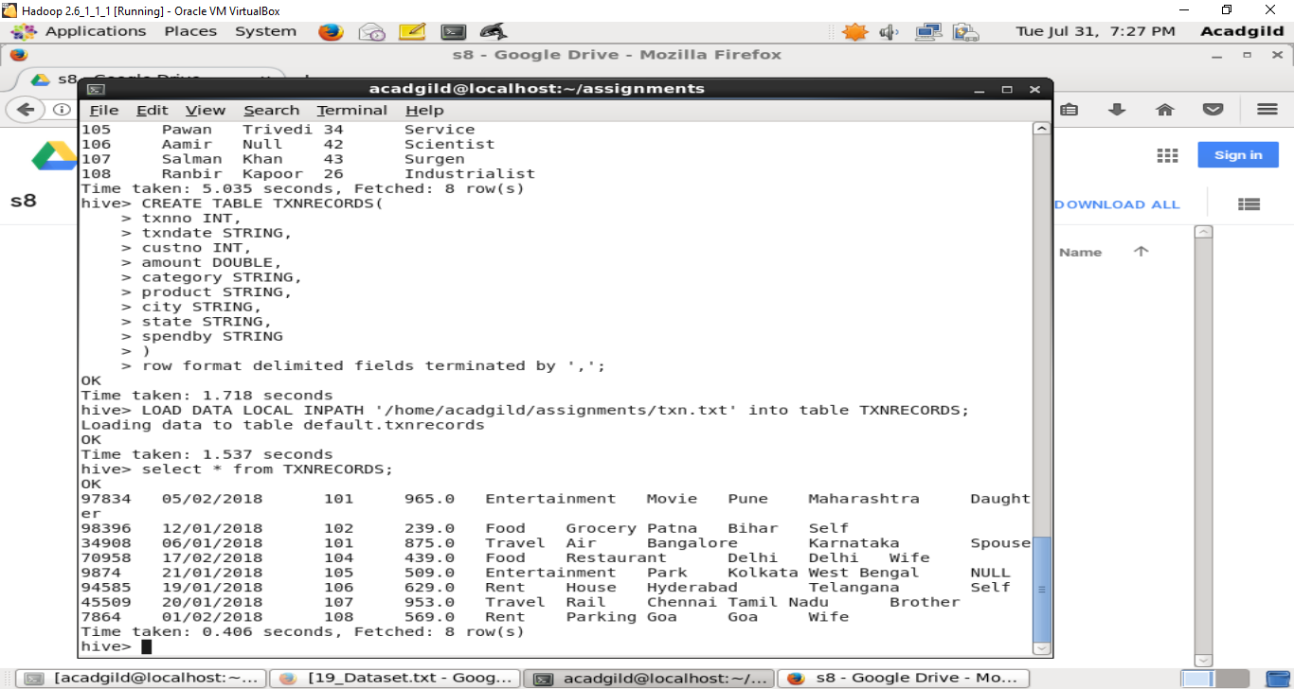

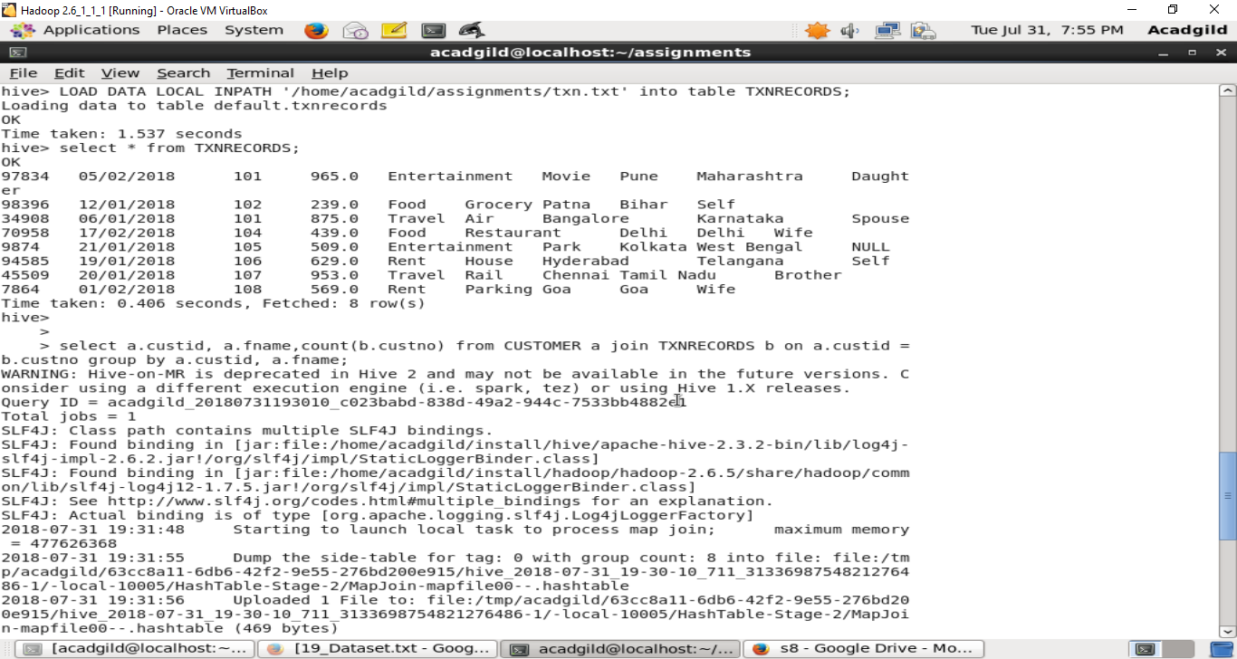

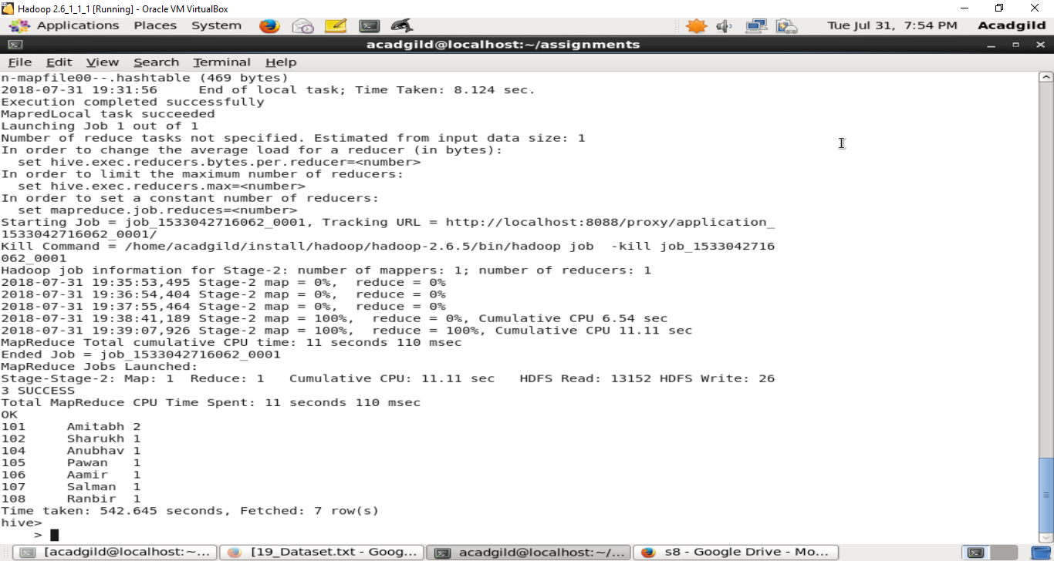

2. Create a new table called TRANSACTIONS_COUNT. This table should have 3 fields - custid, fname and count. (Again to be done in module 8)

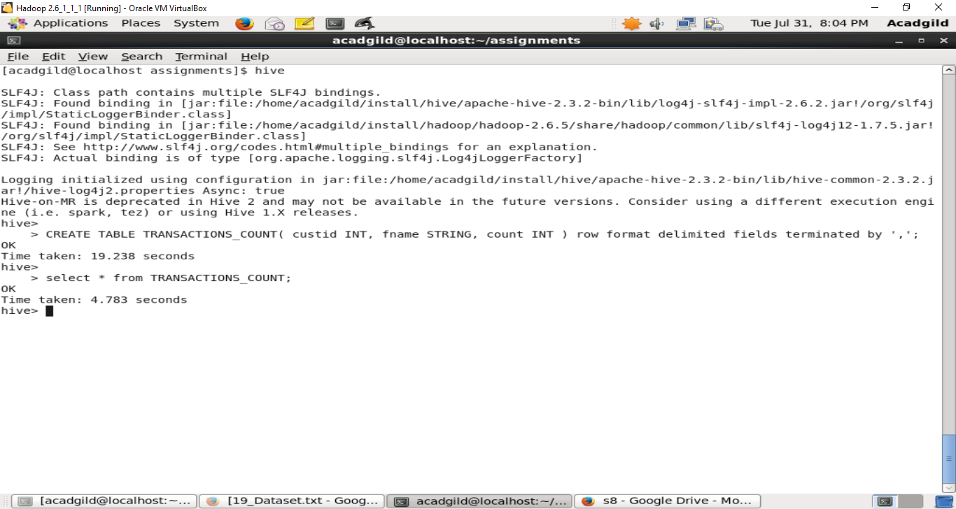

3. Now write a hive query in such a way that the query populates the data obtained in Step 1 above and populate the table in step 2 above. (This has to be done in module 9).

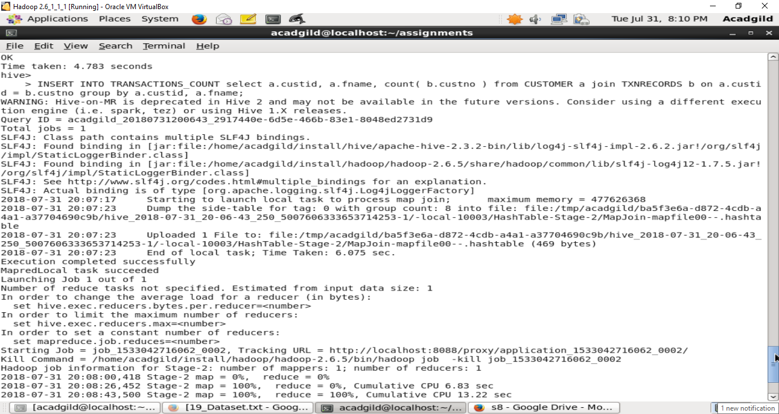

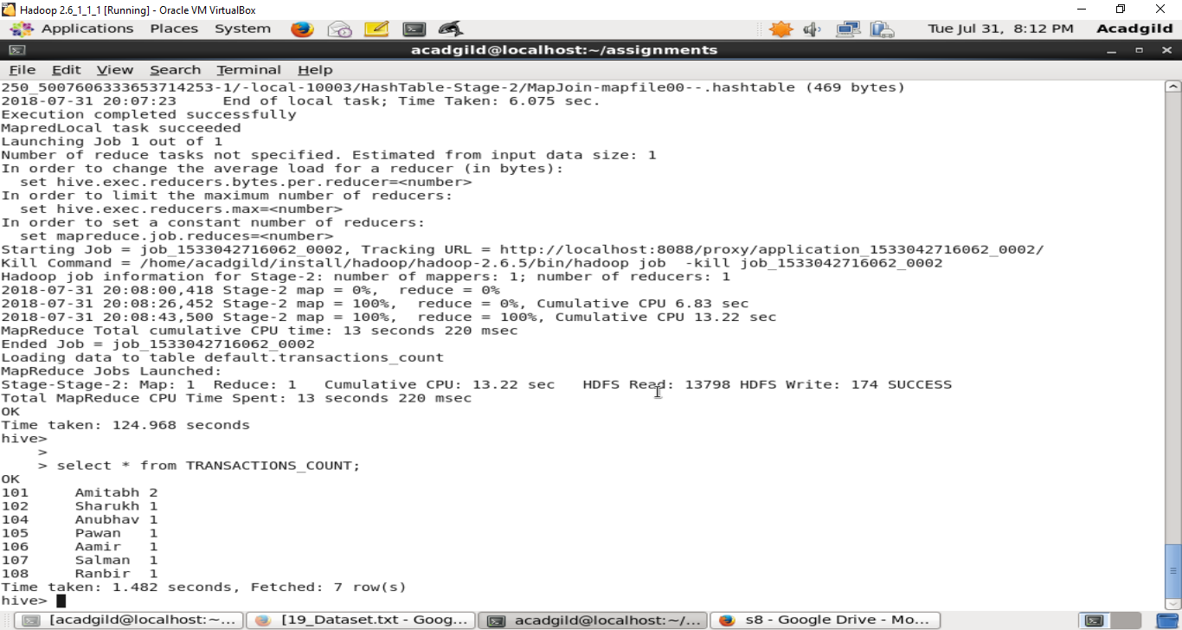

4. Now lets make the TRANSACTIONS_COUNT table Hbase complaint. In the sence, use Ser Des And Storate handler features of hive to change the TRANSACTIONS_COUNT table to be able to create a TRANSACTIONS table in Hbase. (This has to be done in module 10)

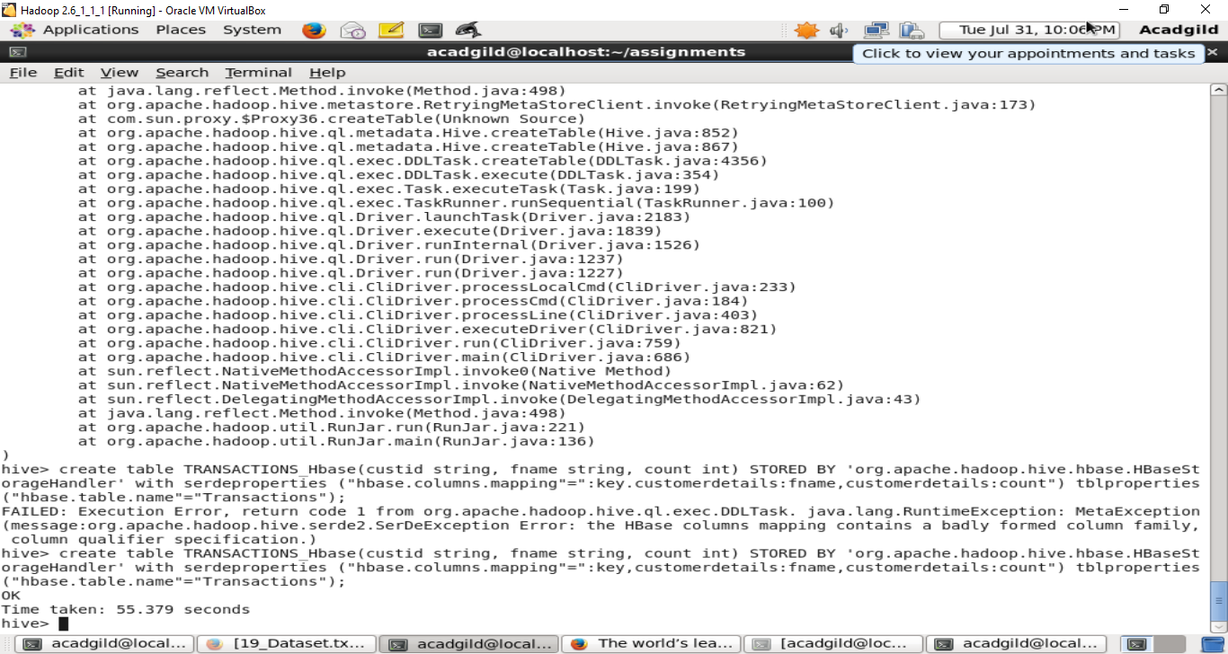

5. Now insert the data in TRANSACTIONS_COUNT table using the query in step 3 again, this should populate the Hbase TRANSACTIONS table automatically (This has to be done in module 10)

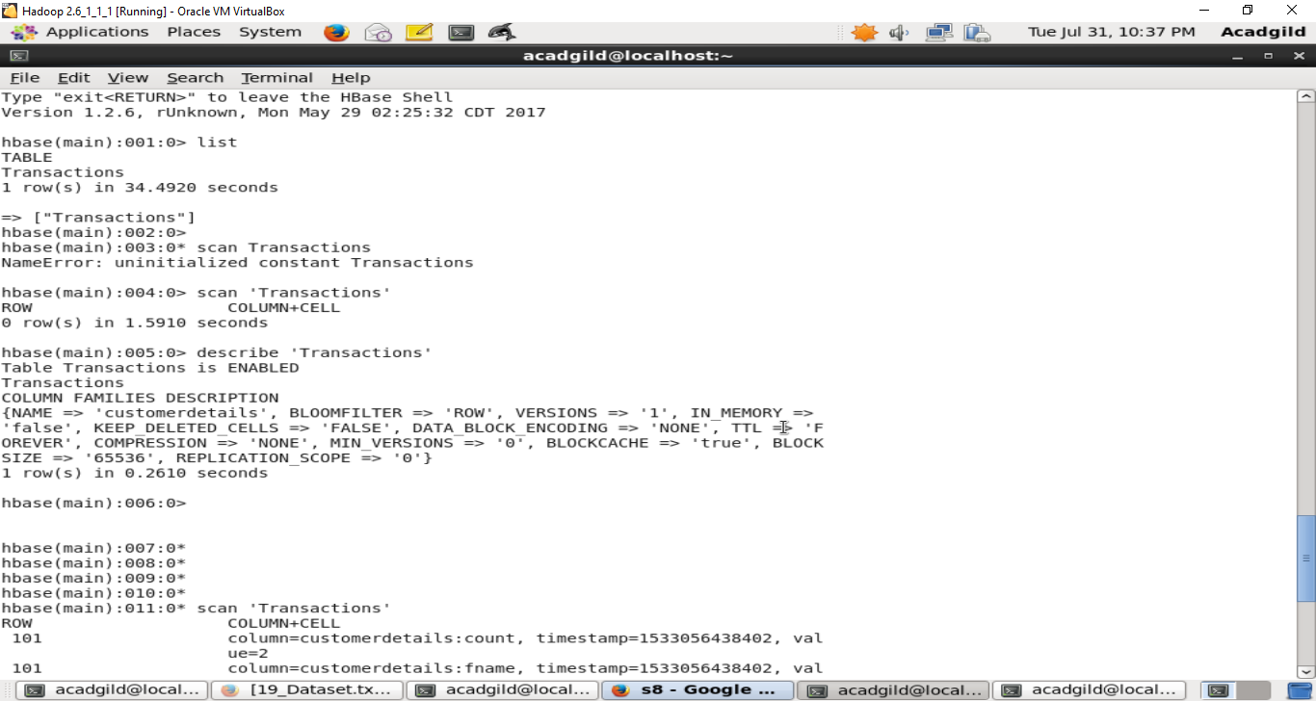

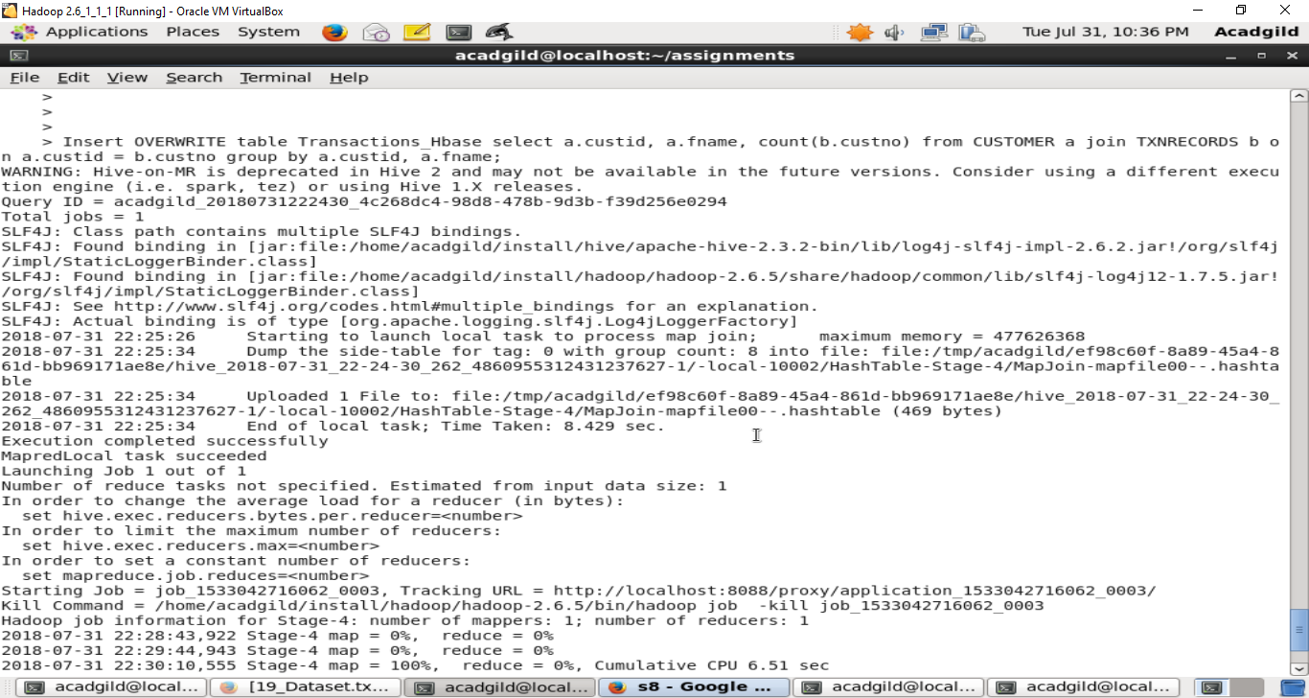

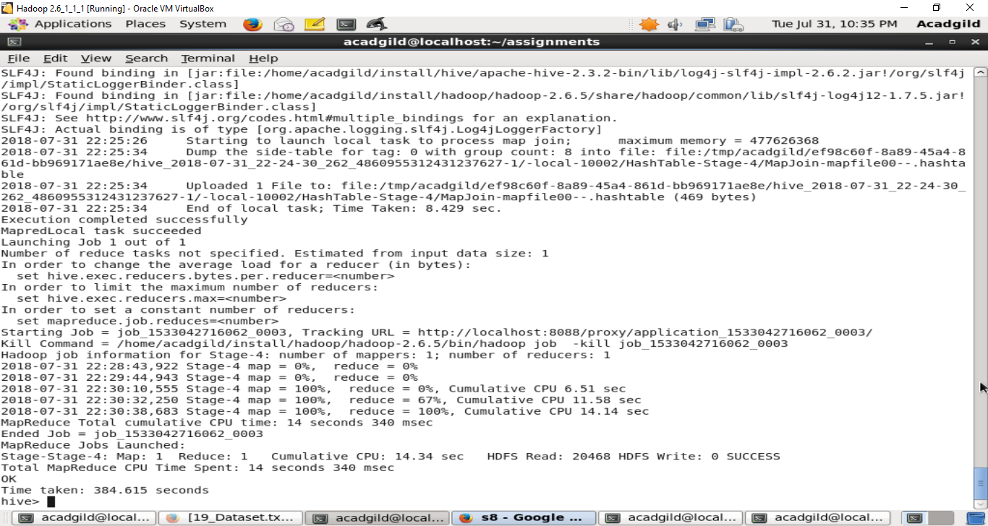

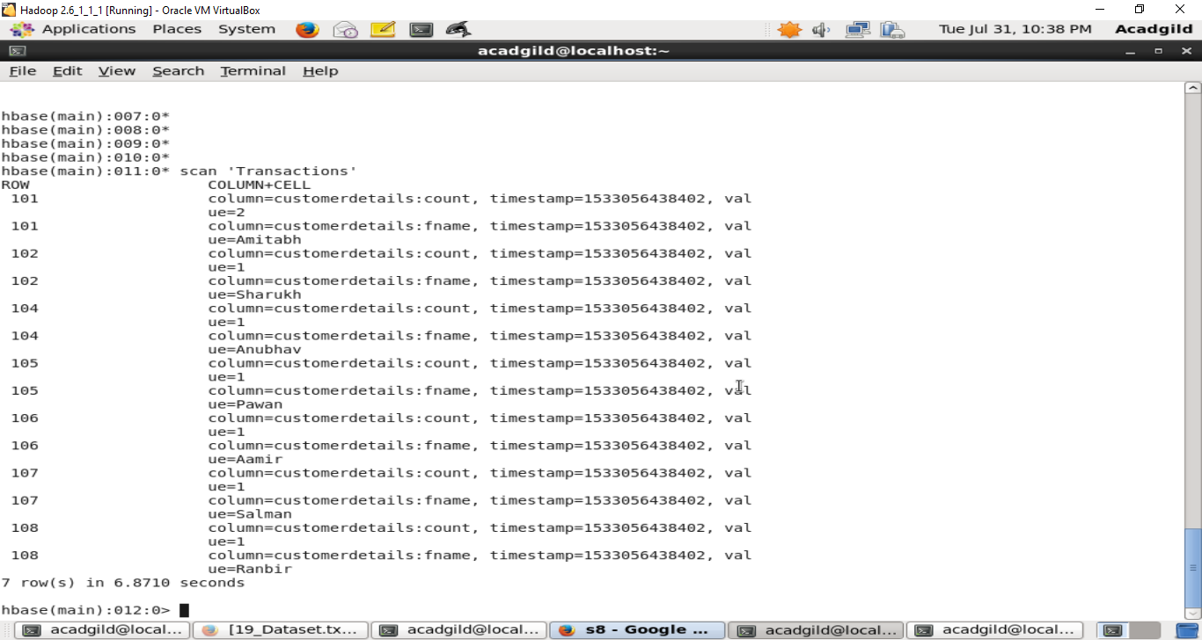

6. Now from the Hbase level, write the Hbase java API code to access and scan the TRANSACTIONS table data from java level.

import java.io.IOException;

import org.apache.hadoop.hbase.HBaseConfiguration;

import org.apache.hadoop.hbase.client.HTable;

import org.apache.hadoop.hbase.client.Result;

import org.apache.hadoop.hbase.client.ResultScanner;

import org.apache.hadoop.hbase.client.Scan;

import org.apache.hadoop.hbase.util.Bytes;

public class ScanTable{

public static void main(String args[]) throws IOException{

org.apache.hadoop.conf.Configuration conf = HBaseConfiguration.create(); // Instantiate Configuration class

HTable table = new HTable(conf, "TRANSACTIONS"); // Instantiate HTable class. TRANSACTIONS is the table name

Scan scan = new Scan(); // Instantiate the Scan class

//Scan the required columns, custom_details is the column family and column is fname

scan.addColumn(Bytes.toBytes("custom_details"), Bytes.toBytes("fname"));

ResultScanner scanner = table.getScanner(scan); // Get scan result

// Reading values from scan result

for (Result result = scanner.next(); result != null; result = scanner.next())

System.out.println("Result Found: " + result);

scanner.close(); //close the scanner

}

}