Working with Sensor Data

Columns those are present in the datasets:

Building.csv – BuildingID, BuildingMgr, BuildingAge, HVACproduct,Country

HVAC.csv – Date, Time, TargetTemp, ActualTemp, System, SystemAge, BuildingID

# Objective 1

* Load HVAC.csv file into temporary table

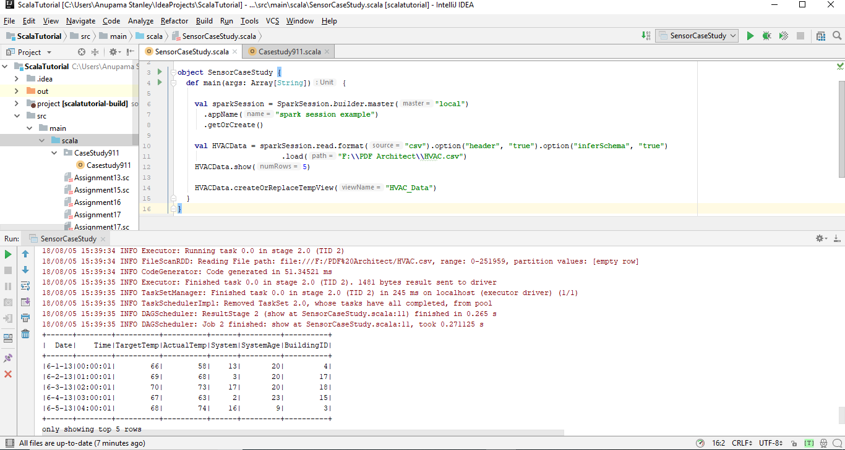

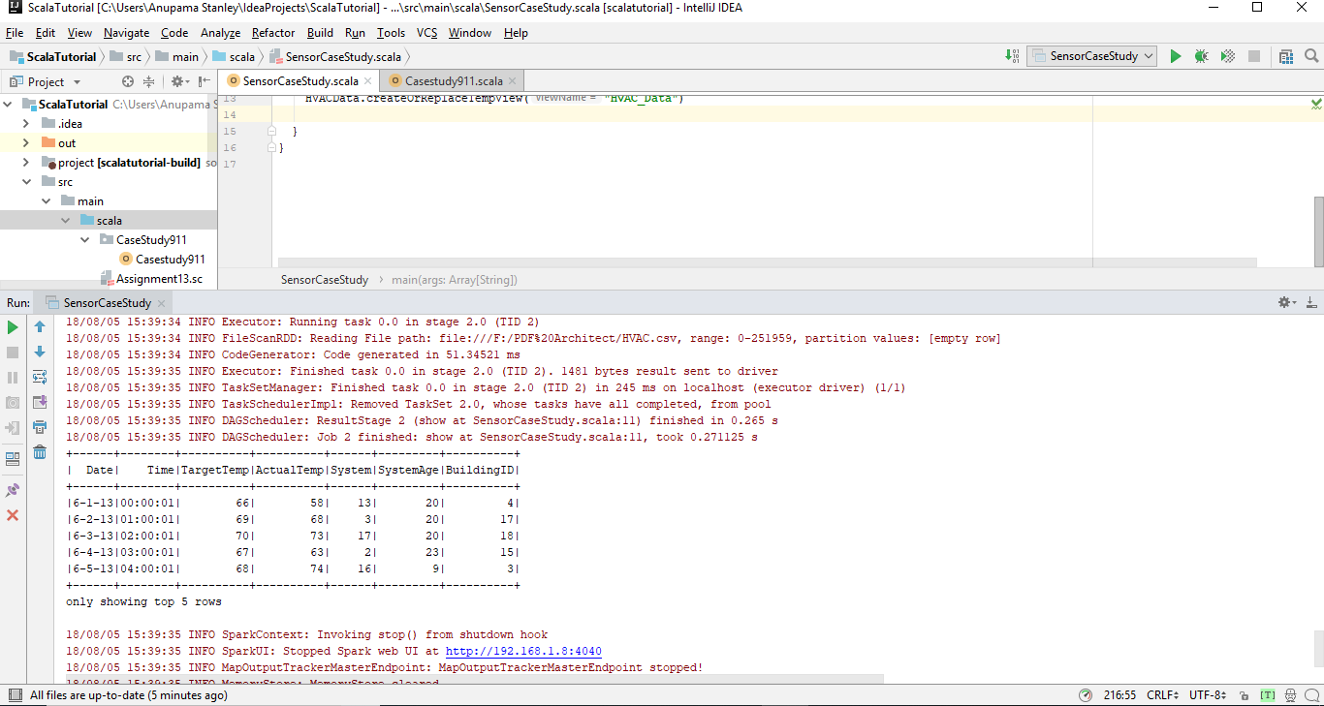

* Add a new column, tempchange - set to 1, if there is a change of greater than +/-5 between actual and target temperature

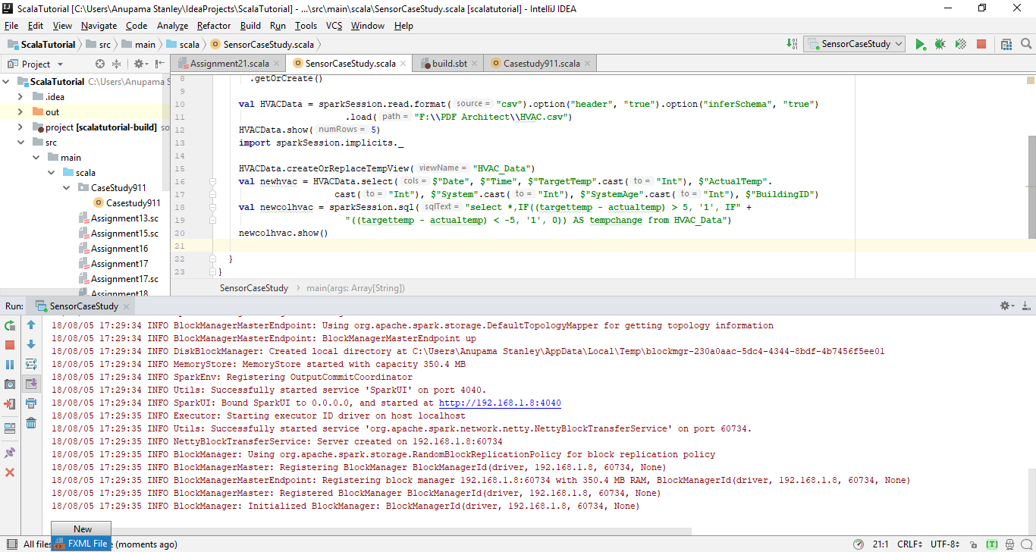

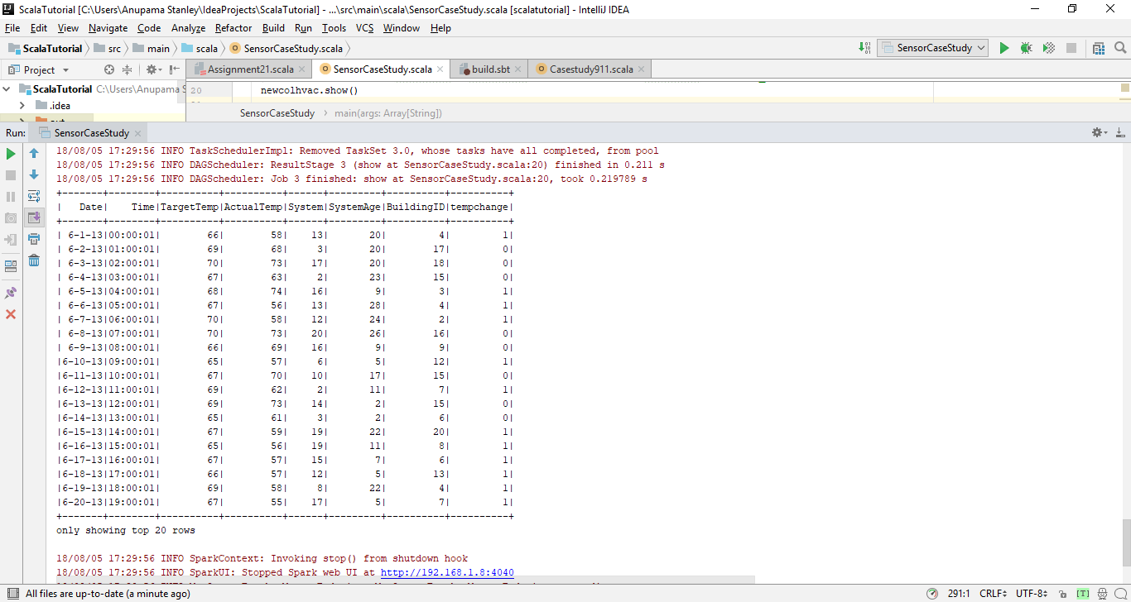

# Objective 2

Load building.csv file into temporary table

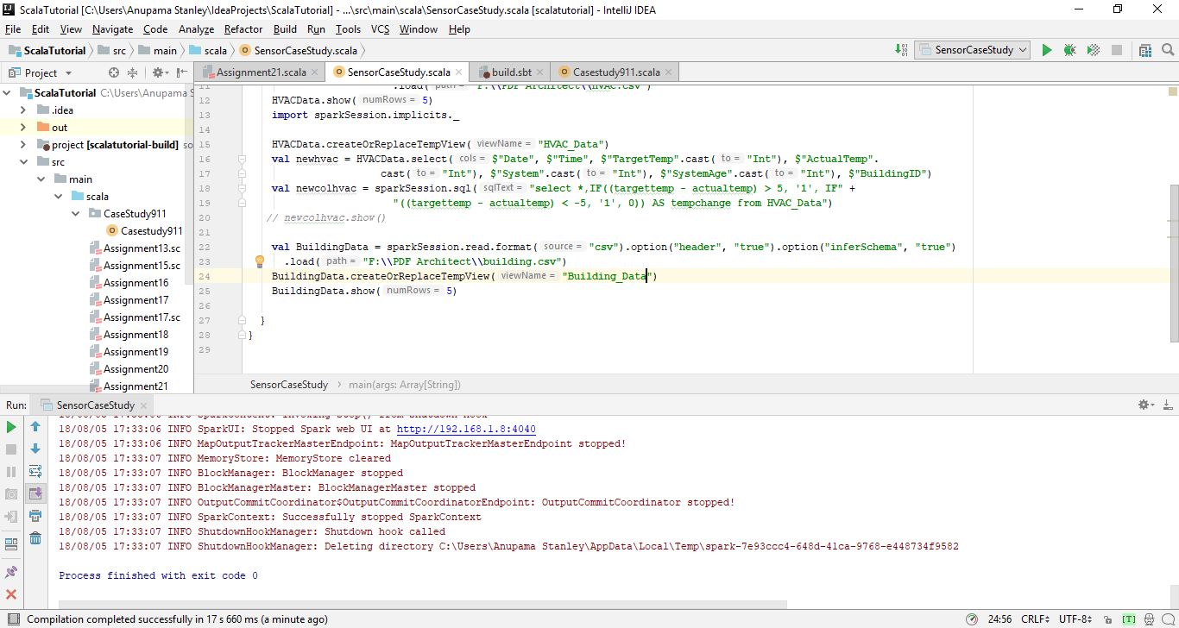

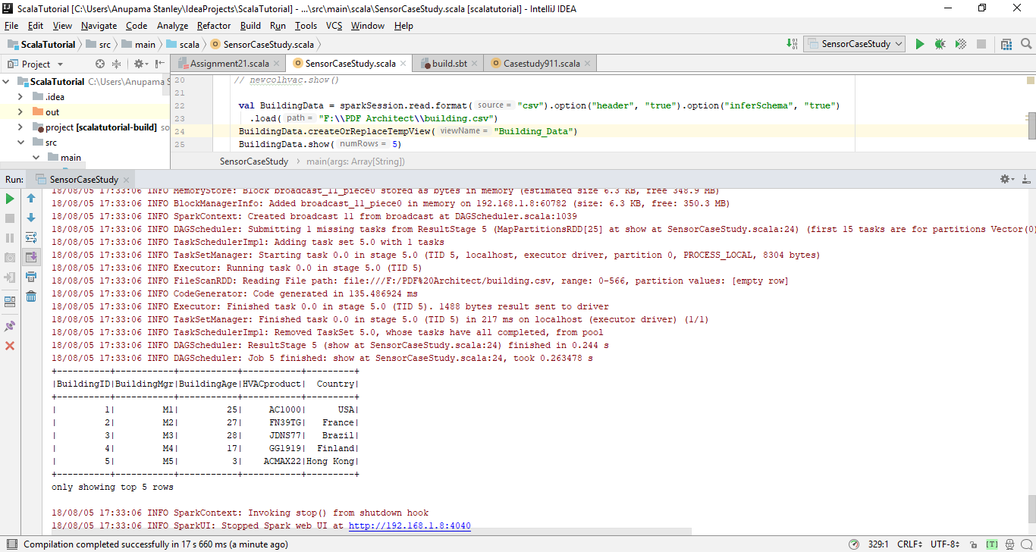

# Objective 3

Figure out the number of times, temperature has changed by 5 degrees or more for each country:

* Join both the tables.
* Select tempchange and country column
* Filter the rows where tempchange is 1 and count the number of occurrence for each country

