



EIA Validation Process

Genic Data QA

This is the Client installation guide for Genic DataManager and Genic Excel Add-In v5.2.3.

The content in this document contains confidential or proprietary information and is subject to change without notice. All content in this publication is copyright of DataGenic Ltd, unless otherwise explicitly stated. No part of this document may be reproduced or transmitted in any form or by any means (electronic or mechanical, or by photocopying, recording or otherwise), without the prior consent of DataGenic Ltd.

The screenshots and graphics are representative of those created by the software and may not be exact copies of what is displayed.

Trademark Information: DataGenic, the DataGenic logo, Genic DataManager, Genic CurveBuilder, Genic WorkFlow, Genic QualityManager, Genic DataiQ, Genic LiveConnect, Genic DataHub and Genic ExcelAdd-In are trademarks or registered trademarks of DataGenic Ltd. All other trade names are trademarks or registered trademarks of their respective holders.

**Copyright © 2017 DataGenic Ltd. All rights reserved.**



 DataGenic Ltd

Cheapside House

138 Cheapside

London

EC2V 6BJ

United Kingdom

[www.datagenicgroup.com](http://datagenicgroup.com)

**VERSIONING**

|  |  |  |  |
| --- | --- | --- | --- |
| **Date** | **Version** | **Author** | **Changes** |
| 17/08/2018 | V1.0 | Anupam Soni | First Version |
|  |  |  |  |
|  |  |  |  |

Purpose

The main purpose of this document is to describe the process EIA TOOL using an automated process

Steps

Follow steps associated with highlighted numbers in red color in screenshots to understand the process.

1. Open 47 test machine via Remote desktop connection and go to the python_tool folder.
2. Then open EIA_Tool folder.

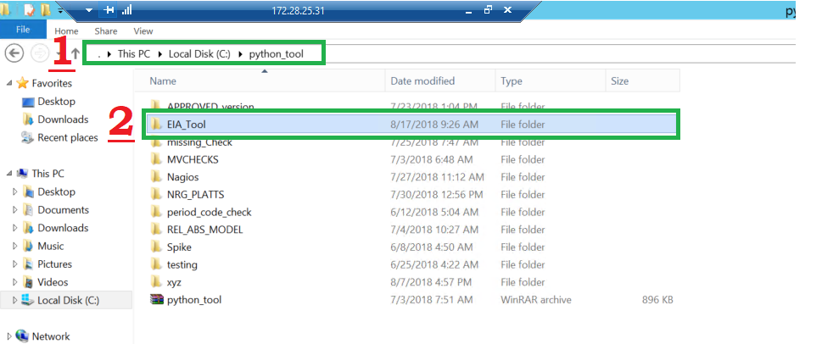

1. In input folder we have to keep data that we will extract from EIA Excel add-in, for this example

We have kept data of EIA_LCICO_CS category.

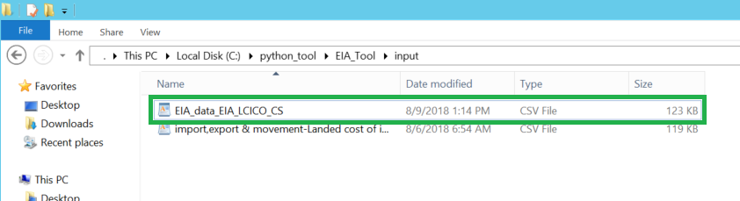

1. In this folder we will get output reports after successful execution of tool.

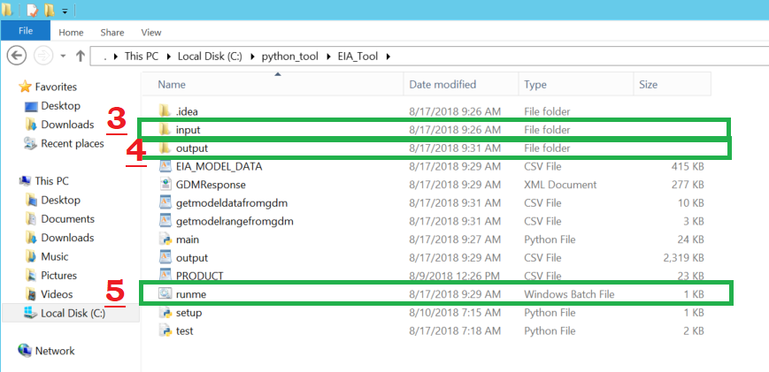

1. Run **runme.bat** file.

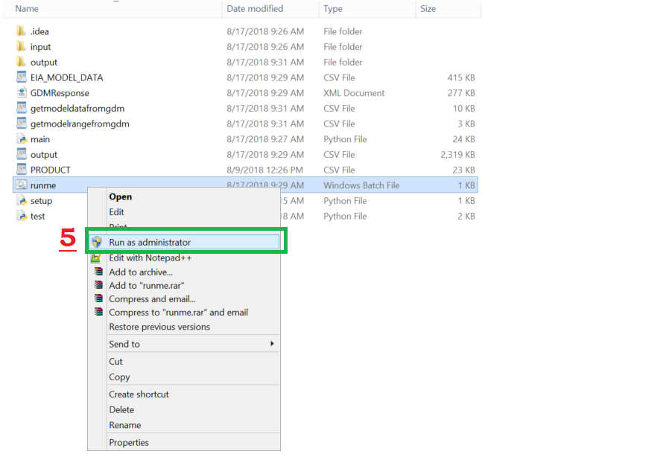

1. Enter dataset category name and then hit enter.

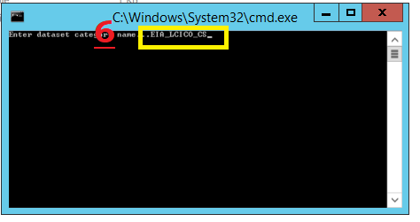

1. Then enter the name of file that we kept in input folder and hit enter.

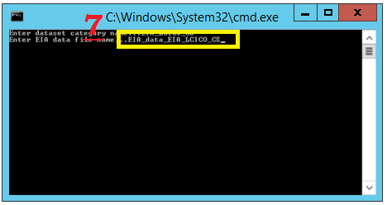

After execution we will get result in output folder.

1. We have got 4 output reports of EIA_tool.

