TASK 4 – Task Sheet

GOOGLE CLASSROOM

Tasks:
- Implement 5 different models to practice boosting for 5 different dataset that prevails in csv format

Topics: LeetCode
1.Solve 5 LeetCode Problems
Topics: GitHub
1.Submit this week complete work to your GitHub repo.
Topics: LinkedIn
1.Share your weekly task overview in your LinkedIn page with proper messages and images. Showcase Your work to public.
Topics: Video Recording in English Language
1.Record a self-video explaining your weekly task, what all challenges you faced and what output you got from this week.
2.Record a self-video explaining any one of the latest technologies in your interested area.
Extra Works
1.Build at least 30 connections in LinkedIn with HR, CEO’s and People from your Domain (Don’t send 30 requests in single day. Try to send 3 or 4 requests daily. Sending bulk connection requests in single day may spam your profile. Build your LinkedIn page as your Brand).

NB: Students, please fill the below details in proper way and upload this word file in to your google drive and share the link in google sheet.
Student Name: | ANUPAMA PT
Semester and Branch: | BTECH CSE(AI&DS)
Email id: | anupamaasrinivasan@gmail.com
Whether you completed all the assigned task in this week (Yes/No):

1. Implement 5 different models to perform Boosting for 5 different dataset that prevails in csv format

1. ✈️ Flight Price Prediction (Regression)
- Goal: Predict the price of a flight ticket based on the airline, date of journey, source, destination, and stops.
- Why it's great: Flight prices fluctuate wildly and have "noisy" patterns. Gradient Boosting models are famous for capturing these complex patterns much better than standard Linear Regression.
- Direct Link: Kaggle - Flight Price Prediction
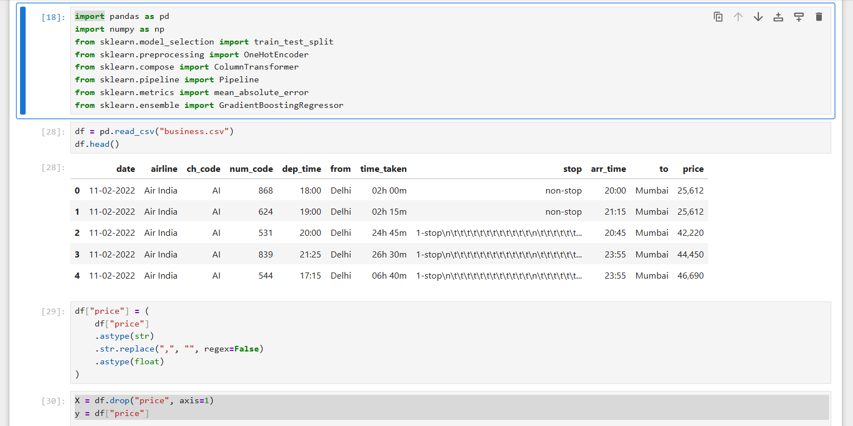
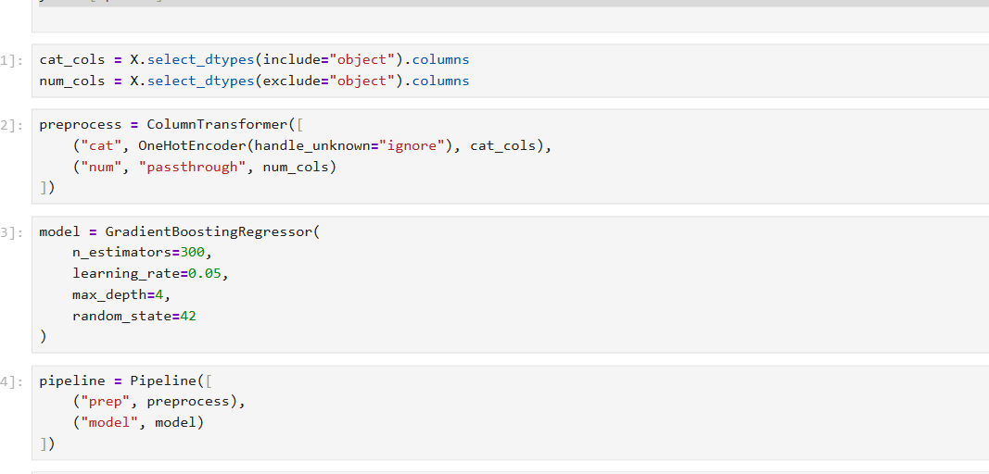
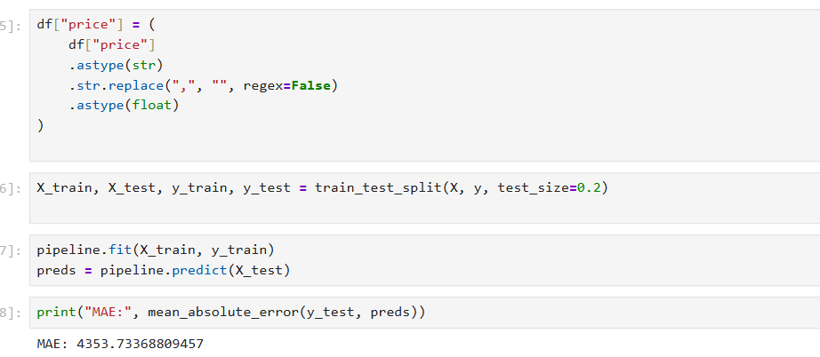
2. 🏠 California Housing Prices (Regression)
- Goal: Predict the median house value in California districts.
- Why it's great: This is a classic "non-linear" problem. Features like longitude and latitude have a complex relationship with price. Boosting models can create highly specific geographic "regions" to improve accuracy.
- Direct Link: Kaggle - California Housing
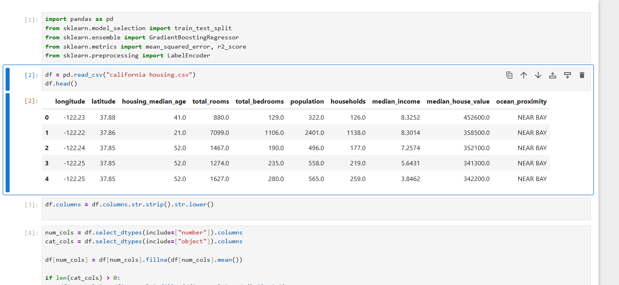
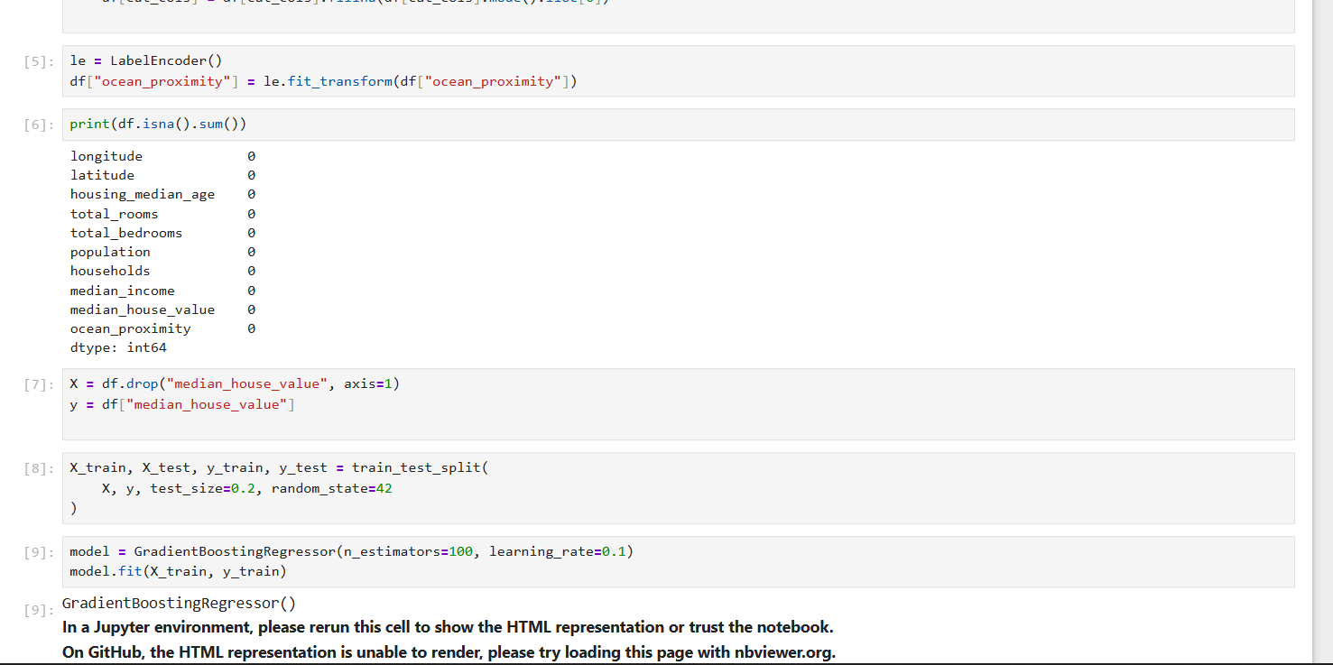
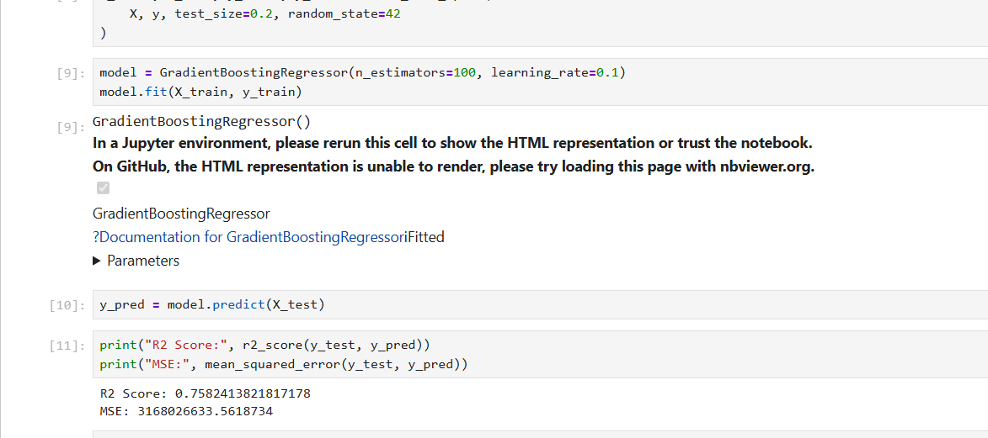

3. 💳 Credit Card Fraud Detection (Imbalanced Classification)
- Goal: Identify fraudulent transactions.
- Why it's great: Because fraud is so rare, you need a model that is extremely precise. Gradient Boosting models have parameters (like scale_pos_weight in XGBoost) specifically designed to handle this kind of extreme class imbalance.
- Direct Link: Kaggle - Credit Card Fraud
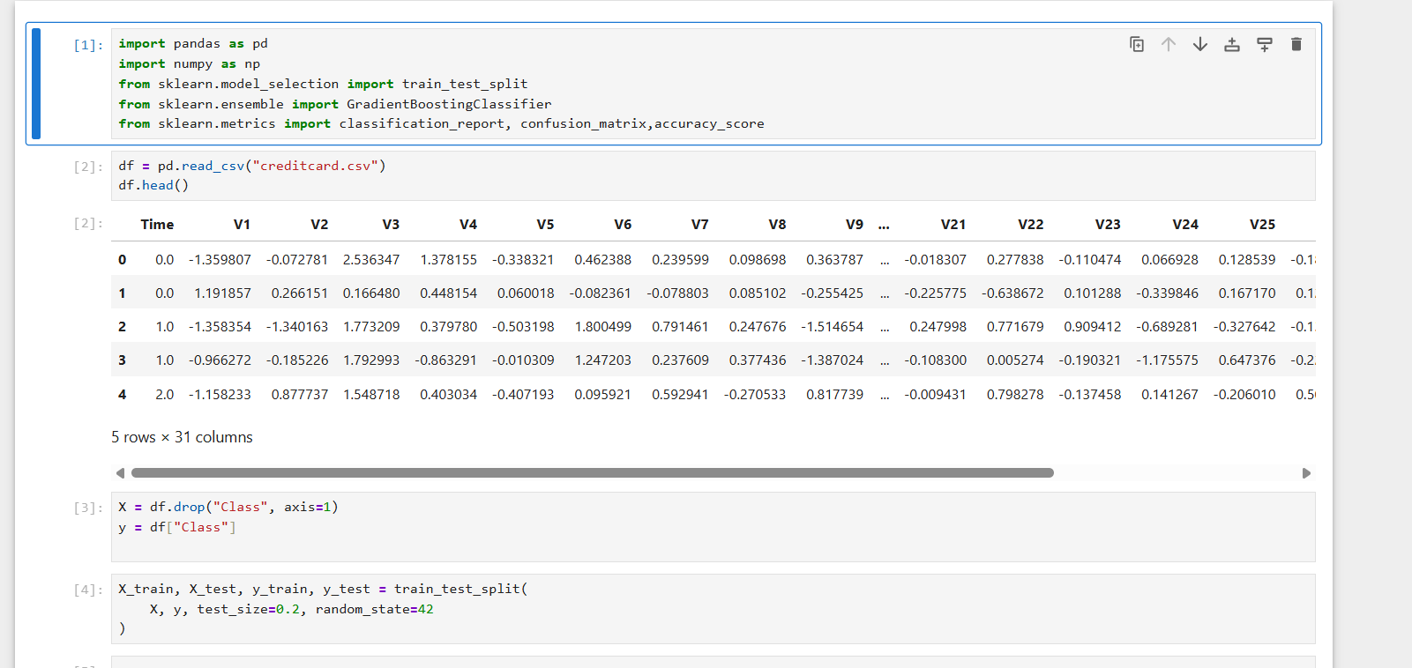
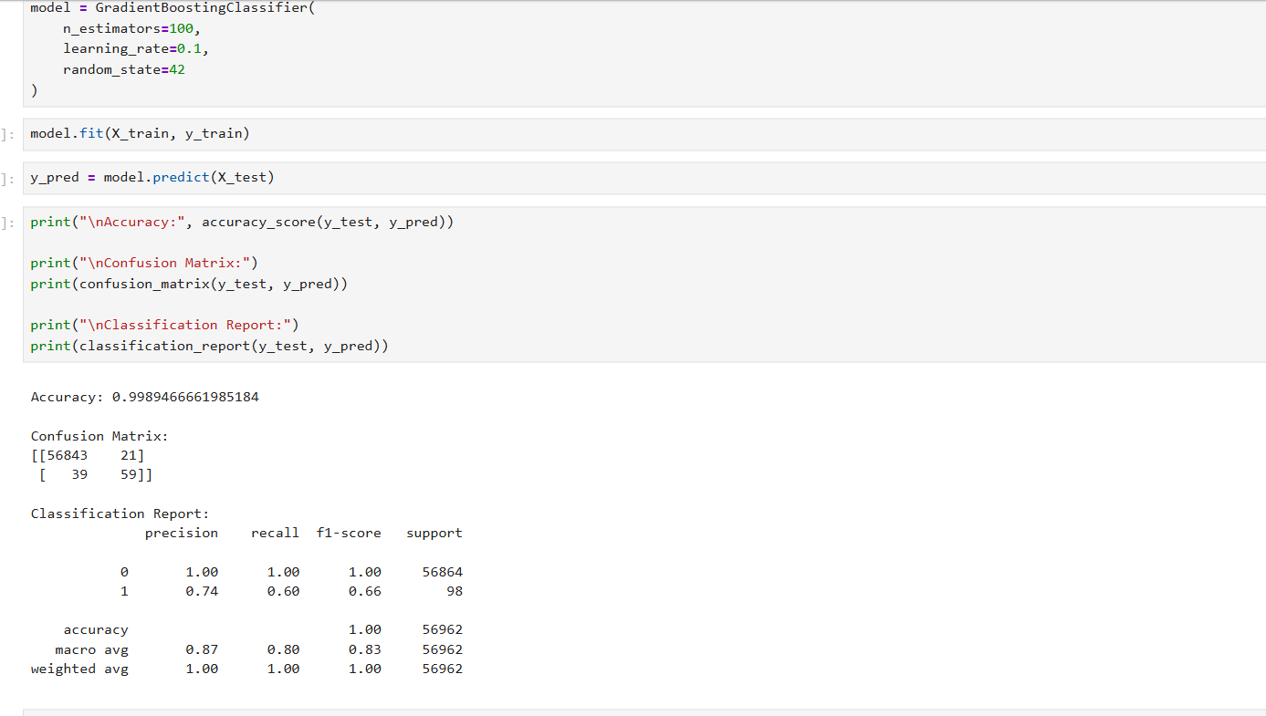
4. 🛒 Walmart Sales Forecast (Time-Series Regression)
- Goal: Predict weekly sales for different departments across various Walmart stores.
- Why it's great: This dataset includes effects of holidays, markdowns, and store sizes. It’s perfect for practicing Feature Engineering (like creating "lag" features) before feeding them into a Boosting model.
- Direct Link: Kaggle - Walmart Sales Forecast

5. 🏥 Stroke Prediction Dataset (Binary Classification)
- Goal: Predict whether a patient is likely to get a stroke based on parameters like gender, age, various diseases, and smoking status.
- Why it's great: Medical data is often "messy" with missing values and categorical strings. This is a great place to test CatBoost, which can handle categorical features automatically without you needing to encode them manually.
- Direct Link: Kaggle - Stroke Prediction Dataset
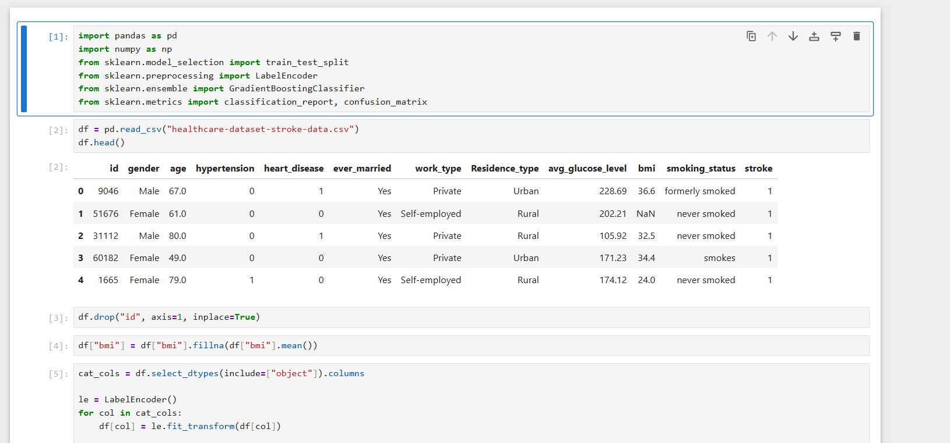
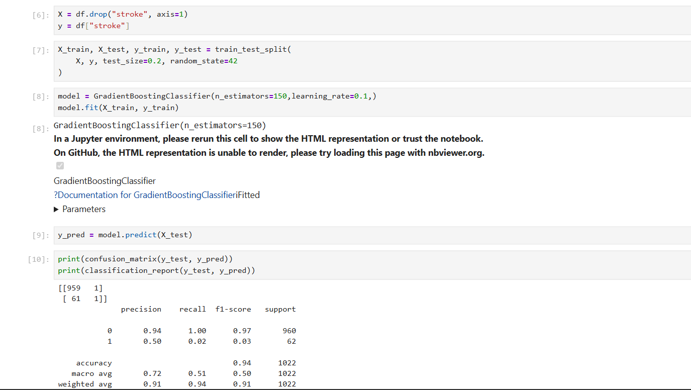
RESOURCES

🧠 1️⃣ StatQuest – Gradient Boosting Explained (Best Intuition)
⭐⭐⭐⭐⭐ (visual + beginner friendly)
🔗 https://statquest.org/gradient-boosting-machine/
📺 YouTube (same topic explained visually):
🔗 https://www.youtube.com/watch?v=3CC4N4z3GJc
Why this is awesome
- Clear step-by-step concept
- No heavy math
- Easy to remember

📘 2️⃣ Google Machine Learning Crash Course — Ensemble Methods
🔗 https://developers.google.com/machine-learning/crash-course/ensemble
Covers
- Bagging vs Boosting
- Basic idea of Gradient Boosting
- Practical examples
Great for beginners.

📊 3️⃣ Scikit-learn Official Docs — Gradient Boosting
🔗 https://scikit-learn.org/stable/modules/ensemble.html#gradient-boosting
Best for
- Correct implementation
- Parameter explanations
- Reference for real projects

💡 4️⃣ Towards Data Science – Gradient Boosting Explained
🔗 https://towardsdatascience.com/gradient-boosting-explain-like-im-five-7048e45c3a4
Why it’s good
- Intuitive (simple language)
- Code + visuals
- Comparison with Random Forest

📊 5️⃣ Machine Learning Mastery – Gradient Boosting in Python
🔗 https://machinelearningmastery.com/gentle-introduction-gradient-boosting-algorithm-machine-learning/
Great for
- Python examples
- Step-by-step hands-on
- Clear explanation

🚀 ADVANCED BOOSTING MODELS

🔥 6️⃣ XGBoost Official Guide
🔗 https://xgboost.readthedocs.io/en/stable/
Covers
- Advanced gradient boosting
- Regularization
- Tree pruning
- Parameter tuning
Great for real industry usage.

📘 7️⃣ Towards Data Science – XGBoost Beginner Guide
🔗 https://towardsdatascience.com/xgboost-for-beginners-a-tutorial-7f388c2de4d2
What you get
- Easy explanation
- Python code
- Interpretation of parameters

⚡ 8️⃣ LightGBM Tutorial for Beginners
🔗 https://lightgbm.readthedocs.io/en/stable/
Why learn this
- Faster than XGBoost
- Works great with large data
- Used in production systems

🐱 9️⃣ CatBoost Beginner Tutorial
🔗 https://catboost.ai/docs/
Best part
- Handles categorical features
- Zero need for encoding
- Very powerful for real tabular data

🛠️ PRACTICAL CODING RESOURCES

📍 10️⃣ Kaggle – Hands-On Practice Notebooks
🔗 https://www.kaggle.com/code
(Search: “Gradient Boosting”, “XGBoost Tutorial”, “LightGBM”, “CatBoost”)
✔ Real data
✔ User notebooks
✔ You can run code in browser

📍 11️⃣ W3Schools — Machine Learning Metrics + Models
🔗 https://www.w3schools.com/python/python_ml_intro.asp
Why useful
- Basic concepts
- Easy code
- Good for beginners

📘 12️⃣ Analytics Vidhya – Boosting Techniques Overview
🔗 https://www.analyticsvidhya.com/blog/2021/05/boosting-algorithms-bagging-boosting-adaboost-gradient-boosting-xgboost-catboost/
What it gives
- Comparisons
- When to use which
- Simple examples

LeetCode Problems : Explain and attach screenshot
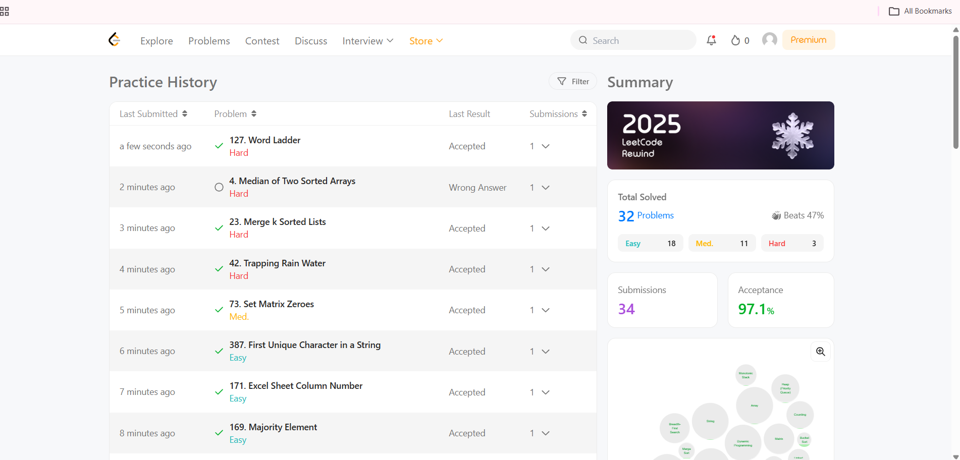

HackerRank problems : Explain and attach screenshot
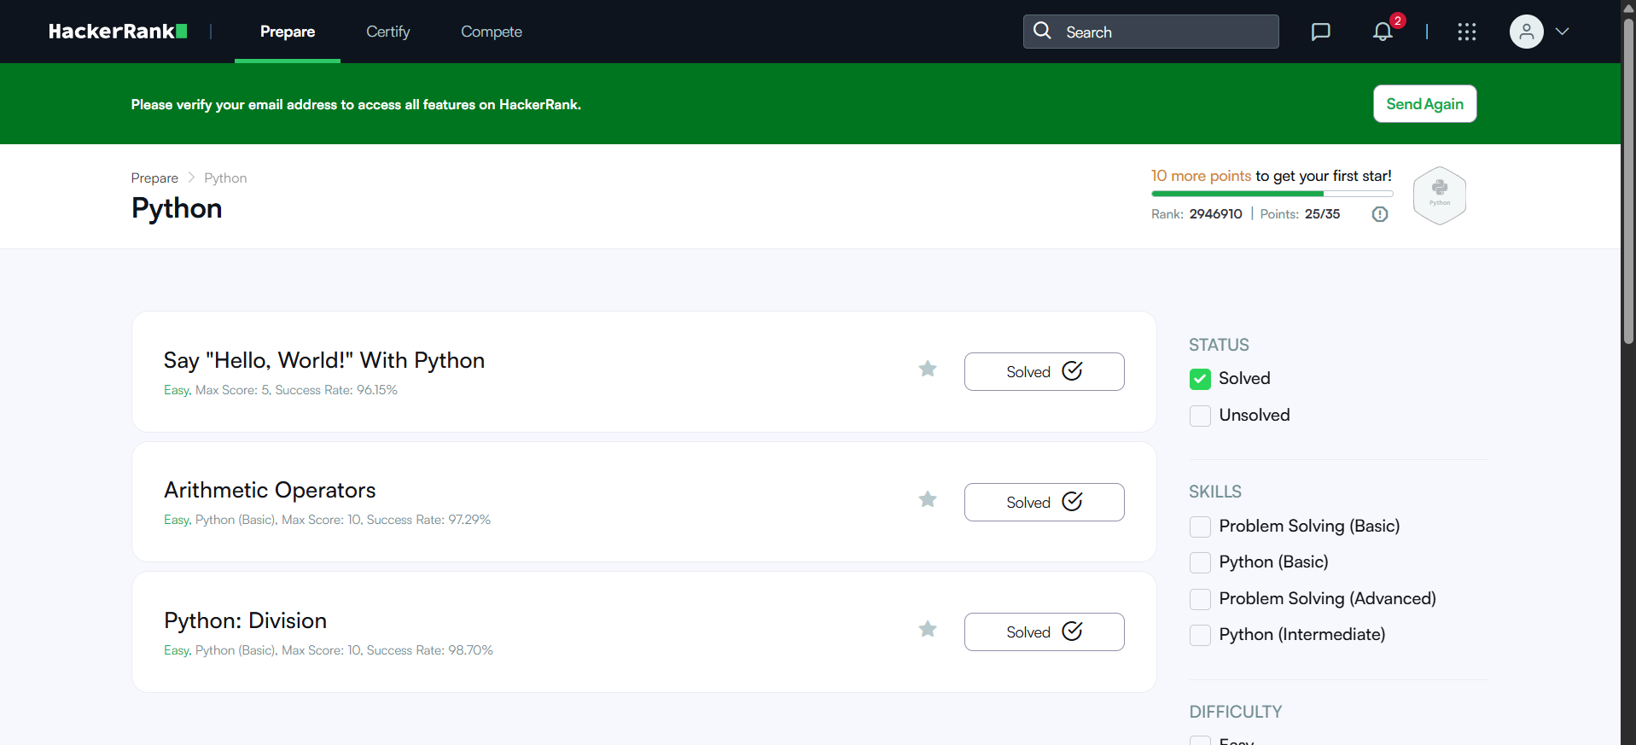

Explain your GitHub submission and attach your submitted Repo screenshot
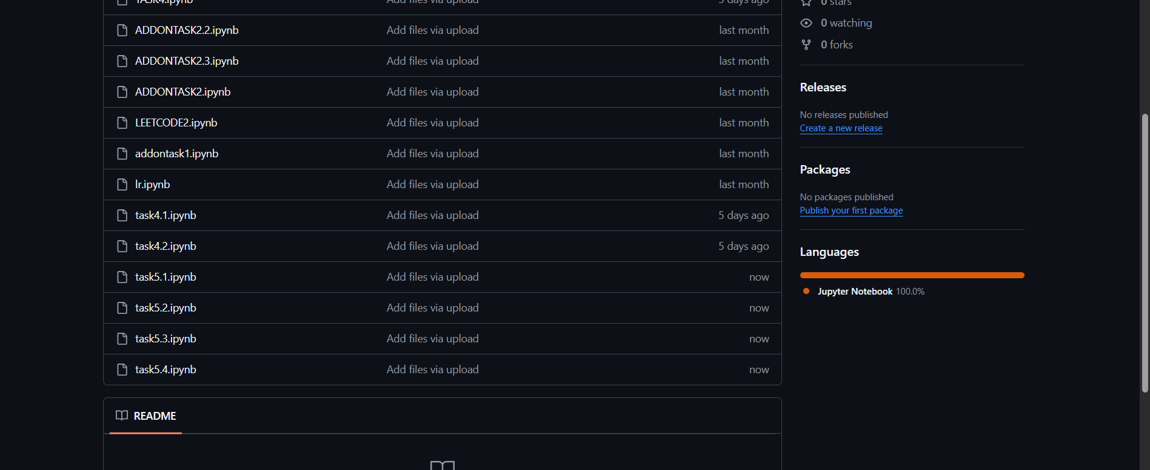

Explain your LinkedIn Post and attach your submitted Post screenshot
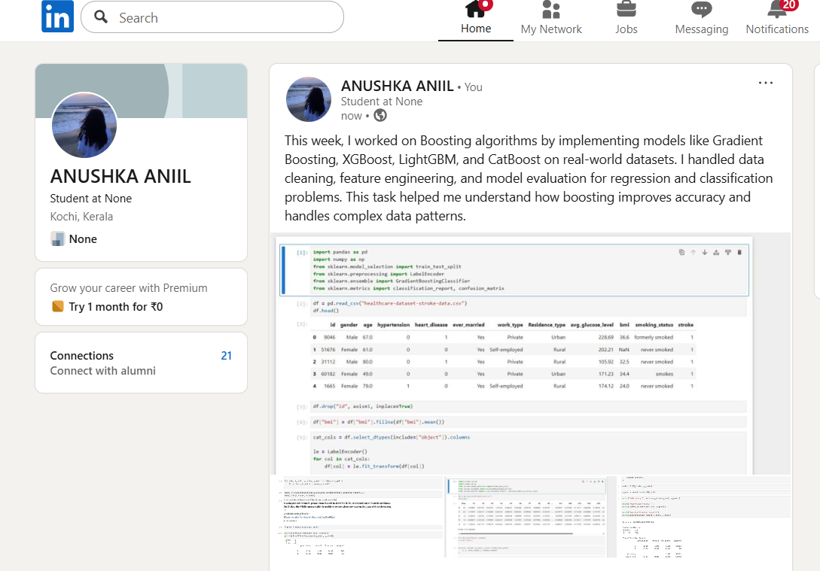

Attach the link of your First Video (YouTube)

Attach the link of your Second Video (YouTube)

🚀 7-DAY PRACTICE PLAN — GRADIENT BOOSTING

🟢 DAY 1 — Boosting Fundamentals (NO CODE)
🎯 Goal
Understand why Gradient Boosting exists.
📘 Learn
- Weak learner concept
- Why Decision Trees fail alone
- Bagging vs Boosting
- Sequential learning idea
🌐 Resources
- StatQuest – Gradient Boosting
https://statquest.org/gradient-boosting-machine/
- Video (StatQuest):
https://www.youtube.com/watch?v=3CC4N4z3GJc
🧠 You must be able to explain:
“Each new tree learns from the mistakes of the previous tree.”
✅ Output
✔ Clear intuition
✔ Can explain boosting without math

🟢 DAY 2 — How Gradient Boosting Works Internally
🎯 Goal
Understand the step-by-step algorithm.
📘 Learn
- Initial prediction
- Calculate residuals
- Train tree on residuals
- Update prediction
- Repeat
Important concepts:
- Loss function
- Residuals
- Learning rate
🌐 Resources
- Machine Learning Mastery
https://machinelearningmastery.com/gentle-introduction-gradient-boosting-algorithm-machine-learning/
🧠 Draw this on paper (important)
Prediction → Error → New tree → Correction
✅ Output
✔ You can explain every step verbally

🟢 DAY 3 — First Gradient Boosting Model (Regression)
🎯 Goal
Build your first working model.
📊 Dataset
California Housing or simple regression dataset.
💻 Practice
from sklearn.ensemble import GradientBoostingRegressor

model = GradientBoostingRegressor(
n_estimators=100,
learning_rate=0.1,
max_depth=3
)

model.fit(X_train, y_train)
📘 Learn parameters
- n_estimators
- learning_rate
- max_depth
✅ Output
✔ Model runs successfully
✔ Understand each parameter

🟢 DAY 4 — Gradient Boosting for Classification
🎯 Goal
Understand classification version.
📊 Dataset
Breast Cancer dataset.
💻 Practice
from sklearn.ensemble import GradientBoostingClassifier
Evaluate using:
- Confusion matrix
- Accuracy
- ROC-AUC
✅ Output
✔ Can use boosting for classification

🟢 DAY 5 — Overfitting & Bias–Variance Control
🎯 Goal
Learn how Gradient Boosting can overfit and how to control it.
📘 Learn
- High number of trees → overfitting
- High learning rate → instability
- Deep trees → variance
💻 Practice
Try:
- learning_rate = 0.1 vs 0.01
- n_estimators = 100 vs 500
Observe performance.
✅ Output
✔ Understand bias–variance tradeoff clearly

🟢 DAY 6 — Model Evaluation & Feature Importance
🎯 Goal
Evaluate models properly.
📘 Learn
- RMSE (regression)
- ROC-AUC (classification)
- Feature importance interpretation
💻 Practice
model.feature_importances_
Plot top features.
✅ Output
✔ Know what features drive predictions

🟢 DAY 7 — Mini Project
🎯 Goal
Apply everything together.
📊 Dataset (choose one)
- Flight Price Prediction
- Housing Price
- Student Performance
- Diabetes Prediction
💻 Project Steps
- Load dataset
- Clean data
- Encode categorical features
- Train Gradient Boosting
- Tune parameters
- Evaluate results
- Write conclusions

🚀 7-DAY PRACTICE PLAN — XGBOOST

🟢 DAY 1 — Understand XGBoost Conceptually (NO CODE)
🎯 Goal
Understand what XGBoost is and why it beats Random Forest.
📘 Learn
- Boosting vs Bagging
- Sequential learning
- Residual learning
- Why “XG” = Extreme Gradient Boosting
🌐 Resources
- StatQuest – Gradient Boosting
https://statquest.org/gradient-boosting-machine/
- StatQuest – XGBoost
https://www.youtube.com/watch?v=OtD8wVaFm6E
🧠 You must be able to explain:
“Each new tree corrects the errors of the previous trees.”
✅ Output
✔ Clear mental picture
✔ Can explain XGBoost in simple words

🟢 DAY 2 — Learn XGBoost Architecture & Parameters
🎯 Goal
Understand how XGBoost is different from normal Gradient Boosting.
📘 Learn
- Regularization (L1 & L2)
- Tree pruning
- Learning rate (eta)
- Subsampling
- Column sampling
🌐 Resources
- XGBoost Documentation
https://xgboost.readthedocs.io/en/stable/
- Analytics Vidhya – XGBoost Guide
https://www.analyticsvidhya.com/blog/2018/10/understanding-xgboost-algorithm/
🧠 Important parameters:
- n_estimators
- max_depth
- learning_rate
- subsample
- colsample_bytree
- gamma
✅ Output
✔ Know what each parameter does

🟢 DAY 3 — First XGBoost Model (Classification)
🎯 Goal
Build your first working XGBoost model.
📊 Dataset
Breast Cancer dataset
💻 Practice
- Train XGBClassifier
- Predict values
- Evaluate accuracy
Example
from xgboost import XGBClassifier

model = XGBClassifier(
n_estimators=100,
learning_rate=0.1,
max_depth=3
)

model.fit(X_train, y_train)
✅ Output
✔ Model runs successfully
✔ Understand difference from sklearn models

🟢 DAY 4 — Evaluation Metrics + ROC-AUC
🎯 Goal
Evaluate XGBoost properly.
📘 Learn
- Confusion Matrix
- Precision / Recall
- ROC-AUC
- Threshold tuning
💻 Practice
- Plot ROC curve
- Calculate AUC
- Compare with Random Forest
✅ Output
✔ You know when XGBoost performs better

🟢 DAY 5 — Hyperparameter Tuning (VERY IMPORTANT 🔥)
🎯 Goal
Learn to optimize XGBoost.
📘 Learn
- GridSearchCV
- RandomizedSearchCV
- Early stopping
💻 Practice
model = XGBClassifier(
n_estimators=500,
learning_rate=0.05
)

model.fit(
X_train, y_train,
eval_set=[(X_test, y_test)],
early_stopping_rounds=20,
verbose=False
)
✅ Output
✔ Understand early stopping
✔ Prevent overfitting

🟢 DAY 6 — Advanced Topics (IMPORTANT)
🎯 Goal
Understand real-world usage.
📘 Learn
- Feature importance
- Handling missing values
- Class imbalance
- scale_pos_weight
💻 Practice
- Fraud dataset or imbalanced dataset
- Use:
scale_pos_weight = negative / positive
✅ Output
✔ Can handle imbalanced data confidently

🟢 DAY 7 — Mini Project
🎯 Goal
Build an end-to-end XGBoost project.
📊 Dataset (choose one)
- Titanic
- Flight price
- Stroke prediction
- Credit fraud
💻 Project Steps
- Load dataset
- Clean data
- Encode features
- Train XGBoost
- Tune parameters
- Evaluate model
- Write conclusions

