LOGIN PAGE FOR PATIENT:

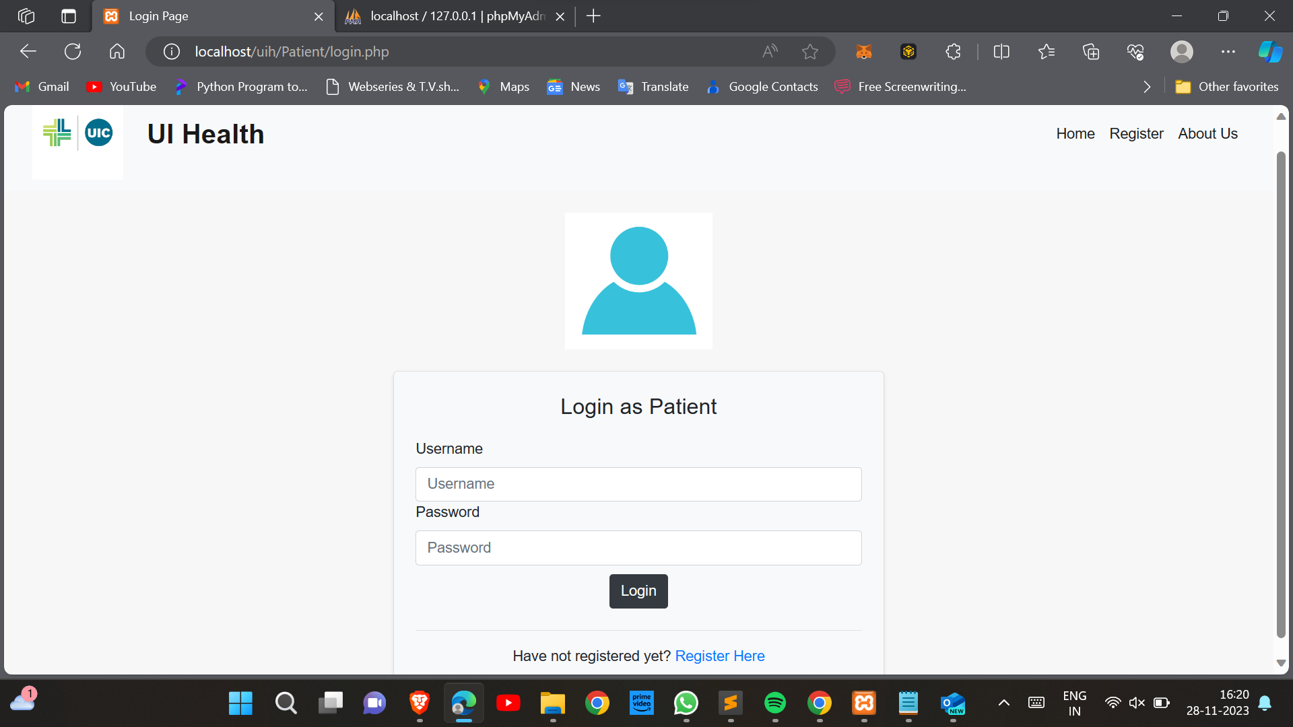

REGISTER PAGE FOR PATIENT:

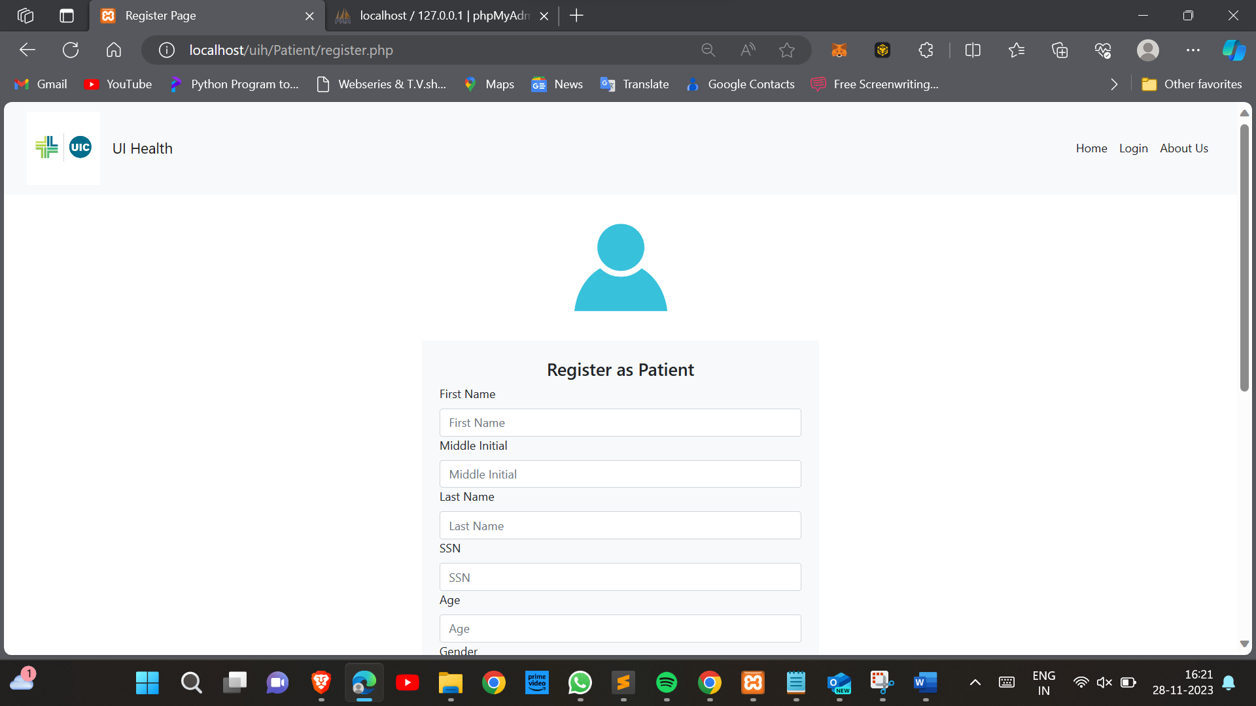

MY PROFILE PAGE FOR PATIENT:

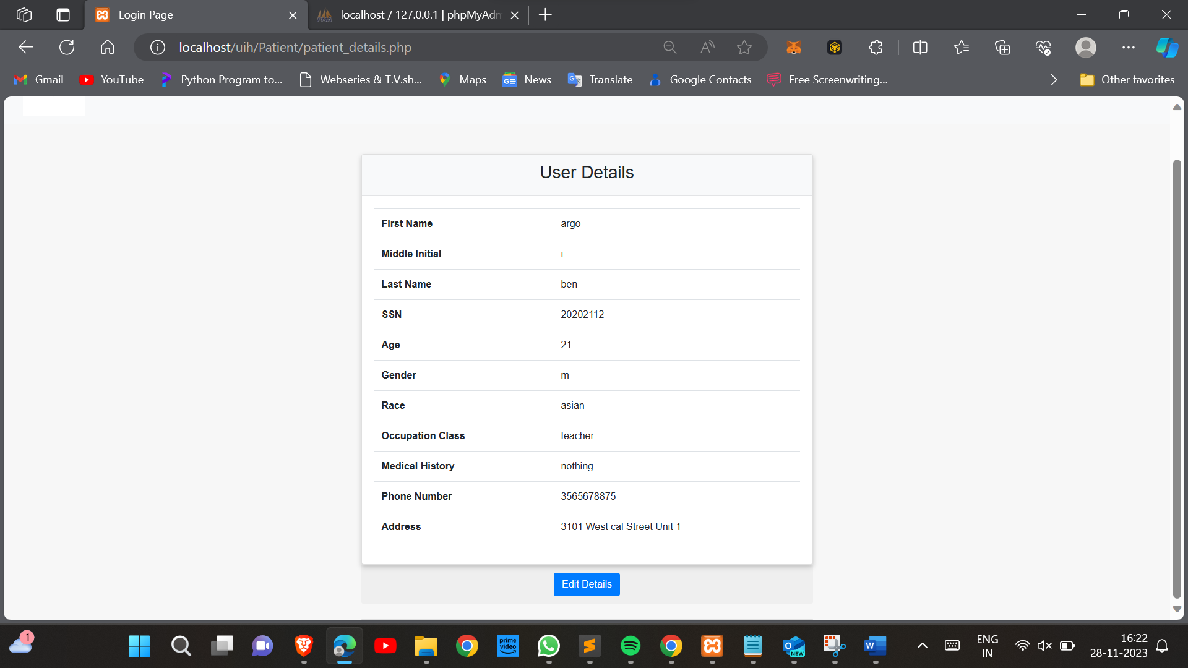

FIRST DOSE SCHEDULING PAGE:

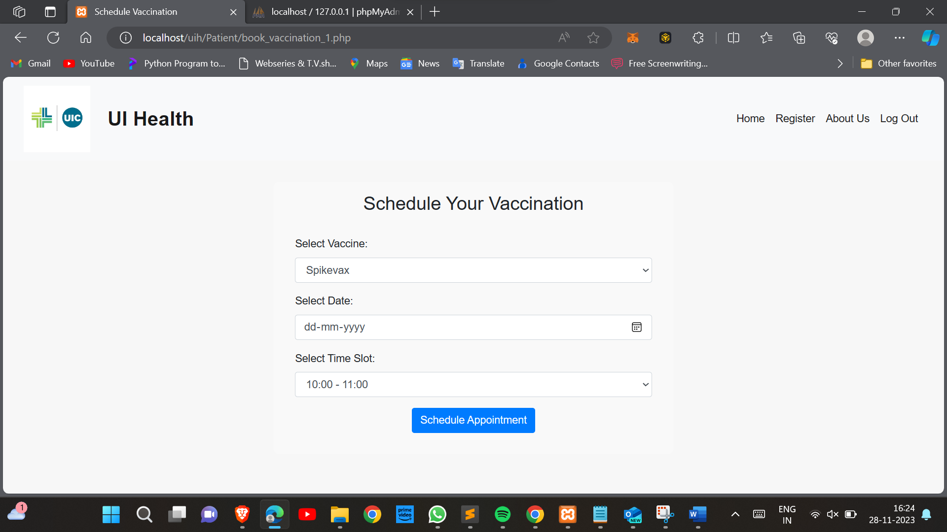

SECOND DOSE SCHEDULING PAGE:

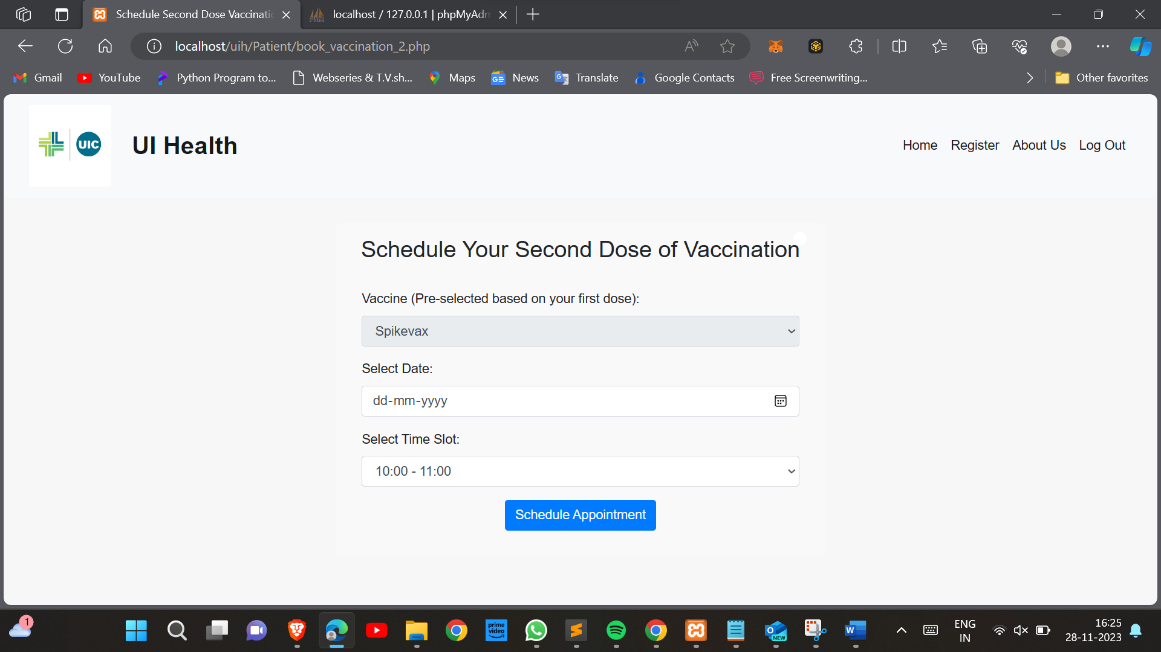

VIEWING AND MANAGING THE VACCINE SCHEDULES:

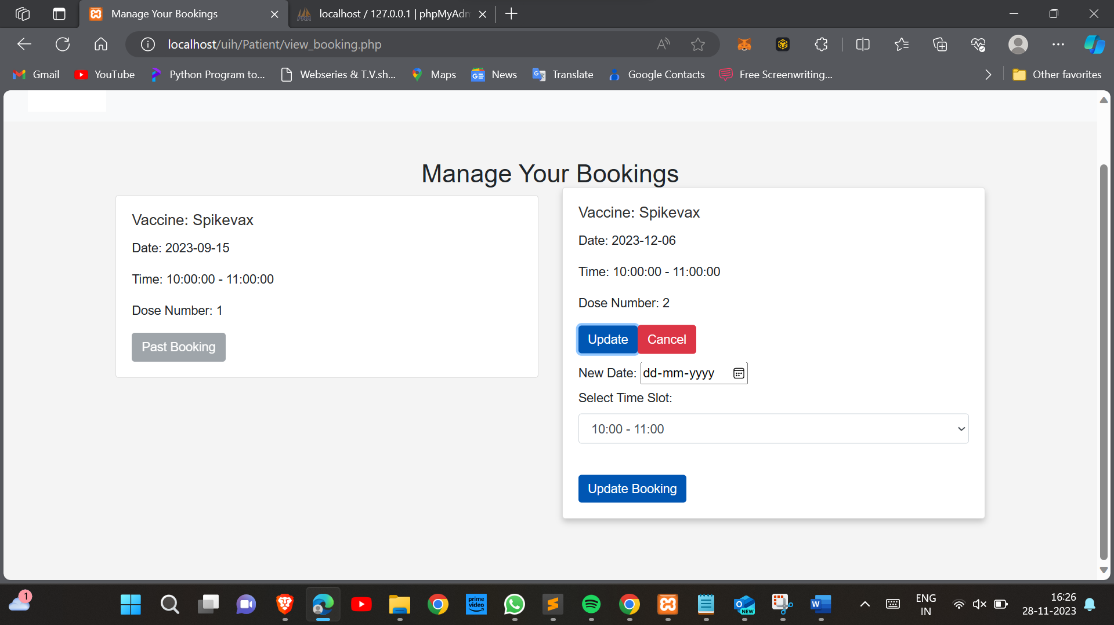

NURSE PROFILE VEIW AND EDIT PAGE:

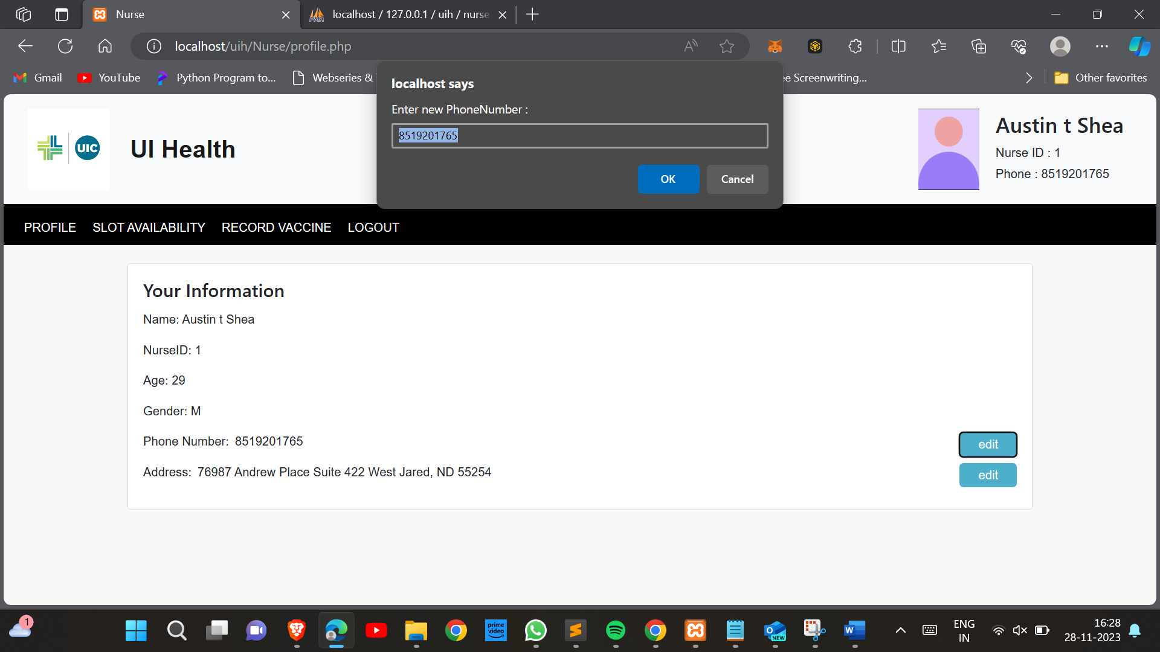

NURSE’S TIMESLOT VIEW PAGE:

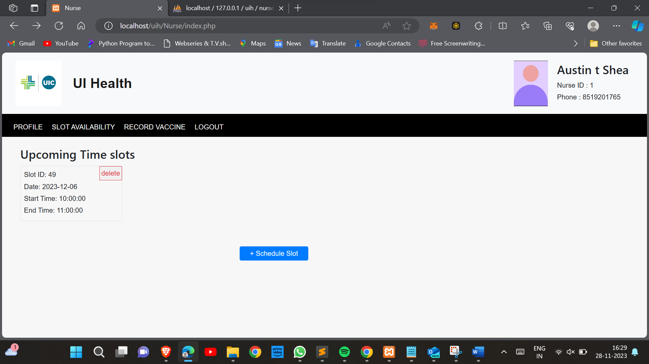

NURSE’S TIMESLOT BOOKING PAGE:

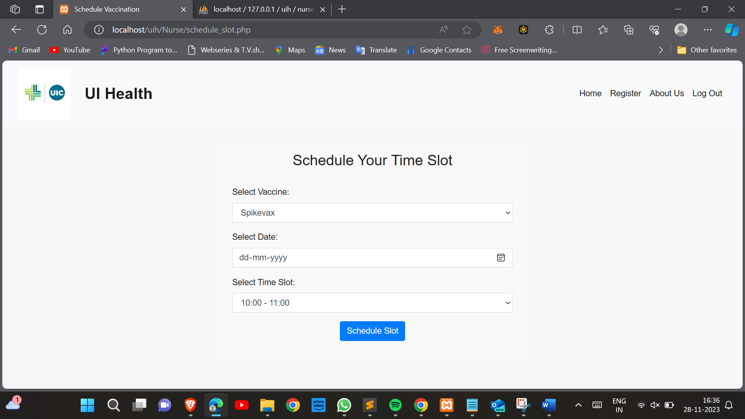

NURSE’S VACCINATION RECORD UPDATE PAGE:

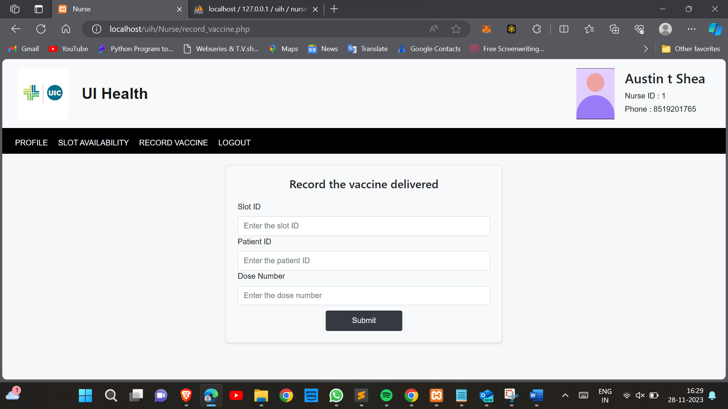

ADMIN’S DASHBOARD:

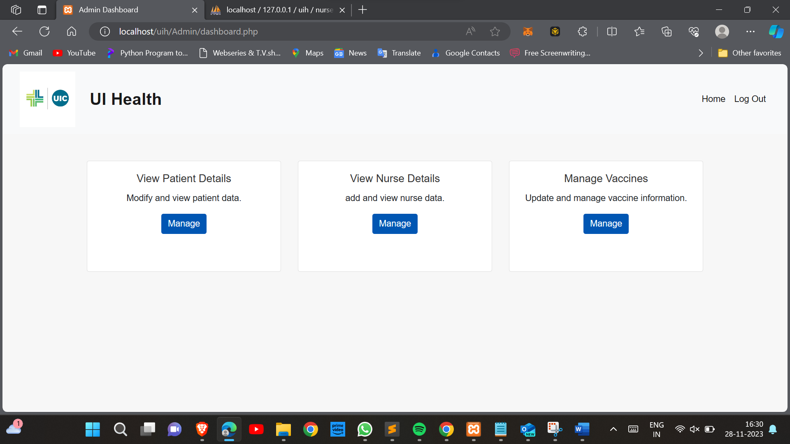

ADMIN’S PATIENT PROFILE VIEW PAGE:

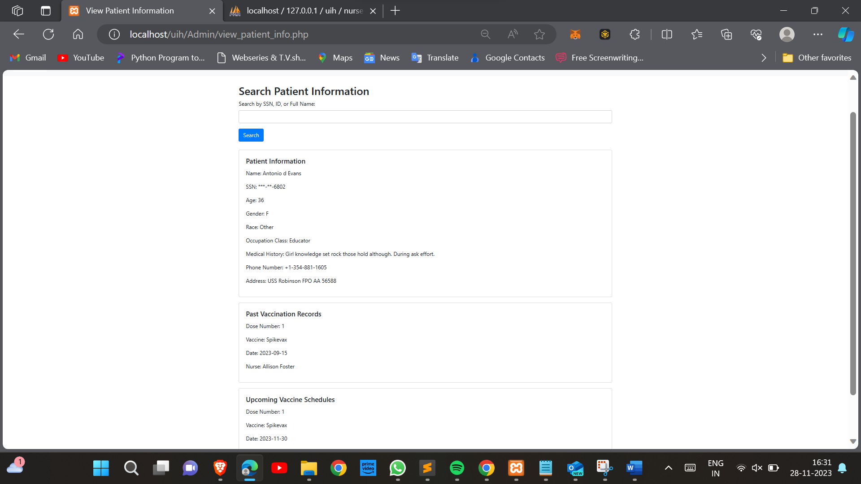

ADMIN’S NURSE REGISTRATION PAGE:

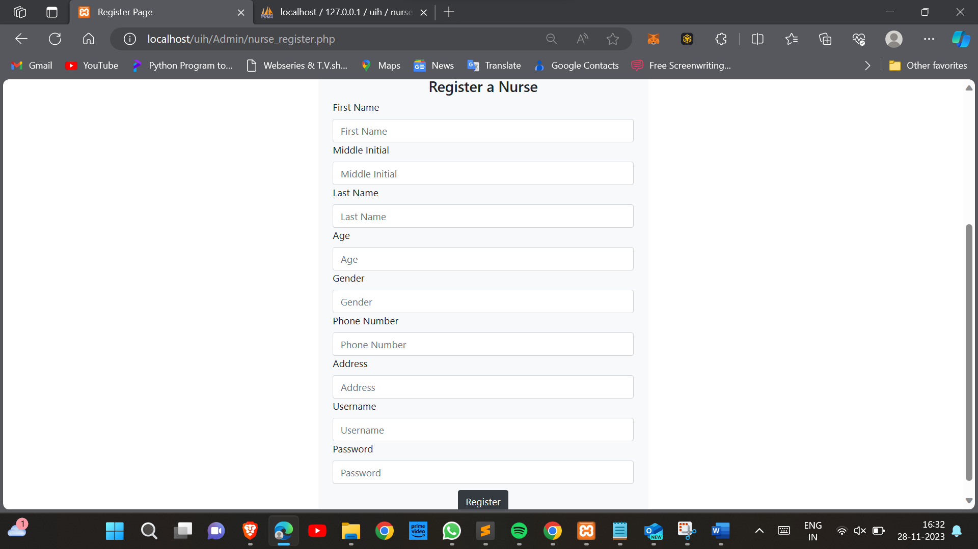

ADMIN’S NURSE PROFILE VIEW, UPDATE AND DELETE PAGE:

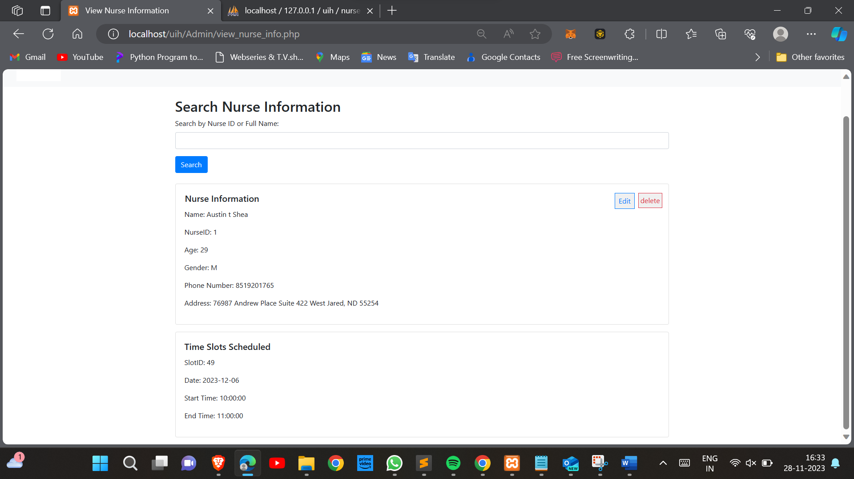

ADMIN’S VACCINE ADD AND UPDATE PAGE:

