Experiment: Parallel Quick Sort
Aim:
To evaluate the performance of Quick Sort in a multi-core system by distributing partitions across multiple processors using parallel execution, compare it with single-threaded execution, and analyze the speedup and scalability.
Algorithm:
Read the number of elements.
Input the array elements.
Select the last element as the pivot.
Partition the array into two subarrays.
If the partition size is large, create parallel sections to sort the left and right partitions simultaneously.
Otherwise, sort recursively in a single thread.
Merge the sorted partitions automatically through recursion.
Measure execution time.
Display the sorted array and execution time.
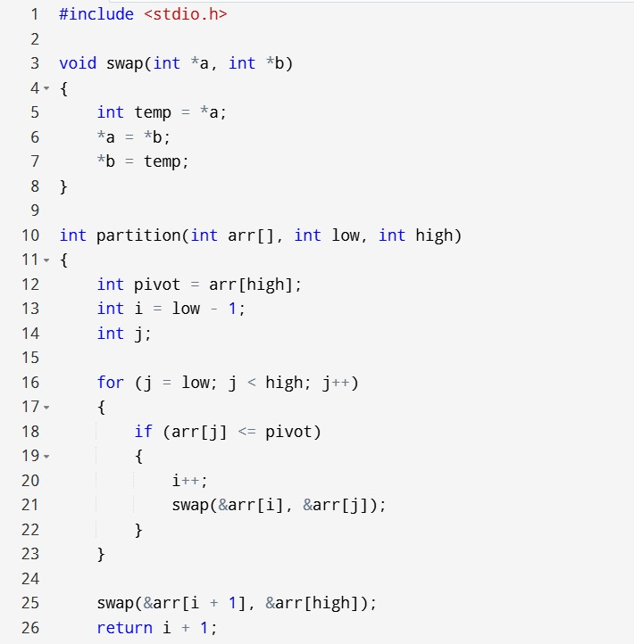
Source Code:
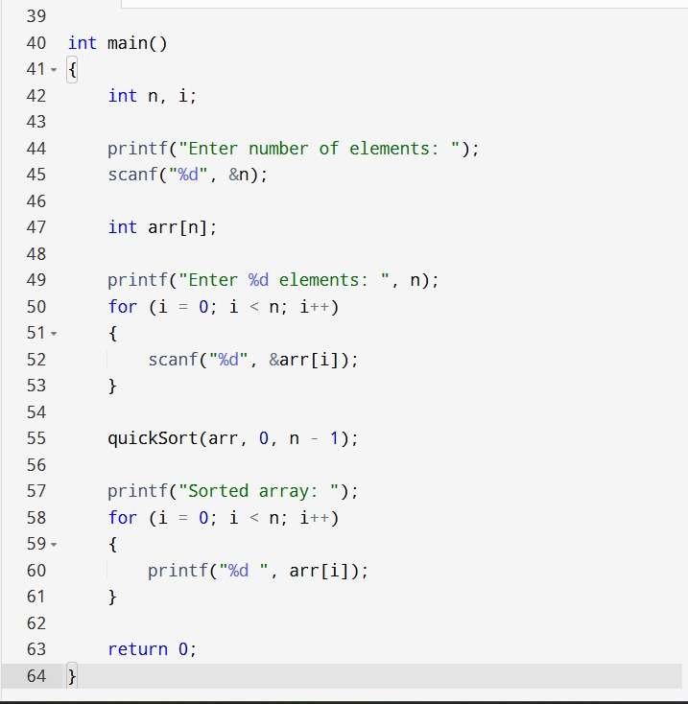
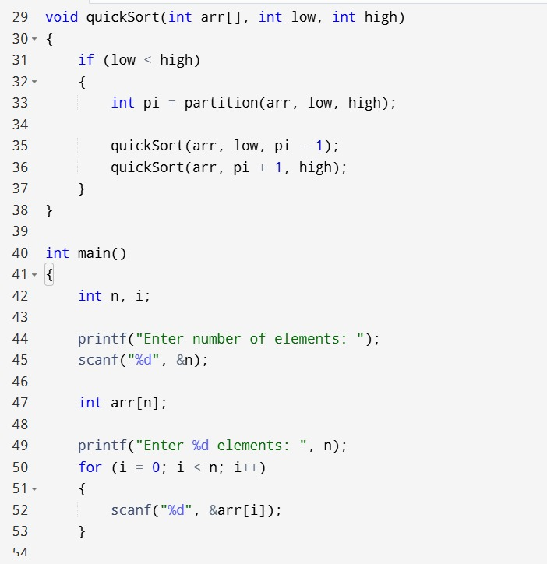

Sample input and output:
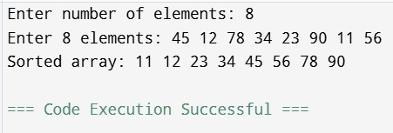

Time Complexity:
Best Case: O(n log n)
Average Case: O(n log n)
Worst Case: O(n²)
Space Complexity:
Recursive Stack: O(log n)
Parallel Threads: O(log n) (additional thread overhead)
Result:
The parallel Quick Sort algorithm successfully sorted the given array. Compared to the single-threaded version, the parallel implementation reduces execution time on multi-core processors and provides improved speedup and scalability for large datasets.

