QUESTION:
A retail company maintains daily sales data that must be searched quickly to find specific transaction IDs. The dataset is unsorted due to continuous updates. The system currently uses Linear Search, but performance degrades as data grows.
a) Explain how Linear Search operates in this scenario.
b) Analyze the time complexity for the best, average, and worst cases.
c) Suggest whether sorting + Binary Search would improve performance and justify your decision.
Title: Searching Transaction IDs Using Linear Search
Aim:
To implement the Linear Search algorithm in Java to search for a transaction ID in an unsorted retail sales dataset.
Algorithm:
- Start.
- Read the number of transaction IDs (n).
- Store the transaction IDs in an array.
- Read the transaction ID to be searched (key).
- Compare the key with each element of the array one by one.
- If the key matches an element:
  - Display the position of the transaction ID.
  - Stop searching.
- If the key is not found after checking all elements:
  - Display "Transaction ID Not Found."
- Stop.

Source Code:
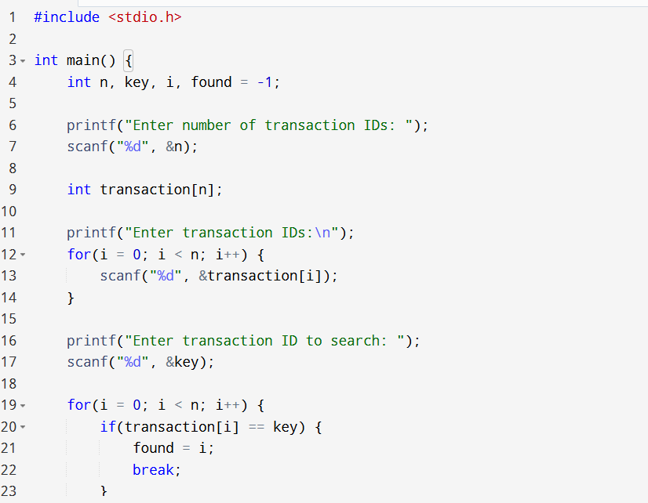
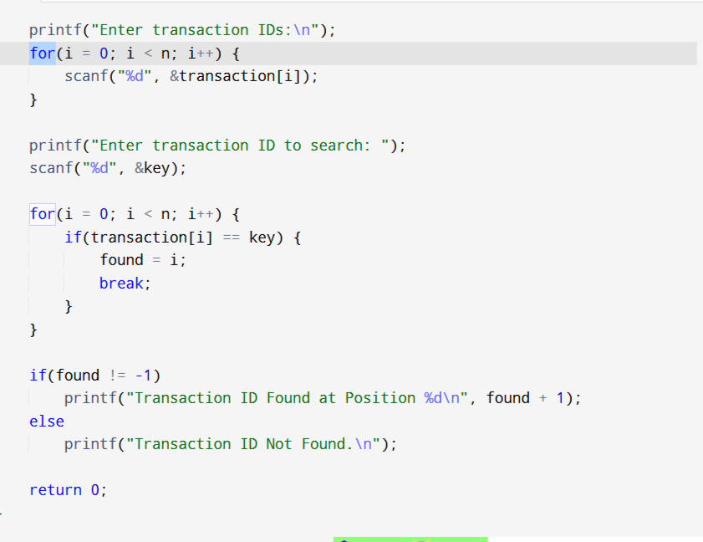

Sample input and output:

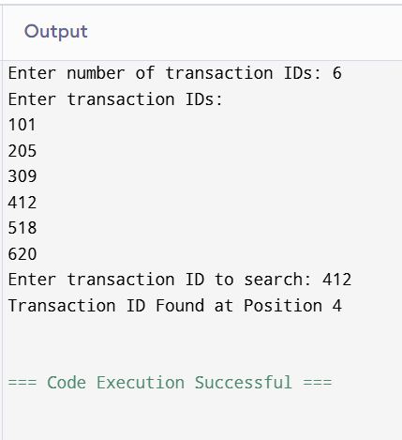
Analysis
- The program uses the Linear Search algorithm.
- It compares the target transaction ID with each element in the array sequentially.
- Since the data is unsorted, Linear Search is suitable.
- If the transaction ID is found, its position is displayed.
- Otherwise, the program displays "Transaction ID Not Found."

Time Complexity

Case | Complexity
Best Case | O(1)
Average Case | O(n)
Worst Case | O(n)

Explanation:
- Best Case: Transaction ID is the first element.
- Average Case: Transaction ID is somewhere in the middle.
- Worst Case: Transaction ID is the last element or not present.

Space Complexity:
O(1) (Auxiliary Space)
Explanation:
- Only a few extra variables (key, found, i) are used.
- No additional data structures are created apart from the input array.

Result:
The C program successfully implements the Linear Search algorithm to search for a transaction ID in an unsorted retail sales dataset. It correctly identifies the position of the transaction ID if it exists; otherwise, it reports that the transaction ID is not found. The algorithm is simple and suitable for small or unsorted datasets, but its performance decreases as the dataset size grows.

