CO4_AT2-DAA
Q6).Huffman Coding – Data Compression
A video streaming platform compresses data based on symbol frequencies to optimize storage and transmission. Analyze how Huffman coding can be used to generate optimal prefix codes. Design the solution by explaining tree construction and encoding process. Suggest tools for implementing compression. Analyze compression efficiency and time complexity. Interpret the results in terms of bandwidth and storage optimization.
Aim:
To implement Huffman Coding for lossless data compression by generating optimal prefix codes based on symbol frequencies, thereby reducing the number of bits required for storage and transmission.
Algorithm:
- Read the symbols and their corresponding frequencies.
- Create a leaf node for every symbol.
- Insert all nodes into a min-priority queue based on frequency.
- Remove the two nodes with the smallest frequencies.
- Create a new internal node whose frequency is the sum of the two removed nodes.
- Insert the new node back into the priority queue.
- Repeat steps 4–6 until only one node remains. This node becomes the root of the Huffman tree.
- Traverse the tree:
  - Assign 0 to a left edge.
  - Assign 1 to a right edge.
- The bit sequence obtained for each symbol is its Huffman code.
- Encode the input data by replacing every symbol with its corresponding Huffman code.
Source Code:
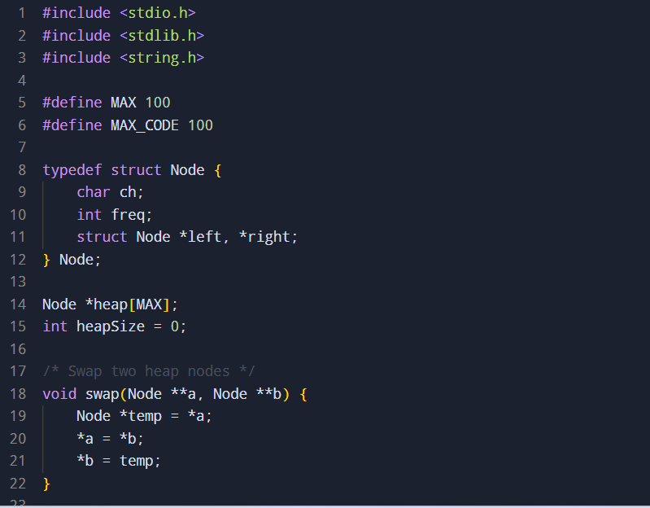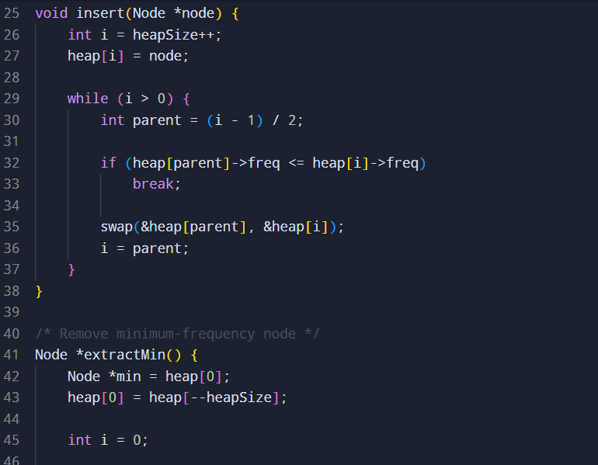
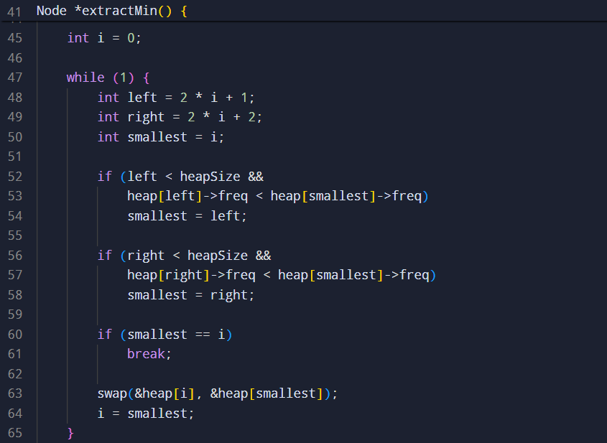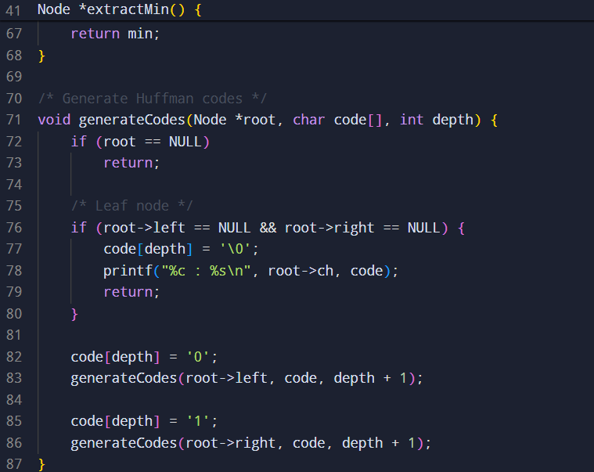
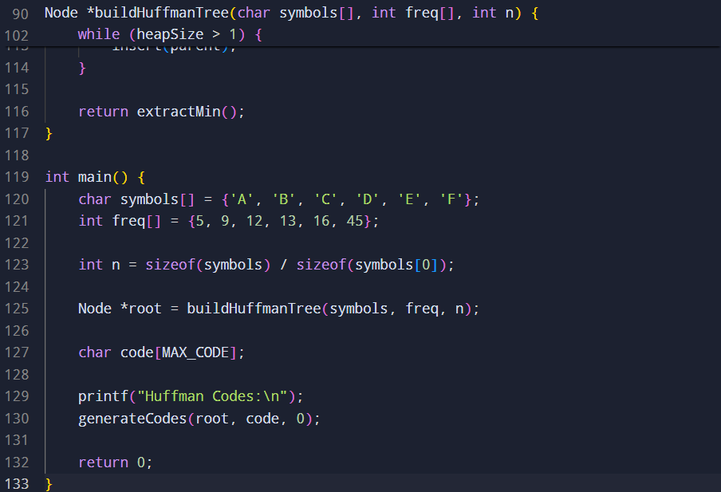

Sample input and output:

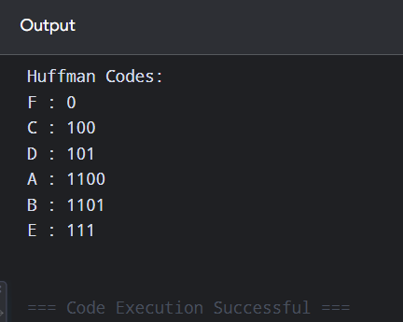
Time Complexity:
Let n be the number of distinct symbols.
- Building the min-heap: O(n)
- Building the Huffman tree: O(n log n)
- Generating the codes: O(n)
- Encoding a message of length m: O(m)
Therefore, the overall complexity is:
O(n log n + m)
Space Complexity:
- Min-heap: O(n)
- Huffman tree: O(n)
- Code storage: O(n)
Therefore:
O(n)
Result:
Huffman coding assigns shorter codes to frequently occurring symbols and longer codes to less frequent symbols. Since the codes form a prefix-free code, encoded symbols can be decoded unambiguously without separators.
For a video-streaming platform, this reduces the number of bits needed to represent metadata, subtitles, logs, headers, or other compressible data. Consequently:
- Storage requirement decreases
- Transmission bandwidth decreases
- Network transfer becomes more efficient
- Frequently occurring symbols require fewer bits
- Decoding can be performed efficiently
Huffman coding is particularly effective when symbol frequencies are highly unequal. For actual video compression, however, Huffman coding is generally one component of a larger codec rather than the entire video-compression process.

