CO4_AT3_DAA
6. All-Pairs vs Single-Source Shortest Path
Given a network graph, compute shortest paths using Floyd–Warshall and Dijkstra’s
algorithm. Compare their results, computational cost, and applicability. Critically evaluate
which method is suitable for all-pairs versus single-source problems. Generate insights on
scalability.
Aim
To implement and compare Floyd–Warshall and Dijkstra’s algorithms for finding shortest paths in a weighted network graph, and analyze their computational cost, applicability, and scalability.

Algorithm
A. Floyd–Warshall Algorithm — All-Pairs
- Represent the graph using an adjacency matrix.
- Initialize dist[i][j] with the edge weight between vertices i and j.
- Set dist[i][i] = 0.
- For every intermediate vertex k:
  - For every source vertex i:
    - For every destination vertex j:
      - Update:
dist[i][j] = min(dist[i][j], dist[i][k] + dist[k][j])
- After all iterations, dist[i][j] contains the shortest distance from i to j.
B. Dijkstra’s Algorithm — Single-Source
- Select a source vertex.
- Initialize the distance of the source to 0 and all other vertices to infinity.
- Select the unvisited vertex with the smallest distance.
- Relax all its adjacent edges.
- Mark the vertex as visited.
- Repeat until all reachable vertices are processed.
- The distance array contains the shortest paths from the selected source.

Source Code
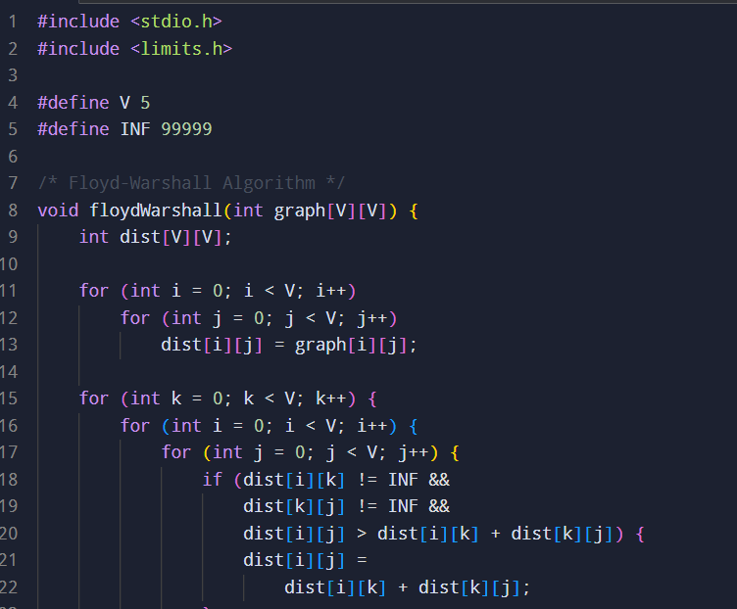

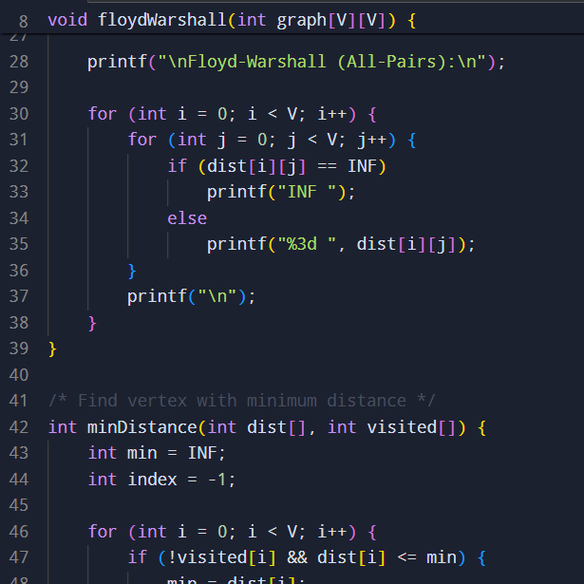
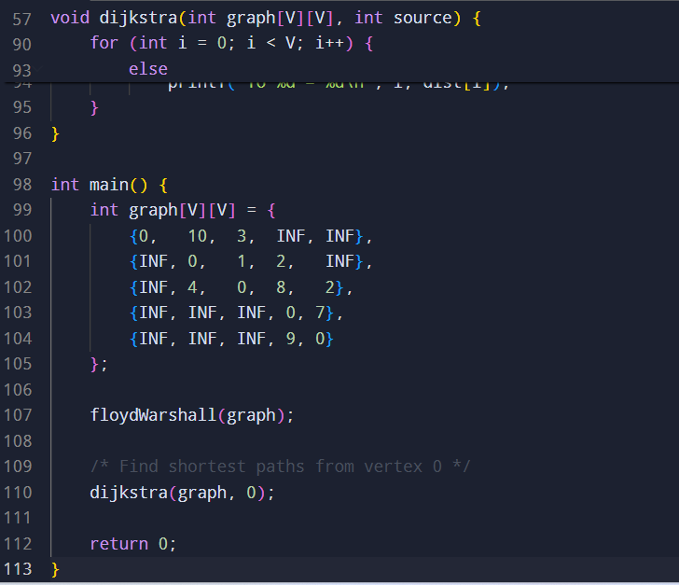
Sample input and output
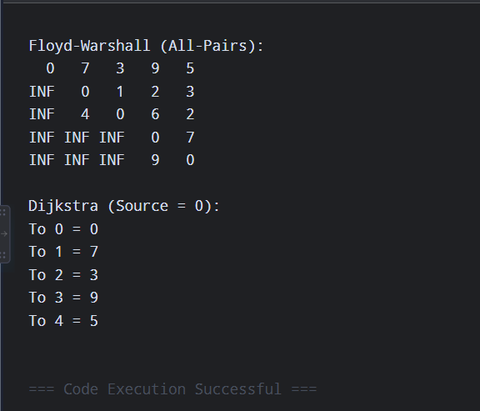
Time Complexity
Algorithm | Problem | Time Complexity
Floyd–Warshall | All-pairs | O(V³)
Dijkstra (array/matrix) | Single-source | O(V²)
Dijkstra + binary heap | Single-source | O((V + E) log V)
Where:
- V = number of vertices
- E = number of edges
Space Complexity
Algorithm | Space Complexity
Floyd–Warshall | O(V²)
Dijkstra | O(V) additional space, or O(V²) when using an adjacency matrix

Result
Both algorithms produce the same shortest-path distances when applied to the same graph and valid edge weights.
- Floyd–Warshall is best suited for all-pairs shortest-path problems, because it calculates the shortest distance between every pair of vertices in a single computation.
- Dijkstra is best suited for single-source shortest-path problems, where paths from one source to all other vertices are required.
- Dijkstra requires non-negative edge weights.
- Floyd–Warshall can handle negative edge weights (provided there are no negative cycles).

