CO5_AT1_DAA
Aim
To solve the N-Queens problem using the backtracking technique, ensuring that N queens are placed on an N × N chessboard such that no two queens attack each other, while using constraint checking and pruning to reduce the search space.

Constraints
For placing N queens on the board:
- Row constraint:
Only one queen can be placed in each row.
- Column constraint:
No two queens can be in the same column.
- Diagonal constraint:
No two queens can lie on the same diagonal.
  - Main diagonal: row - column must be different.
  - Secondary diagonal: row + column must be different.
By placing exactly one queen per row, the row constraint is automatically satisfied. Therefore, the algorithm only needs to check columns and diagonals.
How constraints reduce the search space
Without constraints, there are N^N possible ways to place one queen in each row.
Backtracking immediately rejects a position if:
- its column already contains a queen,
- its main diagonal contains a queen, or
- its secondary diagonal contains a queen.
Thus, invalid partial solutions are discarded before the remaining rows are explored. This pruning greatly reduces unnecessary search.

Algorithm
- Start with an empty N × N board.
- Begin with the first row.
- Try placing a queen in each column of the current row.
- Check whether the position is safe:
  - Column is unused.
  - Main diagonal is unused.
  - Secondary diagonal is unused.
- If the position is safe:
  - Place the queen.
  - Mark its column and diagonals as occupied.
  - Recursively solve the next row.
- If no position works for the next row:
  - Remove the previously placed queen.
  - Unmark the column and diagonals.
  - Try the next possible column.
- When all N rows contain queens, a valid solution is found.
- Continue backtracking if all possible solutions are required.

Source Code:
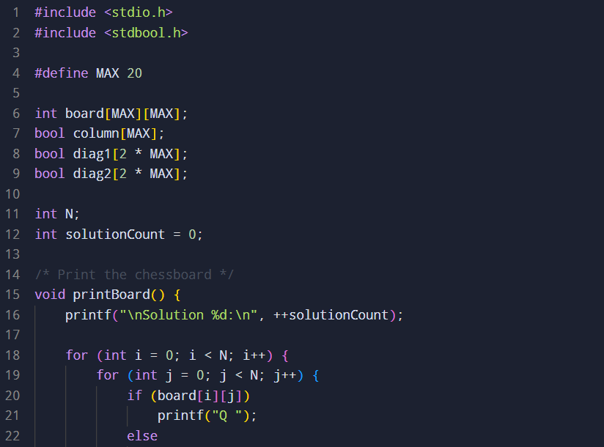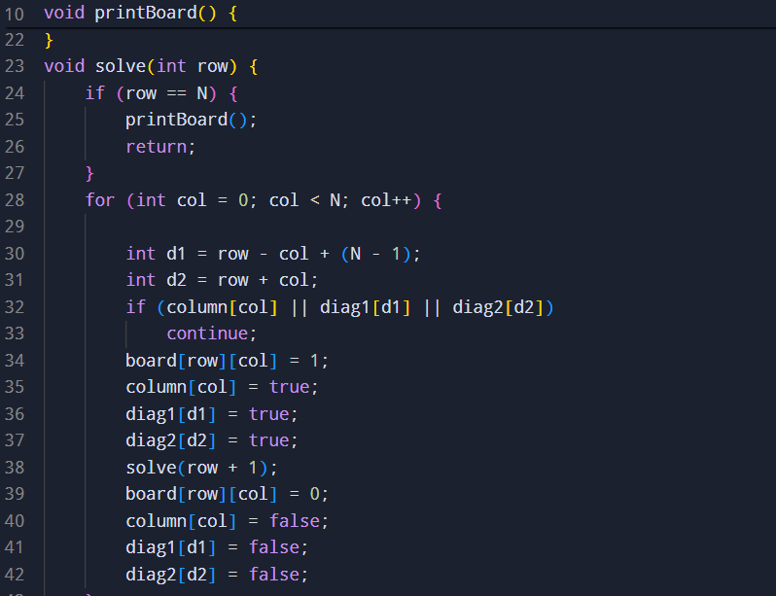

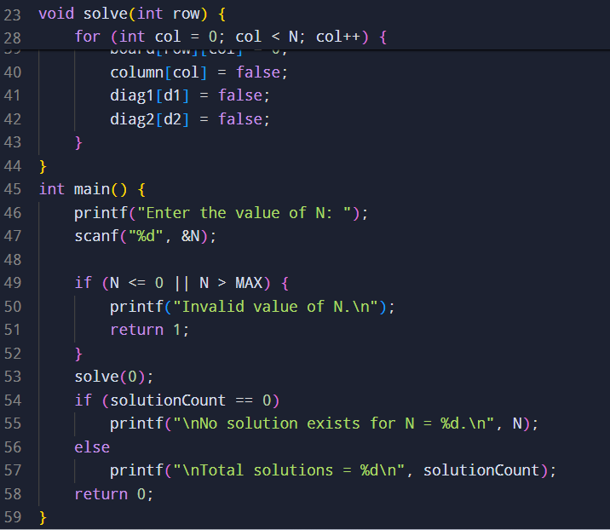
Sample input and output
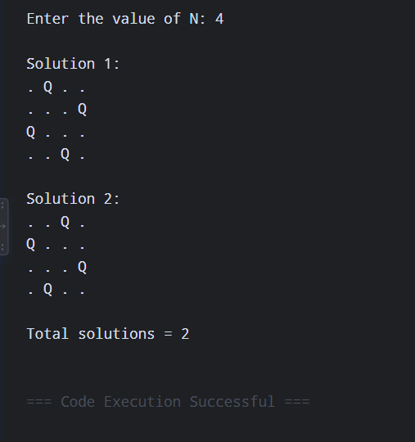
Time Complexity
The worst-case time complexity is approximately:
O(N!)
because one queen is placed in each row and previously used columns are excluded.
The actual number of explored states is much smaller because of diagonal and column pruning.
For generating all solutions, the computation can still become expensive as N increases.
Space Complexity
The space complexity is:
O(N²)
because the chessboard requires N × N storage.
The auxiliary arrays for columns and diagonals require O(N) space, and recursion requires O(N) stack space.
If the board is represented only by the column position of each queen instead of an N × N matrix, the space requirement can be reduced to O(N).
Result
The N-Queens problem is successfully solved using backtracking and constraint-based pruning. The algorithm places queens row by row, validates column and diagonal constraints before each placement, and backtracks whenever a partial arrangement cannot lead to a valid solution.
For example:
- N = 1 → 1 solution
- N = 2 → No solution
- N = 3 → No solution
- N = 4 → 2 solutions
Conclusion: Backtracking efficiently explores the solution space by eliminating invalid configurations at an early stage. It guarantees that all valid configurations are found when the recursive search is allowed to continue after each solution.

