CO5_AT2_DAA
Design a pseudocode using Backtracking to find a path where a knight visits every square on
an N×N chessboard exactly once. Clearly identify inputs (board size) and output (valid tour
path). Develop a logically correct algorithm that follows knight movement rules. Use
appropriate control structures for move generation and validation. Ensure the pseudocode is
well-structured and readable. Handle all cases and optimize by pruning invalid moves.
AIM
To find a path for a knight on an N × N chessboard such that the knight visits every square exactly once, using the backtracking technique and pruning invalid moves.

ALGORITHM
- Read the board size N.
- Initialize all cells of the chessboard to -1, indicating unvisited squares.
- Place the knight at the starting position (0, 0) and mark it as move 0.
- Store the 8 possible moves of a knight.
- For the current position, try each of the 8 possible moves.
- Check whether the new position:
  - Is inside the chessboard.
  - Has not already been visited.
- If the move is valid:
  - Place the knight on the new square.
  - Recursively try to make the next move.
- If the recursive call fails, remove the knight from that square and backtrack.
- If N × N squares have been visited, a valid tour is found.
- If all possible moves fail, report that no solution exists.
Source Code
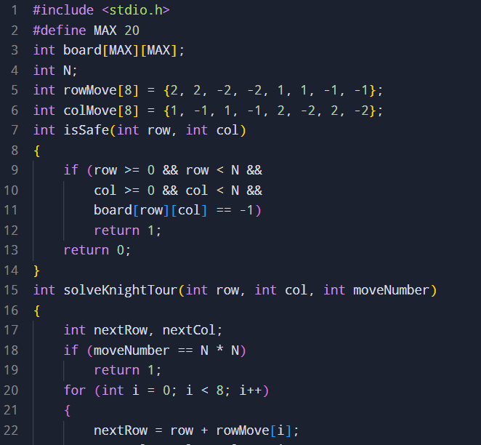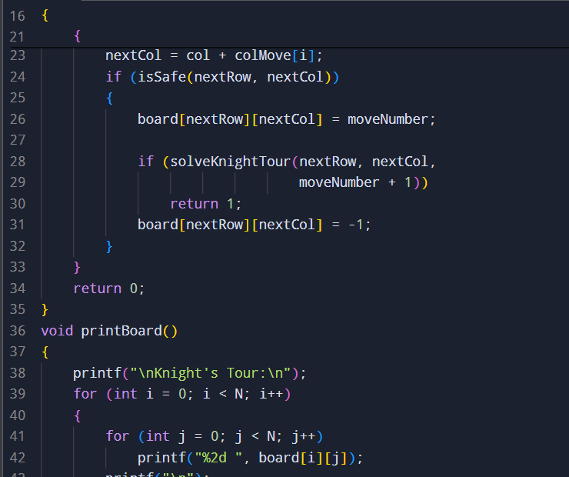
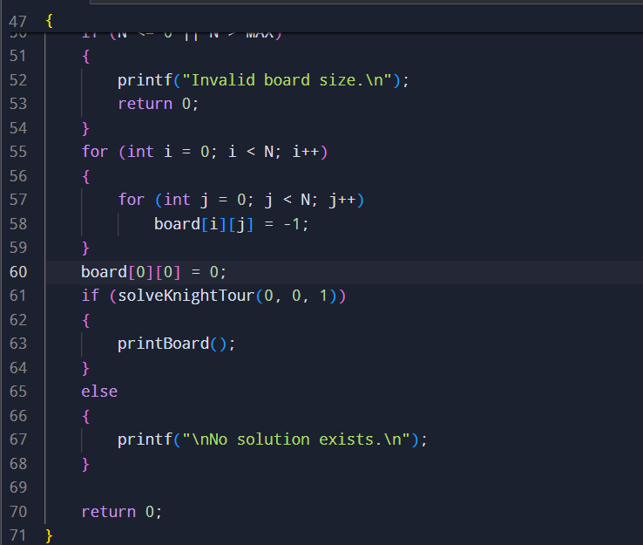
Sample input and output
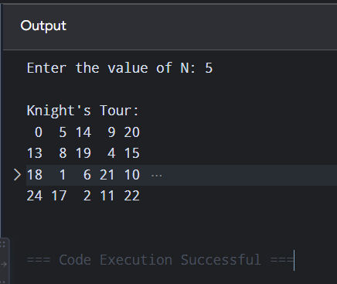

TIME COMPLEXITY
At each step, the knight can have at most 8 possible moves.
Worst-case time complexity:
O(8^(N²))
Backtracking and pruning considerably reduce the practical search space by rejecting invalid or already-visited squares early.

SPACE COMPLEXITY
- Chessboard: O(N²)
- Recursion stack: O(N²)
Therefore:
O(N²)

RESULT
The Knight's Tour problem is successfully solved using backtracking. The algorithm generates all possible knight moves, checks whether each move is valid, and prunes invalid moves immediately. When a dead end is reached, it backtracks and tries another path.
Thus, the algorithm finds a valid tour when one exists and reports "No solution exists" when no tour can be found from the selected starting position.

