Fractional Knapsack
A trader needs to load goods into a container with limited capacity. Unlike 0/1 Knapsack, items can be divided into smaller parts, allowing fractional selection. To maximize profit, items should be selected based on their value-to-weight ratio using a Greedy approach.
Sample Input:
n = 3
Values = 60 100 120
Weights = 10 20 30
W = 50
Expected Output:
Maximum Profit = 240

ANSWER:
Aim:
To implement the Fractional Knapsack problem using the Greedy approach and maximize the total profit within the given capacity.
Algorithm:
1.Read the number of items, their values, weights, and knapsack capacity.
2.Calculate the value/weight ratio for each item.
3.Sort all items in descending order of their value/weight ratio.
4.Select the items with the highest ratio first.
5.If the complete item fits, add its full value.
6.Otherwise, take the required fraction of the item.
7.Continue until the knapsack is full.
8.Display the maximum profits

SOURCE CODE:
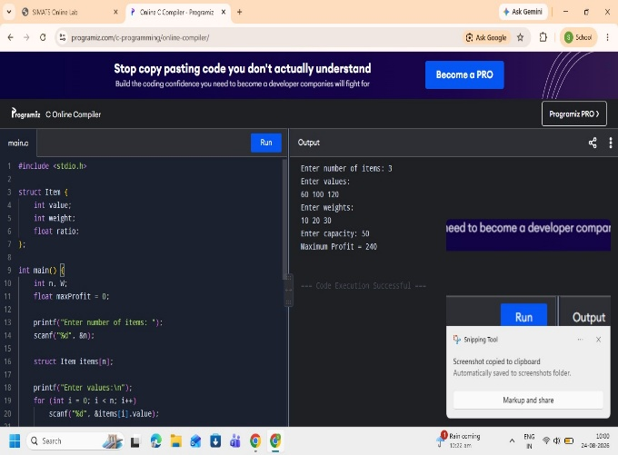

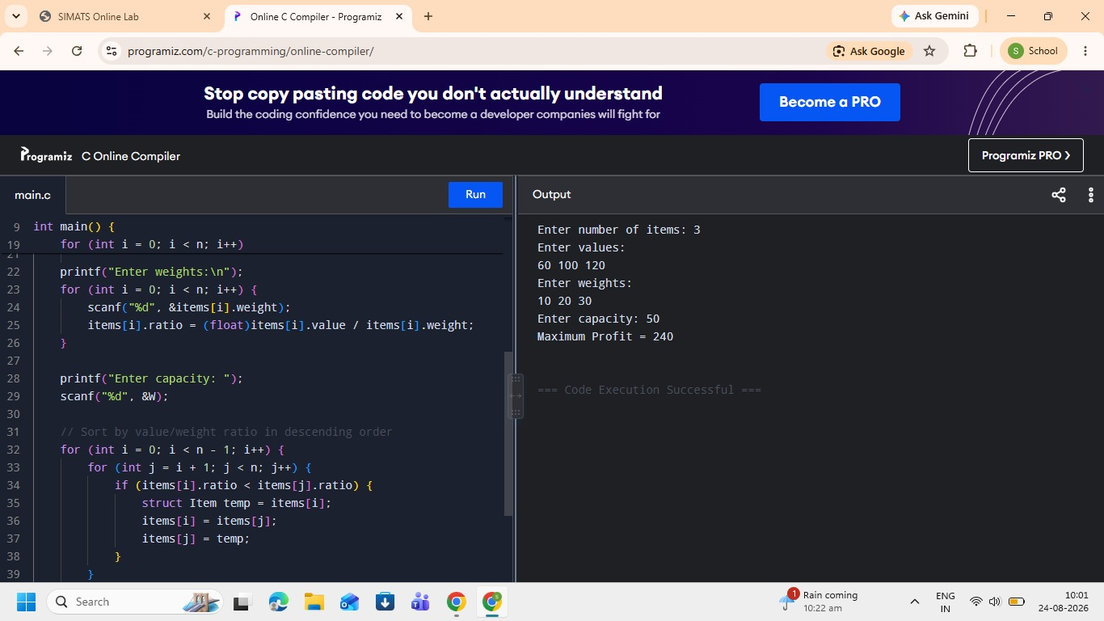

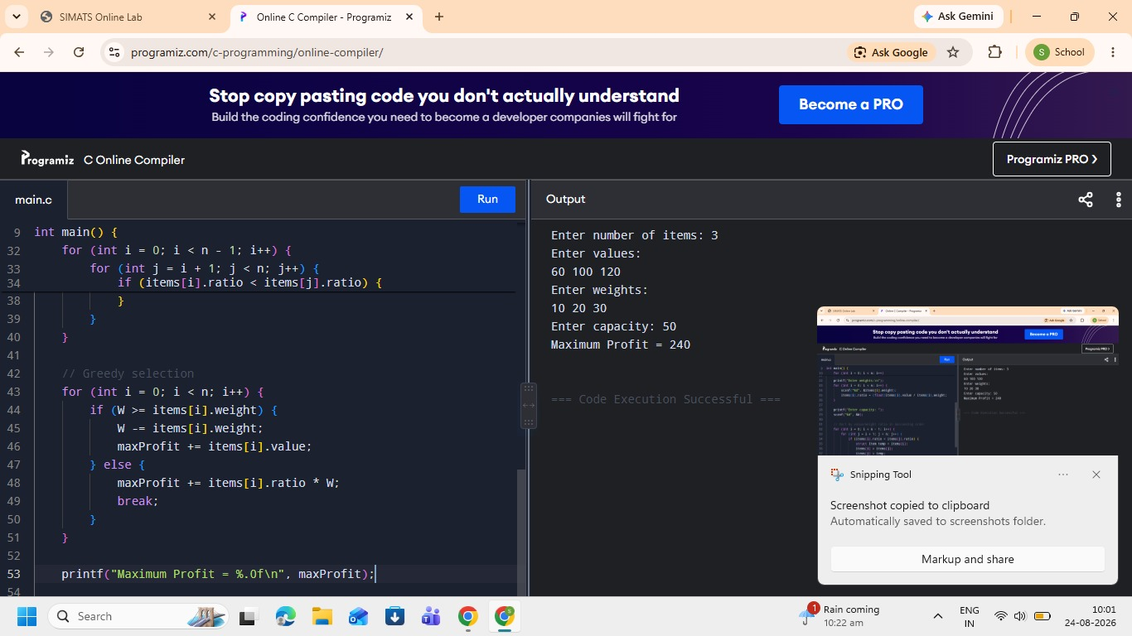

Time Complexity:
O(n²) — due to sorting using the nested-loop method.
Space Complexity:
O(n) — for storing the items.
Result:
Thus, the Fractional Knapsack problem was successfully implemented using the Greedy algorithm, obtaining a maximum profit of 240.

