Experiment: Banking Transaction Processing using Merge Sort
Aim:
To implement the Merge Sort algorithm in C for sorting banking transactions based on timestamps, ensuring stable and efficient sorting for large transaction datasets.
Algorithm:
Start the program.
Read the number of banking transactions (timestamps).
Store all timestamps in an array.
Divide the array into two equal halves recursively until each sub-array contains one element.
Merge the sub-arrays in sorted order while maintaining stability.
Display the sorted transaction timestamps.
Stop the program.
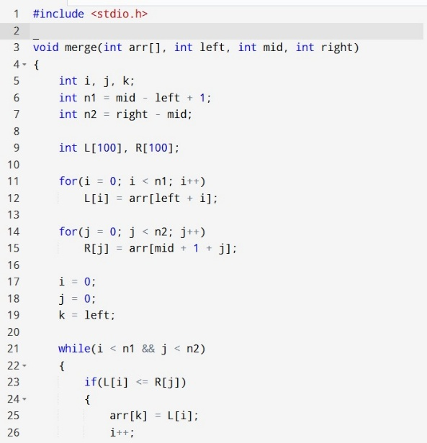
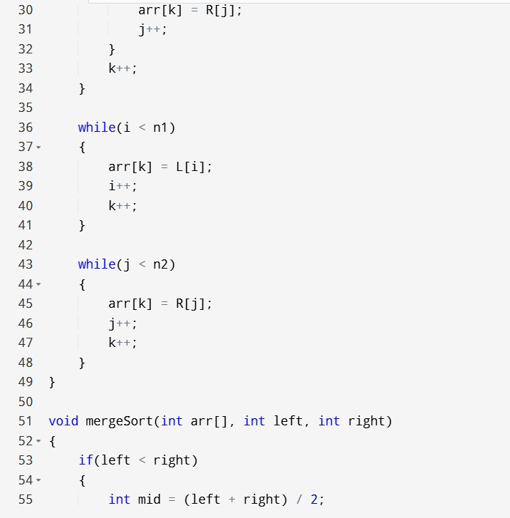
Source Code:

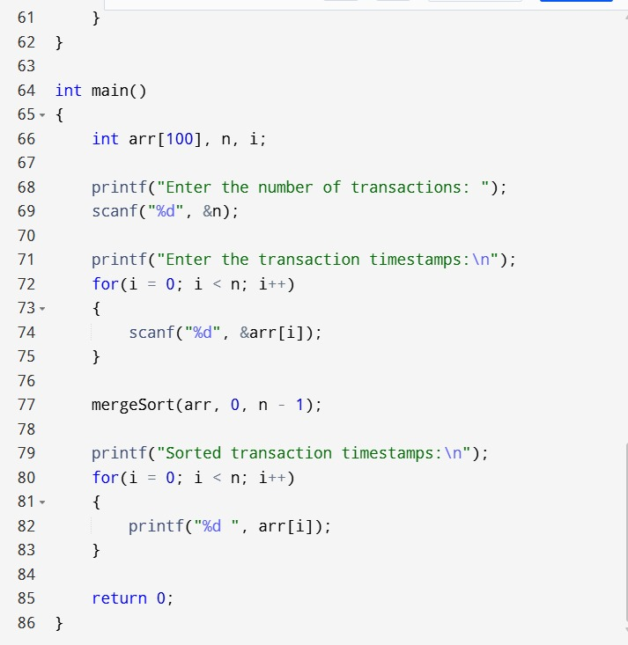
Sample input and output:
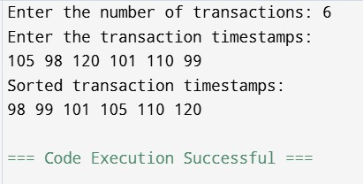

Time Complexity:
Best Case: O(n log n)
Average Case: O(n log n)
Worst Case: O(n log n)
Space Complexity:
O(n) (Extra memory is required for merging sub-arrays.)
Result:
The Merge Sort algorithm was successfully implemented in C to sort banking transaction timestamps. It provides stable sorting, efficiently handles large transaction volumes, and guarantees O(n log n) time complexity, making it suitable for banking transaction processing and auditing systems.

