Title: Debugging Bubble Sort Code
Aim:
To debug and optimize the Bubble Sort algorithm by correcting logical errors in loop conditions and swapping mechanism, reducing unnecessary passes using a flag, and sorting the array in ascending order.

Algorithm:

- Start.
- Read the number of elements (n).
- Read the array elements.
- Repeat for i = 0 to n-2:
  - Set swapped = 0.
  - Repeat for j = 0 to n-i-2:
    - If arr[j] > arr[j+1], swap them.
    - Set swapped = 1.
  - If swapped == 0, stop because the array is already sorted.
- Display the sorted array.
- Stop.

Source Code:

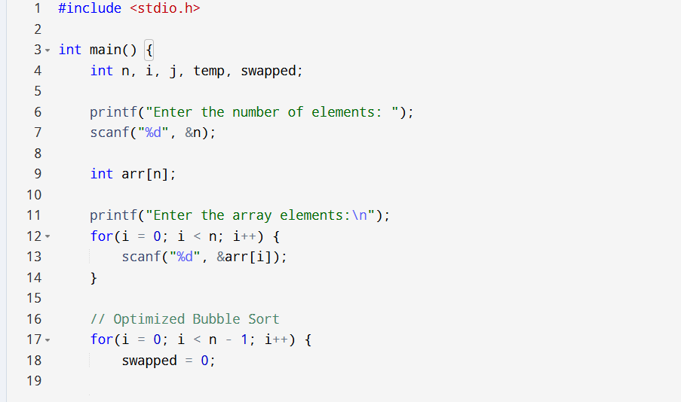
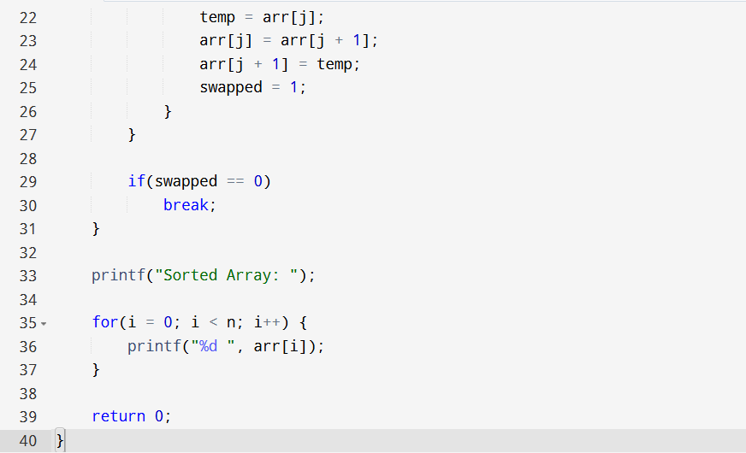

Sample input and output:
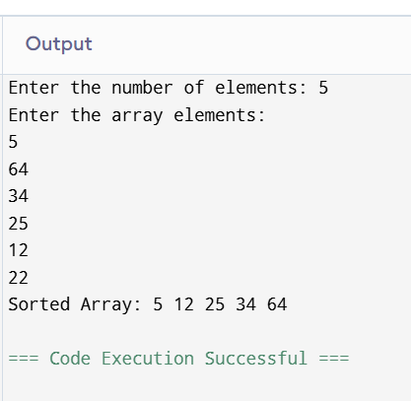

Analysis:
- The original Bubble Sort code contained logical errors:
  - The comparison operator was incorrect (< instead of >).
  - The inner loop executed unnecessary iterations.
  - No flag was used to stop early if the array was already sorted.
- The corrected program:
  - Swaps elements only when required.
  - Uses a swapped flag to terminate early if no swaps occur.
  - Produces the sorted array in ascending order.

Time Complexity:
Case | Complexity
Best Case (Already Sorted) | O(n)
Average Case | O(n²)
Worst Case (Reverse Sorted) | O(n²)

Space Complexity:
Space Complexity = O(1)
Only a few extra variables (temp, swapped, i, j) are used.

Result:
The Bubble Sort program was successfully debugged and optimized. The corrected version sorts the array in ascending order, eliminates unnecessary passes using a swapped flag, and improves efficiency for already sorted arrays while maintaining O(1) auxiliary space complexity.

